521 CMR 37.00: PUBLIC TELEPHONES

37.1 GENERAL
Wherever public pay telephones, public closed circuit telephones, or other public telephones are provided, at least one telephone shall be accessible at each location.

37.2 CLEAR FLOOR OR GROUND SPACE
Unless otherwise specified, a clear floor space that allows either a forward or parallel approach by a person using a wheelchair shall be provided at accessible telephones.

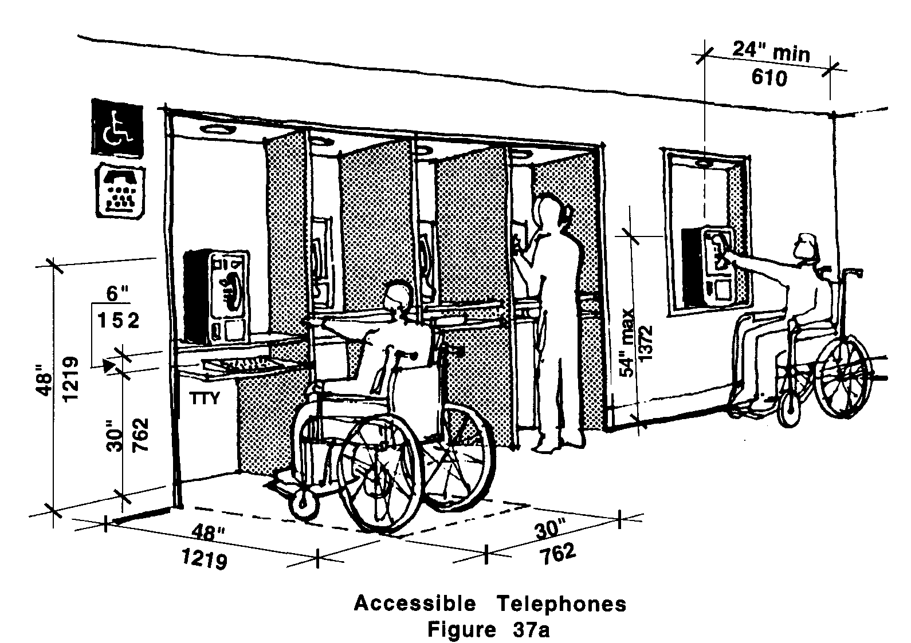

37.2.1 The clear floor space shall comply with 521 CMR 6.5 Forward Reach or 521 CMR 6.6 Side Reach. If a front approach is provided and the clear floor area includes knee space under the telephone, the kneespace shall be at least 30 inches (30" = 762mm) wide and 30 inches (30" = 762mm) high.

37.2.2 Bases, enclosures, and fixed seats shall not impede approaches to telephones by people who use wheelchairs.

37.3 MOUNTING HEIGHT
The highest operable part of the telephone, including dial, handset and coin deposit slots, shall be within the reach ranges specified in 521 CMR 6.5, Forward Reach or 521 CMR 6.6, Side Reach.

37.4 PROTRUDING OBJECTS
Accessible telephones shall be located on accessible routes and shall comply with 521 CMR 20.6, Protruding Objects. See Fig. 37b.
37.00: PUBLIC TELEPHONES

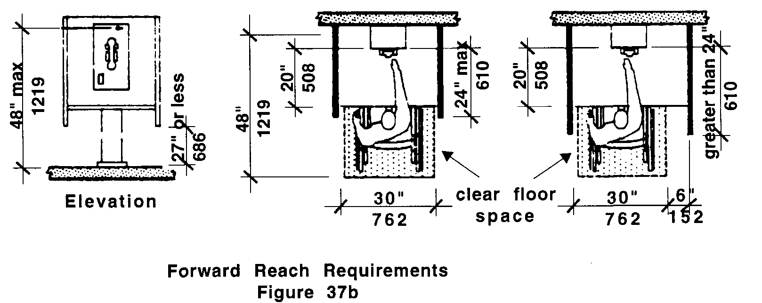

37.5 HEARING AID COMPATIBLE AND VOLUME CONTROL TELEPHONES
All telephones shall be hearing aid compatible and shall be equipped with a volume control.

37.5.1 Volume controls, capable of a minimum of 12 dbA and a maximum of 18 dbA above normal, shall be provided. If an automatic reset is provided then 18 dbA may be exceeded.

37.5.2 Instructions for use of the volume control shall be attached to or next to the telephone.

37.6 CONTROLS
Telephones shall have push button controls where service for such equipment is available.

37.7 TELEPHONE BOOKS
Telephone books, if provided, shall be located in a position that complies with the reach ranges specified in 521 CMR 6.5, Forward Reach and 521 CMR 6.6, Side Reach.

37.8 TEXT TELEPHONE (TTY)
Telephone Distribution: Where two or more telephones are provided in the same location, one shall be equipped with a Text telephone (TTY). The text telephone (TTY) shall be permanently affixed within the telephone enclosure. If an acoustic coupler is used, the telephone cord shall be at least 29 inches (29" = 737mm) long to allow connection of the text telephone (TTY) to the telephone receiver.

Exception: Where single interior public pay phones are provided in a stadium, or arena, a convention center, a hotel with a convention center, a covered mall, a public use area of a governmental building, in or adjacent to a hospital emergency room, recovery room or hospital waiting room, then it shall be equipped with a text telephone (TTY).
37.00: PUBLIC TELEPHONES

37.9 TELEPHONES WITH SHELF AND OUTLET
When three or more telephones are provided in a bank, one shall be designed to accommodate a portable text telephone (TTY) and shall be equipped with a shelf and an electrical outlet within or adjacent to the telephone enclosure. The telephone handset shall be capable of being placed flush on the surface of the shelf. The shelf shall be at least nine inches wide by 12 inches deep (9" x 12" = 229mm x 305mm) and shall have six inches (6" = 152mm) minimum vertical clearance.

37.10 SIGNAGE
Symbols of accessibility and directional signage shall be provided to comply with the following:

37.10.1 Text telephone (TTY) shall be identified by the international TTY symbol. See Fig. 41c.

37.10.2 Directional Signage for text telephone (TTY):

If a facility has a public text telephone (TTY), directional signage indicating the location of the nearest text telephone (TTY) shall be placed adjacent to all banks of telephones which do not contain a text telephone (TTY). Such directional signage shall include the international TTY symbol.

Signage for hearing amplified telephone shall be identified with signage depicting a telephone handset earpiece with radiating sound waves and shall be placed on the wall above the amplified telephone or in a location on or near the phone so that it can be easily seen and located.

