521 CMR 41.00: SIGNAGE

41.1 GENERAL
The following types of signage shall be provided:

41.1.1 Signs that designate permanent rooms and spaces shall comply with 521 CMR 41.2, 41.5 and 41.6. These include toilet room signs, room numbers, stair signs, etc.

Exception: Building directories, menus, and all other signs that are temporary are not required to comply.

41.1.2 Other signs that provide direction to, or information about, functional spaces of the building shall comply with 521 CMR 41.3, 41.4, and 41.6.

41.1.3 Elements and spaces of accessible facilities which shall be identified by the International Symbol of Accessibility (See Fig. 41a) and which shall comply with 521 CMR 41.7, Symbols of Accessibility are:

a. Parking spaces designated as reserved for individuals with disabilities;
b. Accessible passenger loading zones;
c. Accessible entrances when not all are accessible (inaccessible entrances shall have directional signage to indicate the route to the nearest accessible entrance);
d. Accessible toilet and bathing facilities when not all are accessible.
e. Emergency egress signs, which are required to be illuminated.

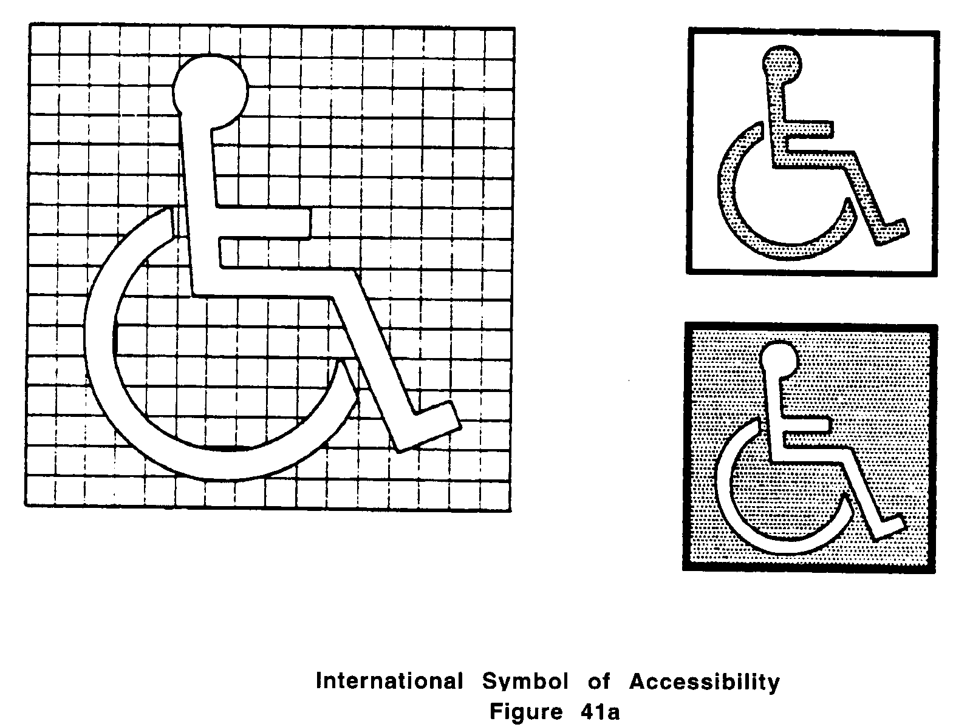

41.2 MOUNTING LOCATION AND HEIGHT
Where permanent identification is provided for rooms and spaces, signs shall be installed on the wall adjacent to the latch side of the door. Where there is no wall space to the latch side of the door, including at double leaf doors, signs shall be placed on the nearest adjacent wall.

41.00: SIGNAGE

41.2.1 Mounting location shall allow a person to approach within three inches (3" = 76mm) of signage without encountering protruding objects or standing within the swing of a door.

41.2.2 Mounting height shall be 60 inches (60" = 1524mm) above the finish floor to the centerline of the sign.

41.3 CHARACTER PROPORTION
Letters and numbers on signs shall have a width-to-height ratio between 3:5 and 1:1, and a stroke-width-to-height ratio between 1:5 and 1:10.

41.4 CHARACTER HEIGHT
Characters and numbers on signs shall be sized according to the viewing distance from which they are to be read.

41.4.1 The minimum height of suspended or overhead characters is three inches (3" = 76mm) and is measured using an upper case X.

41.4.2 Lower case characters are permitted.

41.5 RAISED AND BRAILLED CHARACTERS AND PICTORIAL SYMBOL SIGNS
Shall comply with the following:

41.5.1 Letters and numerals shall be raised one thirty-second of an inch (1/32" = 0.8mm), upper case, sans serif or simple serif type.

41.5.2 Letters and/or numerals shall be accompanied with Grade 2 Braille.

41.5.3 Raised characters shall be at least 5/8” of an inch (5/8" = 16mm) high, but no higher than two inches (2" = 51mm).

41.5.4 Pictograms shall be accompanied by the equivalent verbal description placed directly below the pictogram. The border dimension of the pictogram shall be six inches (6" = 152mm) minimum in height.

41.6 FINISH AND CONTRAST
The characters and background of signs shall be eggshell, matte, or other non-glare finish. Characters and symbols shall contrast with their background: either light characters on a dark background or dark characters on a light background.

41.7 SYMBOLS OF ACCESSIBILITY
Facilities and elements required to be identified as accessible by 521 CMR 41.1.3 shall use the international symbol of accessibility. The symbol shall be displayed as shown in Fig. 41a.
41.00: SIGNAGE

41.8 VOLUME CONTROL TELEPHONES
Telephones required to have a volume control under 521 CMR 37.5, shall be identified by a sign containing a depiction of a telephone handset with radiating sound waves.

41.9 TEXT TELEPHONES (TTY)
Text telephones (TTY) required by 521 CMR 37.8, Text Telephones shall be identified by the international TTY symbol (See Fig. 41c). In addition, if a facility has a public text telephone (TTY), directional signage indicating the location of the nearest text telephone (TTY) shall be placed adjacent to all banks of telephones that do not contain a text telephone (TTY). Such directional signage shall include the international TTY symbol. If a facility has no banks of telephones but a public text telephone (TTY) is available, the directional signage shall be provided at the entrance (e.g., in a building directory).

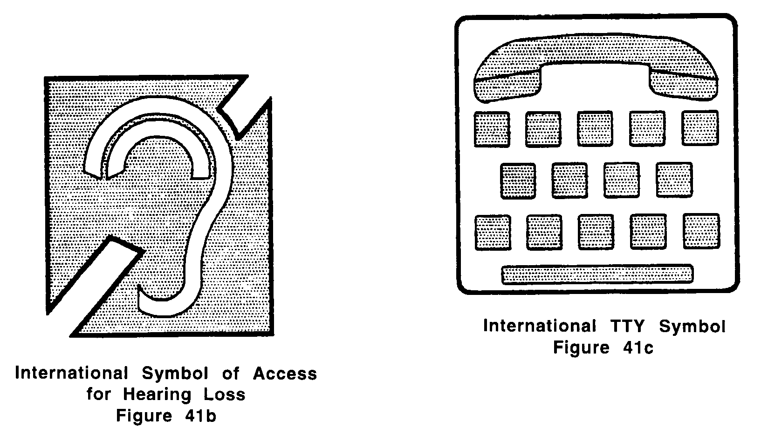

41.10 ASSISTIVE LISTENING SYSTEMS
In assembly areas where permanently installed assistive listening systems are required by 521 CMR 14.5, Assistive Listening Devices the availability of such systems shall be identified with signage that includes the international symbol of access for hearing loss. See Fig 41b.

41.11 ILLUMINATION LEVELS (reserved)

