521 CMR 43.00: GROUP 1 KITCHENS

43.1 GENERAL
In all Group 1 Dwelling units, kitchens shall be designed so that when a unit is adapted a person in a wheelchair has access to the sink, cooking surface, refrigerator, and a food preparation surface and can turn around without having to leave the kitchen.

43.2 CLEAR FLOOR SPACE:
Shall be measured at the face of the base cabinets or appliances, (excluding cabinet hardware and appliance hardware) and shall be provided at the time of first occupancy as follows:

43.2.1 L-shaped kitchens shall have a minimum clear floor space of 48 inches by 48 inches (48" x 48" = 1219mm x 1219mm). See Fig. 43a.

43.2.2 U-shaped kitchens shall provide a minimum clear floor space of 48 inches (48" = 1219mm) between opposing base cabinets or appliances. See Fig. 43b.

43.2.3 Galley kitchens shall provide a minimum clear floor space of 40 inches (40" = 1016mm) between opposing base cabinets or appliances. See Fig. 43c.

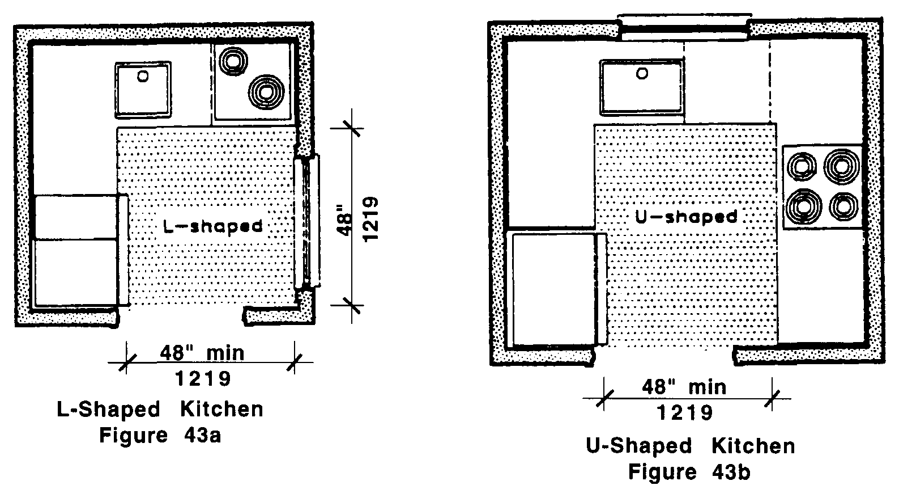
43.00: GROUP 1 KITCHENS

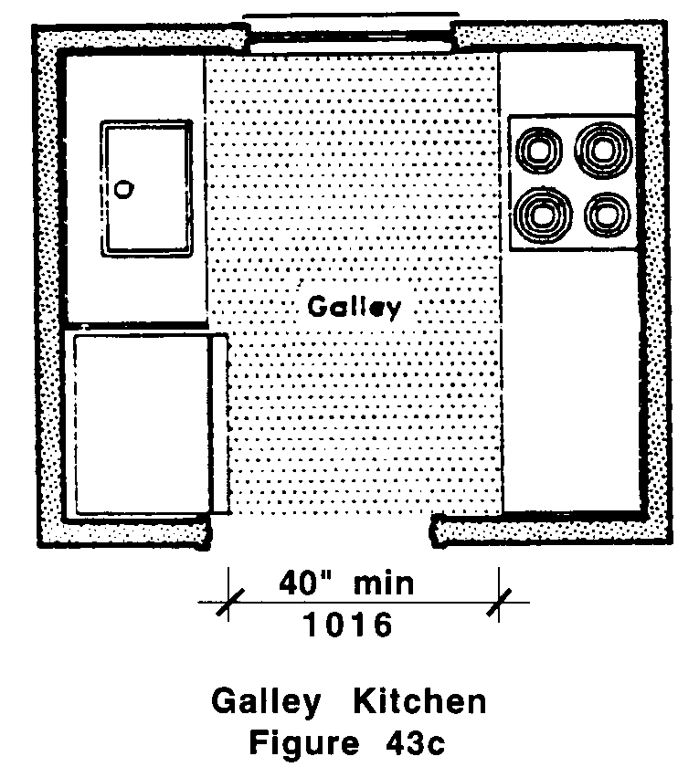
43.3 SINKS
Shall comply with the following:

43.3.1 Sink Cabinet: The base cabinet under the sink shall be capable of being removed to provide a kneespace of 30 inches (30" = 762mm) in width.

43.3.2 Sink Depth: The sink bowl shall not exceed 6½ inches (6½" = 165mm) in depth. Where more than one bowl is provided, only one bowl must meet this requirement.

43.4 COOKING UNITS
Shall comply with the following to ensure that both burners and ovens can be made functional and safe for a person in a wheelchair.

43.4.1 In-Counter cooktops: If a cooktop is provided, its base cabinet shall be capable of being removed to provide future kneespace the width of the cooktop but not less than 30 inches (30" = 762mm) wide. Cooktops shall have controls located at the front or side of the unit.

43.4.2 Wall Ovens: If a wall oven is provided, the floor of the wall oven shall be located 30 inches (30" = 762mm) above the floor.

43.5 WALL CABINETS
Walls shall be capable of structurally supporting wall cabinets at any location from 42 inches to 54 inches (42" to 54" = 1067mm to 1372mm) from the floor to the bottom of the inside of the cabinet.

43.6 BASE CABINETS
Each base cabinet shall be capable of being removed to provide kneespace for persons using wheelchairs.

43.00: GROUP 1 KITCHENS

43.7 REFRIGERATORS
Space shall be provided so that the refrigerator can be located so that its doors can be opened to 180 degrees. If doors cannot be opened to 180 degrees, a minimum of 30 inches (30"= 762mm) of counter space next to the refrigerator shall be provided.

43.7.1 Where refrigerators are provided with less than nine cubic feet of capacity, 521 CMR 43.7, Refrigerators shall not apply.

43.8 OUTLETS AND CONTROLS
Shall comply with 521 CMR 39.00: CONTROLS.

43.9 ALARMS
Shall comply with 521 CMR 40.00: ALARMS.

