521 CMR 44.00: GROUP 2 BATHROOMS

44.1 GENERAL
In all dwelling units required to be Group 2A units, (see 521 CMR 9.4 Group 2A Dwelling Units) all bathrooms and half bathrooms shall comply with 521 CMR 44, exclusive of the bold and italicized text which refer to Group 2B units. In facilities required to have Group 2B bathrooms, such as hotels, motels, inns and health facilities, the bathroom shall comply with 521 CMR including the bold and italicized text which refer to Group 2B units.

44.2 WHEELCHAIR TURNING SPACE
Bathrooms shall have or be capable of having wheelchair turning space which complies with 521 CMR 6.3, Wheelchair Turning Space without coming into contact with any fixtures. See Fig. 44a.

44.3 DOORS
Shall comply with 521 CMR 26.5, Width through 521 CMR 26.11, Door Hardware. Doors shall swing out, fold or slide. Doors may swing into the bathroom only if the door does not impede the wheelchair turning space.

44.4 WATER CLOSETS
Shall comply with the following:

44.4.1 Location: The centerline of the water closet shall be located 18 inches (18" = 457mm) from the nearest side wall and at least 42 inches (42" = 1067mm) from the farthest side wall or the closest edge of an adjacent fixture. There shall be 42 inches (42" = 1067mm) clear from the front edge of the water closet to the nearest wall or fixture.

44.00: GROUP 2 BATHROOMS

44.4.2 Height: The top of the water closet seat shall be 15 inches to 19 inches (15" to 19" = 381mm to 483mm) above the floor.

In Group 2B bathrooms, the water closet seat shall be 17 inches to 19 inches (17"-19" = 470mm to 483mm) above the floor.

44.4.3 Operation: The flush activator shall be operable with a closed fist and shall not require grasping, pinching, or twisting of the wrist. Water closet flush control shall be located on the accessible side of the water closet.

44.4.4 Wall Reinforcement: Walls adjacent to and behind the water closet shall be capable of structurally supporting the future installation of grab bars from 32 to 38 inches (32" to 38" = 813mm to 965mm) above the floor. The back wall shall have reinforcement from the interior corner to a distance of six inches (6" = 152mm) beyond the widest part of the water closet. The side wall shall have reinforcement from the interior corner to a distance of six inches (6"= 152mm) beyond the front edge of the water closet, unless interrupted by a door or other fixture, then the reinforcement shall be installed as far as possible.

In Group 2B bathrooms, two grab bars , one 42 inches (42" = 1067mm) long and one 36 inches (36" = 914mm) long shall be installed at the water closet between 33 inches (33" = 838mm) and 36 inches (36" = 914mm) above and parallel to the floor. The 42 inch (42" = 1067mm) grab bar shall be mounted on the side wall closest to the water closet, no more than 12 inches (12" = 305mm) from the back wall. The 36 inch (36" = 914mm) grab bar shall be mounted on the back wall six inches (6" = 152mm) from the interior corner and may be located up to three inches (3" = 76mm) above the top of the water closet tank.

44.4.5 Toilet Paper Dispensers: The toilet paper dispensers shall be located on the side wall closest to the water closet. The centerline of the roll shall be set at a minimum height of 19 inches (19" = 483mm) above the floor. Dispensers that control delivery or that do not permit continuous paper flow are not allowed.

44.5 SINKS
Shall comply with the following:

44.5.1 Adaptability: The sink, its plumbing, and the walls adjacent to the sink shall be designed so that the sink can be relocated vertically and so that the sink installation meets the definition of structural strength.

44.5.2 Vanity Cabinets: Where a cabinet or vanity is provided under a sink, it shall be removable or replaceable to provide a knee space that complies with 521 CMR 44.5.4 and 44.5.5.

In Group 2B bathrooms, base cabinets can be used only if kneespace is also provided.

44.00: GROUP 2 BATHROOMS

44.5.3 Height: The sink shall be capable of being relocated vertically, in the future, without requiring structural change to the walls of the bathroom. A sink with kneespace shall be installed or be capable of being installed, with at least 27 inches (27" = 686mm) of clearance from the floor to the bottom of the sink or counter apron.

In Group 2B bathrooms, the sink rim or counter surface shall be installed at a height of 34 inches (34" = 864mm) from the floor and there shall be at least 29 inches (29" = 737mm) of clearance from the floor to the bottom of the sink or counter apron.

44.5.4 Kneespace width: The sink shall have or be capable of having, without structural change, a knee space of 30 inches (30" = 762mm) in width, centered on the sink.

In Group 2B bathrooms, a kneespace of 30 inches (30" = 762mm) in width must be provided.

44.5.5 Kneespace depth: The front edge of the sink or the front edge of the countertop in which a sink is located, shall be a minimum of 22 inches (22" = 559mm) from the back wall or be capable of being relocated to create a space 22 inches (22" = 559mm) deep from the back wall to the front edge of the sink.

In Group 2B bathrooms, the front edge of the sink or the front edge of the countertop in which a sink is located, shall be a minimum of 22 inches (22" = 559mm) from the back wall.

44.5.6 Piping: All piping under the sink shall be offset to the back wall so that persons in wheelchairs have maximum possible kneespace.

In Group 2B bathrooms, the hot water and waste pipes under the sink shall be offset to the back wall and insulated.

44.5.7 Hardware: Faucets shall be operable with a closed fist and shall not require grasping, pinching, or twisting of the wrist.

44.6 BATHING FIXTURES
If more than one bathing fixture is provided in a dwelling unit, one shall be a shower unit complying with 521 CMR 44.6.2. If a jacuzzi or whirlpool tub is the only bathing facility, it must meet the requirements of 521 CMR 44.6.1. Where one bathing fixture is provided, it may be either a shower unit or a bathtub.

44.6.1 Bathtubs shall comply with the following:

a. Fixtures: Bathtubs shall be a minimum, nominal dimension of 60 inches (60" = 1524mm) long. The rim shall be between 16 and 18 inches (16" and 18" = 406mm and 457mm) above the floor.
44.00: GROUP 2 BATHROOMS

b. Minimum floor area: A clear floor area 30 inches (30" = 762mm) wide and at least 72 inches (72" = 1829mm) long shall be provided adjacent to the tub. At least 12 inches (12" = 305mm) of the clear floor area length shall extend beyond the drain end of the tub if the tub is 60 inches (60" = 1524mm) long.
c. Wall reinforcement: All walls of the tub shall have structural reinforcement to allow the future installation of grab bars at any location from the rim of the tub to a height of 60 inches (60" = 1524m) above the tub bottom.

In Group 2B bathrooms, two grab bars, 48 inches (48" = 1219mm) long, shall be installed centered on the long wall and parallel to the floor. One shall be mounted at a height of 21 inches (21" = 533mm) and one at a height of 36 inches (36" = 914mm) above the floor.

d. Tub material: Plastic or fiberglass tubs shall be structurally capable of accepting the installation of a lift that clamps onto the rim.
e. Hardware: Faucets shall be operable with a closed fist and shall not require grasping, pinching, or twisting of the wrist.
f. Hardware location: Faucets and mixing valves shall be centered horizontally on the long wall of the tub, 28 inches (28" = 711mm) above the floor. The tub spout shall be located on the end wall above the drain and a shower head may be located on either the end wall or long wall. If hardware is installed in locations other than those specified, piping shall also be provided and capped in the wall.
g. Hand-held showers: A hand-held shower head with a flow regulator, attached to a 60 inch (60" = 1524mm) long flexible hose and an adjustable mounting bar, shall be provided or be capable of being installed on the long wall of the tub.

In Group 2B bathrooms, a tub seat which is portable or permanent shall be provided.

In Group 2B bathrooms, a hand held shower head attached to a 60 inch (60" = 1524mm) long flexible hose and an adjustable mounting bar , 36 inches (36" = 914mm) long, shall be installed on the long wall of the tub. The bottom of the mounting bar shall be located at 40 inches (40" = 1016mm) above the tub bottom.

h. Door enclosures: Tracks for sliding doors or enclosures shall not be mounted on the rim of the bathtub unless they can be removed.

In Group 2B bathrooms, sliding doors shall not be used.

i. Soap Trays: Soap trays shall not have a hand-hold feature and shall be installed or be capable of being relocated with a centerline no higher than 48 inches (48" = 1219mm) above the floor.

In Group 2B bathrooms, soap trays shall be installed no higher than 48 inches (48" = 1219mm) above the floor to the centerline of the soap tray.

44.00: GROUP 2 BATHROOMS

44.6.2 Showers shall comply with the following:

a. Fixture size: The shower shall be the wheel-in type with a minimum, nominal size of 30 inches by 60 inches (30" x 60" = 762mm x 1524mm). The long side shall be fully open. In the alternative, the stall may be 36 by 60 inches (36" x 60" = 914mm x 1524mm) with a 24 inch (24" = 610mm) wing wall on the 60 inch (60" = 1524mm) side. The slope of the shower floor shall not exceed 2%. The curb shall have no more than a ½ inch (½" = 13mm) maximum lip, beveled at a slope no steeper than 1:2. See Fig. 44b and 44c.

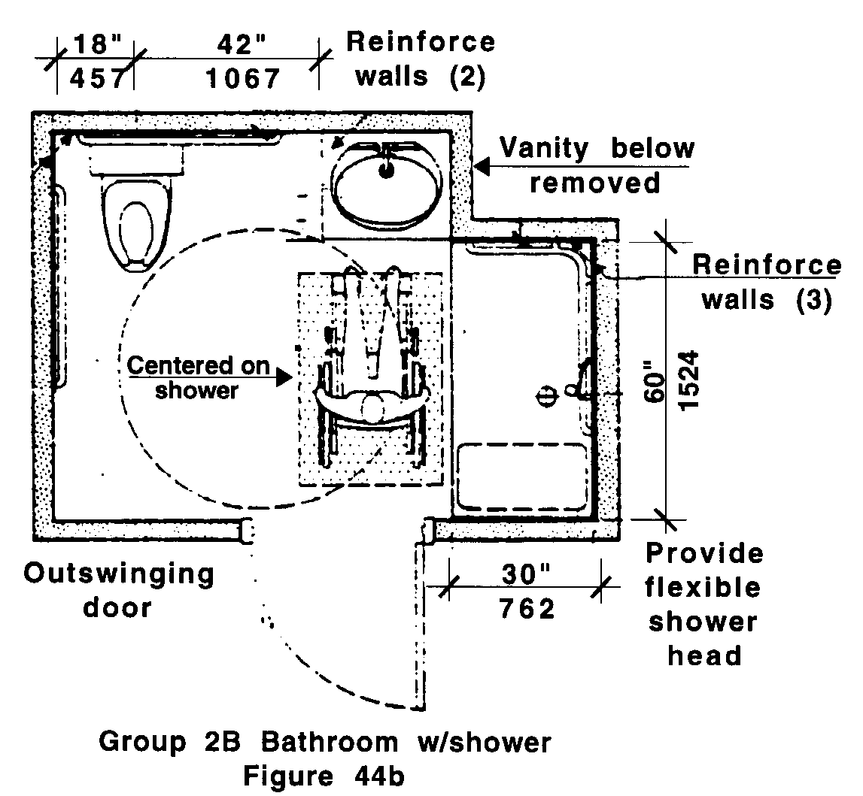

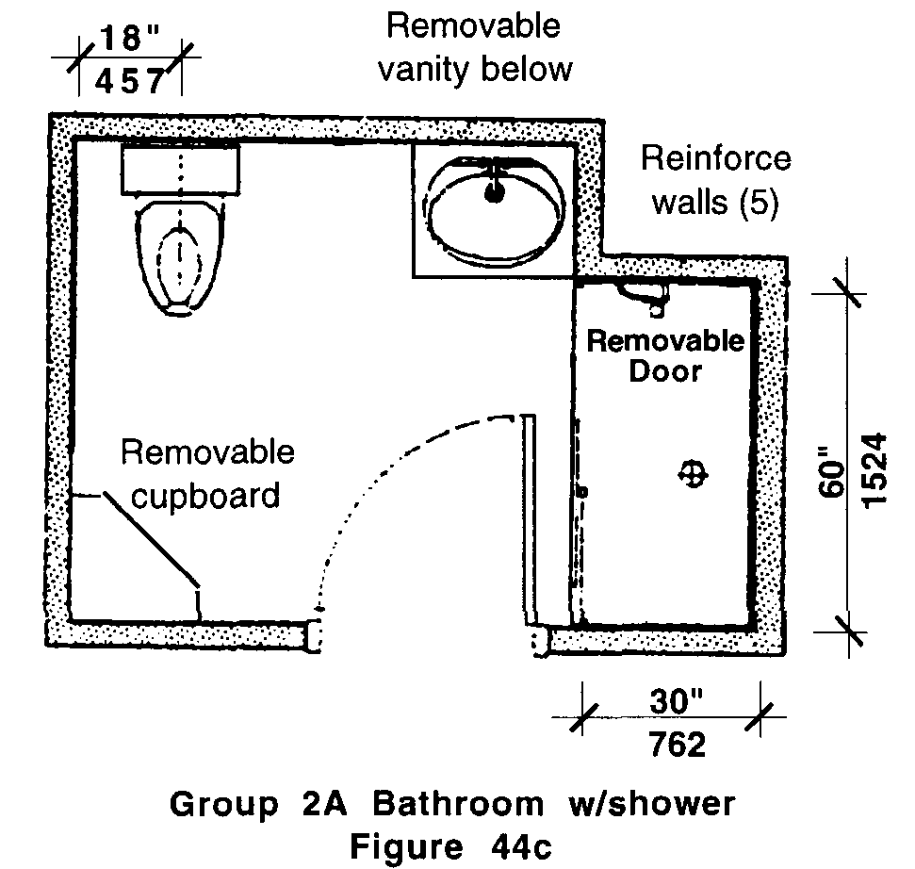
44.00: GROUP 2 BATHROOMS

b. Wall reinforcement: All walls of the shower shall have structural reinforcement to allow the future installation of a seat and grab bars, at any location from the floor to a height of 60 inches (60" = 1524mm) above the floor.

In Group 2B bathrooms, one grab bar 48 inches (48" = 1219mm) long shall be installed on the long wall, at a height of 36 inches (36" = 914mm) above the floor.

c. Seat: A hinged, padded shower seat shall be installed or be capable of being installed on a wall adjacent to the opening. The seat shall be mounted with the edge as close as possible to the opening to provide a safe transfer. The top of the seat shall be 17 to 19 inches (17" to 19" = 432mm to 483mm) above the shower floor.

In Group 2B bathrooms, a hinged, padded shower seat shall be installed and mounted as specified above. The seat shall be a minimum of 16 inches (16" = 406mm) deep by 24 inches (24" = 610mm) long. Grab bars shall not be located behind the seat.

d. Hardware: Faucets shall be operable with a closed fist and shall not require grasping, pinching, or twisting of the wrist.
e. Hardware location: Mixing valves shall be centered horizontally on the long wall. The centerline of the control shall be mounted 38 inches to 48 inches (38" to 48" = 965mm to 1219mm) above the shower floor.
f. Hand held shower: A hand held shower head attached to a 60 inch (60" = 1524mm) long flexible hose and an adjustable mounting bar shall be provided or be capable of being installed in the shower.

In Group 2B bathrooms, a hand held shower head attached to a 60 inch (60" = 1524mm) long flexible hose and an adjustable mounting bar , 36 inches (36" = 914mm) long shall be installed in the shower on the long wall adjacent to the seat. The bottom of the mounting bar shall be located at 40 inches (40" = 1016mm) above the shower floor.

g. Soap tray: Shall not have a hand-hold feature unless it can support 250 lbs for five minutes. If provided, it shall be installed or be capable of being relocated with a centerline no higher than 48 inches (48" = 1219mm) above the shower floor.

In Group 2B bathrooms, soap trays shall be installed no higher than 48 inches (48" = 1219mm) above the floor to the centerline of the soap tray.

44.7 GRAB BARS
Grab bars shall be non-rusting and slip resistant, shall be between 1¼ inches and 1½ inches (1¼" to 1½" = 32mm to 38mm) in outside diameter, and shall be located 1½ inches (1½" = 38mm) clear from the wall. Grab bars shall also meet the definition of structural strength.
44.00: GROUP 2 BATHROOMS

44.8 MIRRORS
Shall comply with the following:

44.8.1 A mirror over a sink shall be installed at or be capable of being relocated to a height of 40 inches (40" = 1016mm) from the floor to the bottom edge of the mirror's reflecting surface.

44.8.2 The top of the mirror shall be at least 72 inches (72" = 1829mm) above the floor.

In Group 2B bathrooms, a mirror shall be installed with the bottom no more than 40 inches (40" = 1016mm) above the floor and the top no less than 72 inches (72" = 1829mm) above the floor.

44.9 MEDICINE CABINETS
If medicine cabinets are provided, one medicine cabinet shall be installed or be capable of being relocated so that the inside bottom surface is at a height of 40 inches (40" = 1016mm) above the floor. If the medicine cabinet is also the only mirror, the bottom of the mirror shall be no higher than 40 inches (40" = 1016mm) above the floor.

In Group 2B bathrooms, the medicine cabinet shall be installed with its inside bottom surface at a height of 40 inches (40" = 1016mm) above the floor.

44.10 OUTLETS AND CONTROLS
Shall comply with 521 CMR 39.00: CONTROLS.

44.11 ALARMS
Shall comply with 521 CMR 41.00: ALARMS.

