521 CMR 45.00: GROUP 2 KITCHENS

45.1 GENERAL
In all dwellings required to be Group 2A units (see 521 CMR 9.4 Group 2 Dwelling Units) all kitchens shall comply with 521 CMR 45, exclusive of the bold and italicized text which refers to Group 2B units. In facilities required to provide Group 2B units, such as hotels, motels, and inns, the kitchen shall comply with 521 CMR 45 plus the bold and italicized text that refers to Group 2B units.

45.2 CLEAR FLOOR SPACE:
A clear floor space complying with 521 CMR 6.4, Clear Floor or Ground Space for Wheelchairs shall be provided in front of those appliances which have no kneespace including but not limited to: refrigerators and wall ovens.

45.3 WHEELCHAIR TURNING SPACE
Shall comply with 521 CMR 6.3, Wheelchair Turning Space, to permit a person using a wheelchair to turn around without coming into contact with any fixtures. In addition, when a sink and a cooktop are located 15 inches (or less) (15" = 381mm) apart, the counter shall provide or shall be capable of providing continuous clear kneespace at least 29 inches (29" = 737mm) in height. See Fig. 45a.

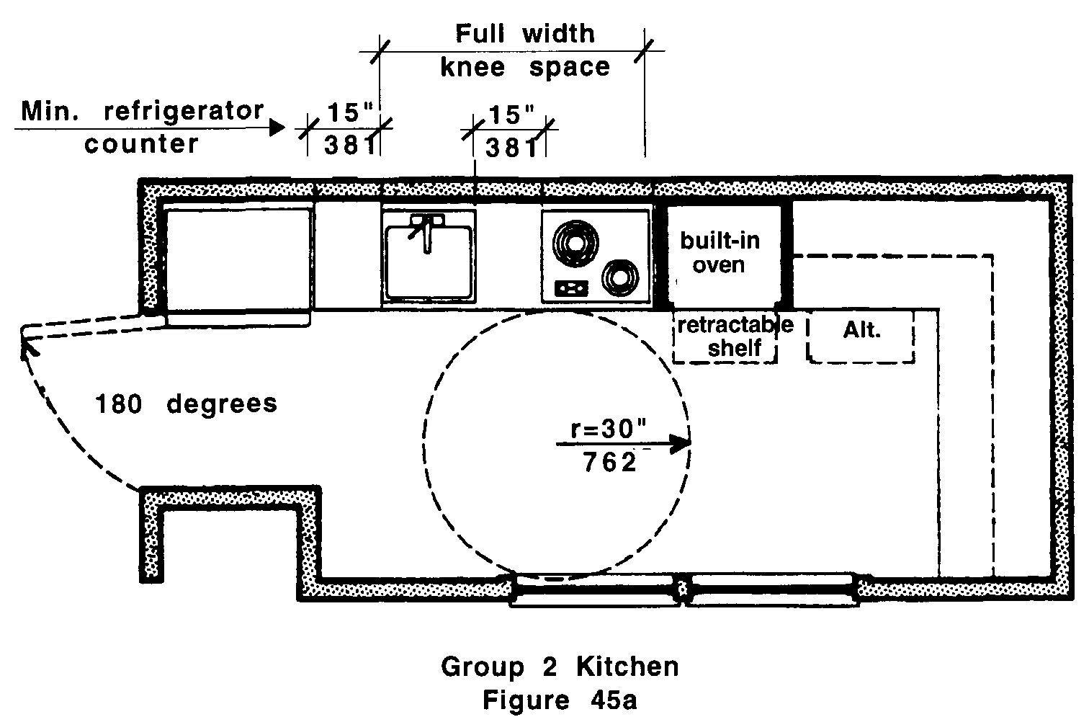

45.4 SINKS
Shall comply with the following:

45.4.1 Sink cabinet: If a base cabinet is provided under the sink, it shall be removable to provide a kneespace that complies with 521 CMR 45.4.2 and 45.4.3.

In Group 2B units, base cabinets shall not be installed unless kneespace is provided.
45.00: GROUP 2 KITCHENS

45.4.2 Kneespace: A clear kneespace shall be provided or be capable of being provided under the sink, 19 inches (19" = 482mm) deep and at least 30 inches (30" = 762mm) wide.

In Group 2B units, kneespace shall be provided.

45.4.3 Height: The sink shall be capable of being relocated vertically in the future, without structural change to the walls of the kitchen.

In Group 2B units, the kitchen sink shall be located so that there is 27 inches (27" = 685mm) from the floor to the underside of the sink.

45.4.4 Countertop: A counter space at least 15 inches (15" = 381mm) wide shall be provided on one side of the sink, at the same height as the sink. This may overlap with one of the 15 inch (15" = 381mm) spaces required in 521 CMR 45.5.4.

In Group 2B units, the countertop shall be set at 34 inches (34" = 863mm) above the floor to the top of the counter.

45.4.5 Sink depth: Sink bowls shall not exceed 6½ inches (6½ = 165mm) in depth and shall have drains offset to the rear.

45.4.6 Piping: Water pipes and drain traps shall be located as close to the rear wall of the kneespace and as high off the floor as possible to provide maximum kneespace. If there is no base cabinet under the sink, pipes and traps shall be insulated or covered.

45.4.7 Disposals: If a garbage disposal has a remote switch, it shall be located on the front face (apron) of the counter located to the left or right of the sink but not in front of the sink.

45.4.8 Sink Hardware: Faucets shall be operated by a single lever. A spray hose shall be provided or a knockout provided on the sink for the future installation of a spray hose.

45.5 COOKTOPS
Standard ranges shall not be the only cooking surface. Cooktops shall be provided and shall comply with the following:

45.5.1 Base cabinets: If a base cabinet is provided under the cooktop, it shall be removable to provide kneespace that complies with 521 CMR 45.5.2 and 45.5.3.

In Group 2B units, base cabinets shall not be installed unless kneespace can be provided.

45.5.2 Kneespace: A clear kneespace shall be provided or be capable of being provided under the cooktop, 19 inches (19" = 482mm) deep and at least 30 inches (30" = 762mm) wide.

In Group 2B units, kneespace shall be provided.
45.00: GROUP 2 KITCHENS

45.5.3 Height: The cooktop shall be capable of being relocated vertically in the future, without structural change to the walls of the kitchen.

In Group 2B units, the kitchen cooktop shall be located so that there is 29 inches (29" = 737mm) from the floor to the underside of the cooktop.

45.5.4 Countertop: A counter space at least 15 inches (15" = 381mm) wide shall be provided on one side of the cooktop, at the same height as the cooktop. This may overlap with one of the 15 inch (15" = 381mm) spaces required in 521 CMR 45.4.4.

45.5.5 Controls: Cooktop controls shall be located at the front or side of the appliance. Exhaust hood: if the controls for a hood are located higher than 54 inches (54" = 1372mm) above the floor, a switch shall be provided at the front face (apron) of counter.

45.6 OVENS
All microwave ovens, if built-in, and at least one conventional oven shall comply with the following:

45.6.1 Height: The floor of the oven shall be 30 inches (30" = 762mm) above the floor.

45.6.2 Oven type: The oven shall be self-cleaning or continuous cleaning.

45.6.3 Control location: Oven controls shall be located within the zone of reach as defined by 521 CMR.

45.6.4 Where a bottom-hinged oven door is provided, a retractable "bread board" type shelf shall be provided in the counter immediately adjacent to the oven door. Where a side-hinged oven is provided, the retractable "bread board" type shelf shall be provided directly under the oven.

45.7 WALL CABINETS
Walls shall be capable of structurally supporting wall cabinets so that the inside bottom surface of the cabinet is capable of being located between 42 inches (42" = 1067mm) and 54 inches (54" = 1372mm) above the floor.

In Group 2B units, the wall cabinets shall be mounted so that the inside bottom surface of the cabinet is no higher than 48 inches (48" = 1219mm) from the floor.

45.8 BASE CABINETS
Shall comply with the following:

45.8.1 Each cabinet shall be capable of being removed to provide clear kneespace for persons using wheelchairs.
45.00: GROUP 2 KITCHENS

45.8.2 Corners: Cabinets located at the inside corner of an L-shaped counter shall have or be capable of providing a built-in lazy susan.

45.8.3 Drawers: At least one base cabinet shall provide a drawer or drawers.

45.9 CABINET HARDWARE
Shall comply with the following:

45.9.1 Type: Opening devices shall not require twisting, pinching or grasping to operate.

45.9.2 Location: Cabinet opening devices shall be located at the tops of base cabinet doors and at the bottom of wall cabinet doors.

45.10 REFRIGERATORS
When the refrigerator is provided with the unit, it may be combination refrigerator-freezers with two doors side by side, or may be two door freezer-above-the-refrigerator units, provided the floor of such freezer is no higher than 44 inches (44" = 1118mm) above the floor, and shall be self-defrosting.

45.10.1 Location: The refrigerator shall be located so that its doors are capable of being opened 180 degrees and so that it meets minimum clear floor space and zone of reach requirements in 521 CMR 6.3, Wheelchair Turning Space, 521 CMR6.5, Forward Reach and 521 CMR 6.6, Side Reach.

45.10.2 Counterspace: A counter space at least 15 inches (15" = 381mm) wide shall be provided on one side of the refrigerator. This may overlap with one of the 15 inch spaces (15" = 381mm) required in 521 CMR 45.4.4 or 45.5.4.

45.11 OUTLETS AND CONTROLS
Shall comply with the applicable parts of 521 CMR 39.00: CONTROLS.

45.12 ALARMS
Shall comply with the applicable parts of 521 CMR 40.00: ALARMS.

