521 CMR 6.00: SPACE ALLOWANCE AND REACH RANGES

6.1 WHEELCHAIR PASSAGE WIDTH
The minimum clear width for single wheelchair passage shall be 36 inches (36" = 914mm) except for a reduction to 32 inches (32" = 813mm) and that reduction shall not exceed a lineal distance of 24 inches (24" = 610mm). See Fig. 6a.

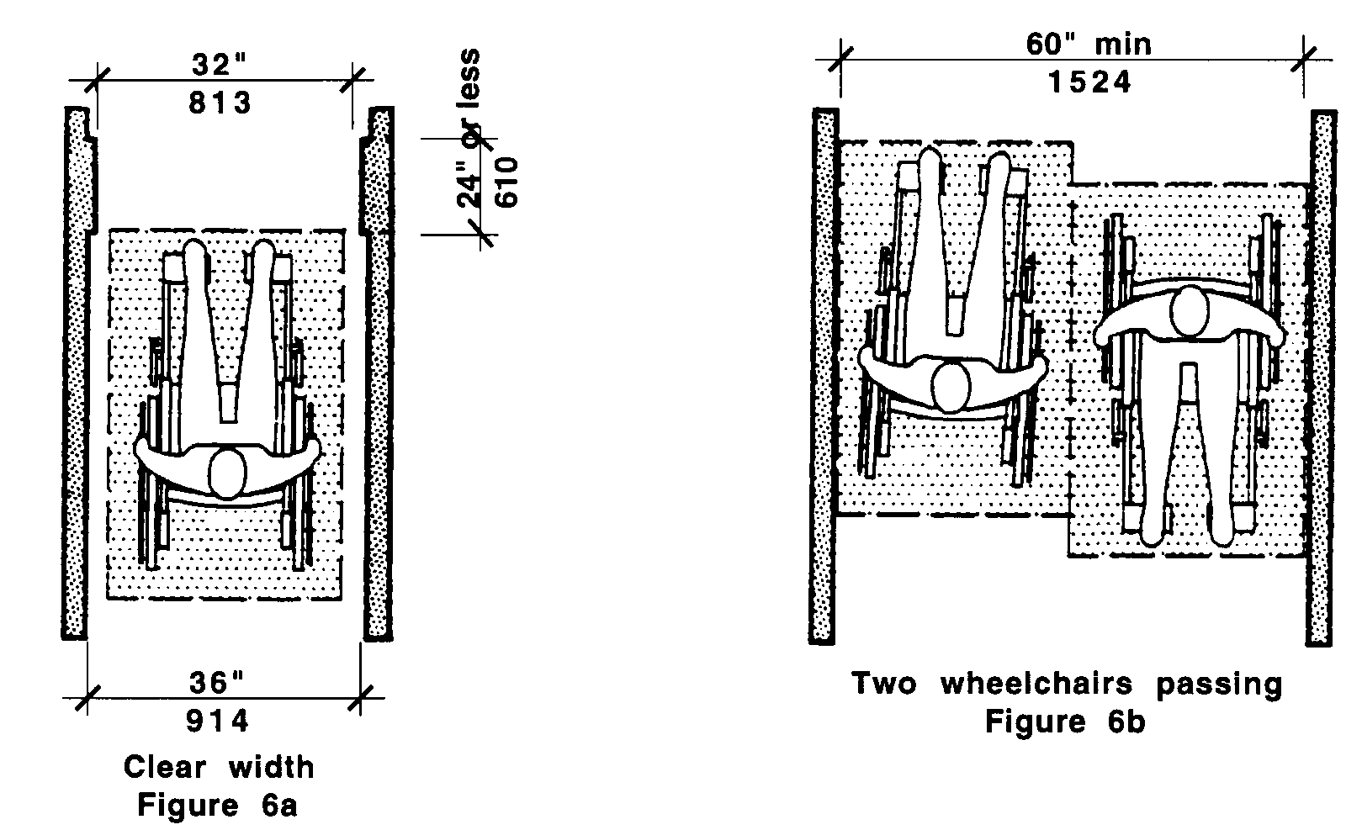

6.2 WIDTH FOR WHEELCHAIR PASSING
The minimum width for two wheelchairs to pass is 60 inches (60" = 1524mm) See Fig. 6b.

6.3 WHEELCHAIR TURNING SPACE
The space required for a wheelchair to make a 180-degree turn is a clear space of 60 inches (60" = 1524mm) diameter (See Fig. 6c) or a T-shaped space. See Fig. 6d.

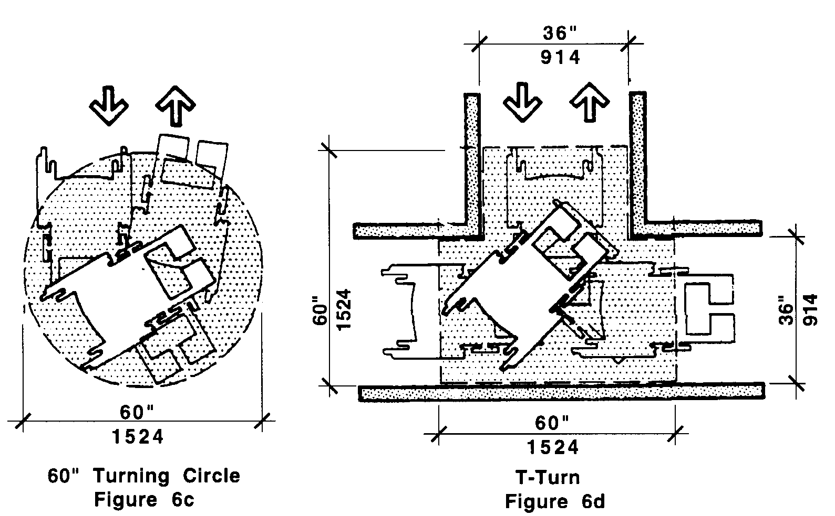

6.4 CLEAR FLOOR OR GROUND SPACE FOR WHEELCHAIRS
shall comply with the following:
6.00: SPACE ALLOWANCE AND REACH RANGES

6.4.1 Size and Approach: The minimum clear floor or ground space required to accommodate a single, stationary wheelchair and occupant is 30 inches by 48 inches (30" x 48" = 762mm x 1219mm) (See Fig. 6e). The minimum clear floor or ground space for wheelchairs may be positioned for forward or parallel approach to an object (See Fig. 6f and 6g). Clear floor or ground space for wheelchairs may be part of the knee space required under objects.

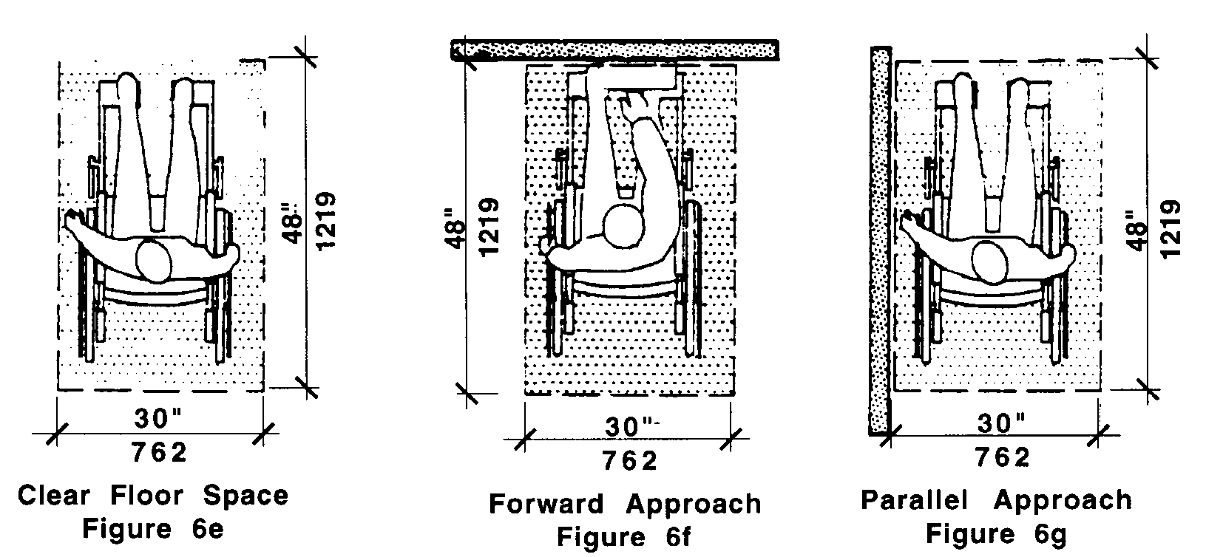

6.4.2 Relationship of Maneuvering Clearance to Wheelchair Spaces: One full unobstructed side of the clear floor or ground space for a wheelchair shall adjoin or overlap an accessible route or adjoin another wheelchair clear floor space. If a clear floor space is located in an alcove or otherwise confined on all or part of three sides, additional maneuvering clearances shall be provided as shown in Fig. 6h and 6j.

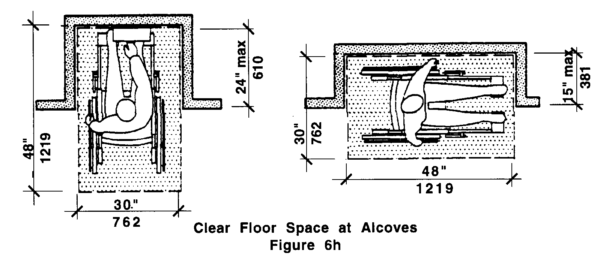
6.00: SPACE ALLOWANCE AND REACH RANGES

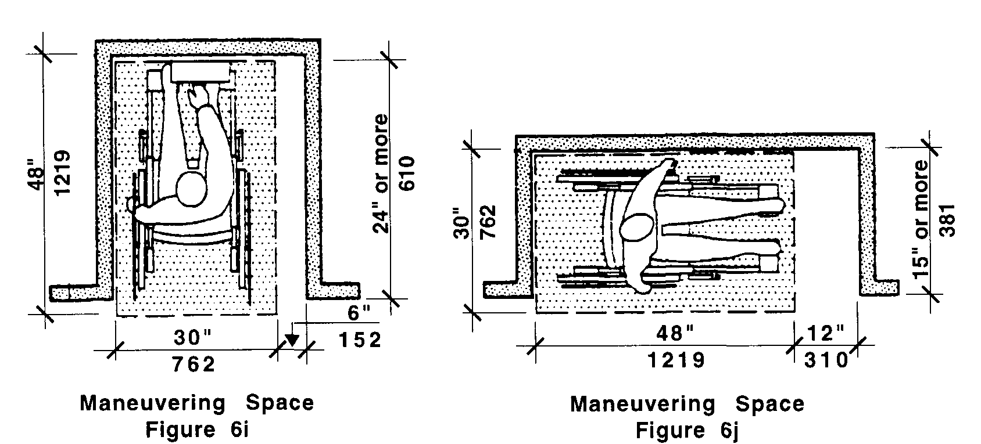

6.4.3 Surfaces for Wheelchair Spaces: Clear floor space for wheelchairs shall comply with 521 CMR 29, Floor Surfaces.

6.5 FORWARD REACH
If the clear floor space only allows forward approach to an object, the maximum high forward reach allowed shall be 48 inches (48" = 1219mm) (See Fig. 6k). The minimum low forward reach is 15 inches (15" = 381mm). If the high forward reach is over an obstruction, reach and clearances shall be as shown in Fig. 6l.

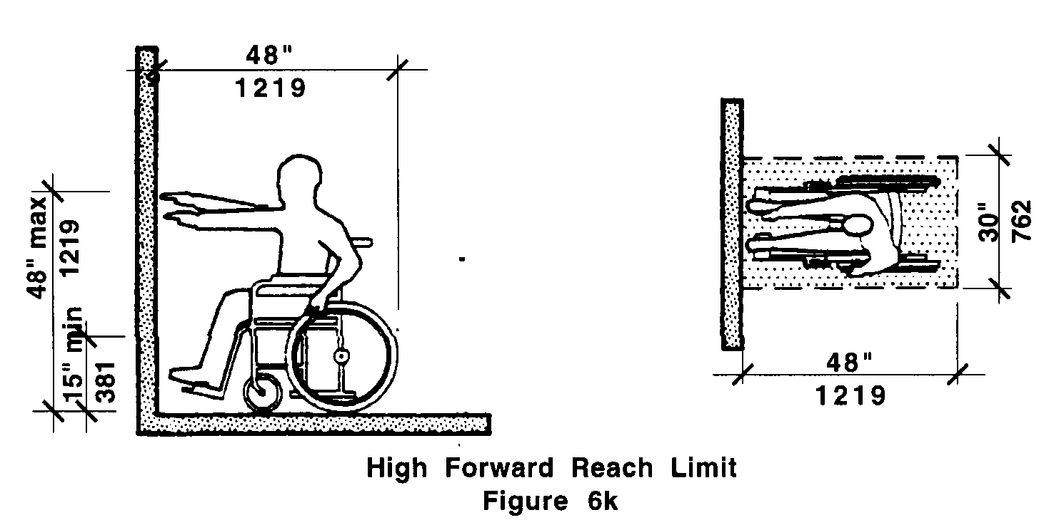
6.00: SPACE ALLOWANCE AND REACH RANGES

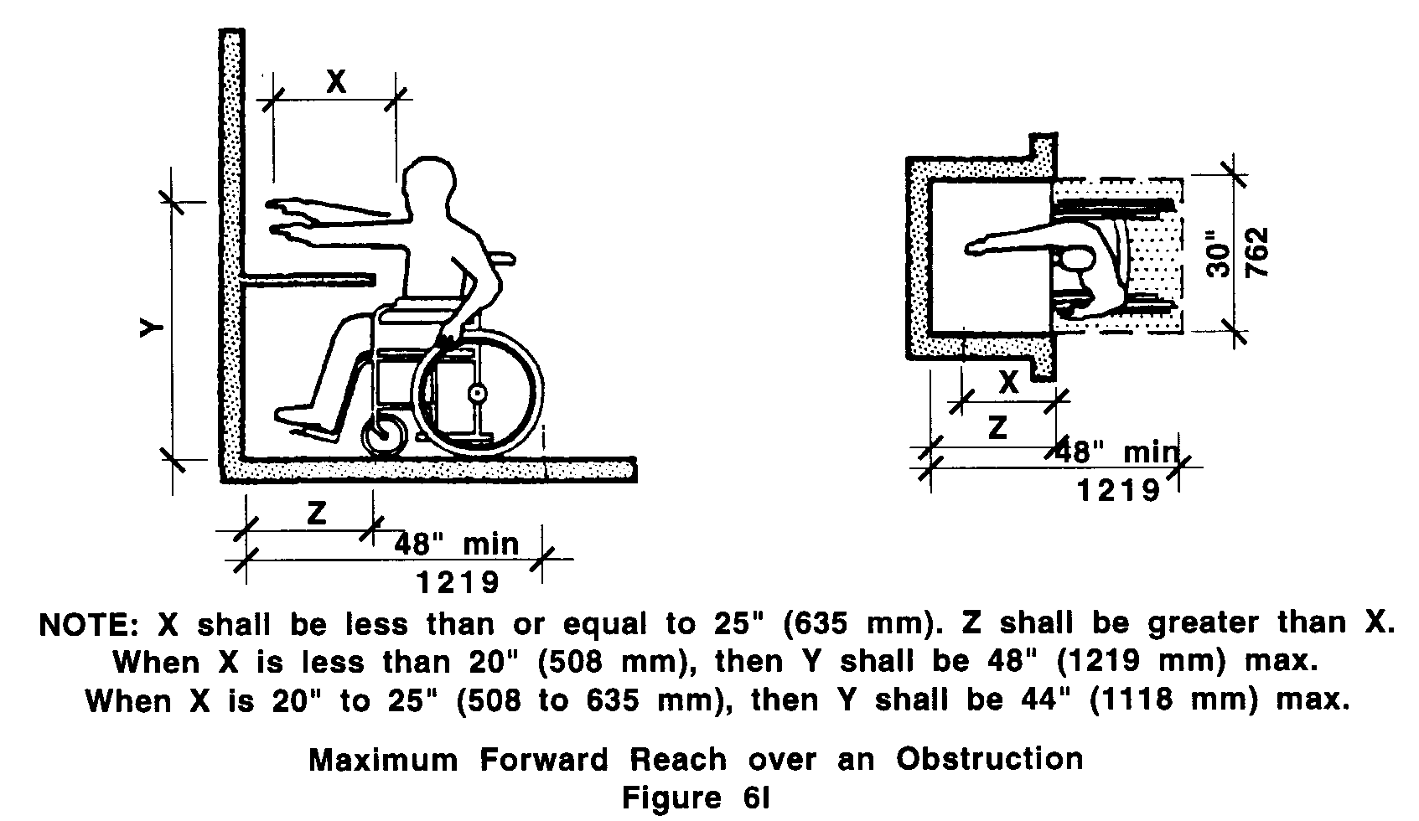

6.6 SIDE REACH
If the clear floor space allows parallel approach by a person in a wheelchair, the maximum high side reach allowed shall be 54 inches (54" = 1372mm) and the low side reach shall be no less than nine inches (9" = 229mm) above the floor (See Fig. 6m). If the side reach is over an obstruction, the reach and clearances shall be as shown in Fig. 6n.

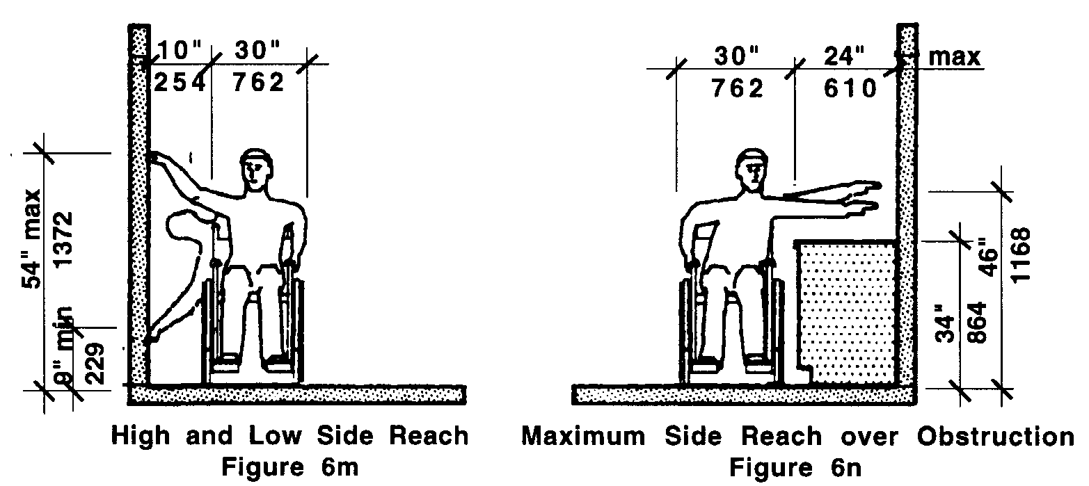

6.00: SPACE ALLOWANCE AND REACH RANGES

NON-TEXT PAGE

