521 CMR 7.00: RETAIL ESTABLISHMENTS

7.1 GENERAL
All retail establishments shall comply with 521 CMR, except as specified or modified in 521 CMR 7.00. Retail establishments shall include but not be limited to: banks, beauty shops, pharmacies, dry cleaners, clothing stores, grocery stores and supermarkets. Areas that must be accessible include but are not limited to the areas where the service or product of the establishment is offered to the public, dressing rooms, and public toilet rooms provided for clientele.

7.2 SALES SERVICE AND INFORMATION, OR TELLER WINDOWS
Shall comply with the following:

7.2.1 Cash register transactions: In department stores and retail stores where counters have cash registers and are provided for sales or distribution of goods or services to the public, at least one of each type shall comply with the following. See Fig. 7a and 7b.

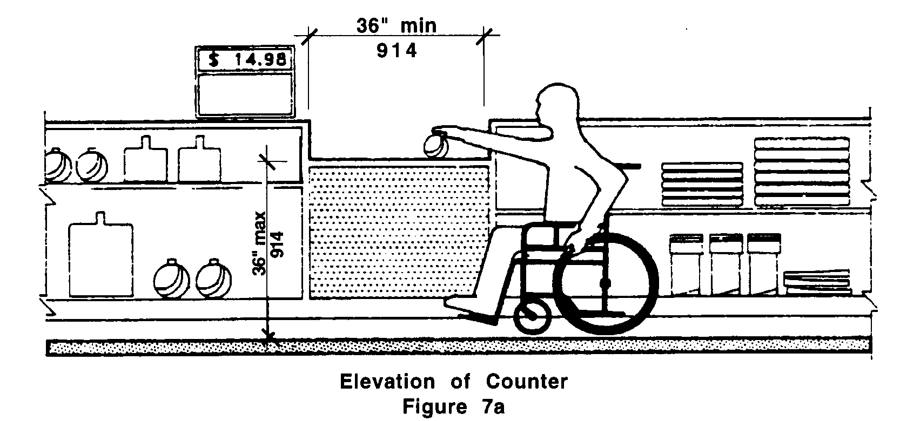

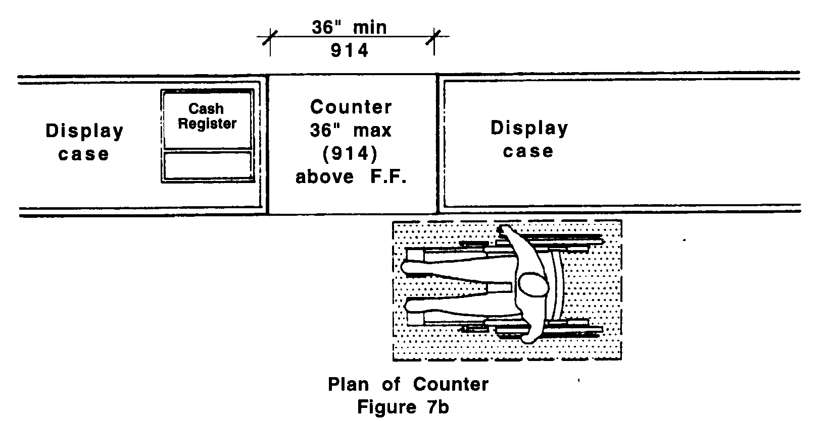

7.00: RETAIL ESTABLISHMENTS

a. Location: The counter shall be on an accessible route complying with 521 CMR 20.00: ACCESSIBLE ROUTE.
b. Length: A portion of the counter shall be at least 36 inches (36" = 914mm) in length and be located closest or nearest the cash register.
c. Height: That portion of the counter shall not exceed 36 inches (36" = 914mm) above the finish floor.
d. Distribution: The accessible counters must be dispersed throughout the building or facility.

7.2.2 Other Transactions: Ticketing counters, teller stations in a bank, registration counters in hotels and motels, box office ticket counters, and other counters that may not have a cash register but at which goods or services are sold or distributed, shall comply with the following. See Fig. 7a and 7b.

a. Location: The counter shall be on an accessible route complying with 521 CMR 20.00: ACCESSIBLE ROUTE.
b. Length: The accessible portion of the counter or an auxiliary counter shall be at least 36 inches (36" = 914mm) in length.
c. Height: The counter shall not exceed 36 inches (36" = 914mm) above the finish floor.

7.3 AISLES
All aisles in retail establishments shall have a minimum clear width of 36 inches (36" = 914mm). Such aisles shall be maintained at all times to provide a clear width of 36 (36" = 914mm) inches.

7.4 CHECK-OUT AISLES
Shall comply with the following:

Total check-out aisles of Minimum number of
each design Accessible check-out aisles
1 - 4 1
5 - 8 2
9 - 15 3
over 15 3, plus 20% of additional aisles

Examples of check-out aisles of different "design" include those which are specifically designed to serve different functions. Different "design" shall include but is not limited to the following features: length of belt or no belt; or permanent signage designating the aisle as an express lane.

7.4.1 Accessible check-out aisles shall always be open.

7.4.2 Width: Clear aisle width for accessible check-out aisles shall be a minimum of 36 inches (36" = 914 mm). See Fig. 7c.
7.00: RETAIL ESTABLISHMENTS

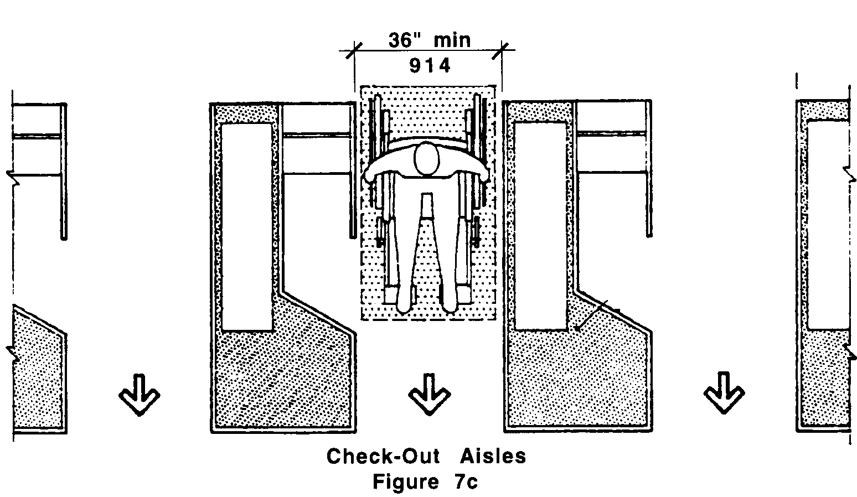

7.4.3 Height: Maximum adjoining counter height shall not exceed 38 inches (38" = 965mm) above the finish floor. The top of the lip shall not exceed 40 inches (40" = 1016mm) above the finish floor.

7.4.4 Identification: Signage identifying accessible check-out aisles shall use the international symbol of accessibility and shall be mounted above the check-out aisle in the same location that the check-out number or type of check-out is displayed.

7.5 TURNSTILES, SECURITY CONTROL DEVICES AND SHOPPING CART BARRIERS
Wherever barriers are provided to prevent the removal of shopping carts from store premises including but not limited to turnstiles, an adjacent, alternate unlocked gate or door that is equally convenient to that provided for the ambulatory population shall be provided. It shall have a minimum clear opening of 32 inches (32" = 813mm).

7.6 DRESSING ROOMS
Where provided, dressing rooms shall comply with 521 CMR 33.00: DRESSING, FITTING AND CHANGING ROOMS

7.7 SHELVING AND DISPLAY UNITS
In retail establishments shelving and display units shall be located on an accessible route. The requirements of 521 CMR 6.5, Forward Reach and 521 CMR 6.6, Side Reach shall apply to those display units encouraging interactive participation including but not limited to, devices such as headphones in stores which sell music tapes and compact disks.

7.8 PUBLIC TOILET ROOMS
When public toilets are provided, they shall be accessible, on an accessible route, and in compliance with 521 CMR 30.00: PUBLIC TOILET ROOMS.
7.00: RETAIL ESTABLISHMENTS

NON-TEXT PAGE

