521 CMR 8.00: TRANSIENT LODGING FACILITIES

8.1 GENERAL
Transient lodging facilities shall comply with 521 CMR, except as specified or modified in 521 CMR 8.00. Transient lodging shall include but not be limited to hotels, motels, bed and breakfasts, inns, boarding houses, dormitories and resorts. Transient lodging facilities shall also include homeless shelters, halfway houses, lodging houses and transitional housing, and other places that provide temporary accommodations. Transient lodging includes facilities, or portions thereof, used for sleeping accommodations. Sleeping accommodations in a medical care facility are covered by 521 CMR 13.00: MEDICAL CARE FACILITIES.

Exception: 521 CMR 8.00 does not apply to an establishment located within a building that:

a. contains five or fewer beds or contains five or fewer rooms for rent or hire; and
b. is actually occupied as a residence by the proprietor of the establishment (See 521 CMR 5.00: DEFINITIONS.)

8.2 PUBLIC AND COMMON USE AREAS
In transient lodging facilities, common use and public use areas shall be designed and constructed to comply with 521 CMR. (See 521 CMR 5.00: DEFINITIONS.)

8.2.1 General: The public use areas in hotels, motels or inns shall include but not be limited to: the general public function areas, recreation areas, health facilities, pools, meeting areas, restaurants, lounges, public toilet rooms, public telephones, vending areas, laundry rooms, other amenities installed for the use of occupants, walks, elevators, and all public entrances as well as the stairs and corridors to the accessible units.

8.2.2 Registration counters shall comply with the following:

a. Location: The counter shall be on an accessible route.
b. Length: A portion of the counter or an auxiliary counter shall be at least 36 inches (36" = 914mm) in length.
c. Height: That portion of the counter shall not exceed 36 inches (36" = 914 mm) above the finish floor.
d. Clear Floor Area: Shall be provided in front of the counter.

8.3 PARKING SPACES
Where parking is provided, it shall comply or be capable of complying with the provisions of 521 CMR 23.2, Number through 521 CMR 23.8, Valet Parking. If parking spaces are assigned to individual units, said spaces designated for accessible units shall have signage reserving said space. An international symbol of accessibility need not be used.

8.3.1 Visitor parking spaces: Where parking is provided for visitors, it shall comply fully with the requirements of 521 CMR 23.00: PARKING AND PASSENGER LOADING ZONES.
8.00: TRANSIENT LODGING FACILITIES

8.4 UNITS, SLEEPING ROOMS, AND SUITES: MINIMUM NUMBER
At least 5% but in no case less than one of the units, sleeping rooms, and suites shall be accessible. In applying the 5% rule to facilities which consist of more than one building, all of the units in the entire facility shall be added together.

8.4.1 Distribution: To provide persons with disabilities a range of options equivalent to those available to other persons served by the facility, accessible sleeping rooms and suites shall be dispersed proportionally among the various classes of sleeping accommodations available to patrons of the place of transient lodging. Factors to be considered include room size, price, location, smoking/ non-smoking, amenities provided, and the number and size of beds provided.

8.4.2 Equivalent Facilitation: The operator of a facility may elect to limit construction of accessible rooms to those intended for multiple occupancy, provided that these rooms are made available at the cost of a single occupancy room to an individual with disabilities who requests a single-occupancy room.

8.4.3 Bathrooms and Kitchens: Accessible units shall have bathrooms and kitchens (where provided), that comply with Group 2B requirements in 521 CMR 44.00: GROUP 2 BATHROOMS and 521 CMR 45.00: GROUP 2 KITCHENS.

8.4.4 Wheel-in Showers: In transient lodging facilities with 50 or more sleeping rooms or suites, accessible sleeping rooms or suites shall include a wheel-in shower in conformance with the table below. Wheel-in showers shall comply with the requirements of 521 CMR 44.6.2, Showers.

Number of rooms Rooms with Wheel-in Showers
50 to 100 1
101 to 200 2
201 to 300 3
301 to 400 4
401 to 500 5
501 to 1000 2% of total
1001 and over 22 plus one for each 100 over 1000

8.00: TRANSIENT LODGING FACILITIES

8.4.5 Sleeping Accommodations for persons who are deaf or hard of hearing. In all transient lodging facilities, additional accessible sleeping rooms and suites with accommodations for persons who are deaf or hard of hearing shall be provided in conformance with the table below. These rooms and suites shall comply with the requirements of 521 CMR 8.6, Sleeping Accommodations.

Number of Rooms Accessible Equipment Provided
5 to 25 1
26 to 50 2
51 to 75 3
76 to 100 4
101 to 150 5
151 to 200 6
201 to 300 7
301 to 400 8
401 to 500 9
501 to 1000 2% of total
1001 and over 20 plus 1 for each 100 over 1000

8.4.6 In facilities with multi-bed rooms (such as dormitories) or spaces, 5% of the beds shall comply with 521 CMR 8.5.3, Maneuvering space.

8.5 UNITS, SLEEPING ROOMS AND SUITES: MINIMUM REQUIREMENTS
Accessible units, sleeping rooms and suites shall comply with the following:

8.5.1 Accessible Route: Accessible units, sleeping rooms, and suites shall be on an accessible route. An accessible route shall connect all accessible spaces and elements including telephones, televisions, alarms clocks, and climate controls within the unit, sleeping room, or suite.

8.5.2 Elevators: An elevator is not required in a transient lodging facility that is less than three stories or that has less than 3000 square feet per story if all rooms are proportionately distributed in accordance with 521 CMR 8.4.1 and all public spaces are fully accessible.

8.5.3 Maneuvering Space: Accessible sleeping rooms shall have a 36 inch (36" = 914mm) clear width maneuvering space located along both sides of a bed, except that where two beds are provided, this requirement can be met by providing a 36 inch (36" = 9 14mm) wide maneuvering space located between the two beds.

8.5.4 Doors and doorways designed to allow passage into and within all accessible units, sleeping rooms, or suites shall comply with 521 CMR 26.00: DOORS AND DOORWAYS.
8.00: TRANSIENT LODGING FACILITIES

8.5.5 Visitor Identification: Every entry door to each accessible unit shall have a means by which the person can visually identify a visitor before opening the door. This may be achieved by any of the following means:

a. A peephole mounted at 42 inches (42" = 1067mm) above the floor;
b. A vision panel in the door with its bottom edge no higher than 42 inches (42" = 1067mm) above the floor
c. A sidelight with its bottom edge no higher than 42 inches (42" = 1067mm) above the floor.

8.5.6 Storage: If fixed or built-in storage such as cabinets, shelves, closets, and drawers are provided in accessible spaces, at least one of each type of storage space shall comply with 521 CMR 34.00: STORAGE.

8.5.7 Controls: All controls in accessible units, sleeping rooms, and suites shall comply with 521 CMR 39.00: CONTROLS.

8.5.8 Accessible spaces: Where provided as part of an accessible unit, sleeping room, or suite, the following spaces shall be accessible and shall be on an accessible route:

a. the living area;
b. the dining area;
c. at least one sleeping area;
d. at least one bathroom;
e. if only half baths are provided, at least one half bath;
f. carports, garages or parking spaces; and
g. patios, terraces, and balconies.

8.5.9 Patios, Terraces, and Balconies: Where it is necessary to utilize a door threshold or a change in level between the interior and exterior greater than ½ inch (½" = 13mm) to protect the integrity of the unit from water or snow damage, equivalent facilitation such as raised decking or a ramp shall be provided. See Fig. 8a.
8.00: TRANSIENT LODGING FACILITIES

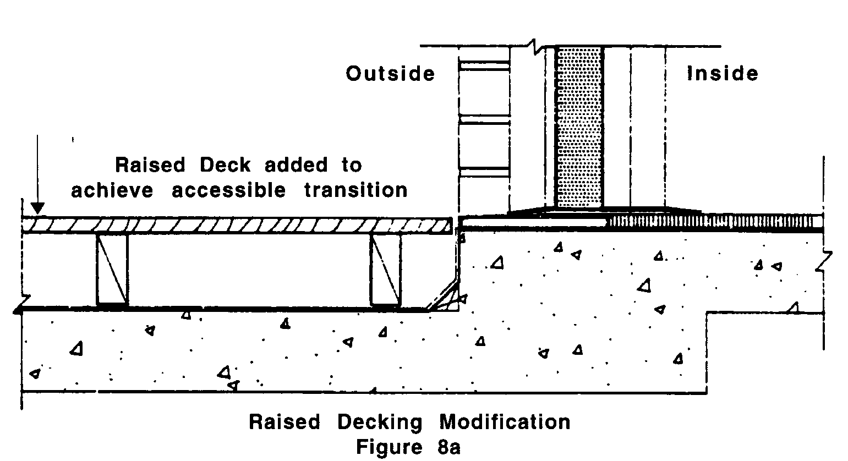

8.5.10 Kitchenettes: When provided, kitchens and kitchenettes in accessible units, sleeping rooms, and suites shall comply with the requirements for Group 2B Kitchens in 521 CMR 45.00: GROUP 2 KITCHENS.

8.5.11 Wet Bars: When provided as an accessory to an accessible unit, sleeping room or suite, wet bars or similar amenities shall be accessible, on an accessible route, and comply with the following:

a. Clear floor space for a front or parallel approach to cabinets, counters, sinks, and appliances shall be provided to comply with Fig. 8b.
b. Countertops and sinks shall be at a maximum height of 34 inches (34" = 864mm) above the floor.
c. Accessible storage: At least 50% of shelf space in cabinets or refrigerator/freezers shall comply with 521 CMR 6.5, Forward Reach and 521 CMR 6.6, Side Reach and space shall be designed to allow for the operation of cabinet and/or appliance doors so that all cabinets and appliances are accessible and usable.
d. Controls and operating mechanisms shall comply with 521 CMR 39.00: CONTROLS.
8.00: TRANSIENT LODGING FACILITIES

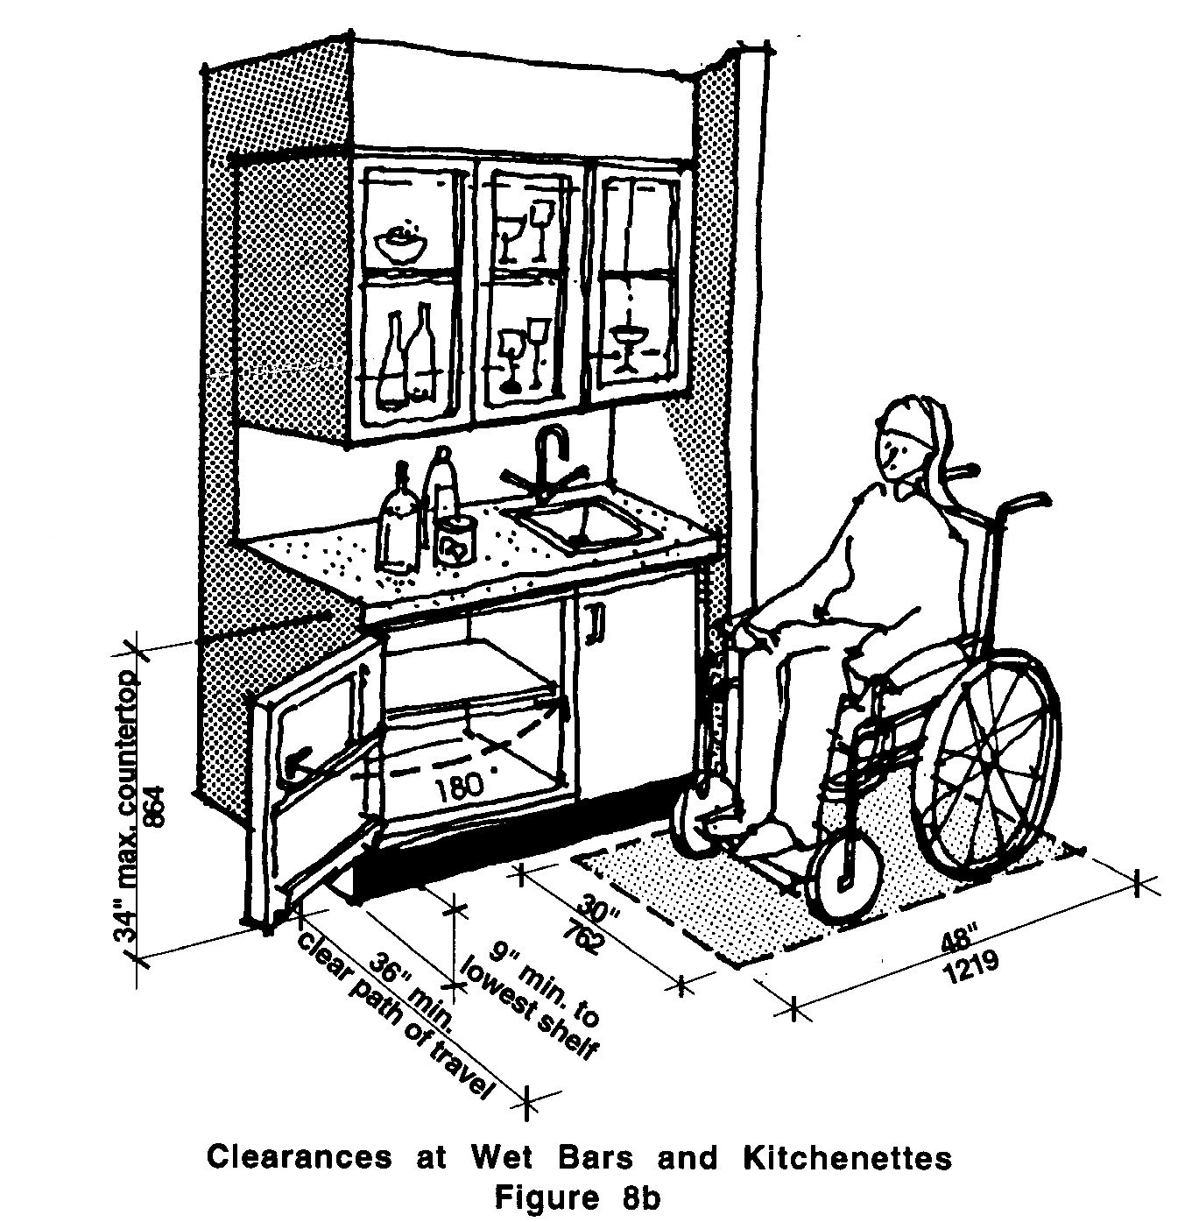

8.6 SLEEPING ACCOMMODATIONS FOR PERSONS WHO ARE DEAF OR HARD OF HEARING
Sleeping accommodations for persons who are deaf or hard of hearing required by 521 CMR 8.4.5 shall comply with the following requirements for smoke/fire/safety alarms, visual signal devices, telephones, televisions, alarm clocks and climate controls.

8.6.1 Auxiliary Visual Alarms: Sleeping Accommodations shall be equipped with auxiliary visual alarms which comply with 521 CMR 40.4:

a. a visual alarm connected to the building emergency alarm system; or
b. a standard 110-volt electrical receptacle into which such an alarm can be connected and a means by which a signal from the building emergency alarm system can trigger such an auxiliary alarm. Such receptacle shall be connected to the emergency or standby power, (if provided in the building).

The visual alarm signal shall be visible in all areas of the unit or room. Instructions for use of the auxiliary alarm or receptacle shall be provided.

8.00: TRANSIENT LODGING FACILITIES

8.6.2 Visual Notification Devices shall be provided in sleeping accommodations to alert room occupants of incoming telephone calls and a door knock or doorbell. Visual notification devices shall not be connected to auxiliary visual alarm signal appliances.

8.6.3 Telephones: Telephones in rooms for persons who are deaf or hard of hearing shall have volume controls complying with 521 CMR 37.00: PUBLIC TELEPHONES. An accessible electrical outlet within 48 inches (48" = 1219mm) of a telephone connection shall be provided to facilitate the use of a Text Telephone (TTY).

8.6.4 Televisions: Where televisions are provided in sleeping rooms or suites, the operator of the facility shall provide a television amplifier and a caption decoder in rooms for persons who are deaf or hard of hearing.

8.6.5 Equivalent Facilitation: For rooms required under 521 CMR 8.3.5, the operator of a facility may either permanently install the equipment required under 521 CMR 8.5 or may elect to install electrical outlets (including outlets connected to a facility's central alarm system) and telephone wiring in sleeping rooms and suites to enable persons with hearing impairments to utilize portable visual alarms and communication devices, which shall be provided by the operator of the facility.

8.7 OTHER SLEEPING ROOMS AND SUITES
Doors and doorways designed to allow passage into and within all sleeping units or other covered units shall comply with 521CMR 26.00: DOORS AND DOORWAYS on the corridor side of the door only.

8.00: TRANSIENT LODGING FACILITIES

NON-TEXT PAGE

