521 CMR 9.00: MULTIPLE DWELLINGS

9.1 GENERAL
A multiple dwelling is considered to be either a lodging facility or a residential facility for hire, rent, lease, or sale containing three or more dwelling units in a building. Facilities used for temporary accommodations are considered transient lodging facilities. See 521 CMR 8.00: TRANSIENT LODGING FACILITIES. For public and common use spaces in Multiple Dwellings, See 521 CMR 10.00: PUBLIC USE AND COMMON USE SPACES IN MULTIPLE DWELLINGS.

9.1.1 A lodging facility is a building or a portion of a building, primarily used for the purpose of sleeping accommodations. Lodging facilities shall include but not be limited to shelters, hospices, group homes, and congregate living facilities. A dwelling unit in a lodging facility is defined as the sleeping space provided to a single individual; i.e., a bedroom.

9.1.2 A residential facility is a building or buildings consisting of dwelling units each of which provides complete, independent living facilities for one or more persons, including permanent provisions for living, sleeping, eating, cooking and sanitation. When a dwelling unit houses more than three lodgers or boarders it is a lodging facility. Residential facilities shall include but not be limited to apartments, condominiums, assisted living and cooperatives.

9.2 APPLICABILITY
New construction: Multiple dwellings, for which building permits for new construction are issued on or after September 1, 1996 shall meet the requirements of 521 CMR 9.3, Group 1 Dwelling Units and 521 CMR 9.4, Group 2 Dwelling Units.

9.2.1 Renovation and reuse: Any building previously occupied for any purpose, which is converted, renovated, reconstructed, altered or remodeled for residential use after this date is exempt from 521 CMR 9.3 Group 1 Dwelling Units.

9.2.2 Renovation and reuse of dwelling units is subject to 521 CMR 9.4, Group 2 Dwelling Units through 521 CMR 9.5, Dwelling Unit Interiors provided the work being performed, in a three year period, exceeds 30% of the full and fair cash value of the building (See 521 CMR 3.3.2). Work performed to public use and common use areas however, is subject to all of 521 CMR 3.3.

9.3 GROUP 1 DWELLING UNITS
In multiple dwellings, for which building permits for new construction are issued on or after September 1, 1996, that are for rent, hire, lease or sale and that are equipped with an elevator, all dwelling units must be constructed as Group 1 Dwelling Units, except those covered in 521 CMR 9.4, Group 2 Dwelling Units.

In multiple dwellings that are for rent, hire, lease, or sale but are not equipped with an elevator, only units on the ground floor must be constructed as Group 1 Dwelling Units.
9.00: MULTIPLE DWELLINGS

Group 1 units must comply with 521 CMR 9.5, and, 521 CMR 42.00: GROUP 1 BATHROOMS; 521 CMR 43.00: GROUP 1 KITCHENS; and 521 CMR 46.00: GROUP 1 BEDROOMS.

9.4 GROUP 2 DWELLING UNITS
In multiple dwellings that are for rent, hire, or lease (but not for sale) and contain 20 or more units, at least 5% of the dwelling units must be Group 2A units. Group 2A units must comply with 521 CMR 9.5, Dwelling Unit Interiors; and 521 CMR 44.00: GROUP 2 BATHROOMS; and 521 CMR 45.00: GROUP 2 KITCHENS; and 521 CMR 47.00: GROUP 2 BEDROOMS.

9.4.1 Total dwelling units in a complex: When multiple dwellings consist of more than one building on a site or are located on several, non-contiguous sites, all dwelling units shall be added together to determine applicability of 521 CMR 9.4.

9.4.2 Distribution: Group 2A dwelling units shall be proportionally distributed across the total number of units according to number of bedrooms, size, quality, price and location.

EXCEPTION FOR TOWNHOUSES: When 5% of the total number of units required to be accessible includes townhouses, they shall comply by any of the following means:

a. substitute a fully accessible flat of comparable size, amenities, etc.;
b. provide space for the future installation of a wheelchair lift to access either upper or lower level of townhouse.
c. provide space for the future installation of a residential elevator to access either the upper or lower level of the townhouse.

9.4.3 Variance: The Board may consider applications for a variance from the 5% requirement if there is a greater or lesser need for Group 2A units in certain areas of the Commonwealth. A variance may be granted only if there is a sufficient factual basis, using data from the central registry of the Massachusetts Rehabilitation Commission or other sources, to establish with a reasonable degree of certainty the present and future needs for the applicable Group 2A units. The Board may not require more than 10% of the dwelling units to be Group 2A units. A variance for less than 5% shall not be granted unless the applicant can demonstrate that the units are not needed by disabled persons and cannot be readily rented, hired, or leased to other persons. Applications for variances to increase or decrease must be made to the Board before the issuance of a building permit.

9.5 DWELLING UNIT INTERIORS
The interiors of all Group 1 and 2 dwelling units, except as exempted by 521 CMR 9.2.1, shall comply with the following requirements:
9.00: MULTIPLE DWELLINGS

9.5.1 Doorways: All doorways and all openings that allow passage in a Group 2 unit must comply with 521 CMR 26.2, Double Leaf Doorways, through 521 CMR 26.11, Door Hardware. All doorways and all openings that allow passage in Group 1 units shall be capable of complying, without structural change, with 521 CMR 26.2, Double Leaf Doorways, through 521 CMR 26.11, Door Hardware. For door types such as bifold, pocket, and accordion doors, the clear opening is measured when the door is in its most fully open position. See Fig. 26b and 26c. For Group 1 units, only the common area and apartment entrance door hardware are required to comply with 521 CMR 26.11, Door Hardware.

9.5.2 Every entry door to each dwelling unit shall have a means by which the resident can visually identify a visitor before opening the door. This may be achieved by any of the following means:

a. In Group 1 and 2A units, a peephole mounted 60 inches (60" = 1524mm) above the floor, a vision panel in the door with its bottom edge no higher than 60 inches (60" = 1524mm) above the floor, or a sidelight with its bottom edge no higher than 60 inches (60" = 1524mm) above the floor, shall be provided.
b. In Group 2B units, an additional peephole mounted at 42 inches (42" = 1067mm) above the floor; a vision panel in the door with its bottom edge no higher than 42 inches (42" = 1067mm) above the floor; or a sidelight with its bottom edge no higher than 42 inches (42" = 1067mm) above the floor. See Fig. 9a.

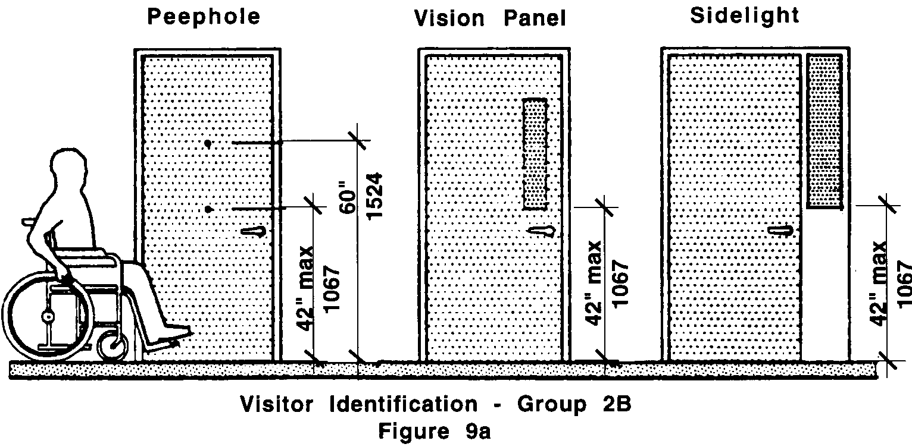

9.5.3 Buzzers/bells and intercoms: All buzzers/bells and intercom systems shall comply with 521 CMR 6.5, Forward Reach or 521 CMR 6.6, Side Reach.
9.00: MULTIPLE DWELLINGS

9.5.4 Accessible routes: An accessible route at least 36 inches (36" = 914mm) wide shall be provided to all rooms and spaces in the dwelling unit including exterior decks, patios, balconies, attached garages, and storage closets. An accessible route shall be provided to mechanical spaces, only if the resident is expected to service, adjust or maintain the equipment therein.

a. Patios, Terraces, and Balconies: Where it is necessary to use a door threshold or a change in level between the interior and exterior, greater than ½ inch (½" = 13mm) to protect the integrity of the unit from water or snow damage, equivalent facilitation such as raised decking or a ramp shall be provided or capable of being provided.

In Group 2B Units, the exterior deck, patio, balcony surfaces shall be either permanently installed at no more than ½ inch (½" = 13mm) below the floor level of the interior of the dwelling unit or a temporary raised surface, such as duckboards, that is no more than ½ inch (½" = 13mm) below the interior floor level shall be available upon request.

9.5.5 Laundry Facilities: If a washer or dryer is provided in a Group 1 or Group 2A unit, it shall be front loading or capable of being replaced with a front loading appliance. If a washer or dryer is provided in a Group 2B dwelling unit, it shall be front loading. Operating controls for washers and dryers shall be located within the zone of reach. If residents are expected to operate shut-off valves for the washer, the shut-off valves shall be located within the zone of reach. For common area laundry facilities, see 521 CMR 10.8, Laundry Facilities.

9.5.6 Outlets: Electrical outlets, telephone outlets, cable TV jacks, and other wall outlets shall be located between 15 inches (15" = 381mm) and 48 inches (48" = 1219mm) above the floor, measured at the centerline of the lowest receptacle. All outlets shall be located no less than 18 inches (18" = 457mm) from interior corners. When outlets are located on walls above counters or other fixtures that are 22 inches (22" = 559mm) or greater in depth, they shall be no higher than 44 inches (44" = 1118mm). In Group 1 and 2 units, at least one electrical outlet must be provided on the same wall as the telephone outlet and the door chime. Wherever exterior decks, patios, and balconies are provided, an exterior electrical outlet shall also be provided.

In Group 2B units, all telephone outlets must have an electrical outlet located within 12 inches (12" = 305mm) for installation of a TTY.

9.5.7 Controls and alarms: In Group 2A and 2B units, the operable portions of all controls and alarms, including but not limited to: intercoms, and heat and air controls, shall be located between 36 and 48 inches (36" to 48" = 914mm to 1219mm) above the floor, measured at the centerline of the operable portion in its highest position. Operable portions shall be located at least 24 inches (24" = 610mm) from interior corners. Controls and alarms in Group 1 units may be located at other locations so long as sufficient wiring is provided to permit future location from 36 inches to 48 inches (36" to 48" = 914mm to 1219mm) above the floor.
9.00: MULTIPLE DWELLINGS

9.5.8 Closets/pantries and linen closets: Shall comply with the following:

a. Closet shelves/poles: Closet walls shall be structurally capable of supporting the installation of shelves and poles which are relocatable from 42 inches to 72 inches (42" to 72" = 1067mm to 1829mm) to the top of shelf or pole whichever is higher.
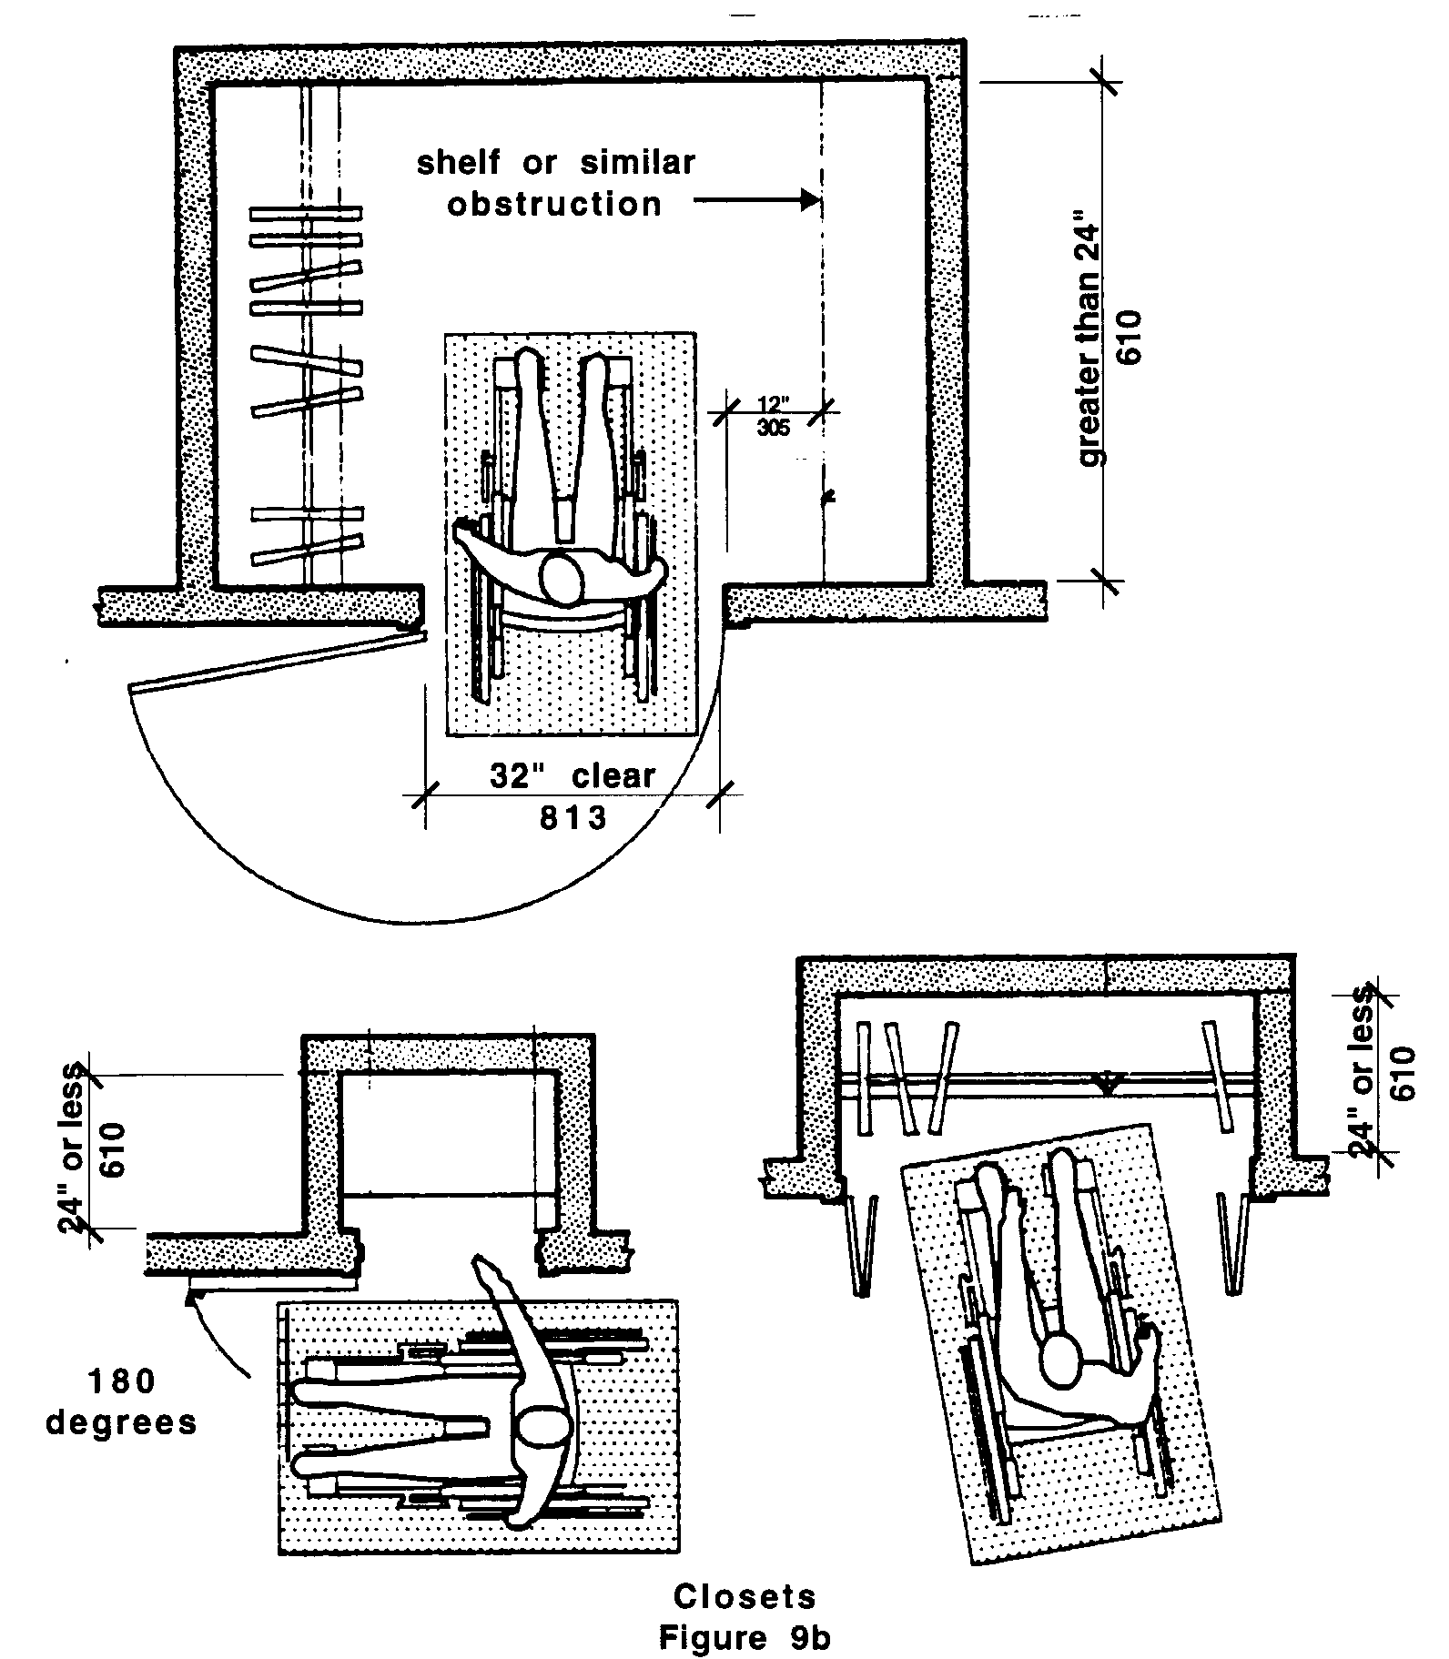
b. Closet depth: Where the interior depth of the closet exceeds 24 inches (24" = 610mm), the doorway must comply with 521 CMR 26.5, Width so that a disabled person can enter the closet. The bottom track of the closet door must also be recessed with no more than ¼ of an inch (¼" = 6mm) change in finish material. For Group 2 units, when the interior depth of the closet is 24 inches (24" = 610mm) or less, it shall be open to the room to permit a person with a disability to reach all parts of the closet. See Fig. 9b.

9.00: MULTIPLE DWELLINGS

9.6 TOWNHOUSES - GROUP 1 UNITS ONLY: RESERVED until further notice. In the interim, they are exempt.

9.7 SLEEPING ACCOMMODATIONS FOR PERSONS WHO ARE DEAF OR HARD OF HEARING.
In addition to those units required to be accessible by 521 CMR 9.4, Group 2 Dwelling Units, 2% of the total number of dwelling units in the complex or project, but not less than one shall comply with the following:

9.7.1 Sleeping accommodations for persons who are deaf or hard of hearing required by 521 CMR 9.7 shall comply with the following requirements for smoke/fire/safety alarms, visual signal devices, telephones, televisions, alarm clocks and climate controls.

9.7.2 Auxiliary Visual Alarms: Sleeping accommodations shall be equipped with auxiliary visual alarms which comply with 521 CMR 40.4:

a. a visual alarm connected to the building emergency alarm system; or
b. a standard 110-volt electrical receptacle into which such an alarm can be connected and a means by which a signal from the building emergency alarm system can trigger such an auxiliary alarm. Such receptacle shall be connected to the emergency or standby power, (if provided in the building).

The visual alarm signal shall be visible in all areas of the unit or room. Instructions for use of the auxiliary alarm or receptacle shall be provided.

9.7.3 Visual Notification Devices shall be provided in sleeping accommodations to alert room occupants of incoming telephone calls and a door knock or doorbell. Visual notification devices shall not be connected to auxiliary visual alarm signal appliances.

9.7.4 Equivalent Facilitation: For rooms required under 521 CMR 9.7, the operator of a facility may either permanently install the equipment required under 521 CMR 9.7 or may elect to install electrical outlets (including outlets connected to a facility’s central alarm system) and telephone wiring in sleeping rooms and suites to enable persons with hearing impairments to utilize portable visual alarms and communication devices. For purposes of equivalent facilitation, such devices shall be provided by the operator of the facility during the tenancy of a person with a hearing impairment.
9.00: MULTIPLE DWELLINGS

NON-TEXT PAGE

