INDOOR AIR QUALITY ASSESSMENT

600 Washington Street
Fifth Floor
Boston, Massachusetts

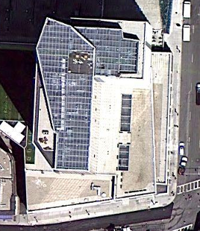

Prepared by:
Massachusetts Department of Public Health
Bureau of Environmental Health
Indoor Air Quality Program
November 2010

Background/Introduction
In response to a request by Jeffery McCue, Director of Human Resources, Executive Office of Health and Human Services (EHS), the Massachusetts Department of Public Health (MDPH), Bureau of Environmental Health (BEH) provided assistance and consultation regarding indoor air quality at 600 Washington Street, Boston, Massachusetts. On October 20, 2010, Cory Holmes and Sharon Lee, Environmental Analysts within BEH’s Indoor Air Quality (IAQ) Program visited 600 Washington Street to conduct an IAQ assessment. The assessment was prompted by potential IAQ concerns related to airborne dust/debris resulting from renovation activities on the fifth floor of the building.
BEH staff were accompanied by Ms. Claire Ghiloni, Director of EHS’ Office of Leasing and State Owned Property for portions of the assessment. At the completion of the assessment, BEH staff provided verbal recommendations to Ms. Ghiloni related to depressurization and isolation of renovation areas from occupied areas. These recommendations are discussed in this report.
The fifth floor of 600 Washington Street contains private offices, open work areas (cubicles), conference rooms and storage areas. Windows in the building are weighted sash windows that were originally designed to be opened; but have been reportedly sealed for some time (Picture 1).

Methods
BEH staff performed a visual inspection of the building’s fifth floor to evaluate any potential IAQ issues related to renovation between work areas and occupied portions of the fifth floor. Air tests for airborne particulate matter with a diameter less than 2.5 micrometers (PM2.5) were taken with the TSI, DUSTTRAK™ Aerosol Monitor Model 8520.

Results and Discussion
Renovation activities can produce a number of indoor pollutants, including dirt, dust and particulate matter. These materials can be irritating to the eyes, nose and respiratory tract. Particulates generated from renovation activities can also settle on horizontal surfaces where they can also be re-aerosolized by normal activities and/or mechanical ventilation components, which can exacerbate irritant effects
During the assessment, floor to ceiling plastic polyethylene barriers were being erected to separate occupied areas from the renovation zones (Pictures 2 and 3). BEH staff recommended sealing the barriers along all sides (i.e. ceiling, walls, floor) with tape on the inside and outside of the barrier to render as airtight as possible. BEH staff also recommended depressurizing the work areas by using fans to direct pollutants out of the building. This requires opening at least one window in each of the two work areas. In addition to establishing negative ventilation in the work areas, BEH staff recommended the deactivation of HVAC vents in work areas or, if not feasible, sealing the vents to prevent entrainment into the general ventilation system.
In subsequent e-mail correspondence with Ms. Ghiloni and David Greene, Northland Corp., Building Management, it was reported that windows could not be opened as they had reportedly been sealed shut. As an alternative, Northland intended to depressurize the fifth floor work site by deactivating the supply vents in the work area and maximizing pressure in occupied spaces. Positive pressurization in occupied areas can be established by maximizing fresh air intake to produce increased airflow. According to Mr. Greene, direct exterior ventilation will be achieved via the HVAC systems fan coil units and mechanical dampers that are located in the HVAC plenum located in the work area. Northland is also monitoring the HVAC system to ensure continuous ventilation function. In addition, the polyethylene membrane seams have reportedly been sealed, including at wall interfaces, as well as floor and ceiling interfaces. Northland is also installing a membrane closing off the ceiling mounted supply diffusers in the containment area.

IAQ Evaluations/Air Testing Particulate Matter
The primary purpose the BEH IAQ visit was to identify and reduce/prevent pollutant pathways in areas impacted by renovation activities. Air monitoring was conducted in areas most directly impacted due to close proximity to renovation sites and other areas for comparison. To determine whether indoor airborne particulates presented health concerns, BEH staff obtained measurements for particulate matter with a diameter of 2.5 micrometers (μm) or less (PM2.5), which can produce immediate, acute health effects upon exposure. Please note, air measurements are only reflective of the indoor air concentrations present at the time of testing.
The US Environmental Protection Agency (US EPA) has established NAAQS limits for exposure to particulate matter. Particulate matter is airborne solids that can be irritating to the eyes, nose and throat. The NAAQS originally established exposure limits to particulate matter with a diameter of 10 μm or less (PM10). According to the NAAQS, PM10 levels should not exceed 150 micrograms per cubic meter (μg/m³) in a 24-hour average (US EPA, 2006). These standards were adopted by both the American Society of Heating Refrigeration and Air-Conditioning Engineers (ASHRAE, 1989) and the Building Officials & Code Administrators (BOCA) National Mechanical Code of 1993 (BOCA, 1993), which is now an HVAC standard included in the Massachusetts State Building Code (SBBRS, 1997). Since the issuance of the ASHRAE standard and BOCA Code, US EPA established a more protective standard for fine airborne particles. This more stringent PM2.5 standard requires outdoor air particle levels be maintained below 35 μg/m³ over a 24-hour average (US EPA, 2006). Although both the ASHRAE standard and BOCA Code adopted the PM10 standard for evaluating air quality, MDPH uses the more protective PM2.5 standard for evaluating airborne particulate matter concentrations in the indoor environment.
Outdoor PM2.5 concentrations ranged from 52 to 70 μg/m³ (Table 1), which were above the NAAQS PM2.5 level of 35 μg/m³; these elevated measurements are most likely due to vehicle traffic, idling busses and smoking outside the building. At the time of assessment, work had ceased until protective measures could be employed (e.g., barriers, depressurization). PM2.5 levels measured in occupied areas ranged from 6 to 12 μg/m³, which similar to those measured inside the barrier of the work area (8 to 13 μg/m³) (Table 1). Throughout the fifth floor PM2.5 levels were below the NAAQS PM2.5 level of 35 μg/m³ at the time of assessment.
Frequently, indoor air levels of particulates (including PM2.5) can be at higher levels than those measured outdoors. A number of mechanical devices and/or activities that occur indoors can generate particulate during normal operations. Sources of indoor airborne particulates may include but are not limited to particles generated during the operation of fan belts in the HVAC system, use of stoves and/or microwave ovens in kitchen areas; use of photocopiers, fax machines and computer printing devices; operation of an ordinary vacuum cleaner and heavy foot traffic indoors.

Conclusions/Recommendations
As discussed, the Northland Corp., Building Management will work to create pressurization of the fifth floor space to ensure removal of renovation related indoor pollutants. MDPH guidance “Methods Used to Reduce/Prevent Exposure to Construction/Renovation Generated Pollutants in Occupied Buildings” is included as Appendix A for additional methods for improving indoor air quality. The MDPH prepared this guidance document in order to prevent/reduce the migration of renovation-generated pollutants into occupied areas. The MDPH recommends the following in view of findings at the time of this assessment:
- Continue with plans to adjust the HVAC system to depressurize the work areas (in relation to occupied areas) and vent pollutants/debris out of the building.
- Consider implementing one of the following alternatives in the event that depressurization of the work areas this method does not prove effective:
  - Temporarily break the seal and open at least one window in each of the two work areas. Once windows are open, several fans should be stationed on the INSIDE/work area of the plastic barriers to direct air TOWARDS the open windows with an additional fan near the open window to direct airborne dust/particulates/odors outside the building. If HVAC system in work areas cannot be isolated from occupied areas, all HVAC supply vents should be sealed with plastic/tape to prevent pressurization of the work areas in relation to occupied areas.
  - If windows cannot be temporarily opened, industrial exhaust fans should be stationed in the work areas and ducted out of the building via the stairwell to the outside.
  - If dust/debris cannot be vented to the outdoors, employ air filtration units/“air scrubbers” equipped with high efficiency particulate arrestance (HEPA) filters inside the work areas (see Picture 4 for example).
- Ensure polyethylene plastic barriers are sealed on all sides with duct tape. Seal these barriers on both renovation and occupied sides to create a dual barrier. Ensure integrity of barriers by monitoring for drafts around seams.
- Designate a single responsible person (and assigned backup) to inspect the barriers daily (first thing in AM) to report any issues to management for prompt response/correction.
- Relocate susceptible persons and those with pre-existing medical conditions (e.g., hypersensitivity, asthma) away from areas of renovations, if possible.
- Implement prudent housekeeping and work site practices to minimize exposure to renovation pollutants. Consider increasing the number of full-time equivalents or work hours for existing staff to accommodate increase in dirt, dust accumulation due to renovation activities. To control for dusts, a high efficiency particulate air filter (HEPA) equipped vacuum cleaner in conjunction with wet wiping/mopping of all surfaces is recommended.

References
ASHRAE. 1989. Ventilation for Acceptable Indoor Air Quality. American Society of Heating, Refrigeration and Air Conditioning Engineers. ANSI/ASHRAE 62-1989
BOCA. 1993. The BOCA National Mechanical Code/1993. 8th ed. Building Officials and Code Administrators International, Inc., Country Club Hill, IL.
MGL. 1983. Hazardous Substances Disclosure by Employers. Massachusetts General Laws. M.G.L. c. 111F.
SBBRS. 1997. Mechanical Ventilation. State Board of Building Regulations and Standards. Code of Massachusetts Regulations. 780 CMR 1209.0.
US EPA. 2006. National Ambient Air Quality Standards (NAAQS). US Environmental Protection Agency, Office of Air Quality Planning and Standards, Washington, DC. http://www.epa.gov/air/criteria.html.

Picture 1
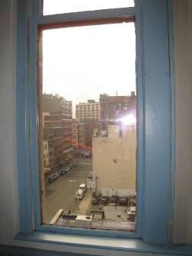
Typical Sash Window on Fifth Floor
Picture 2
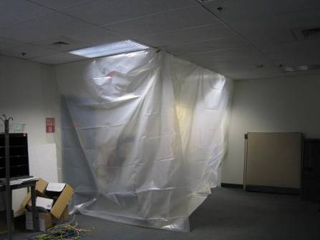
Area Sealed with Plastic Polyethylene Sheeting

Picture 3
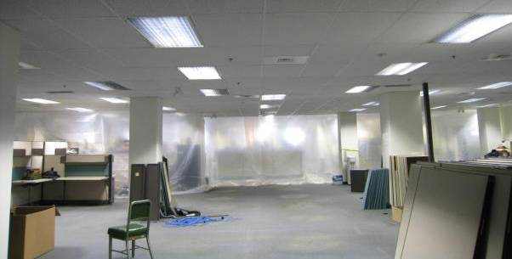
Area Sealed with Plastic Polyethylene Sheeting

Picture 4
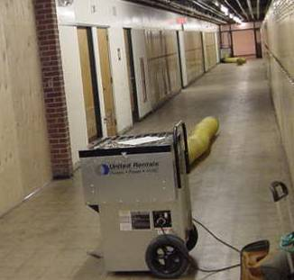
Example of Air Filtration Unit “Air Scrubber” Equipped with High Efficiency Particulate Arrestance (HEPA) Filters at Construction Site

Location | PM2.5*  (µg/m³)  Inside Barrier | PM2.5*  (µg/m³)  Outside Barrier/Occupied Area | Comments
Background/Outside  PM2.5 = 52-70 (µg/m³) |  |  | Cool, mostly cloudy, wind: SSW 6-15 mph/gusts up to 21 mph, moderate to heavy traffic, idling busses, smoking outside the building
5008 | 12 | 10 | 5008
5134 | 13 | 12
5248 | 9 | 6
5267 | 9 | 6
Emergency Exit/Lounge Hallway | 8 | 7
Kitchen Area | 8 | 6
Clinical Affairs | 11 | 10

