INDOOR AIR QUALITY ASSESSMENT

Massachusetts Executive Office of Health and Human Services
600 Washington Street, 7th floor
Boston, Massachusetts

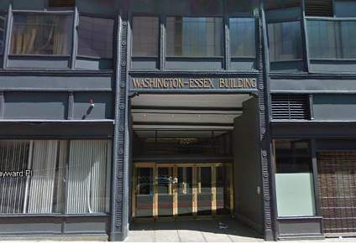

Prepared by:
Massachusetts Department of Public Health
Bureau of Environmental Health
Indoor Air Quality Program
November 2015

Executive Summary:
No significant public health concerns were identified during this visit. Ventilation parameters of carbon dioxide, temperature and relative humidity were generally within the MDPH/IAQ recommended comfort ranges. Some water-damaged materials were found. A door leading to a freight elevator area may be a source of odors. This door needs to be made tighter with new door sweeps and gaskets.

Background
Building: | Executive Office of Health and Human Services (EOHHS)
Address: | 600 Washington Street, 7th floor, Boston, MA
Assessment Requested by: | Rhett Cavicchi, Director of Human Resources-Children, Youth and Families
Date of Assessment: | October 15, 2015
Bureau of Environmental Health/Indoor Air Quality (BEH/IAQ) Program Staff Conducting Assessment: | Ruth Alfasso, Environmental Engineer/Inspector  Jason Dustin, Environmental Analyst/Inspector
Date of Building Construction: | 1904
Reason for Request: | Respiratory concerns/general assessment

Building Description
The EOHHS space is housed in a seven-story, brick-faced building that reportedly underwent interior renovations in 2011 including updated lighting, carpeting, interior walls, ceiling tiles and furnishings. The building has a flat roof with a black rubber membrane. The building houses offices, conference rooms, open cubicle areas, and storage rooms. Windows are not openable.

Results and Discussion
This space is occupied by approximately 300 employees. Members of regional EOHHS agencies also visit the space daily for trainings. Test results are presented in Table 1. Methods and indoor air related sampling information can be found in the IAQ Manual and Appendices for IAQ Reports, which can be found at:
http://www.mass.gov/eohhs/gov/departments/dph/programs/environmental-health/exposure-topics/iaq/iaq-rpts/general-appendices-for-iaq-reports.html

Ventilation
It can be seen from Table 1 that carbon dioxide levels were below 800 parts per million (ppm) in almost all areas surveyed indicating adequate ventilation throughout the 7th floor. Mechanical ventilation is provided by rooftop air handling units (AHUs). Ducts carry air from the AHUs to offices and distribute tempered air via supply vents (Picture 1). Return air is drawn into ceiling-mounted vents (Picture 2) and brought back to AHUs through a ceiling plenum. In some areas, such as the kitchen, restrooms and some conference rooms, direct exhaust vents are present to remove stale air and generated pollutants from the building without recirculating them in the building’s general ventilation system.
To maximize air exchange, the Massachusetts Department of Public Health (MDPH) recommends that both supply and exhaust ventilation operate continuously during periods of occupancy. The MDPH recommends that thermostats be set to the fan “on” setting during occupied hours to provide a continuous source of fresh air and filtration.

Temperature and Relative Humidity
Indoor temperature measurements ranged from 72°F to 76°F (Table 1), which were within the MDPH recommended comfort range. The MDPH recommends that indoor air temperatures be maintained in a range of 70°F to 78°F in order to provide for the comfort of building occupants.
Indoor relative humidity (RH) ranged from 30 to 44 percent (Table 1), with RH below the MDPH comfort range in some areas. The MDPH recommends a comfort range of 40 to 60 percent for indoor air relative humidity. Relative humidity levels in the building would be expected to drop during winter months due to heating. The sensation of dryness and irritation is common in a low relative humidity environment. Low relative humidity is a very common problem during the heating season in the northeast part of the United States.

Microbial/Moisture Concerns
Water-damaged ceiling tiles were observed in some areas (Pictures 3 and 4; Table 1). The US Environmental Protection Agency (US EPA) and the American Conference of Governmental Industrial Hygienists (ACGIH) recommend that porous materials (e.g., carpeting, gypsum wallboard) be dried with fans and heating within 24 to 48 hours of becoming wet (US EPA, 2001; ACGIH, 1989). If not dried within this time frame, mold growth may occur. Once mold has colonized porous materials, they are difficult to clean and should be removed. The source of the leak above the ceiling tiles should be repaired and the water-damaged ceiling tiles should be removed and replaced.
Plants were observed in some offices and open areas (Pictures 5 and 6; Table 1). Plants can be a source of pollen and mold, which can be respiratory irritants to some individuals. Plants should be properly maintained, over-watering of plants should be avoided and drip pans should be inspected periodically for mold growth and cleaned or replaced as necessary.
Water dispensing equipment and small refrigerators were observed in carpeted areas (Picture 7; Table 1). Spills or leaks from this equipment can moisten carpet and lead to microbial growth and carpet degradation.

Other IAQ Evaluations
Indoor air quality can be negatively influenced by the presence of respiratory irritants, such as products of combustion. The process of combustion produces a number of pollutants. Common combustion emissions include carbon monoxide, carbon dioxide, water vapor, and smoke (fine airborne particle material). Of these materials, exposure to carbon monoxide and particulate matter with a diameter of 2.5 micrometers (μm) or less (PM2.5) can produce immediate, acute health effects upon exposure. To determine whether combustion products were present in the indoor environment, BEH/IAQ staff obtained measurements for carbon monoxide and PM2.5

Carbon Monoxide
Carbon monoxide should not be present in a typical, indoor environment. If it is present, indoor carbon monoxide levels should be less than or equal to outdoor levels. Carbon monoxide levels outdoors were measured at 1.6 ppm. No measureable levels of carbon monoxide were detected inside the building during the assessment.

Particulate Matter
Outdoor PM2.5 concentrations were measured at 19 μg/m³ (Table 1), which were below the NAAQS limit of 35 μg/m³. Indoor PM2.5 levels ranged from 1 to 15 μg/m³ (Table 1), which were also below the NAAQS PM2.5 level of 35 μg/m³. Frequently, indoor air levels of particulate matter (including PM2.5) can be at higher levels than those measured outdoors.

Volatile Organic Compounds (VOCs)
Exposure to low levels of total VOCs (TVOCs) may produce eye, nose, throat and/or respiratory irritation in some sensitive individuals. In order to determine if VOCs were present, BEH/IAQ staff examined rooms for products containing VOCs. BEH/IAQ staff noted air fresheners, hand sanitizer, cleaners and dry erase materials in use within the space (Table 1). All of these have the potential to be irritants to the eyes, nose, throat and respiratory system of sensitive individuals.

Other Concerns
Other conditions that can affect IAQ were observed during the assessment. Some personal fans and supply vents were observed to be dusty (Picture 8). Also, one return vent was noted to have debris behind the vent (Picture 2). Dust on these items can be reaerosolized and cause irritation or odors.
BEH/IAQ staff observed a door leading to an unoccupied space containing freight elevators (Picture 9). Large gaps were noted beneath the door into the hallway. If freight elevators are used, the area can be pressurized and distribute odors and particulate matter to occupied areas. The installation of a tight-fitting door sweep and gaskets would help mitigate this concern. A stack of new AHU filters were found stored in this room (Picture 10). These filters should be stored in a sealed bag or container to prevent them from absorbing odors or dust prior to installation.
In some areas, accumulation of items, including papers, boxes, and personal items, were stored on floors desks, tables, and counters (Picture 11). Large numbers of items provide a source for dusts to accumulate. These items make it difficult for custodial staff to clean. Items should be relocated and/or cleaned periodically to avoid excessive dust build up.
Some EOHHS staff members reported complaints regarding drafts due to the direction of airflow from supply diffusers. In some areas, staff have taped over supply diffusers (Picture 12).

Conclusions/Recommendations
In view of the findings at the time of the visit, the following recommendations are made:
- Continue to operate all thermostats in the fan “on” setting to provide continuous airflow/filtration during occupied hours.
- Replace water-damaged ceiling tiles once the source of the leak is discovered and repaired.
- Consider placing water dispensers/small refrigerators in non-carpeted areas or place a waterproof mat underneath them.
- Maintain indoor plants, use non-porous drips pans, prevent overwatering and refrain from placing them near supply diffusers.
- Consider installing a tight-fitting door sweep and gaskets for the door leading to the freight elevators.
- Store new AHU filters in a sealed bag or container to prevent damage/contamination.
- Reduce the use of items containing VOCs including scented cleaners, air fresheners, dry erase materials and hand sanitizer.
- Clean surfaces, carpets and vents on a preventative maintenance schedule.
- Store items in an organized manner and move them to clean periodically to prevent a buildup of dust.
- Consider redirecting supply diffusers in areas where staff have reported comfort complaints and remove blockages to airflow.
- For buildings in New England, periods of low relative humidity during the winter are often unavoidable. Therefore, scrupulous cleaning practices should be adopted to minimize common indoor air contaminants whose irritant effects can be enhanced when the relative humidity is low. To control for dusts, a high efficiency particulate arrestance (HEPA) filter equipped vacuum cleaner in conjunction with wet wiping of all surfaces is recommended. Avoid the use of feather dusters. Drinking water during the day can help ease some symptoms associated with a dry environment (throat and sinus irritations).
- Refer to resource manuals and other related indoor air quality documents for further building-wide evaluations and advice on maintaining public buildings. These materials are located on the MDPH’s website: http://mass.gov/dph/iaq.

References
ACGIH. 1989. Guidelines for the Assessment of Bioaerosols in the Indoor Environment. American Conference of Governmental Industrial Hygienists, Cincinnati, OH.
US EPA. 2001. Mold Remediation in Schools and Commercial Buildings. US Environmental Protection Agency, Office of Air and Radiation, Indoor Environments Division, Washington, DC. EPA 402-K-01-001. March 2001.

Picture 1
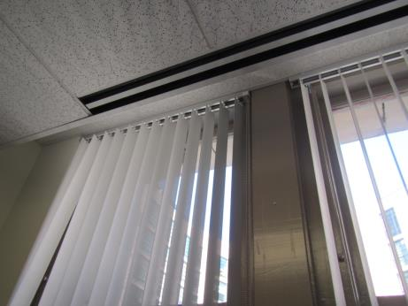
Supply diffuser
Picture 2
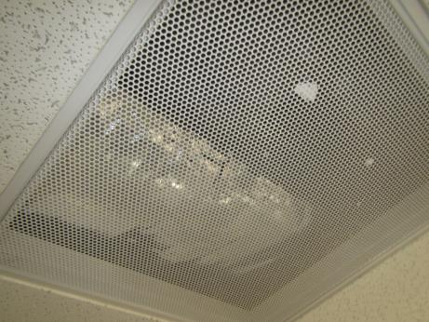
Ceiling-mounted return air grate (note debris in vent)
Picture 3
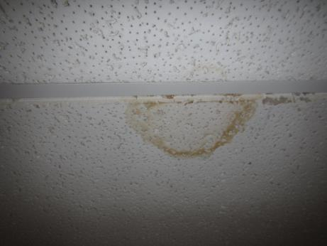
Water-damaged ceiling tile
Picture 4
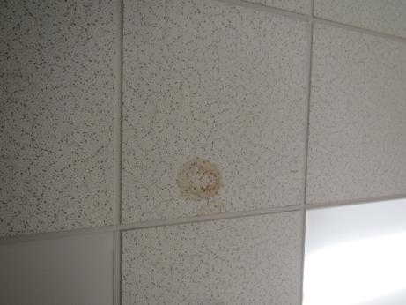
Water-damaged ceiling tile
Picture 5
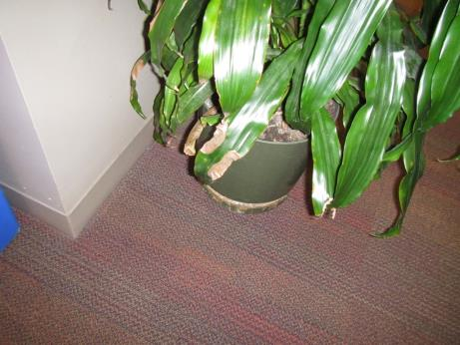
Plant on carpeting
Picture 6
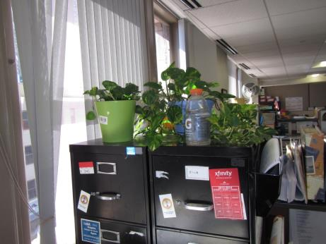
Plants located under supply air stream
Picture 7
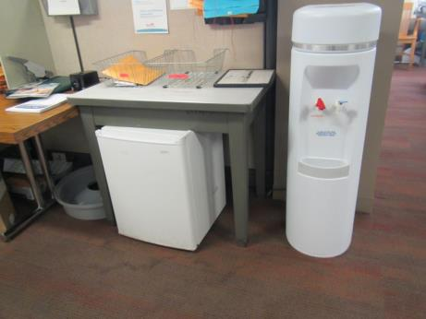
Small refrigerator and water dispenser on carpet (note carpet staining)
Picture 8
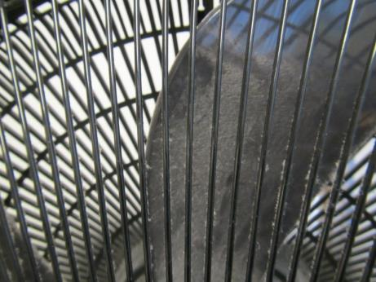
Personal fan showing dust accumulation
Picture 9
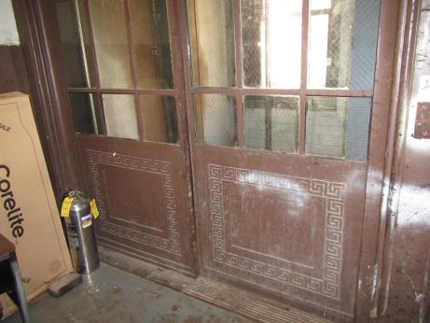
Unoccupied area with freight elevators
Picture 10
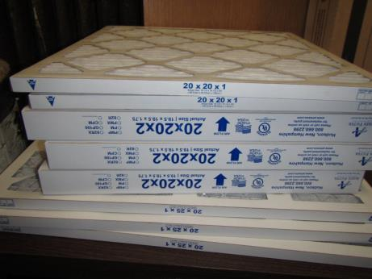
New AHU filters stored unprotected in freight elevator room
Picture 11
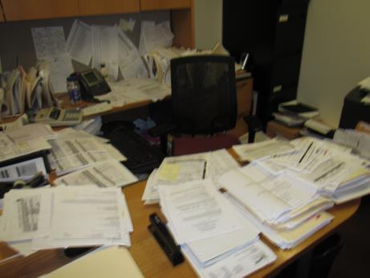
Large accumulation of items on flat surfaces
Picture 12
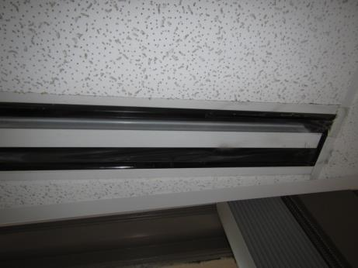
Supply vent showing tape blocking vent openings
Location | Carbon  Dioxide  (ppm) | Carbon Monoxide  (ppm) | Temp  (°F) | Relative  Humidity  (%) | PM2.5  (µg/m³) | Occupants  in Room | Windows  Openable | Ventilation |  |  | Remarks
 |  |  |  |  |  |  |  | Intake | Exhaust
Background outside | 483 | 1.6 | 61 | 54 | 19
Cubicle near kitchen | 651 | ND | 76 | 31 | 3 | 0 | N | N |  | N | HS
DVS supply room | 684 | ND | 73 | 42 | 3 | 0 | N | Y |  | Y
Elevator lobby | 741 | ND | 75 | 35 | 5 | 2 | N | Y |  | Y | Slight oil odor
Freight elevator area |  |  |  |  |  |  |  |  |  |  | Needs door sweeps, complete plenum. Stored antifreeze and air filters
Ladies room |  |  |  |  |  |  | N | Y |  | Y | Ducted exhaust
Waiting | 734 | ND | 75 | 34 | 5 | 0 | N | Y |  | Y | WC on carpet
7004 conference | 716 | ND | 74 | 34 | 2 | 0 | N | Y |  | Y
7009 training | 789 | ND | 74 | 36 | 3 | 1 | N | Y |  | Y
7011 Interview | 780 | ND | 74 | 37 | 3 | 0 | N | Y |  | Y
7013 | 721 | ND | 75 | 32 | 4 | 3 | N | Y |  | Y | AT, DO, plants and dried flowers
7015 | 687 | ND | 74 | 33 | 3 | 0 | N | Y |  | Y
7016 | 688 | ND | 73 | 34 | 2 | 1 | N | Y |  | Y | DO, HS
7017 | 697 | ND | 73 | 34 | 7 | 1 | N | Y |  | Y | DO, heater
7018 | 682 | ND | 73 | 34 | 2 | 2 | N | Y |  | Y | AP/fan, plants
7019 | 676 | ND | 73 | 34 | 1 | 0 | N | Y |  | Y | Plant, popcorn odor
7020 | 693 | ND | 73 | 34 | 2 | 0 | N | Y |  | Y | Heater on
7021 | 741 | ND | 73 | 35 | 2 | 0 | N | Y |  | Y | DO
7022 | 704 | ND | 73 | 37 | 3 | 1 | N | Y |  | Y
7024 | 703 | ND | 73 | 37 | 3 | 0 | Y | Y |  | Y | CPs
7030 cubes | 719 | ND | 73 | 35 | 2 | 2 | N | Y |  | Y | PF
7035 | 723 | ND | 73 | 37 | 2 | 0 | N | Y |  | Y | PF
7036 cubes | 743 | ND | 73 | 37 | 4 | 0 | N | Y |  | Y
7037 cubes | 740 | ND | 73 | 37 | 3 | 1 | N | Y |  | Y
7047 cubes | 701 | ND | 74 | 34 | 2 | 2 | N | Y |  | Y
7050 | 688 | ND | 75 | 32 | 5 | 0 | N | Y |  | Y | PF (on), DO
7051 | 680 | ND | 75 | 31 | 6 | 0 | N | Y |  | Y | WC on carpet
7052 | 751 | ND | 75 | 32 | 4 | 1 | N | Y |  | Y | PF, DEM
7054 | 675 | ND | 73 | 32 | 2 | 1 | N | Y |  | N | DO
7055 | 668 | ND | 73 | 35 | 3 | 1 | N | Y |  | Y | DEM
7056 | 678 | ND | 74 | 36 | 3 | 0 | N | Y |  | Y
7057 ½ | 692 | ND | 74 | 32 | 6 | 0 | N | Y |  | N
7058 ½ | 715 | ND | 74 | 33 | 14 | 2 | N | Y |  | N
7059 ½ | 705 | ND | 74 | 33 | 2 | 0 | N | Y |  | Y
7064 cubes | 693 | ND | 74 | 33 | 3 | 2 | N | Y |  | Y | Plants
7066 cubes | 643 | ND | 74 | 36 | 2 | 1 | N | Y |  | Y | Plants
7071 cubes | 683 | ND | 73 | 34 | 2 | 2 | N | Y |  | Y | Plants
7074 cubes | 743 | ND | 73 | 37 | 4 | 1 | N | Y |  | Y | PF
7076 | 626 | ND | 73 | 34 | 2 | 0 | N | Y |  | Y | DO, HS, DEM
7077 | 673 | ND | 73 | 34 | 1 | 0 | N | Y |  | Y | DO
7078 | 662 | ND | 73 | 36 | 3 | 2 | N | Y |  | Y | DEM
7080 | 671 | ND | 74 | 33 | 2 | 2 | N | Y |  | Y | DO
7081 | 606 | ND | 73 | 35 | 3 | 0 | N | Y |  | Y
7082 | 658 | ND | 74 | 33 | 2 | 2 | N | Y |  | Y | AP
7083 | 603 | ND | 73 | 36 | 2 | 0 | N | Y |  | Y | AI
7085 | 634 | ND | 74 | 31 | 2 | 2 | N | Y |  | Y
7086 | 578 | ND | 73 | 33 | 3 | 1 | N | Y |  | Y
7087 | 618 | ND | 74 | 31 | 2 | 2 | N | Y |  | Y | DEM, DO
7088 | 557 | ND | 73 | 32 | 4 | 0 | N | Y |  | Y
7089 | 711 | ND | 74 | 33 | 2 | 2 | N | Y |  | Y
7090 ½ | 624 | ND | 74 | 32 | 2 | 2 | N | N |  | N | Space behind cube wall and window
7091 ½ | 633 | ND | 74 | 32 | 3 | 3 | N | Y |  | Y | DO
7095 cubes | 585 | ND | 74 | 30 | 3 | 2 | N | Y |  | Y | Plants
7097 | 538 | ND | 74 | 32 | 2 | 2 | N | Y |  | Y
7098 | 545 | ND | 74 | 32 | 2 | 1 | N | Y |  | Y
7100 | 560 | ND | 74 | 33 | 2 | 1 | N | Y |  | Y | AI
7104 cubes | 676 | ND | 75 | 32 | 2 | 2 | N | Y |  | Y | Solar gain, fan, AI on floor
7104 reception | 707 | ND | 75 | 31 | 15 | 2 |  | Y |  | Y | PF
7107 cubes | 636 | ND | 75 | 34 | 2 | 2 | N | Y |  | Y | Crock pot
7108 ½ | 659 | ND | 74 | 33 | 4 | 4 | N | N |  | Y | DO
7109 copy | 654 | ND | 74 | 32 | 3 | 3 | N | Y |  | N | NC, 1 WD CT, PCs, mini fridge, food outside PC room
7110 | 613 | ND | 74 | 31 | 2 | 3 | N | Y |  | Y
7111 | 611 | ND | 74 | 30 | 2 | 0 | N | Y |  | Y | DO
7112 | 570 | ND | 74 | 30 | 2 | 0 | N | Y |  | Y | DO
7113 | 588 | ND | 74 | 31 | 4 | 3 | N | Y |  | Y | Fridge on carpet
7114 ½ | 612 | ND | 74 | 31 | 3 | 0 | N | Y |  | Y
7115 | 710 | ND | 74 | 33 | 3 | 1 | N | Y |  | Y | HS
7119 cubes | 654 | ND | 74 | 34 | 1 | 0 | N | Y |  | N
7123 cubes | 670 | ND | 75 | 35 | 2 | 2 | N | Y |  | Y
7126 ½ | 682 | ND | 75 | 35 | 2 | 1 | N | N |  | Y | Plants and dried flowers
7130 ½ | 658 | ND | 75 | 34 | 3 | 0 | N | Y |  | N | PF on, DEM
7132 kitchen | 626 | ND | 76 | 33 | 8 | 0 | N | Y |  | Y | NC, fridges and microwaves and toasters. Stained fridge gasket
7134 cubes | 640 | ND | 75 | 32 | 4 | 3 | N | Y |  | Y | PF on
7135 cubes | 614 | ND | 74 | 35 | 3 | 2 | N | Y |  | Y
7138 cubes | 677 | ND | 75 | 36 | 4 | 1 | N | Y |  | Y | PF, HS
7141 cubes | 665 | ND | 75 | 34 | 1 | 1 | N | Y |  | Y
7142 cubes | 669 | ND | 75 | 35 | 2 | 1 | N | Y |  | Y
7143 cubes | 642 | ND | 75 | 33 | 2 | 1 | N | Y |  | Y | HS
7146 | 588 | ND | 75 | 34 | 2 | 1 | N | Y |  | Y
7147 ½ | 662 | ND | 75 | 34 | 8 | 0 | N | N |  | N | PC in hall
7148 ½ | 658 | ND | 75 | 34 | 5 | 1 | N | N |  | N | DEM
7149 ½ | 668 | ND | 75 | 35 | 4 | 1 | N | N |  | N
7151 cubes | 637 | ND | 74 | 35 | 3 | 1 | N | Y |  | Y | AI, supply diffuser overhead
7152 cubes | 816 | ND | 75 | 35 | 5 | 2 | N | Y |  | Y | HS, Personal HEPA air filter, PF
7155 cubes | 688 | ND | 75 | 35 | 4 | 2 | N | Y |  | Y | Plants
7167 | 668 | ND | 75 | 36 | 4 | 0 | N | Y |  | Y | DEM, PF
7169 | 741 | ND | 75 | 37 | 6 | 0 | N | Y |  | Y | DEM
7170 RMV library | 685 | ND | 74 | 37 | 2 | 0 | N | Y |  | Y | DO
7173 | 689 | ND | 75 | 37 | 3 | 1 | N | Y |  | Y
7176 | 663 | ND | 75 | 38 | 3 | 2 | N | Y |  | Y
7181 | 659 | ND | 75 | 35 | 1 | 0 | N | Y |  | Y | Plant
7185 cubes | 730 | ND | 73 | 40 | 2 | 2 | N | Y |  | Y | Plants
7188 | 695 | ND | 75 | 37 | 3 | 2 | N | Y |  | Y
7190 | 683 | ND | 75 | 38 | 3 | 2 | N | Y |  | Y | DEM
7192 | 734 | ND | 75 | 38 | 3 | 0 | N | Y |  | Y | AI
7193 | 682 | ND | 74 | 40 | 4 | 0 | N | Y |  | Y | DEM
7195 cubes | 665 | ND | 73 | 40 | 3 | 0 | N | Y |  | Y | DEM, AI
7197 ½ | 720 | ND | 74 | 37 | 1 | 0 | N | N |  | N | PF
7198 ½ | 717 | ND | 74 | 39 | 2 | 0 | N | N |  | N | DO, AI
7199 ½ wall | 700 | ND | 74 | 39 | 1 | 0 | N | N |  | N | DO, HS in hall
7203 cubes | 738 | ND | 73 | 40 | 4 | 1 | N | Y |  | Y | Plants
7207 cubes | 705 | ND | 74 | 39 | 2 | 0 | N | Y |  | Y | Items, plants, dog accoutrements
7210 cubes | 754 | ND | 74 | 40 | 2 | 1 | N | Y |  | Y
7212 cubes | 723 | ND | 73 | 40 | 4 | 1 | N | Y |  | Y | Plush items
7217 | 685 | ND | 73 | 42 | 2 | 1 | N | Y |  | Y | Plants
7219 cubes | 716 | ND | 74 | 39 | 5 | 1 | N | Y |  | Y | Plants
7222 cubes | 694 | ND | 74 | 39 | 8 | 1 | N | Y |  | Y | PFs
7223 | 657 | ND | 72 | 41 | 3 | 0 | N | Y |  | Y | Plants
7224 | 710 | ND | 73 | 43 | 4 | 0 | N | Y |  | Y | Plants
7225 | 686 | ND | 73 | 42 | 3 | 0 | N | Y |  | Y | DEM
7226 | 691 | ND | 72 | 43 | 3 | 1 | N | Y |  | Y | Plants, PF
7227 | 730 | ND | 73 | 42 | 1 | 1 | N | Y |  | Y | DEM, plant, AT
7228 | 722 | ND | 73 | 41 | 1 | 0 | N | Y |  | Y | Printer
7229 | 700 | ND | 73 | 41 | 1 | 0 | N | Y |  | Y | Plants, shoes, DO
7230 | 700 | ND | 73 | 41 | 2 | 0 | N | Y |  | Y | AI on floor, plant
7231 | 717 | ND | 72 | 44 | 3 | 1 | N | Y |  | Y | DEM, plant
7233 cubes | 642 | ND | 73 | 40 | 2 | 0 | N | Y |  | Y | DEM
7235 cubes | 648 | ND | 73 | 40 | 3 | 1 | N | Y |  | Y | HS, PF
7241 cubes | 650 | ND | 73 | 40 | 3 | 1 | N | Y |  | Y | PF
7245 cubes | 665 | ND | 73 | 41 | 2 | 1 | N | Y |  | Y | Plant
7246 conf | 685 | ND | 73 | 39 | 1 | 2 | N | Y |  | Y | DEM
7248 conf | 686 | ND | 73 | 39 | 2 | 0 | N | Y |  | Y | DO, perfume/body odor, DEM
7250 | 774 | ND | 73 | 40 | 1 | 1 | N | Y |  | Y | DEM, AI, papers on floor
7251 conf | 665 | ND | 73 | 38 | 1 | 0 | N | Y |  | Y | DEM, direct and return exhaust in this room
7252 | 670 | ND | 73 | 38 | 1 | 0 | N | Y |  | Y | DEM
7253 | 671 | ND | 73 | 38 | 1 | 1 | N | Y |  | Y | DEM, DO, PC in hall
7254 | 667 | ND | 73 | 38 | 2 | 0 | N | Y |  | Y | DEM
7254A | 680 | ND | 73 | 39 | 1 | 0 | N | Y |  | Y | Workroom – big printers, fridge on carpet, microwave
7261 cubes | 624 | ND | 74 | 37 | 3 | 2 | N | Y |  | Y | Numerous stored computers
7262 conference | 786-818 | ND | 75 | 37 | 7 | 10 | N | Y |  | Y
7263 | 638 | ND | 74 | 34 | 1 | 0 | N | Y |  | Y | DEM, DO
7264 | 645 | ND | 74 | 35 | 1 | 0 | N | Y |  | Y | Coffee pot, DO
7265 | 621 | ND | 74 | 35 | 1 | 0 | N | Y |  | Y | Toaster and microwave
7266 | 658 | ND | 74 | 35 | 2 | 1 | N | Y |  | Y | DEM
7267 | 638 | ND | 74 | 35 | 1 | 0 | N | Y |  | N | WD CT
7268 ½ | 688 | ND | 74 | 36 | 3 | 0 | N | Y |  | Y | Skylight/window beyond wall/ceiling
7269 ½ | 687 | ND | 74 | 36 | 2 | 1 | N | Y |  | Y
7270 ½ | 658 | ND | 74 | 36 | 2 | 0 | N | Y |  | Y
7271 | 663 | ND | 74 | 36 | 1 | 0 | N | Y |  | Y
7272 | 716 | ND | 74 | 37 | 2 | 0 | N | Y
Corridor outside 7272 | - | - | - | - | - | - | - | - |  | - | WD CTs
7273 cubes | 677 | ND | 74 | 38 | 4 | 0 | N | Y |  | Y | HS, AF
7275 cubes | 639 | ND | 74 | 37 | 2 | 1 | N | Y |  | Y
7279 cubes | 625 | ND | 74 | 37 | 3 | 1 | N | Y |  | Y | PF, CPs
7282 cubes | 640 | ND | 74 | 37 | 3 | 2 | N | Y |  | Y
7283 cubes | 623 | ND | 75 | 37 | 4 | 1 | N | Y |  | Y | Space heater
7294 | 709 | ND | 73 | 39 | 1 | 0 | N | Y |  | Y | Plant, DEM

