INDOOR AIR QUALITY ASSESSMENT

Massachusetts Commission for the Blind
600 Washington Street, 3rd Floor
Boston, Massachusetts

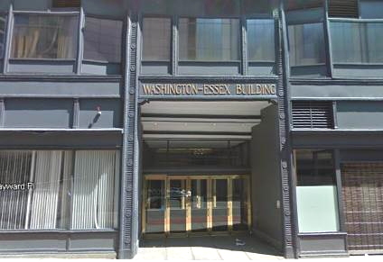

Prepared by:
Massachusetts Department of Public Health
Bureau of Environmental Health
Indoor Air Quality Program
March 2013

Background/Introduction
In response to a request from Shandra Krasser, Director for Financial Compliance at the Massachusetts Commission for the Blind (MCB), the Massachusetts Department of Public Health (MDPH), Bureau of Environmental Health (BEH) conducted an indoor air quality (IAQ) assessment at the MCB office located at 600 Washington Street, Boston, Massachusetts. The request was prompted by occupant concerns of eye, nose and throat irritation in the building as well as general IAQ concerns.
On Thursday, August 30, 2012, a visit was made to this location by Michael Feeney, Director and Ruth Alfasso, Environmental Engineer/Inspector in BEH’s IAQ Program to conduct an IAQ assessment. During the assessment, BEH/IAQ staff had been alerted to a water damage issue in one location regarding a rubber-backed carpet that had been installed over carpet tile that was losing it adhesion to the floor. Mr. Feeney made verbal recommendations related to: removal of the wet carpeting; identifying the source of water moistening the wall-to-wall carpet; procedures to contain the carpet removal pollutants from affecting remainder of the MCB offices; and relocation of employees from the carpet removal area until the investigation and remediation was complete. Mr. Feeney offered to return to the building to assist in identification of the water damage source once the carpet was removed. Building management began the remediation activities over the Labor Day weekend.
On Wednesday, September 5, 2012, Mr. Feeney returned to the MCB to examine progress of the investigation and remediation efforts. Mr. Feeney made several additional verbal recommendations which were followed up with telephone correspondence about the progress of water damage remediation in the MCB offices subsequent to the September 5, 2012 visit.
The MCB offices are located on the third floor of 600 Washington Street, a high-rise building containing many other state offices. BEH/IAQ visits to other tenants and floors of this building have been conducted previously. The space consists of offices, modular workstations with cloth-covered dividers (cubicles), and semi-private offices separated with clear plastic walls that continue to within about a foot of the ceiling. Ceilings consist of suspended ceiling tiles. Flooring in the majority of areas consists of carpet squares. Windows appeared to be openable along the sides of the building, but it was not known whether they had been sealed.

Methods
Air tests for carbon monoxide, carbon dioxide, temperature and relative humidity were conducted with the TSI, Q-Trak, IAQ Monitor, Model 7565. Air tests for airborne particle matter with a diameter less than 2.5 micrometers were taken with the TSI, DUSTTRAK™ Aerosol Monitor Model 8520. Air tests for Total Volatile Organic Compounds (TVOCs) were conducted with a Mini-RAE 2000 photoionization detector. Moisture content of porous building materials was measured with a Delmhorst, BD-2100 Model, Moisture Detector equipped with a Delmhorst Standard Probe. BEH/IAQ staff also performed visual inspection of building materials for water damage and/or microbial growth.

Results
Approximately 100 people work in this MCB office with members of the public visiting daily. Tests were taken during normal operations and results appear in Table 1. Results are listed by room number or closest cubicle number.

Discussion

Ventilation
It can be seen from Table 1 that carbon dioxide levels were below 800 parts per million (ppm) in 57 of 67 areas surveyed, indicating adequate air exchange in most areas at the time of assessment (Table 1). Note that many areas were empty or sparsely populated at the time of testing. Carbon dioxide levels would be expected to increase with greater occupancy. Heating, ventilation and air-conditioning (HVAC) is provided by an air handling unit (AHU) located in a mechanical room. Fresh air is supplied to each floor by ceiling-mounted air diffusers (Picture 1). Return air is ducted from ceiling-mounted exhaust vents (Picture 2) and returned to the AHU.
BEH/IAQ staff noted that the arrangement of supply and particularly, exhaust vents in the space may not be in an optimal configuration. In the open cubicle areas, there were significantly more supply vents than exhaust vents noted, and there were typically no exhaust vents located above items such as photocopiers and shredders, which may be a source of waste heat, odors and pollutants. An exhaust vent was noted directly adjacent to the door to the mechanical room (between rooms 3164 and 3165) and the mechanical room door was outfitted with a passive door vent which had been sealed, but not tightly. In this configuration the exhaust vent would tend to draw air from the mechanical room, which would entrain pollutants directly from the mechanical room into the HVAC system.
In addition, the semi-private office configurations did not correspond well with the location of supply and exhaust vents, leading many of these areas to have no direct source of supply and/or exhaust (Table 1) and possibly impairing fresh air circulation among nearby offices and cubicles. It was noted that when occupied, many of these spaces had the doors open which would be one way of improving air circulation.
To maximize air exchange, the MDPH recommends that both supply and exhaust ventilation operate continuously during periods of occupancy. In order to have proper ventilation with a mechanical supply and exhaust system, the systems must be balanced to provide an adequate amount of fresh air to the interior of a room while removing stale air from the room. It is recommended that existing ventilation systems be re-balanced every five years to ensure adequate air systems function (SMACNA, 1994). The date of the last balancing was not available at the time of assessment.
Minimum design ventilation rates are mandated by the Massachusetts State Building Code (MSBC). Until 2011, the minimum ventilation rate in Massachusetts was higher for both occupied office spaces and general classrooms, with similar requirements for other occupied spaces (BOCA, 1993). The current version of the MSBC, promulgated in 2011 by the State Board of Building Regulations and Standards (SBBRS), adopted the 2009 International Mechanical Code (IMC) to set minimum ventilation rates. Please note that the MSBC is a minimum standard that is not health-based. At lower rates of cubic feet per minute (cfm) per occupant of fresh air, carbon dioxide levels would be expected to rise significantly. A ventilation rate of 20 cfm per occupant of fresh air provides optimal air exchange resulting in carbon dioxide levels at or below 800 ppm in the indoor environment in each area measured. MDPH recommends that carbon dioxide levels be maintained at 800 ppm or below. This is because most environmental and occupational health scientists involved with research on IAQ and health effects have documented significant increases in indoor air quality complaints and/or health effects when carbon dioxide levels rise above the MDPH guidelines of 800 ppm for schools, office buildings and other occupied spaces (Sundell et al., 2011). The ventilation must be on at all times that the room is occupied. Providing adequate fresh air ventilation with open windows and maintaining the temperature in the comfort range during the cold weather season is impractical. Mechanical ventilation is usually required to provide adequate fresh air ventilation.
Carbon dioxide is not a problem in and of itself. It is used as an indicator of the adequacy of the fresh air ventilation. As carbon dioxide levels rise, it indicates that the ventilating system is malfunctioning or the design occupancy of the room is being exceeded. When this happens, a buildup of common indoor air pollutants can occur, leading to discomfort or health complaints. The Occupational Safety and Health Administration (OSHA) standard for carbon dioxide is 5,000 parts per million parts of air (ppm). Workers may be exposed to this level for 40 hours/week, based on a time-weighted average (OSHA, 1997).
The MDPH uses a guideline of 800 ppm for publicly occupied buildings. A guideline of 600 ppm or less is preferred in schools due to the fact that the majority of occupants are young and considered to be a more sensitive population in the evaluation of environmental health status. Inadequate ventilation and/or elevated temperatures are major causes of complaints such as respiratory, eye, nose and throat irritation, lethargy and headaches. For more information concerning carbon dioxide, please see Appendix A.
Temperatures in occupied areas ranged from 70 ºF to 77 ºF, which were within the MDPH recommended comfort guidelines. The MDPH recommends that indoor air temperatures be maintained in a range of 70 ºF to 78 ºF in order to provide for the comfort of building occupants. In many cases concerning indoor air quality, fluctuations of temperature in occupied spaces are typically experienced, even in a building with an adequate fresh air supply. It was noted that areas near the windows on the south and west sides of the building experienced heating from the sun (solar gain).
The relative humidity ranged from 44 to 55 percent, which was also within the MDPH recommended comfort range in all areas surveyed. The MDPH recommends a comfort range of 40 to 60 percent for indoor air relative humidity. In the heating season, relative humidity levels would be expected to be lower due to heating; low relative humidity is a very common problem during the heating season in the northeast part of the United States. The sensation of dryness and irritation is common in a low relative humidity environment.

Microbial/Moisture Concerns
Of particular concern the day of the original assessment (August 30, 2012) was an area of water-damaged flooring located in the wing extending along the southeast side of the floor. An area of carpet tiles that were curling up from the floor was reportedly discovered a few days prior to the assessment. Since a number of employees and visitors to this office have vision problems, it is very important to render the floor as free from obstructions as possible, so this area was covered with a taped-down floor mat (Picture 3). It was determined during the assessment that there was moisture in and underneath the carpet tiles in this area (Pictures 4 and 5). However, the source of water was not identified during that visit. Several potential sources were ruled out at the time based on the location and pattern of moistening, including window or ceiling leaks, leaks from the adjacent space, or a disused theater that could not be accessed at the time of the assessment.
During the September 5, 2012 visit, BEH/IAQ staff were informed that the source of water was a deactivated condensation pump for the AHU (Picture 6) installed in the ceiling plenum. Condensation from the AHU filled the condensation pump, which overflowed wetting carpet/flooring in a 5-foot radius around the pillar (Picture 7). At the time of the September 5, 2012 visit, building/facility maintenance had opened the floor and had used carpet fans to aid in drying the floor materials. No musty or unusual odors were observed in this area by BEH/IAQ staff during the September 5, 2012 visit.
A water-damaged ceiling tile was found in one location. This may indicate an historic plumbing leak. Water-damaged building materials can provide a source of mold and should be replaced after a water leak is discovered and repaired. Water dispensers and mini refrigerators were found located on carpeting (Pictures 8 and 9). Carpeting underneath this equipment is vulnerable to water damage, which can lead to mold growth. These items should be relocated to non-carpeted areas or carpeting under this equipment should be covered by a rubber/plastic mat to prevent moistening.

Other IAQ Evaluations
Indoor air quality can be negatively influenced by the presence of respiratory irritants, such as products of combustion. The process of combustion produces a number of pollutants. Common combustion emissions include carbon monoxide, carbon dioxide, water vapor and smoke (fine airborne particle material). Of these materials, exposure to carbon monoxide can produce immediate, acute health effects upon exposure. To determine whether combustion products were present in the indoor environment, BEH/IAQ staff obtained measurements for carbon monoxide and PM2.5.

Carbon Monoxide
Carbon monoxide is a by-product of incomplete combustion of organic matter (e.g., gasoline, wood and tobacco). Exposure to carbon monoxide can produce immediate and acute health effects. Several air quality standards have been established to address carbon monoxide and prevent symptoms from exposure to these substances. The MDPH established a corrective action level concerning carbon monoxide in ice skating rinks that use fossil-fueled ice resurfacing equipment. If an operator of an indoor ice rink measures a carbon monoxide level over 30 ppm, taken 20 minutes after resurfacing within a rink, that operator must take actions to reduce carbon monoxide levels (MDPH, 1997).
The American Society of Heating, Refrigerating and Air-Conditioning Engineers (ASHRAE) has adopted the National Ambient Air Quality Standards (NAAQS) as one set of criteria for assessing indoor air quality and monitoring of fresh air introduced by HVAC systems (ASHRAE, 1989). The NAAQS are standards established by the US EPA to protect the public health from six criteria pollutants, including carbon monoxide and particulate matter (US EPA, 2006). As recommended by ASHRAE, pollutant levels of fresh air introduced to a building should not exceed the NAAQS levels (ASHRAE, 1989). The NAAQS were adopted by reference in the Building Officials & Code Administrators (BOCA) National Mechanical Code of 1993 (BOCA, 1993), which is now an HVAC standard included in the Massachusetts State Building Code (SBBRS, 2011). According to the NAAQS, carbon monoxide levels in outdoor air should not exceed 9 ppm in an eight-hour average (US EPA, 2006).
Carbon monoxide should not be present in a typical, indoor environment. If it is present, indoor carbon monoxide levels should be less than or equal to outdoor levels (Table 1). No measureable levels of carbon monoxide were detected inside the building during the assessment (Table 1).

Particulate Matter
The US EPA has established NAAQS limits for exposure to particulate matter. Particulate matter (PM) is airborne solids that can be irritating to the eyes, nose and throat. The NAAQS originally established exposure limits to PM with a diameter of 10 μm or less (PM10). In 1997, US EPA established a more protective standard for fine airborne particulate matter with a diameter of 2.5 μm or less (PM2.5). The NAAQS has subsequently been revised, and PM2.5 levels were reduced. This more stringent PM2.5 standard requires outdoor air particle levels be maintained below 35 μg/m³ over a 24-hour average (US EPA, 2006). Although both the ASHRAE standard and BOCA Code adopted the PM10 standard for evaluating air quality, MDPH uses the more protective PM2.5 standard for evaluating airborne PM concentrations in the indoor environment.
Indoor PM2.5 levels ranged from 2 to 7 μg/m³ (Table 1), which were below the NAAQS PM2.5 level of 35 μg/m³. Frequently, indoor air levels of particulates (including PM2.5) can be at higher levels than those measured outdoors. A number of mechanical devices and/or activities that occur indoors can generate particulate during normal operations. Sources of indoor airborne particulates may include but are not limited to particles generated during the operation of fan belts in the HVAC system, use of stoves and/or microwave ovens in kitchen areas; use of photocopiers, fax machines and computer printing devices; operation of an ordinary vacuum cleaner; and heavy foot traffic indoors.

Volatile Organic Compounds
Indoor air can be greatly impacted by the use of products containing volatile organic compounds (VOCs). VOCs are carbon-containing substances that have the ability to evaporate at room temperature. Frequently, exposure to low levels of total VOCs (TVOCs) may produce eye, nose, throat and/or respiratory irritation in some sensitive individuals. For example, chemicals evaporating from a paint can stored at room temperature would most likely contain VOCs.
Some of the issues that prompted the assessment concerned irritant symptoms since the office was occupied in April of 2012. In an effort to determine whether VOCs were present in the building, air monitoring for TVOCs was conducted. No measureable levels of TVOCs were detected inside the building during the assessment (Table 1). Please note, that the TVOC air measurements are only reflective of the indoor air concentrations present at the time of sampling.
Indoor air concentrations can be greatly impacted by the use TVOC-containing products. While no measureable levels of TVOCs were detected in the building during the assessment, materials containing VOCs were present. BEH/IAQ staff examined rooms for products containing these respiratory irritants.
Hand sanitizer was found in many locations. Hand sanitizer products may contain ethyl alcohol and/or isopropyl alcohol, which are highly volatile and may be irritating to the eyes and nose, and may also contain fragrances to which some people may be sensitive (GOJO, 2007). Other cleaning products were also noted in some areas. Cleaning products should be properly labeled and stored. In addition, a Material Safety Data Sheet (MSDS) should be available at a central location for each product in the event of an emergency.
As mentioned previously, there were several photocopiers present (Table 1), which were not outfitted with local exhaust ventilation or near an exhaust vent. VOCs and ozone can be produced by photocopiers, particularly if the equipment is older and in frequent use. Ozone is a respiratory irritant (Schmidt Etkin, 1992).
There were significant amounts of electronics, including standard desktop computers and adaptive devices, in the office. Computers and electronics contain plastics, resins and metal components which may give off fumes and odors, particularly when they are new or when they are heated (Maddalena, et al, 2011). The number and placement of exhaust vents may not be sufficient for the amount of equipment currently present in the office.

Other Conditions
Other conditions that can potentially affect indoor air quality were identified during the assessment. In several areas, items were observed on windowsills, tabletops, counters, bookcases and desks. The large number of items stored provides a source for dusts to accumulate. These items (e.g., papers, folders, boxes) make it difficult for maintenance staff to clean. Items should be relocated and/or be cleaned periodically to avoid excessive dust build up.
There were reports of “black particles” coming from supply vents in one section of the office. No particles were noted at the time of the assessment. This is typically due to dust and debris on the supply vent or in the ductwork, and represents a cleaning issue. Since respirable particles were not found to be elevated in the office, increased cleaning along with regular filter changes should remedy this issue.

Conclusions/Recommendations
Several recommendations were made verbally following the assessment to specifically address the condensation leak/water damage issue in the carpeting, including:
- Continue to operate fans to dry out flooring.
- Remove water-damaged flooring to restore the floor to a smooth surface.
- Ensure that the condensation pump is operational and actively pumping as needed.

In view of the other findings from the August 30, 2012 and the September 5, 2012 visits, the following additional recommendations are made:
- Operate the HVAC system continuously during occupancy to provide a source of fresh air and removal of pollutants.
- Consider adopting a balancing schedule of every 5 years for all mechanical ventilation systems, as recommended by ventilation industrial standards (SMACNA, 1994).
- Remove or relocate the exhaust vent directly adjacent to the mechanical room door. Consider adding additional exhaust vents in the cubicle areas and if possible rearranging the locations of supply vents to provide occupants of the semi-private offices with both supply and exhaust ventilation and increase exhaust ventilation near the location of copiers.
- Use room shades to adjust the amount of sunlight in rooms on sunny days to prevent glare and feelings of excessive heat.
- For buildings in New England, periods of low relative humidity during the winter are often unavoidable. Therefore, scrupulous cleaning practices should be adopted to minimize common indoor air contaminants whose irritant effects can be enhanced when the relative humidity is low. To control for dusts, a high efficiency particulate arrestance (HEPA) filter equipped vacuum cleaner in conjunction with wet wiping of all surfaces is recommended. Avoid the use of feather dusters. Drinking water during the day can help ease some symptoms associated with a dry environment (throat and sinus irritations).
- Ensure leaks are repaired and replace water-damaged ceiling tiles.
- Consider relocating refrigerators to areas with tile floors, or use impermeable mats to contain potential spills or leaks.
- Consider increasing fresh air and exhaust ventilation when significant numbers of new computers and other electronic equipment is added to the office.
- Clean carpeting annually or semi-annually in soiled high traffic areas as per the recommendations of the Institute of Inspection, Cleaning and Restoration Certification (IICRC). Copies of the IICRC fact sheet can be downloaded at: http://www.certifiedcleaners.org/faq.shtml
- Relocate or consider reducing the amount of materials stored in offices, work stations and common areas to allow for more thorough cleaning. Clean items regularly with a wet cloth or sponge to prevent excessive dust build-up.
- Clean air diffusers and return/exhaust vents periodically of accumulated dust/debris (e.g., during regular filter changes).
- Change filters for the AHU as per the manufacture’s instructions or more frequently as needed.
- Refer to resource manuals and other related indoor air quality documents for further building-wide evaluations and advice on maintaining public buildings. Copies of these materials are located on the MDPH’s website: http://mass/gov/dph/iaq.

References
ASHRAE. 1989. Ventilation for Acceptable Indoor Air Quality. American Society of Heating, Refrigeration and Air Conditioning Engineers. ANSI/ASHRAE 62-1989.
BOCA. 1993. The BOCA National Mechanical Code-1993. 8th ed. Building Officials & Code Administrators International, Inc., Country Club Hills, IL.
GOJO. 2007. Material Safety Data Sheet for Purell® Instant Hand Sanitizer. GOJO Industries, Akron, OH. October 15, 2007.
Maddalena. 2011. Maddalena, R., T. McKone, H. Destaillats, M. Rusell, A. Hodgson, and C. Perino. Quantifying Pollutant Emissions from Office Equipment: A Concern in Energy‐Efficient Buildings. California Energy Commission, PIER Energy‐Related Environmental Research. CEC-500-2011-046.
MDPH. 1997. Requirements to Maintain Air Quality in Indoor Skating Rinks (State Sanitary Code, Chapter XI). 105 CMR 675.000. Massachusetts Department of Public Health, Boston, MA.
OSHA. 1997. Limits for Air Contaminants. Occupational Safety and Health Administration. Code of Federal Regulations. 29 C.F.R 1910.1000 Table Z-1-A.
SBBRS. 2011. Mechanical Ventilation. State Board of Building Regulations and Standards. Code of Massachusetts Regulations, 8th edition. 780 CMR 1209.0.
Schmidt Etkin, D. 1992. Office Furnishings/Equipment & IAQ Health Impacts, Prevention & Mitigation. Cutter Information Corporation, Indoor Air Quality Update, Arlington, MA.
SMACNA. 1994. HVAC Systems Commissioning Manual. 1st ed. Sheet Metal and Air Conditioning Contractors’ National Association, Inc., Chantilly, VA.
Sundell. 2011. Sundell, J., H. Levin, W. W. Nazaroff, W. S. Cain, W. J. Fisk, D. T. Grimsrud, F. Gyntelberg, Y. Li, A. K. Persily, A. C. Pickering, J. M. Samet, J. D. Spengler, S. T. Taylor, and C. J. Weschler. Ventilation rates and health: multidisciplinary review of the scientific literature. Indoor Air, Volume 21: pp 191–204.
US EPA. 2006. National Ambient Air Quality Standards (NAAQS). US Environmental Protection Agency, Office of Air Quality Planning and Standards, Washington, DC. http://www.epa.gov/air/criteria.html
Picture 1

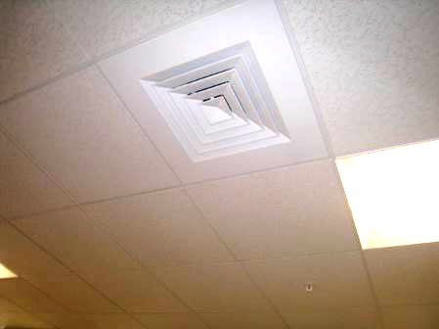

Typical supply vent

Picture 2

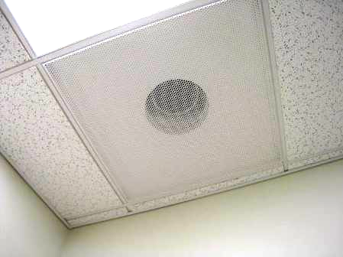

Typical exhaust vent

Picture 3

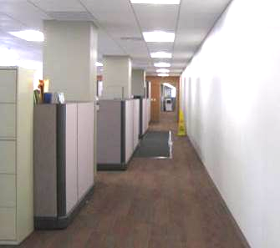

Southeast hallway with taped-down runner

Picture 4

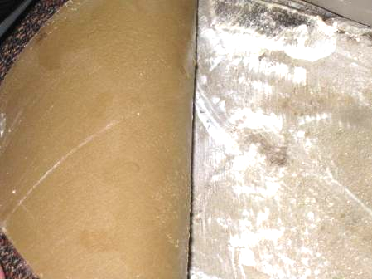

Lifting/loosened carpet tile with moisture underneath

Picture 5

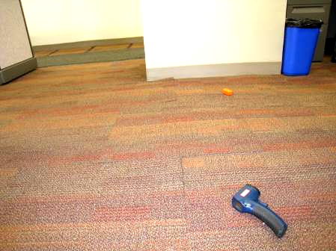

Area with lifting carpet tiles (arrow)

Picture 6

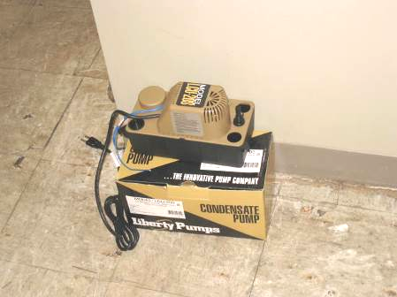

Condensate pump

Picture 7

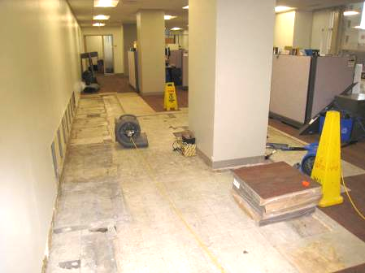

Area of flooring removal

Picture 8

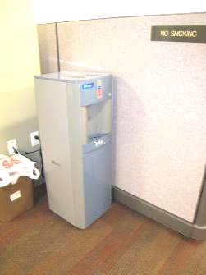

Water dispenser on carpeting
Picture 9

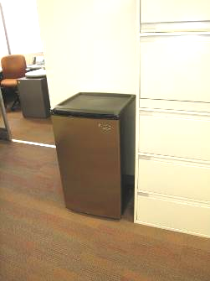

Mini refrigerator on carpeting
Location | Carbon  Dioxide  (ppm) | Carbon Monoxide  (ppm) | Temp  (°F) | Relative  Humidity  (%) | TVOCs  (ppm) | PM2.5  (μg/m³) | Occupants  in Room | Windows  Openable | Ventilation |  |  | Remarks
 |  |  |  |  |  |  |  |  | Intake | Exhaust |  | Remarks
Background |  |  | 80 | 50 |  |  |  |  |  |  |  | Light breeze. Temperature and humidity from wunderground.com
3051 (semi-office) | 802 | ND | 74 | 50 | ND | 4 | 0 | N | N |  | N | Bulk forms
3052 (semi-office) | 836 | ND | 74 | 50 | ND | 4 | 0 | N | N |  | Y | DEM
3053 (semi-office) | 842 | ND | 74 | 50 | ND | 4 | 1 | N | N |  | N
3057 (cubicles) | 892 | ND | 74 | 50 | ND | 3 | 4 | N | Y |  | N | WD CT
3060 | 820 | ND | 75 | 50 | ND | 6 | 2 | N | Y |  | N | Reports of black dust
3061 (semi-office) | 845 | ND | 74 | 50 | ND | 5 | 1 | N | N |  | N
3063 | 801 | ND | 74 | 49 | ND | 6 | 1 | N | Y |  | Y
3065 | 774 | ND | 74 | 49 | ND | 6 | 1 | N | Y |  | Y
3066 (semi-office) | 742 | ND | 74 | 48 | ND | 6 | 0 | N | Y |  | N | PC
3067 (cubicles) | 734 | ND | 72 | 52 | ND | 4 | 0 | N | Y |  | Y | Water cooler on carpet, cleaners
3068 (recording) | 723 | ND | 72 | 50 | ND | 4 | 0 | N | Y |  | Y
3069 (recording) | 728 | ND | 71 | 51 | ND | 4 | 0 | N | Y |  | Y
3070 (recording) | 759 | ND | 71 | 52 | ND | 4 | 1 | N | Y |  | Y
3071 (office) | 786 | ND | 71 | 53 | ND | 4 | 0 | N | Y |  | Y | Mini-fridge
3072 (semi-office) | 780 | ND | 71 | 54 | ND | 4 | 2 | N | N |  | Y
3073 (cubicles, row end) | 792 | ND | 70 | 54 | ND | 4 | 2 | Y | Y |  | Y | PF, printers, water dispenser on carpet
3077 (cubicles) | 881 | ND | 71 | 55 | ND | 4 | 3 | N | Y |  | N | Reports of black dust from supply, vent moved
3080 (cubicles, row end) | 802 | ND | 71 | 55 | ND | 5 | 1 | Y | Y |  | Y | AT
3085 (kitchen) | 739 | ND | 75 | 47 | ND | 5 | 1 | N | Y |  | Y | 2 fridge, sink, microwave, vending machines, not carpeted
3086 (semi-office) | 735 | ND | 76 | 46 | ND | 6 | 0 | N | N |  | N
3087 (office) | 785 | ND | 76 | 47 | ND | 5 | 2 | N | Y |  | Y
3088 (office) | 741 | ND | 76 | 47 | ND | 5 | 0 | N | Y |  | Y | Boxes on floor
3089 (office) | 739 | ND | 75 | 48 | ND | 6 | 0 | N | Y |  | Y
3090 (office) | 767 | ND | 75 | 48 | ND | 5 | 2 | N | Y |  | Y | Faux plants
3091 (semi-office) | 846 | ND | 75 | 49 | ND | 7 | 1 | N | N |  | N | Clutter
3092 (semi-office) | 743 | ND | 74 | 49 | ND | 4 | 1 | N | N |  | N
3093 (semi-office) | 750 | ND | 74 | 49 | ND | 4 | 0 | N | N |  | N | Clutter
3094 (Semi-office) | 748 | ND | 72 | 54 | ND | 4 | 1 | N | Y |  | N | Clutter
3095 (cubicles, end of row) | 692 | ND | 74 | 48 | ND | 5 | 3 | Y | N |  | Y
3097 (cubicles) | 776 | ND | 74 | 49 | ND | 6 | 3 | N | Y |  | Y | Shredder (off)
3099 (cubicles) | 780 | ND | 75 | 49 | ND | 5 | 0 | N | Y |  | Y
3101 (cubicles) | 768 | ND | 75 | 47 | ND | 5 | 1 | N | Y |  | N
3102 (cubicles) | 719 | ND | 75 | 47 | ND | 6 | 3 | N | Y |  | Y
3104 (cubicles) | 744 | ND | 76 | 46 | ND | 6 | 3 | N | Y |  | Y
3106 (office) | 715 | ND | 74 | 49 | ND | 4 | 1 | N | Y |  | Y | PC outside office
3107 (office) | 715 | ND | 74 | 50 | ND | 5 | 0 | N | Y |  | Y
3108 (office) | 714 | ND | 73 | 50 | ND | 5 | 1 | N | Y |  | Y
3109 (office) | 687 | ND | 73 | 49 | ND | 4 | 0 | N | Y |  | Y
3113 (cubicles) | 679 | ND | 74 | 49 | ND | 5 | 2 | N | Y |  | N
3123 (cubicles) | 695 | ND | 75 | 48 | ND | 5 | 2 | N | N |  | Y
3125 (cubicles) | 745 | ND | 75 | 48 | ND | 6 | 2 | N | Y |  | Y
3128 (cubicles) | 682 | ND | 75 | 49 | ND | 5 | 1 | N | Y |  | N
3133 (cubicles) | 709 | ND | 74 | 49 | ND | 5 | 1 | N | Y |  | N
3134 (semi-office) | 652 | ND | 74 | 47 | ND | 5 | 0 | N | N |  | N
3135 (semi-office) | 623 | ND | 74 | 47 | ND | 4 | 0 | N | N |  | N | Clutter
3136 | 356 | ND | 74 | 48 | ND | 3 | 2 | N | N |  | Y
3139 (cubicles) | 689 | ND | 74 | 48 | ND | 3 | 1 | N | Y |  | N | PC
3142 (cubicles) | 697 | ND | 74 | 48 | ND | 3 | 0 | N | Y |  | N
3145 (cubicles) | 722 | ND | 74 | 49 | ND | 2 | 3 | N | Y |  | Y
3148 (cubicles) | 673 | ND | 74 | 48 | ND | 2 | 0 | N | Y |  | N
3151 (office) | 667 | NDE | 73 | 48 | ND | 3 | 0 | Y | Y |  | N
3158 (semi-office) | 645 | ND | 75 | 48 | ND | 4 | 1 | Y | Y |  | N | Solar gain
3159 (semi-office) | 636 | ND | 75 | 48 | ND | 4 | 0 | Y | Y |  | Y (just outside wall) | Cleaners and sanitizers
3160 (office) | 650 | ND | 74 | 46 | ND | 2 | 0 | Y | Y |  | Y | Microwave, fridge, scented candle (unburned)
3161 conference room | 660 | ND | 75 | 46 | ND | 2 | 0 | Y | Y |  | Y | Microwave, toaster oven, Clorox wipes
3162 (office) | 686 | ND | 76 | 46 | ND | 2 | 1 | Y | Y |  | Y
3163 (office) | 721 | ND | 76 | 46 | ND | 2 | 1 | Y | Y |  | Y
3164 (office) | 669 | ND | 76 | 45 | ND | 2 | 0 | Y | Y |  | Y
3165 (office) | 692 | ND | 76 | 44 | ND | 2 | 0 | Y | Y |  | Y | Faux plants
3166 (office) | 706 | ND | 77 | 44 | ND | 2 | 2 | Y | Y |  | Y | Not occupied
3167 (semi-office) | 599 | ND | 74 | 47 | ND | 4 | 0 | N | N |  | Y
3168 (semi-office) | 586 | ND | 74 | 47 | ND | 5 | 0 | Y | Y |  | N | Microwave
3169 (cubicles) | 587 | ND | 74 | 47 | ND | 5 | 1 | Y | Y |  | Y
3174 | 573 | ND | 74 | 47 | ND | 5 | 1 | Y | Y |  | N | Clutter
3176 | 567 | ND | 74 | 47 | ND | 5 | 1 | Y | Y |  | Y
3180 | 569 | ND | 73 | 48 | ND | 5 | 0 | N | Y |  | Y
3181 (Semi-office) | 564 | ND | 74 | 47 | ND | 5 | 0 | Y | Y |  | N | PC outside office

