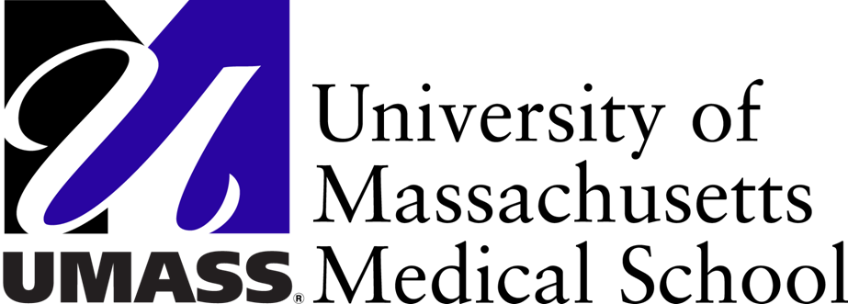
Drug Utilization Review (DUR) Program
Clinical Pharmacy Services
University of Massachusetts Medical School
333 South Street
Shrewsbury MA, 01545
1-800-745-7318 (phone) 1-877-208-7428 (fax)
`

DUR BOARD

Quarterly Meeting

June 10, 2015

AGENDA

- Welcome and Introductory Remarks

- Resident Research Manuscript:
Impact of the 2014 American Academy of Pediatrics Guidance for Synagis (palivizumab) Prophylaxis on Incidence of Respiratory Syncytial Virus and Respiratory-Related Hospitalizations and Emergency Room Visits in a Medicaid Population

- Synagis (palivizumab) Quality Assurance analysis

- Special Populations Update

- MHDL Update

- DUR Operational Update

- MassHealth Update Paul Jeffrey, MassHealth

Location: DUR Time: 6:00pm – 8:00pm
333 South Street
Shrewsbury, MA

Next DUR Board (open meeting): September 9, 2015

