MOLD INVESTIGATION

76 South River Street
Former South River Elementary School
Marshfield, Massachusetts 02050

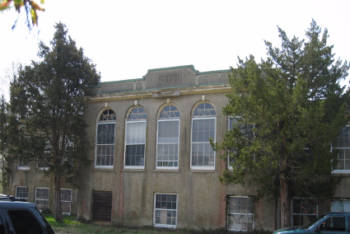

Prepared by:
Massachusetts Department of Public Health
Bureau of Environmental Health
Indoor Air Quality Program
May 2009

Background/Introduction
At the request of Michael Clancy, Building Commissioner for the Town of Marshfield, the Massachusetts Department of Public Health (MDPH), Bureau of Environmental Health (BEH) conducted a mold investigation at the former South River Elementary School located at 76 South River Street, Marshfield, Massachusetts.
On April 27, 2009, Cory Holmes Environmental Analyst/Inspector for BEH’s Indoor Air Quality (IAQ) Program visited the building. Mr. Holmes was accompanied during the assessment by Commissioner Clancy. The assessment was prompted by mold growth experienced due to chronic damage from water infiltration through the roof and building envelope.
This early 1980s building consists of brick covered with stucco/plaster. The building has reportedly been abandoned since 1979 and is used to store surplus school materials and town records, files and plans.

Methods
BEH staff conducted a visual inspection for standing water, water-damaged building materials, and microbial growth.

Discussion

Microbial/Moisture Concerns
Extensive water damage and microbial growth was observed on porous building materials (e.g., wall plaster, ceiling plaster, wooden flooring and carpeting) throughout the building (Pictures 1 to 11). At the time of the assessment, standing water was observed in a number of areas and indicated roof leaks (Pictures 10 to 12). Mr. Clancy reported that approximately 18-inches of standing water was previously observed on the roof due to clogged roof drains. The weight/pressure of such an amount of standing water on the roof can also impact the roof supports. Without proper drainage, water would enter the building via any holes or breaches in the building envelope. A large number of stored items were also observed to be water-damaged and or colonized with mold (Pictures 13 through 17).
MDPH staff examined the outside perimeter of the building to identify breaches in the building envelope and/or other conditions that could provide a source of water penetration. A number of exterior sources for moisture infiltration were identified:
- Clinging plants and trees were observed growing in close proximity and/or overhanging the roof (Pictures 18 to 21). Clinging plants can cause water damage to brickwork through insertion of tendrils into brick and mortar. Water can penetrate into the brick along the tendrils. Water trapped in brick can subsequently freeze and thaw during the winter. This freezing/thawing action can weaken bricks and mortar, resulting in wall damage.
- Missing/damaged exterior masonry was observed (Pictures 22 and 23) as well as rotted wooden windowsills, damaged window frames/exterior doors and broken/missing windowpanes (Pictures 24 through 27).
- Damage/breaches in wooden eaves were seen along the roof edge (Picture 28).
These conditions can undermine the integrity of the building envelope and provide a means of water entry by capillary action into the building through exterior walls, foundation concrete and masonry (Lstiburek & Brennan, 2001). In addition, these breaches in exterior areas can provide a means of drafts and pest entry into the building.
The US Environmental Protection Agency (US EPA) and the American Conference of Governmental Industrial Hygienists (ACGIH) recommends that porous materials be dried with fans and heating within 24 to 48 hours of becoming wet (US EPA, 2001; ACGIH, 1989). If porous materials are not dried within this time frame, mold growth may occur. Water-damaged porous materials cannot be adequately cleaned to remove mold growth. The application of a mildewcide to moldy porous materials is not recommended.

Conclusions/Recommendations
The conditions noted at 76 South River Street raise a number of indoor air quality concerns. Each issue including general building conditions, chronic water damage, building envelope integrity, extensive mold growth and structural soundness, if considered individually, present conditions that could degrade indoor air quality. When combined, these conditions can serve to further negatively affect indoor air quality. Remediation of these issues will require alteration to the building structure, equipment, and in some cases wholesale replacement of building components. In view of the findings at the time of the visit, the following recommendations are made:
- Consider hiring a professional mold remediation/flooding restoration firm for repairs/removal of the extensive mold colonization throughout the building.
- Remove and replace any mold contaminated/water-damaged building materials (wall/ceiling plaster, wooden flooring/framing, carpeting). This measure will remove actively growing mold colonies that may be present. Remove mold contaminated materials in a manner consistent with recommendations found in “Mold Remediation in Schools and Commercial Buildings” published by the US Environmental Protection Agency (US EPA, 2001). The document is available at the US EPA website: http://www.epa.gov/iaq/molds/mold_remediation.html.
- Repair/replace damaged windows, window frames, and exterior doors to prevent water penetration.
- Repair roof to prevent leaks.
- Remove clinging plants, trim overhanging branches, and remove trees from close proximity to exterior walls.
- Inspect roof drains periodically for proper drainage, make repairs and/or clean as needed.
- Consult with a licensed asbestos contractor to regarding removal/remediation of building materials. Due to the age of the building, certain building materials (e.g., window caulking, floor tiles, insulation) may contain asbestos. Contact the Massachusetts Department of Labor and Workforce Development, Division of Occupational Safety (DOS), Asbestos Program and/or a licensed asbestos abatement contractor to identify and remediate potential asbestos containing materials in conformance with all applicable Massachusetts asbestos abatement and hazardous materials disposal laws.
- Consult a structural engineer to evaluate the structural integrity of the building.
- Repair breaches in the building envelope including, cracks in walls and foundation, missing/damaged roofing materials. Consider consulting with an architect, masonry firm or general contractor regarding the integrity of the building envelope.
- Consider options concerning the storage and preservation of numerous materials stored in the building (e.g., plans, town records; Pictures 29 through 31). Porous materials that are judged not worthy of preservation, restoration or transfer to another media (e.g., microfiche or computer scanning) should be discarded. Where stored materials are to be preserved, restored or otherwise handled, an evaluation should be done by a professional book/records conservator. This process can be rather expensive, and may be considered for conservation of irreplaceable documents that are colonized with mold. Due to cost of preservation/conservation, disposal or replacement of moldy materials may be the most economically feasible option.
- Refer to resource manual and other related indoor air quality documents located on the MDPH’s website for further building-wide evaluations and advice on maintaining public buildings. These documents are available at: http://mass.gov/dph/indoor_air.

References
ACGIH. 1989. Guidelines for the Assessment of Bioaerosols in the Indoor Environment. American Conference of Governmental Industrial Hygienists, Cincinnati, OH.
Lstiburek, J. & Brennan, T. 2001. Read This Before You Design, Build or Renovate. Building Science Corporation, Westford, MA. U.S. Department of Housing and Urban Development, Region I, Boston, MA

US EPA. 2001. “Mold Remediation in Schools and Commercial Buildings”. Office of Air and Radiation, Indoor Environments Division, Washington, DC. EPA 402-K-01-001. March 2001. Available at: http://www.epa.gov/iaq/molds/mold_remediation.html
Picture 1

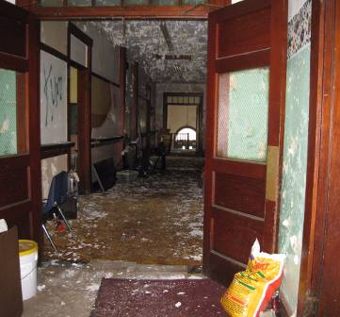

Extensive Water Damage to Building Materials

Picture 2

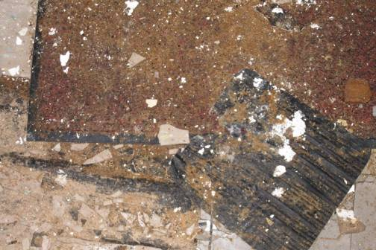

Water Damaged/Mold Colonized Carpeting and Damaged Floor Tiles

Picture 3

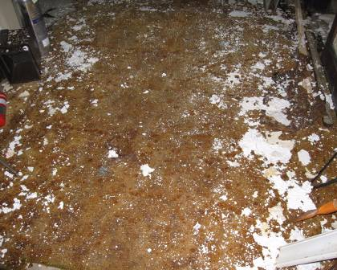

Water Damaged/Mold Colonized Carpeting

Picture 4

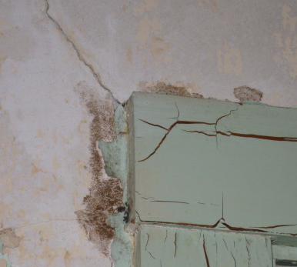

Water Damaged/Mold Colonized Wall Plaster

Picture 5

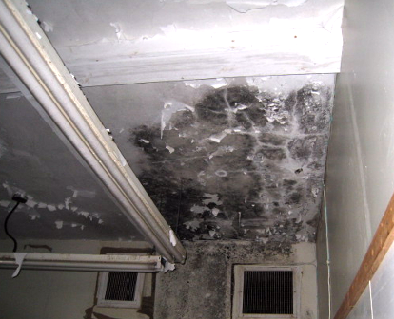

Extensive Water Damage/Mold Growth on Ceiling Plaster

Picture 6

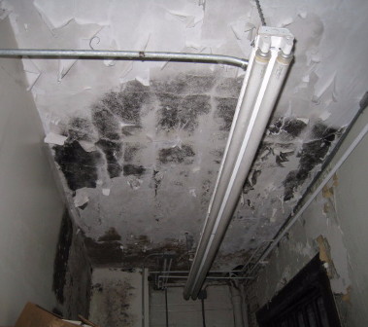

Extensive Water Damage/Mold Growth on Wall and Ceiling Plaster

Picture 7

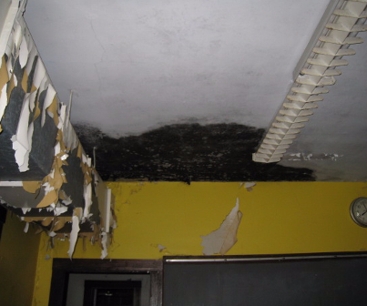

Extensive Water Damage/Mold Growth on Ceiling Plaster

Picture 8

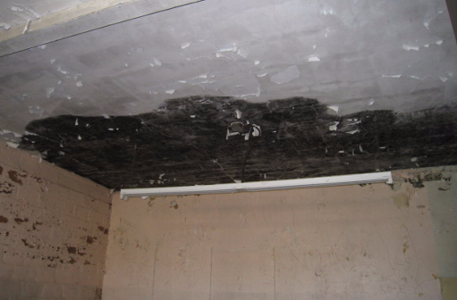

Extensive Water Damage/Mold Growth on Ceiling Plaster

Picture 9

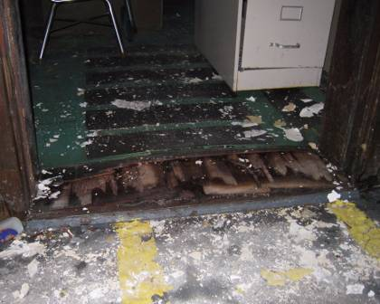

Water Damaged/Buckling/Mold Colonized Flooring Material

Picture 10

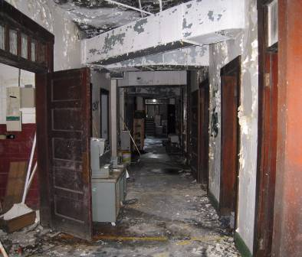

Standing Water and Extensive Water Damage to Building Materials

Picture 11

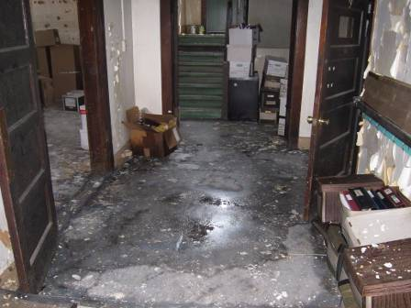

Standing Water and Extensive Water Damage to Building Materials

Picture 12

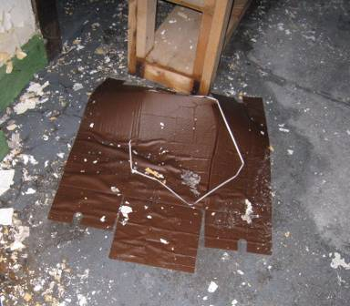

Saturated Cardboard

Picture 13

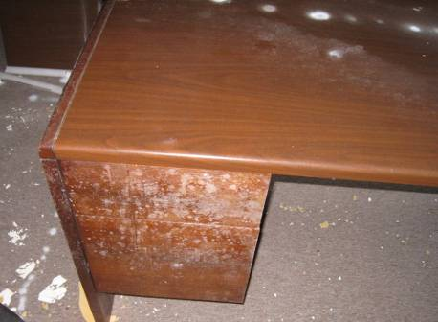

Visible Mold on Desk

Picture 14

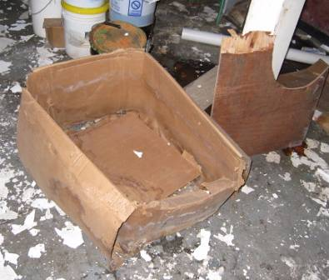

Water Damaged/Mold Colonized Cardboard Box

Picture 15

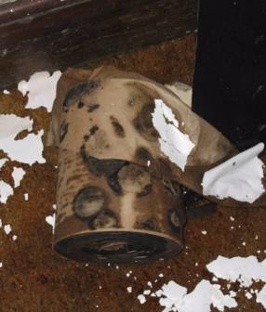

Water Damaged/Mold Colonized Paper

Picture 16

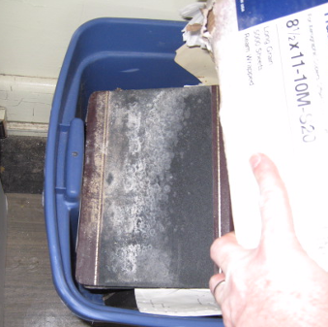

Water Damaged/Mold Colonized Books

Picture 17

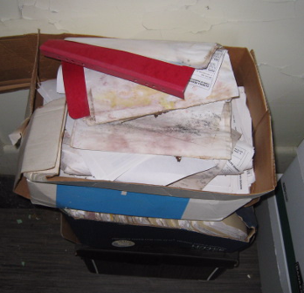

Water Damaged/Mold Colonized Building Plans

Picture 18

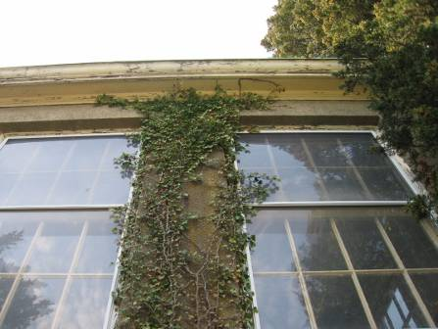

Clinging Plants and Overhanging Trees

Picture 19

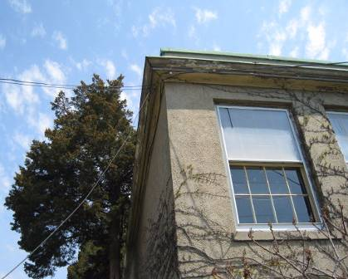

Clinging Plants and Overhanging Trees

Picture 20

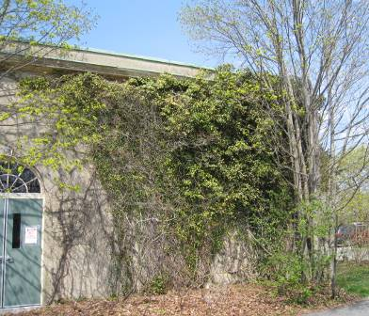

Clinging Plants and Overhanging Trees

Picture 21

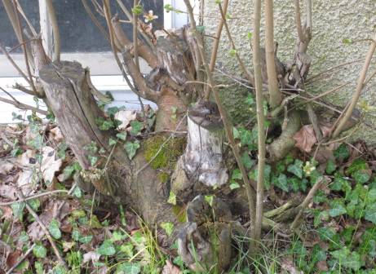

Tree Stump against Foundation

Picture 22

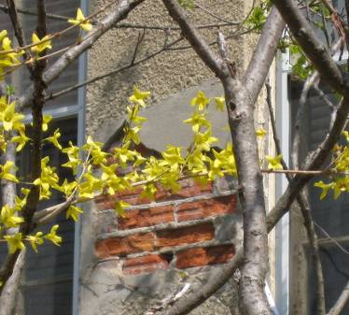

Missing/Damaged Exterior Masonry

Picture 23

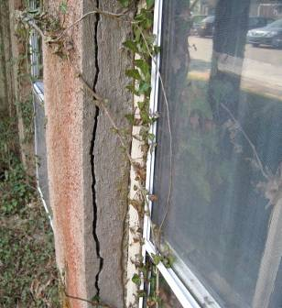

Damaged Exterior Masonry

Picture 24

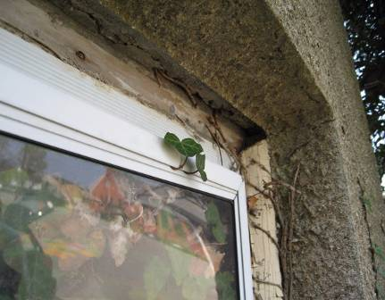

Breaches around Window Frame, Note Vegetation Growing Inside the Building

Picture 25

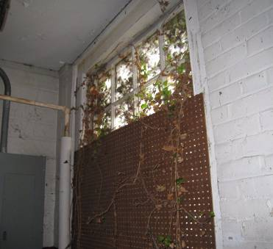

Vegetation Growing Inside Building through Broken/Breached Window System

Picture 26

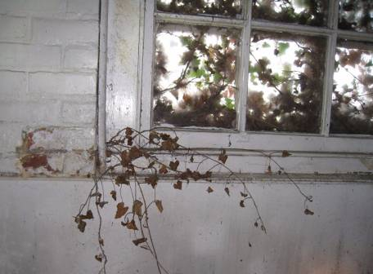

Vegetation Growing Inside Building through Broken/Breached Window System

Picture 27

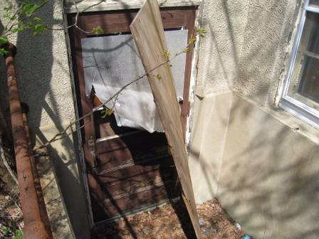

Damaged Exterior Door with Broken Windows

Picture 28

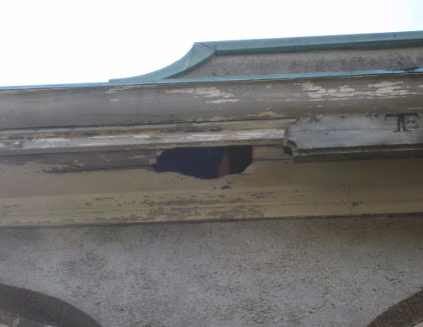

Breach/Damaged Wood along Roof Eave

Picture 29

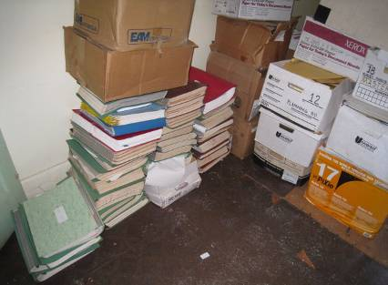

Town Records Stored at 76 South River Street, Note Some Materials Stored
Directly on Floor

Picture 30

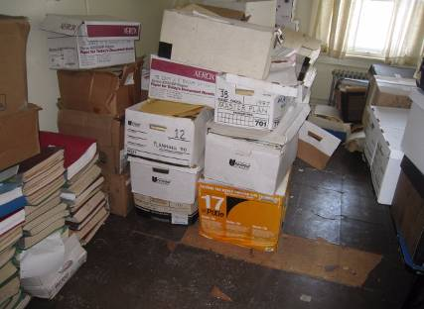

Town Records Stored at 76 South River Street, Note Some Materials Stored
Directly on Floor

Picture 31

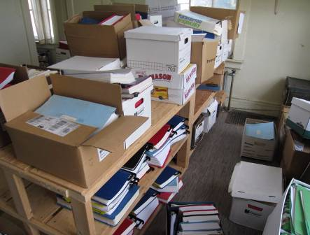

Town Records Stored at 76 South River Street, Note Some Materials Stored
Directly on Floor

