Commonwealth of Massachusetts
Executive Office of Health and Human Services

Office of Medicaid
www.mass.gov/masshealth

MassHealth
Transmittal Letter 766-15
December 2016

TO: Providers Participating in MassHealth

FROM: Daniel Tsai, Assistant Secretary for MassHealth 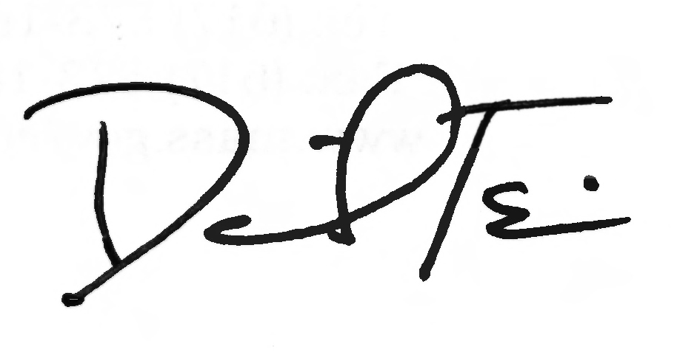

RE: Chapter 766 Manual (Rescission of Regulation)

130 CMR 439.000: Chapter 766 Services governed services provided to MassHealth members by Chapter 766 providers. After a review of this regulation, MassHealth has determined that this regulation is obsolete. MassHealth therefore has rescinded this regulation. This rescission is effective as of December 16, 2016.

MassHealth Website

This transmittal letter and attached pages are available on the MassHealth website at www.mass.gov/masshealth.

Questions

If you have any questions about the information in this transmittal letter, please contact
the MassHealth Customer Service Center at 1-800-841-2900, e-mail your inquiry to providersupport@mahealth.net, or fax your inquiry to 617-988-8974.

NEW MATERIAL
(The pages listed here contain new or revised language.)

Chapter 766 Manual

None

OBSOLETE MATERIAL
(The pages listed here are no longer in effect.)

Chapter 766 Manual

Pages iv and 6-1 through 6-3 — transmitted by Transmittal Letter 766-12

Page viii and 6-4 — transmitted by Transmittal Letter 766-14

