811 Project rental assistance and the money follows the person demonstration | Abstract  This report details Massachusetts’ Year Two outcomes of the collaboration between the Department of Housing and Community Development and the Money Follows the Person Demonstration in successfully re-housing individuals leaving long term care facilities.  Courtenay Loiselle  MFP Strategic Housing Partnership Coordinator  January, 2017

Contents
1 Executive Summary 4
2 Section 811 Program Overview 6
3 811 PRA 7
4 Services available to 811 PRA Tenants 8
5 Consumers Receiving 811 Housing Subsidies 9
5.1 Consumer Demographics 10
5.2 Consumer Quality of Life 11
6 Cost Savings Outcomes 13
7 MFP Support For Housing Goals and Current Housing Search Snapshot 15
7.1 Demographics of Individuals Searching for Housing 15
7.2 Housing Search 17
7.3 Housing Training 18
8 Next Steps for 811 PRA 18
9 Appendix 18
9.1 811 PRA Implementation Team 18
9.2 Selected Quality of Life Survey Results 20

MFP Success Story: Mr. G and 811 Project Rental Assistance
Mr. G was the first person to sign a lease at Massachusetts’ first 811 Project Rental Assistance (PRA) property at Georgetowne Homes in Hyde Park, owned by Beacon Properties. 811 PRA program is a HUD-funded project-based operating subsidy for units targeted to serve one of Massachusetts’ most vulnerable populations, non-elderly persons with disabilities. The individuals being served through this program have been referred and supported by Executive Office of Health and Human Service (EOHHS) agencies. Beacon Properties signed on as the state’s first partner in the 811 PRA process, offering 6 units at their property to people in the target populations who are transitioning from long term care facilities.
Mr. G had bounced from place to place for nearly 5 years before getting his apartment at Georgetowne Homes, moving from a homeless shelter and living at a campsite, living at a rest home, and three separate nursing facilities in that time. Mr. G enrolled in the Massachusetts MFP Demonstration and began working with Sue Amann, his Transition Coordinator at Center for Living and Working in Worcester, to search for housing starting in 2012. Sue describes Mr. G as “having a heart for the down-trodden. He has helped at the facilities he has been at.” She also describes that Mr. G has grown his faith over time, contributing to his now peaceful nature. When Georgetowne became an option, Mr. G and Sue worked quickly to submit his application. Mr. G was found eligible for the Money Follows the Person Community Living waiver, which provides him a number of supports in the community. When Mr. G was selected for a unit at Georgetowne, Sue and his case manager, David Maine from Massachusetts Rehabilitation Commission, mobilized to assist Mr. G in getting to the property. They began the processes to get Mr. G approved for the apartment, as well as helping him to arrange the community services, once he was offered the apartment.
Mr. G was approved and moved into his apartment in August of 2016. Mr. G says he feels more at ease and comfortable in his home than in a facility, and likes the location of the community and the people that make up the community. His MFP-CL waiver assists in providing various services, including nursing and adult companion services, which help him complete his activities of daily living, as tasks around his home and community. When asked about the MFP-CL waiver, Mr. G said, “I would very highly recommend their services to anyone in a situation like mine or worse.”

Executive Summary
The Massachusetts 811 Project-based Rental Assistance (PRA) Program is a partnership between the Department of Housing and Community Development and the Executive Office of Health and Human Services to provide housing options for extremely low income adults with disabilities under the age of 62 who are transitioning from long term care facilities into the community or who are at risk of re-entering these facilities. The target populations, during the period being reported, are:
(1) Persons in institutions enrolling in the state’s Money Follows the Person Demonstration (MFP), administered by the Executive Office of Health and Human Services (EOHHS), the single state agency for the operation of the state’s Medicaid program, MassHealth;
(2) Persons in institutions who are not eligible for MFP but are eligible for one of MassHealth’s Home and Community-Based Services (HCBS) waivers;
(3) Persons residing in a long term care facility who are not eligible for either MFP or a HCBS waiver, but who are eligible for Medicaid State Plan services; and
(4) Persons living in the community who are eligible for and receiving services through a HCBS waiver.
Massachusetts received two 811 grants for the program, one in Federal fiscal year 2012 and another in Federal fiscal year 2013. As part of the state’s grant submissions, DHCD included additional state-identified units for the priority populations. The total identified resources currently available under these grants are listed below.
197 811 Project-based Rental Assistance Units, to be placed at existing and new properties
12 Project-based Section 8 Vouchers
25 Massachusetts Rental Voucher Program vouchers
13 Housing Choice Voucher Program vouchers
This report discusses the first 2 units leased under the 811 Project Rental Assistance funding at Georgetowne Homes in Hyde Park, as well as findings for the ongoing residency and turnover issuance of 25 Massachusetts Rental Voucher Program (MRVP) vouchers and 13 Housing Choice Voucher Program (HCV) vouchers which were issued to eligible populations in September, 2014. As of September 30, 2016, 21 of the MRVP vouchers are leased and 11 of the HCVP vouchers are leased. All MRVP and HCVPs have been issued to MFP Demonstration participants; 4 individuals passed away during the year and vouchers were re-issued to eligible individuals. Individuals who received vouchers, but who have not yet leased units, are in the process of searching for housing at this time. Individuals utilizing mobile vouchers, had, as of September 30, 2016 been leasing their units for an average of 488 days.
Information on consumers receiving these vouchers was collected including information on their quality of life in the facility and differences in cost of care from facility to community. Data within the report reflects Quality of Life surveys conducted as consumers were leaving the facility and at the 11 month mark. Data within this report reflects information from all MFP Quality of Life survey respondents, not only those who have leased housing, as representative of the individuals receiving housing through the 811 program.
Quality of Life survey results indicate more individuals like their community residences, with nearly 85% of individuals responding to the survey indicating that they like where they live in the community, versus 49% in the facility. Individuals responded that they could see family and friends slightly more in the community versus in the facility, and that they were more likely to be able to go where they needed to go. Although respondents still indicate there are things they can’t do outside that they want to do, 15% more respondents indicated that there is nothing that they want to do outside that they can’t do now. Nearly 20% more respondents are happy with the way they live their life after their transition from a long term care facility.
Annual cost of facility care was calculated utilizing MassHealth claims data for 33 individuals who have received mobile vouchers and moved to the community. Most consumers had been residing in the facility for 12 months or more, so actual costs were used. For those that were not in the facility for 12 months, the full 12 months cost was projected based on monthly claims. MassHealth claims for long-term services and supports in the community were also utilized to compare costs. For consumers who have not been in the community for 12 months, costs were projected utilizing average monthly claims information. Averaged across all consumers receiving vouchers, MassHealth savings amounted to $15,434.12 per consumer per year. Housing data was calculated using the amount of housing subsidy paid for months in the community utilizing data collected from the Department of Housing and Community Development. Housing subsidy was projected for 12 months for those consumers who have not been in the community for a full 12 months. The average cost of housing subsidy for each consumer is $9,577.
The average full cost of serving the member in the community was found by combining the cost of MassHealth services in the community with the cost of the housing subsidy. Cost comparisons found that the projected cost savings of receiving care in the community over facility care, including the housing subsidy, is approximately $5,857.12 per member per year on average. Please note that the information provided is for a sample of individuals for a specific time period and should not be used to make any other estimates of calculations on the cost of care for any other individuals receiving MassHealth services.

- Average Cost of Facility Care for 12 Months Prior to Move to Community | $72,656.24
- Average MassHealth Cost for 12 Months Following the Move to the Community | $57,222.12
- Average annual savings of facility vs. community MassHealth costs | $15,434.12
- Average cost of Housing Subsidy Provided | $9,577.00
- Total Community Cost (MassHealth plus Housing Subsidy) [b+d] | $66,799.12
- Projected Annual Savings per Member [a – e] | $5,857.12

The cost of services received as part of the Money Follows the Person Demonstration are not included in the annualized costs, since the cost is primarily for one-time transition-related expenses; such as housing search, furniture, household goods, security deposit, assistive technology, or other one-time expenses. The average MFP Transition costs for the individuals who received a housing subsidy during this year was $11,400.
This report focuses only on the mobile component of the 811 PRA program along with the first two project-based units leased at Georgetowne Homes in Boston. Primarily due to the early nature of the project-based lease-up, limited data exists on the project-based 811 vouchers. Units for 811 PRA placements continue to be identified and granted 811 PRA funding.

Section 811 Program Overview
Through the Section 811 Supportive Housing for Persons with Disabilities program, the U.S. Department of Housing and Urban Development (HUD) provided funding to subsidize rental housing with the availability of supportive services for extremely low-income adults with disabilities.
The Section 811 Project Rental Assistance program allows adults with disabilities to live as independently as possible in the community by subsidizing rental housing opportunities where the individuals can access appropriate supportive services.
In Massachusetts, the 811 Project Rental Assistance (PRA) program is a partnership between the state’s Executive Office of Health and Human Services (EOHHS) and Department of Housing and Community Development (DHCD) to provide housing options for adults with disabilities under the age of 62 who are transitioning from long term care facilities to the community or are at risk of re-entering these facilities.
DHCD and EOHHS collaborated to identify the target populations for this program, among individuals who are otherwise eligible for the units, as described below, in priority order:
- persons in institutions enrolling in the state’s Money Follows the Person Demonstration (MFP) operated by MassHealth;
- persons in institutions who are not eligible for MFP but are eligible for one of the state’s Home and Community-Based Services (HCBS) waivers administered by MassHealth;
- persons residing in a long term care facility who are not eligible for either MFP or a HCBS waiver, but who are eligible for Medicaid State Plan services; and
- persons living in the community who are eligible for and receiving services through a HCBS waiver.
The program is deliberately designed to be cross-disability, serving a range of people with different disabilities and service needs. The stated goal of this program is to provide housing for individuals with disabilities who are transitioning from long-stay facilities, have extremely low-income, are under 62 and who need and are eligible for community based Long-Term Services and Supports through the Medicaid program.

811 PRA
The 811 Project Rental Assistance program was authorized by the Frank Melville Supportive Housing Investment Act of 2010, and was first implemented through a demonstration program in Federal Fiscal Year (FFY) 2012.
Under this program, state housing agencies that have entered into partnerships with state health and human services and Medicaid agencies can apply for Section 811 Project Rental Assistance for new or existing affordable housing developments funded by Low Income Housing Tax Credits (LIHTC), Home Investment Partnership Program (HOME), or other sources of funds. Under the state health care/housing agency partnership, the health care agency must develop a policy for referrals, tenant selection, and service delivery to ensure that this housing is targeted to a population most in need of very affordable supportive housing. The state’s application for these funds focused efforts on supporting individuals transitioning from long-stay facilities, such as under the MFP Demonstration grant, at the direction of HUD and CMS in their joint effort to support MFP goals. This Section 811 assistance comes in the form of project rental assistance alone; no funds are available for construction or rehabilitation.
Massachusetts has received 811 PRA funding in two separate grants, one grant in federal fiscal year 2012 and the other in federal fiscal year 2013. These 811 PRA grants combined will fund 197 project-based units statewide. The properties selected for 811 operating subsidies must have existing financing or financing commitments from Low Income Housing Tax Credits, HOME funds, or other federal, state, or local programs. Under the terms agreed to by the state, 811 PRA units must be placed in properties with no more than 15% of units set aside as 811 PRA, where 811 PRA units are not distinguishable from other units within the property. The units will be placed in communities with accessible transportation and near community services. Primarily one bedroom units will be selected, with some two bedrooms.
Massachusetts issued a Request for Responses for eligible property owners with existing units who are interested in 811 PRA units. The first selected property is Georgetowne Homes in the Hyde Park neighborhood of Boston, where 6 units of 811 PRA will be placed. Within this reporting period, 2 of the 6 units have been leased by eligible participants; 4 more units are dependent on turnover to be leased within the 2017. Although only 2 units had been leased as of the period being reported, a total of 17 units have been identified by developers for this 811 PRA during this period, and will be leased to individuals from the target population as they become available. Continuous outreach efforts are being pursued to identify/place the remaining 811 PRA units. The Department of Housing and Community Development and the Executive Office of Health and Human Services will work in partnership to identify the needs of eligible consumers and place the remaining 811 subsidies in properties which meet those needs.
Current and Future Identified 811 Resources
811 Property Name | City/Town | Number of Units
Georgetowne Homes | Boston | 6
Duck Mill | Lawrence | 2
Tenney Place | Haverhill | 3
Hayes | Haverhill | 3
Parcel 25 | Boston | 3
Total as of Dec 2016 |  | 17

The 811 PRA grant for Federal fiscal year 2012 also included vouchers which would be leveraged with the 811 PRA resources. DHCD provided 25 Massachusetts Rental Vouchers (MRVP), 13 Housing Choice Voucher Program vouchers (HCVP), and 12 Project-based Section 8 vouchers. The mobile vouchers (25 MRVP and 13 HCVP) began accepting referrals in August, 2014 and the first vouchers were issued in September of that year. Since the last writing of this report, four consumers who received vouchers passed away. Available vouchers were re-issued to next eligible individuals on the waiting lists for these mobile vouchers.

Services available to 811 PRA Tenants
All 811 PRA tenants have an individualized Person-Centered Transition Plan, and, as eligible, have access to a rich array of supportive services through the MassHealth program, including MassHealth State Plan services, Money Follows the Person Demonstration services (MFP), services through a Home and Community-Based Services Waiver (“waiver”), and/or other EOHHS state agency services. Access to services in Massachusetts is, by design, highly self-directed and individualized, with the consumers themselves directing development of their service plans, and, in some cases, to the degree they want and are able to, self-directing certain services.
“Money Follows the Person” was a federal demonstration rebalancing grant that assists elders and people with disabilities who want to move from facility-based care to the community. MFP was funded through a grant from the Centers for Medicare and Medicaid services (CMS). The demonstration helps Massachusetts expand its longstanding commitment to community living, and further develop community-based long-term services and supports for elders and people with disabilities.
The Massachusetts Money Follows the Person grant provided an array of “demonstration” services including Case Management, Assistive Technology, Orientation and Mobility, and Transitional-Assistance services designed to help individuals transition from nursing facilities and other long-stay facility settings to the community. Transitions from long term care facilities to the community supported by the Massachusetts MFP Demonstration concluded on December 31, 2016; however, services are delivered to individuals for 365 days after they transition. The majority of the services offered through the Demonstration will be added to the two HCBS waivers that were created in support of the Massachusetts MFP Demonstration, the MFP-Community Living Waiver (MFP-CL) and the MFP-Residential Supports Waiver (MFP-RS).
These, and other Home and Community-Based Services Waivers, provide a range of services to support successful transition to the community. Before moving to the community, a Transition Coordinator works closely with the individual and/or guardian to plan and arrange supports and services that will be needed to live safely in the community. The MFP Participant and Transition Coordinator also work collaboratively with a Case Manager, who will oversee the person’s individualized Person-Centered Plan of Care for ongoing services and supports after transition.
Home and Community Based Services Waivers can also provide purchases of goods and services. These items can include basic household furnishings, kitchenware, bed linens, towels, security deposit, utility deposits, moving expenses, home modifications, peer support, and other services. Waiver Participants may also receive Assistive Technology services which include devices, controls, or appliances that enable an individual to increase his or her ability to perform activities of daily living more independently.
Once an individual has transitioned out of a facility, he/she may be eligible for ongoing support services through a Home and Community Based Services Waiver (“waiver”) and/or MassHealth State Plan services. The availability of MassHealth waiver programs provides home and community based services to eligible individuals in their own homes or community settings, who would otherwise require care in a nursing facility or long-stay hospital. Individuals in a waiver can receive both traditional MassHealth services and the additional services available under a waiver to the extent these are not duplicative.

Consumers Receiving 811 Housing Subsidies
The application process for the 25 MRVP and 13 HCVP vouchers made available through the 2012 grant, which were offered by the Department of Housing and Community Development in support of the Commonwealth’s efforts to house individuals leaving long term care facilities, was opened in August, 2014, with the first vouchers issued to eligible consumers in September 2014. All vouchers were issued to individuals eligible for the MFP Demonstration, with the HCVP vouchers prioritized to individuals who had been in the facility the longest. As of September 30, 2016, twenty-one (21) of the MRVP vouchers have been leased. The average number of days an individual took to lease with this voucher was 112 days. During the year, four individuals who had previously leased with the MRVP vouchers passed away. These vouchers were re-issued to MFP-Demonstration eligible individuals, who at the time of this writing had not yet leased. Eleven (11) of the 13 HCVP vouchers have been leased by September 30, 2016. The average number of days an individual took to transition with this voucher was 171 days. Individuals receiving the HCVP vouchers had been in the facilities for a significant amount of time (an average of more than 4 ½ years); many faced some substantial barriers to housing primarily due to the need to locate accessible housing in the private market and lacked a housing history. Individuals receiving MRVP and HCVP vouchers have been leased an average of 488 days in the community. Finally, because they had the opportunity to find housing in any community in Massachusetts, the arrangements for community-based services and supports required additional time.
As of September 30, 2016, two consumers have leased at Georgetowne Homes in 811 PRA –funded units. The remaining four units under contract at Georgetowne Homes will become available upon turnover of other existing tenancies at the property. These units are expected to be leased in 2017.

Consumer Demographics
The following information on consumer demographics noted here is based on self-reporting on the 811 Referral Form by the 41 consumers who have received vouchers or 811 PRA subsidies (including those who passed away and those who are currently searching for housing with their voucher). In summary, most recipients of the 811 PRA vouchers were white, non-Hispanic males with physical disabilities and an average age of 53 years. However, vouchers were awarded to a higher percentage of minority individuals (29%) than is seen in the general population of Massachusetts. Although there are a slightly higher percentage of men under the age of 60 than women under the age of 60, who are MassHealth members in long term care facilities (6% versus 5% respectively), it is unclear why more men received vouchers than women, although it may be that more men are or had been homeless prior to their tenure in the facility. Information on the types of housing settings individuals prefer and information on family housing opportunities is unavailable for this population.
Ages of Consumers
 |  |  | Count |  |  | Percentage
30-39 |  |  | 1 |  |  | 2.4%
40-49 |  |  | 14 |  |  | 34.1%
50-59 |  |  | 17 |  |  | 41.5%
60-63 |  |  | 9 |  |  | 22.0%
 | Gender
 |  | Count |  |  | Percentage
 | Female | 12 |  |  | 29.3%
 | Male | 29 |  |  | 70.7%
 | Disability Type (consumers could indicate more than one disability type)
 |  |  |  | Count |  |  | Percentage
 | Physical |  |  | 35 |  |  | 85.4%
 | Psychiatric |  |  | 6 |  |  | 14.6%
 | No response |  |  | 2 |  |  | 4.9%

Race
 | Count | Percentage
Black or African American | 11 | 26.8%
No response | 3 | 7.3%
White | 26 | 63.4%
Multiple Races | 1 | 2.4%

Consumer Quality of Life
As part of the Money Follows the Person Demonstration, eligible consumers are interviewed, utilizing a standardized tool, the MFP Quality of Life survey. This survey asks about aspects of their quality of life prior to leaving the facility, and again at 11 months and 24 months post discharge. Twenty nine recipients reached the 11 month mark at the issuance of this report; however, only 5 consumers had completed the 11 month Quality of Life survey. To provide a more demonstrative sample, this report utilized data from the Quality of Life surveys for the MFP Demonstration participants that responded to the survey prior to leaving the facility and at the 11 month mark. Data was selected about living situation, community access and inclusion, access to personal care, and health status; additional data is available. The charts below represent only several of the questions within, and therefore show responses for a selection of the total information collected in the MFP Quality of Life survey, for the broader group of MFP Demonstration participants who responded to the surveys.
Quality of Life survey results indicate more individuals like their community residences, with nearly 85% of individuals responding to the survey indicating that they like where they live in the community, versus 49% in the facility. Individuals responded that they could see family and friends slightly more in the community versus in the facility, and that they were more likely to be able to go where they needed to go sometimes. Although respondents still indicate there are things they can’t do outside that they want to do, 15% more respondents indicated that there is nothing that they want to do outside that they can’t do now. Nearly 20% more respondents are happy with the way they live their life after their transition from a long term care facility than they were before leaving the facility.
Detailed survey response information is attached in Appendix 9.2 at the end of this document.

811 Success Story Year 2: Troy
The interview below revisits a success story from our 811 Year 1 report about Troy, who leased an apartment with an 811 mobile voucher in Pittsfield, Massachusetts. Troy and his cat Lucky continue to live successfully in his unit, which was modified utilizing MFP Demonstration funds to meet his accessibility needs.
How has your life changed since moving to the community?
Troy: “I was basically homeless; I was staying at friends’ houses; couch to couch. I was in and out of the nursing homes and different hospitals a few times. After spending time in the Nursing Home, I was approved for the financial and services parts of the waiver. I have freedom, I am happier. I have hope and the services that I need to be able to live on my own in the community.”
What’s a typical day like for you?
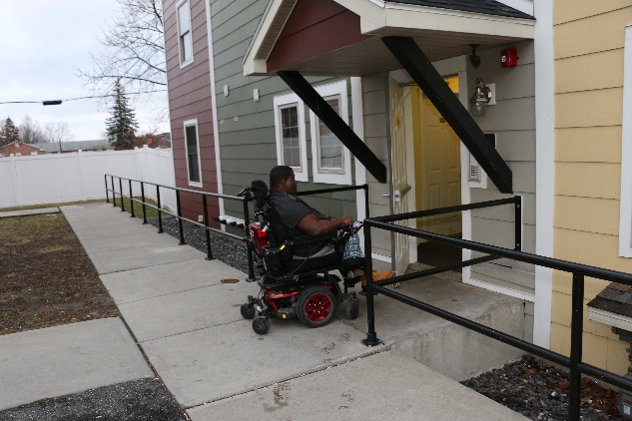
Troy: “My overnight PCA assists with making sure that I am ready for the day. They make me breakfast, or typically I make it myself. After a nurse comes in twice a week to make sure my meds are taken care of, my blood pressure taken, and review of my medical diagnosis. After, I leave my apartment and take the bus to the store to get the things I need. When I get back from the store I clean and cook my own food. My friends that I have made in this area also come over to visit often.”
What is the best part of living in this apartment?
Troy: “I love Pittsfield, the people are quieter, it’s nicer, and you don’t have to look over your shoulder or back all the time. I also love living here because everything is local; the doctors, the movies, the farmers market, the barbershop, the bus station. Everything is easy to get to in my power wheel chair; there are not a lot of hills. Everything is so close to my apartment.”
What services do you use in the community?
Troy: “I use the Personal Care Attendant services and HCBS waivers services and have someone who periodically checks in to make sure that I am doing alright.
I also use the Berkshire Regional Transit Authority transportation, 24 hours in advance and I can go to Church, Walmart, and other stores to get what I need. Or I can go to the bus station, which is right down the street; from there I can jump on a bus go anywhere.

The community center is just up the street. I head over there to eat lunch, play cards games, and talk to people.”
What advice would you give to other people who are in facilities looking to move to the community?
Troy: “Through the entire process, you have to advocate for yourself. Don’t rely on others; you have to fight for yourself. Pick up the phone and make the calls to make sure your services are taken care. It’s a scary process. But life is a lot better living in the community. Get out of there; life is so much better, the food is so much better!”

Cost Savings Outcomes
This report will compare cost differences for individuals receiving assistance under the 811 PRA resources. We hope to examine cost differences for additional individuals who receive 811 PRA resources in future reports.
Annual cost of facility care was calculated utilizing MassHealth claims data for 33 individuals who have received mobile vouchers and moved to the community. Most consumers had been residing in a facility for 12 months or more, so actual costs were used. For those that were not in the facility for 12 months, the full 12 months cost was projected based on monthly claims. MassHealth claims for long-term services and supports in the community were also utilized to compare costs. For consumers who have not been in the community for 12 months, costs were projected for the year utilizing average monthly claims information. Averaged across all consumers receiving vouchers, MassHealth savings amounted to $15,434.12 per consumer per year. Housing data was calculated using the amount of housing subsidy paid for months in the community utilizing data collected from the Department of Housing and Community Development. Housing subsidy was projected for 12 months for those consumers who have not been in the community for a full 12 months. The average cost of housing subsidy for each consumer is $9,577.
Full cost of supporting a member in the community was found by combining the cost of MassHealth services in the community with the cost of the housing subsidy. Cost comparisons found that the projected cost savings of members receiving care in the community, including the housing subsidy, over facility-based care is approximately $5,857.12 per member per year on average. Please note that the information provided is for a relatively small sample of individuals for a specific time period and should not be used to make any other estimates of calculations on the cost of care for any other individuals receiving MassHealth services.

- Average Cost of Facility Care for 12 Months Prior to Move to Community | $72,656.24
- Average MassHealth Cost for 12 Months Following the Move to the Community | $57,222.12
- Average annual savings of facility vs. community MassHealth costs | $15,434.12
- Average cost of Housing Subsidy Provided | $9,577.00
- Total Community Cost (MassHealth plus Housing Subsidy) [b+d] | $66,799.12
- Projected Annual Savings per Member [a – e] | $5,857.12

The cost of services received as part of the Money Follows the Person Demonstration which supported the member’s actual transition are not included in the annualized costs, since this cost is primarily for one-time transition-related expenses; such as housing search, furniture, household goods, security deposit, assistive technology, or other one-time expenses. The average MFP Transition costs for the individuals who received a housing subsidy during this year was $11,400.

We expect to monitor and report on cost patterns for future periods, as individuals become accustomed to being in the community over time.

MFP Support For Housing Goals and Current Housing Search Snapshot
The Money Follows the Person Demonstration considers and plans for housing needs of individuals eligible for the program who are leaving qualified facilities, including nursing facilities, and chronic, rehabilitation and psychiatric hospitals. MFP Transition Entity staff work with each individual who requires housing in the community to present options, and those that require housing search are asked what their needs and preferences are for housing. Individuals may work with qualified Housing Search Entities, which are agencies that have been identified as skilled at housing search; however, in some cases individuals work with a Transition Coordinator to find housing. Information on communities of choice, accessibility needs, amenities, number of bedrooms required, and barriers to housing such as credit issues, lack of housing history, or other potential barriers are identified. From the Demonstration’s beginning in 2011, 46% of all MFP transitions have been to an apartment leased to the participant.

Demographics of Individuals Searching for Housing
Age: Although to be eligible for the 811 Project Rental assistance program, applicants must be under the age of 62, to be eligible for the Massachusetts MFP Demonstration an individual must be age 18 or over and meet the remaining eligibility criteria; there is no upper age limit for eligible MFP Demonstration participants. The majority of the MFP-eligible consumers who are searching for housing are between the ages of 50 and 69 years old

Regions: Individuals are searching in all parts of Massachusetts, with the largest percentage (35%) searching in the greater Boston area. MFP Demonstration data also shows that 37% of individuals prefer/seek housing in the eastern part of Massachusetts outside of Boston, with 19% of individuals looking in the Northeast region and 18% in the Southeast/Cape Cod region of the state.

Accessibility: At this time, about 54% of people searching for housing require mobility accessibility accommodations. Another 5% of individuals currently searching for housing require accommodations for visual impairments, and 6% require auditory accommodations.
Homelessness: All individuals searching for housing that are enrolled in the Massachusetts MFP Demonstration are currently in a qualified facility with no other housing available to them. Of these individuals, 16.6% were homeless prior to entering the facility. Individuals may have been living in their cars, outdoors, in a homeless shelter, or in condemned housing immediately prior to entering the facility.

Housing Search
The Massachusetts MFP Demonstration included efforts to collect information on continuing housing searches. As well, housing search activities and outcomes are regularly measured. As of September 2016, 659 housing searches have been recorded. Through this process, 284 individuals have found housing, and 168 individuals are currently searching for housing. The decrease in total housing searches for MFP Demonstration-eligible individuals reflects the focus of Transition Entities to transitioning existing enrollees before the end of the Massachusetts MFP Demonstration which occurred on December 31, 2016. Individuals may have withdrawn from housing search without finding a qualified housing unit for a number of reasons, including because the individual’s care may have warranted a group home setting, and/or they may have decided to remain in the facility, or they had passed away.

Housing Training
The Massachusetts MFP Demonstration has supported and the Strategic Housing Partnership Coordinator has created, delivered, and facilitated extensive housing training and support for MFP Transition Coordinators and Housing Search Entities on a regular basis. In addition, all staff that generates referrals to the 811 PRA program are required to complete training on referral processes to ensure complete and accurate applications are submitted in a timely manner for all available housing subsidies. To date, 250 staff have received this training statewide. In addition, the following trainings have been offered:
- Preparing Consumers for Housing Search Success
- Housing Basics
- Overcoming Housing Barriers and Mitigation for Common Issues for MFP Consumers
- Collection of Documents [required for housing applications] for MFP Consumers
- Reasonable Accommodation and Modification
- Credit Repair
- Housing Search Step-by-Step
- Applying for Public Housing Opportunities

Next Steps for 811 PRA
The Department of Housing and Community Development, in implementing the 811 PRA program, has identified a number of units, and continues with ongoing work to identify the total number of units available under this program. In addition, efforts to occupy currently identified units are underway. A total of six (6) units have been contracted with two occupied at Georgetowne Homes as of the date of this report. Two units in a second property, Duck Mill, in Lawrence, were occupied in spring of 2017, along with additional properties as outlined in earlier sections which expect to be leased in mid- to late-2017 or early in 2018. Identification of additional properties where 811 PRA can be placed is the goal for the next year as the program is brought to scale. Future reports will review the 811 PRA units becoming available, with cost analysis and information on tenant quality of life for the leveraged mobile vouchers and new 811 project-based subsidies.

Appendix

811 PRA Implementation Team
Sara Barcan, Housing Development Program Manager, CEDAC
David Eng, Massachusetts Housing Finance Agency (MassHousing)
John Garcia, Money Follows the Person Project Director, MassHealth
Ayana Gonzalez, Manager, Supportive Housing and Special Projects, Department of Housing and Community Development
Roger Herzog, Executive Director, CEDAC
Courtenay Loiselle, Money Follows the Person Strategic Housing Partnership Coordinator
Joanne McKenna, Special Programs Coordinator, Department of Housing and Community Development
Alana Murphy, Deputy Associate Director, Housing Development, Department of Housing and Community Development
Helen Plant, Acting Director, Bureau of Rental Assistance, Department of Housing and Community Development
Catherine Racer, Director, Housing Development, Department of Housing and Community Development
Charlene Regan, Technical Assistance Collaborative
Simon Sandvik, Housing Choice Voucher Program Analyst and System Specialist, Department of Housing and Community Development
Liz Stewart, Technical Assistance Collaborative

Selected Quality of Life Survey Results
(Note: baseline survey conducted in facility or immediately post-discharge; 11th month conducted 11 months post-discharge)
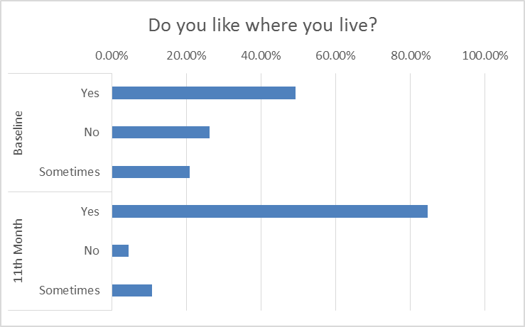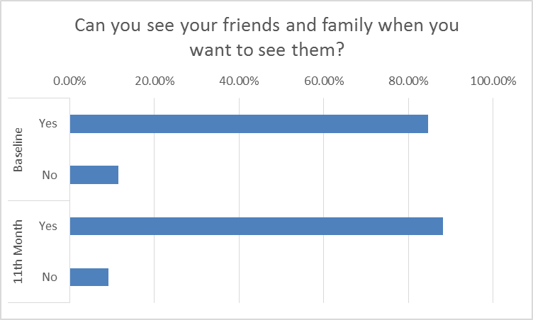
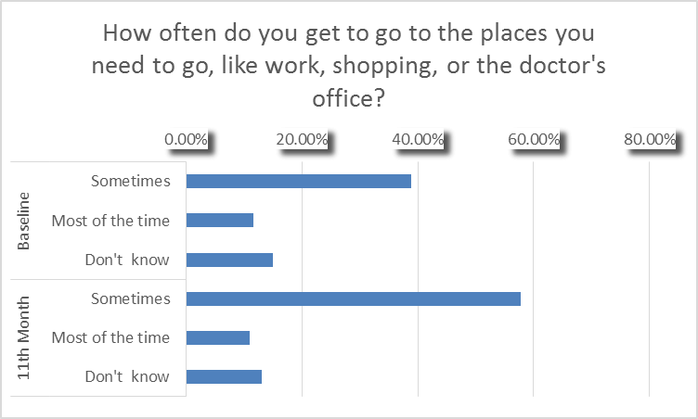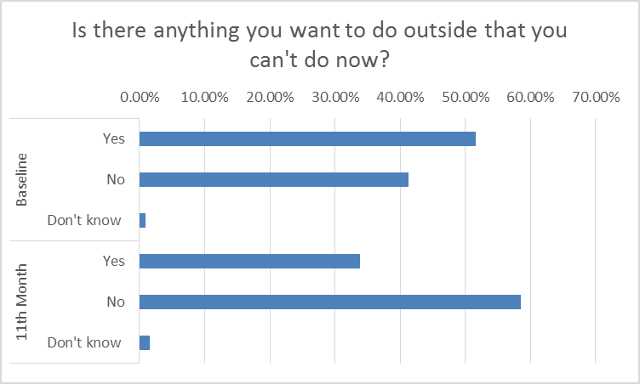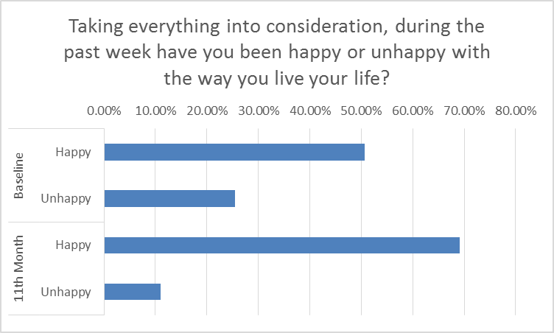

Number reflects average days leased for the 21 MRVP vouchers and 11 HCVP vouchers indicated above. Each individual’s leased number of days was calculated using the date of discharge from long term care through September 30, 2016.
Cost calculations excluded one individual as their cost of care was unusual as compared to overall claims data.
To make the process of calculating the claims more efficient, the claims from only full months in the facility were utilized. Full months of claims were then annualized (Total dollar amount of claims in X months)/ (# days in X months) X 365. Please note that this information is a sample and should not be used to make any other estimates or calculations on the cost of care for other members receiving MassHealth services.
The claims in the community were calculated starting from the date of discharge through September 30, 2016. Claims with a date of service on the discharge date were omitted if they were made by the facility or appeared to have been for services delivered in the facility prior to discharge. Acute inpatient hospitalizations, short-term nursing facility stays (90 days or less), and long term nursing facility stays (91 days or more) were excluded in the community claims data. The calculation for annualizing the fee for service claims, long term care, and waiver services is: (Total dollar amount of claims from discharge to Sep 30, 2016)/ (# days from discharge to Sep 30, 2016) X 365. If discharged after 10/1/15, claims were annualized using the formula: (amount of claims)/days from discharge to 9/30/16) X365. Two people passed way prior to 9/30/16, and their claims were annualized by: (claim amount)/ (days from 10/1/15 to date of death) X365. To annualize managed care claims, the monthly rate of the managed care costs was used to project managed care costs through the remainder of the individual’s first year in the community. Three individuals were excluded from the calculation as they had insufficient claims history to annualize (less than 6 weeks of claims for community services).
Housing subsidy was calculated utilizing data from the Department of Housing and Community Development’s Tracker software system showing actual housing subsidy paid for months the tenant lived in the unit. For individuals who had not lived in the unit for a full year, the average monthly subsidy was annualized.
According to the 2010 Census, 82.5% of the population of Massachusetts was white with the remainder of the population being black, Asian, or other; Information gathered from the United States Census 2010 at http://factfinder.census.gov/faces/tableservices/jsf/pages/productview.xhtml?src=CF
Information on gender of MassHealth members in nursing facilities provided by the Office of Long Term Services and Supports for State Fiscal Year 2015
Although individuals must be under the age of 62 to be eligible for any housing resources discussed in this report, they continue to receive housing support as they age.
31 individuals lived in the community for more than 11 months; however, two passed away before completing the survey
Year 1 data reflects the responses of 25 of the voucher holders with submitted Quality of Life survey responses.
Cost calculations excluded one individual as their cost of care was unusual as compared to overall claims data.
To make the process of calculating the claims more efficient, the claims from only full months in the facility were utilized. Full months of claims were then annualized (Total dollar amount of claims in X months)/ (# days in X months) X 365. Please note that this information is a sample and should not be used to make any other estimates or calculations on the cost of care for other members receiving MassHealth services.
The claims in the community were calculated starting from the date of discharge through September 30, 2016. Claims with a date of service on the discharge date were omitted if they were made by the facility or appeared to have been for services delivered in the facility prior to discharge. Acute inpatient hospitalizations, short-term nursing facility stays (90 days or less), and long term nursing facility stays (91 days or more) were excluded in the community claims data. The calculation for annualizing the fee for service claims, long term care, and waiver services is: (Total dollar amount of claims from discharge to Sep 30, 2016)/ (# days from discharge to Sep 30, 2016) X 365. If discharged after 10/1/15, claims were annualized using the formula: (amount of claims)/days from discharge to 9/30/16) X365. Two people passed way prior to 9/30/16, and their claims were annualized by: (claim amount)/ (days from 10/1/15 to date of death) X365. To annualize managed care claims, the monthly rate of the managed care costs was used to project managed care costs through the remainder of the individual’s first year in the community. Three individuals were excluded from the calculation as they had insufficient claims history to annualize (less than 6 weeks of claims for community services).
Housing subsidy was calculated utilizing data from the Department of Housing and Community Development’s Tracker software system showing actual housing subsidy paid for months the tenant lived in the unit. For individuals who had not lived in the unit for a full year, the average monthly subsidy was annualized.
As reported in the MFP-Information System.

