Commonwealth of Massachusetts
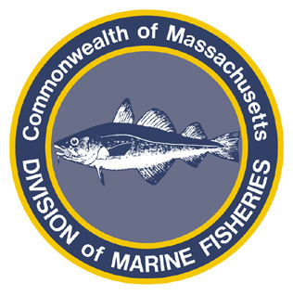
Paul J. Diodati
Director

Deval Patrick
Governor
Timothy P. Murray
Lt. Governor
Richard K. Sullivan, Jr.
Secretary
Mary B. Griffin
Commissioner

Division of Marine Fisheries
251 Causeway Street, Suite 400
Boston, Massachusetts 02114
(617)626-1520
fax (617)626-1509

August 11, 2011
MarineFisheries Advisory
PUBLIC COMMENT ON WINTER II SCUP FISHERY TRIP LIMIT
8,000 LBS PER TRIP FROM NOVEMBER 1 – DECEMBER 31

Under the provisions of M.G.L. Ch 30A and pursuant to the authority found in M.G.L. Ch. 130 ss. 17A & 80 and 322 CMR 6.28(9)(d), the Division of Marine Fisheries (DMF) will take comment on the Winter II scup fishery trip limit. The National Marine Fisheries Service has set the Winter II (November 1 – December 31) trip limit at 8,000 lbs, and the Division of Marine Fisheries seeks to establish the 8,000 lb trip for vessels landing scup in Massachusetts during this period. The Marine Fisheries Advisory Commission will review comment and vote on the trip limit at the September 8, 2011 Marine Fisheries Advisory Commission meeting.

Public comments will be received until 5PM on September 7, 2011. Please e-mail all public comments to marine.fisheries@state.ma.us or send to 251 Causeway Street, Suite 400, Boston, MA 02114.

More information can be found on the agency’s website (www.mass.gov/marinefisheries) or by contacting the agency by phone (617-626-1520) or email (marine.fisheries @state.ma.us).

