Commonwealth of Massachusetts
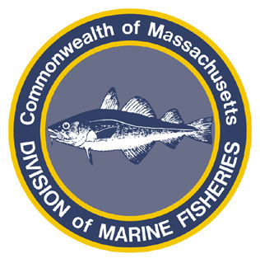
Paul J. Diodati
Director

Deval Patrick
Governor
Timothy P. Murray
Lt. Governor
Richard K. Sullivan, Jr.
Secretary
Mary B. Griffin
Commissioner

Division of Marine Fisheries
251 Causeway Street, Suite 400
Boston, Massachusetts 02114
(617)626-1520
fax (617)626-1509

August 18, 2011
MarineFisheries Advisory

COMMERCIAL BLACK SEA BASS FISHERY TO CLOSE
EFFECTIVE MONDAY, AUGUST 22, 2011

The Director has determined 100% of the Commonwealth’s 2011 black sea bass fishery quota (222,440 lbs.) will be reached by the end of the fishing day on Sunday, August 21, 2011. The fishery will then close to commercial fishermen on Monday, August 22, 2011, at 12:00 AM, when it shall be unlawful for commercial fishermen to land or possess black sea bass. MarineFisheries will advise the commercial fishing community of when this fishery will re-open in the spring of 2012.
For further information contact DMF at 617-626-1520 or please visit our website at www.mass.gov/marinefisheries.

