Commonwealth of Massachusetts
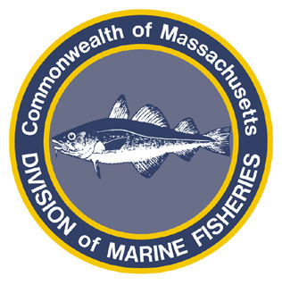
Paul J. Diodati
Director

Deval Patrick
Governor
Timothy P. Murray
Lt. Governor
Richard K. Sullivan, Jr.
Secretary
Mary B. Griffin
Commissioner

Division of Marine Fisheries
251 Causeway Street, Suite 400
Boston, Massachusetts 02114
(617)626-1520
fax (617)626-1509

August 19, 2011
MarineFisheries Advisory

Open Meeting for Public Market Commission’s Sub-Committee on Fish and Seafood Scheduled for August 29, 2011

The Public Market Commission Subcommittee on Fish and Seafood is holding an open public meeting on Monday, August 29 at 3:30 at 100 Cambridge Street, Conference Room B, 2nd floor in Boston, MA. The purpose of this meeting is for Commission members to hear firsthand from seafood producers, the fishing community, and other interested parties about how a new public market in downtown Boston can showcase the Commonwealth's seafood, fishing, and aquaculture industries. This is an opportunity for prospective seafood vendors, fishermen/women, and others to offer their thoughts about how a year round market can help create new opportunities for this critical part of the Massachusetts economy.

While the final agenda is still being prepared, the Subcommittee is particularly interested in discussing the following questions:

--What type of preparation does the fishing/seafood industry need to do in order to supply a year-round market in Boston with adequate product?
--What types of products would the industry like to sell?
--What is the appropriate balance of fresh to prepared food in a public market?
-- Given that the Massachusetts industry will be a priority, should the seafood for sale at the market be “Massachusetts only”, “regional”, “international/national” or a blend of the three? What defines those terms?
--Are there opportunities for seafood cooperatives or other shared-risk models?
--How would seafood producers market to restaurateurs from the public market?

For relevant information, background and latest news about the public market project, please see www.mass.gov/publicmarket. For important background information, the Subcommittee suggests that interested parties read the Implementation Plan for a Public Market in Boston, a report that presents a series of recommendations for how this market gets from good idea to opening day. You can read the report here. If you would like to make a suggestion for the agenda or offer a comment without attending the meeting, please send it to public.market@state.ma.us or call 617-626-1183.

