Commonwealth of Massachusetts
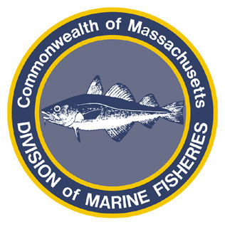
Paul J. Diodati
Director

Deval Patrick
Governor
Timothy P. Murray
Lt. Governor
Richard K. Sullivan, Jr.
Secretary
Mary B. Griffin
Commissioner

Division of Marine Fisheries
251 Causeway Street, Suite 400
Boston, Massachusetts 02114
(617)626-1520
fax (617)626-1509

August 23, 2011
MarineFisheries Advisory
REVISION TO EARLIER NOTICE ON SPINY DOGFISH CLOSURE:
2011/2012 STATE WATERS COMMERCIAL SPINY DOGFISH FISHERY TO CLOSE Thursday, September 1, 2011

The Atlantic States Marine Fisheries Commission Northern Region (ME-CT) spiny dogfish quota is projected to be harvested by the end of the fishing day on Wednesday, August 31, 2011. Effective at 0001 hours on Thursday, September 1, 2011, the possession and landing of spiny dogfish by state permitted commercial fishermen shall be prohibited. The Northern Region fishery is scheduled to re-open on May 1, 2012. The overall 2011/2012 spiny dogfish quota was set at 20-million lb., with the Northern Region fishery being allocated 58% or the overall harvest, for a total of 11,580,000 lbs.
As notified earlier, the federal Period 1 fishery is scheduled to close at 0001 hours on Thursday August 26, 2011. Once the federal fishery closes, the possession and landing of spiny dogfish by federally permitted commercial fishermen shall be prohibited.
State permitted commercial fishermen are reminded that August 2011 trip-level reports are due by September 15, 2011, even if the permit was not fished. Trip level reports should be sent to DMF Statistics Project, 30 Emerson Ave, Gloucester, MA 01930. Failure to submit these reports in a timely manner may result in the non-renewal of a permit or permit endorsement in 2012. Blank forms and instructions were mailed out prior to the beginning of the 2011 commercial fishing season, and additional copies can be obtained from the MarineFisheries web site at: http://www.mass.gov/dfwele/dmf/commercialfishing/trip_level.htm
For further information on closures and reporting contact DMF at 617-626-1520 or please visit our website at www.mass.gov/marinefisheries.

