Commonwealth of Massachusetts
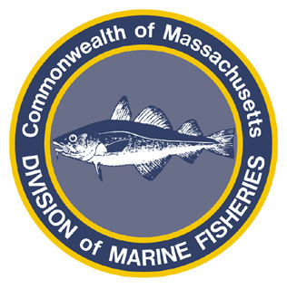
Paul J. Diodati
Director

Deval Patrick
Governor
Timothy P. Murray
Lt. Governor
Richard K. Sullivan, Jr.
Secretary
Mary B. Griffin
Commissioner

Division of Marine Fisheries
251 Causeway Street, Suite 400
Boston, Massachusetts 02114
(617)626-1520
fax (617)626-1509

August 25, 2011
MarineFisheries Advisory
CLARIFICATION ON 2011 SPINY DOGFISH CLOSURE

The typical scenario for the annual dogfish fishery is fish are off New England in the spring and summer and migrate south during fall and winter, so it is expected that there will be negligible landings by states south of CT during the first part of the fishing year that starts May 1. However, this year there was roughly 400,000 lbs of dogfish attributable to Mid-Atlantic states (NY, NJ and VA) that counts against the NMFS seasonal quota but not the ASMFC regional quota, which produced disparate fishery closure dates.

Under current rules, fishermen with a state permit are authorized to catch and land spiny dogfish from state-waters until 0001 hours on September 1, 2011. This fish may be sold only to a state permitted dealer, including those dealers that are both federally and state permitted. Fishermen with a federal permit are not authorized to retain and land dogfish after August 25, 2011. However, NMFS has indicated they will be allowing federal permit holders to relinquish their federal permit and fish as a state permitted fisherman. Federally permitted dealers may not purchase spiny dogfish from fishermen who hold a federal dogfish permit after August 25, 2011.
On November 1, NMFS will re-open the fishery for federal permit holders but the Commonwealth will not allow any fish to be landed by any vessel including any federally permitted vessel.
For further information on closures and reporting contact DMF at 617-626-1520 or please visit our website at www.mass.gov/marinefisheries.

