Commonwealth of Massachusetts
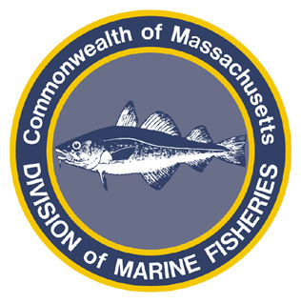
Paul J. Diodati
Director

Deval Patrick
Governor
Timothy P. Murray
Lt. Governor
Richard K. Sullivan, Jr.
Secretary
Mary B. Griffin
Commissioner

Division of Marine Fisheries
251 Causeway Street, Suite 400
Boston, Massachusetts 02114
(617)626-1520
fax (617)626-1509

August 25, 2011
MarineFisheries Advisory
OPEN MEETING NOTICE:
PUBLIC MARKET COMMISSION SUBCOMMITTEE ON FISH AND SEAFOOD
MEETING DATE CHANGED TO WEDNESDAY AUGUST 31, 2011 AT 3:30 pm

Commissioner Mary Griffin, of the Department of Fish and Game and Chair of the Public Market Commission Subcommittee on Fish and Seafood, will host a public meeting and listening session to consider a number of issues relevant to the establishment of the Boston Public Market and specific to seafood.
Due to the potential impacts of Hurricane Irene on Monday’s travel, this public meeting has been rescheduled for Wednesday, August 31, 2011 at 3:30 PM at 100 Cambridge Street, Conference Room B, 2nd Floor, Boston, MA 02114.
For more information please visit: www.mass.gov/publicmarket or call (617) 626-1183.
The meeting’s agenda can be found here.

