Electronic Claims HIPAA File and Provider Online Service Center (POSC) Updates
February 17, 2021

Executive Office of Health & Human Services

Agenda

- Overview
- Operating Physician
- Service Facility Location Address
- Supervising Physician
- Resources

Overview

On March 14, 2021, MassHealth will implement modifications to the submission requirements related to operating physician, service facility location, and supervising physician information submitted on claims transactions.

Additionally, any Operating, Supervising or Attending Physician entered on a claim should be actively participating/enrolled with MassHealth at least as a nonbilling provider. Informational edits will be issued for any claim that includes an Operating, Supervising, or Attending Physician that is not actively participating/enrolled with MassHealth.

- The changes will impact both 837 batch claims transactions and the Provider Online Service Center (POSC) Direct Data Entry (DDE) claims transactions. To support these minor changes, the companion and billing guides have been updated.

- MassHealth began conducting general information sessions for providers, trading partners, and vendors in January 2021. Registration can be completed at www.mass.gov/service-details/trading-partner-education.

- It is highly recommended for providers, trading partners, and vendors to participate in each of the information sessions available as they will include updates as released.

- Testing
  - MassHealth providers may submit DDE test claims using their existing POSC login credentials on the MMIS Test Portal link below between March 1, 2021 – March 12, 2021 MMIS Test Portal.
  - Providers who would like to submit an 837 test file must contact MassHealth’s EDI department at edi@mahealth.net to arrange the test.

Operating Physician

Operating Physician

If a surgical procedure code and/or an Other Operating Physician is entered, an Operating Physician with a valid NPI is required on the claim and should be actively participating/ enrolled with MassHealth at least as a nonbilling provider.

These requirements apply to 837I and Institutional DDE claim submissions. The loops and segments for Operating Physician and Other Operating Physician (837I) are:
- Operation Physician Name Loop (2310B) Segment (NM1)
- Other Operating Physician Name Loop (2310C) Segment (NM1)
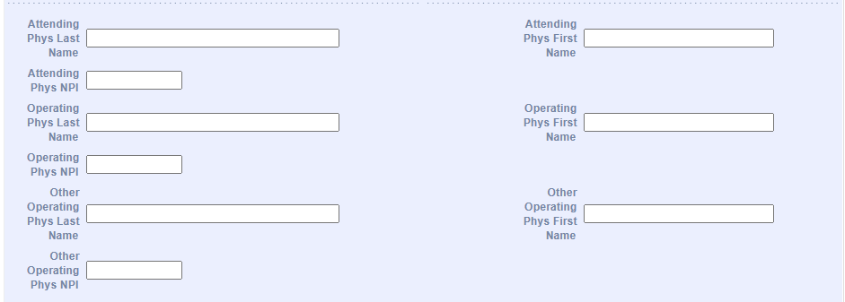The Operating and Other Operating Physician fields can be found in the Billing and Service tab on the POSC

Operating Physician

POSC Warning and Error Messages
Entering a Surgical Procedure Code
When entering a surgical procedure code on a claim on the POSC, the following Warning Message will display to remind providers of the Operating Physician requirement:
- An Operating Physician should be entered when entering a Surgical Procedure
If a claim with a surgical procedure code is submitted without an Operating Physician, the claim will adjudicate with one or more edits (listed on the next slide).

Adding an Other Physician
If the provider enters the Other Operating Physician information on the claim without entering the Operating Physician information, the following Error Message will display:
- An Operating Physician is required when listing an Other Operating Physician
The claim will not proceed to adjudication if this requirement is not met.

6
Operating Physician

Edit Codes and CARCs/RARCs

Below are the Edit Codes, Claim Adjustment Reason Codes (CARCs)/ Remittance Advice Remark Codes (RARCs) the provider may receive for a claim submitted with Operating Physician information requirements, along with their descriptions.

These edits will temporarily be informational only. MassHealth will issue further guidance with advance notice before implementing denials for these specific edits.

Edit Code | CARC/RARC | Description
383 – FIRST OPERATING PHYSICIAN ID INVALID | Adjustment Reason Code:  16 - CLAIM/SERVICE LACKS INFORMATION OR HAS SUBMISSION/BILLING ERROR(S).  Remark Code(s):  N270 - MISSING/INCOMPLETE/INVALID OTHER PROVIDER PRIMARY IDENTIFIER. | THE OPERATING PHYSICIAN IS SUBMITTED ON THE CLAIM BUT THE NPI IS NOT EXACTLY 10 NUMERIC DIGITS
477 – DETAIL FIRST OPERATING PHYSICIAN ID INVALID | Adjustment Reason Code:  16 - CLAIM/SERVICE LACKS INFORMATION OR HAS SUBMISSION/BILLING ERROR(S).  Remark Code(s):  N270 - MISSING/INCOMPLETE/INVALID OTHER PROVIDER PRIMARY IDENTIFIER. | THE OPERATING PHYSICIAN IS SUBMITTED ON THE CLAIM BUT THE NPI IS NOT EXACTLY 10 NUMERIC DIGITS
1021 – FIRST OPERATING PHYSICIAN ID NOT ON FILE | Adjustment Reason Code:  208 - NATIONAL PROVIDER IDENTIFIER - NOT MATCHED. | THE OPERATING PHYSICIAN IS LISTED:  WITH AN INVALID NPI / PID/SL
1053 – DETAIL FIRST OTHER PHYSICIAN ID NUMBER NOT ON FILE | Remark Code(s):  N270 - MISSING/INCOMPLETE/INVALID OTHER PROVIDER PRIMARY IDENTIFIER. | OR  THERE IS NO NPI / PID/SL SUBMITTED

Operating Physician
Edit Codes and CARCs/RARCs (con’t)

Edit Code | CARC/RARC | Description
1028 – NPI REQUIRED FOR OPERATING PHYSICIAN | Adjustment Reason Code:  206 – NATIONAL PROVIDER IDENTIFIER - MISSING  Remark Code(s):  N262 - MISSING/INCOMPLETE/INVALID OPERATING PROVIDER PRIMARY IDENTIFIER. | THE OPERATING PHYSICIAN WAS SUBMITTED ON THE CLAIM WITH A PID/SL BUT THERE IS NO NPI SUBMITTED
1030 – NPI REQUIRED FOR DETAIL OPERATING PHYSICIAN | Adjustment Reason Code:  206 – NATIONAL PROVIDER IDENTIFIER - MISSING  Remark Code(s):  N262 - MISSING/INCOMPLETE/INVALID OPERATING PROVIDER PRIMARY IDENTIFIER. | THE OPERATING PHYSICIAN WAS SUBMITTED ON THE CLAIM WITH A PID/SL BUT THERE IS NO NPI SUBMITTED
1025 – OPERATING PHYSICIAN REQUIRED FOR SURGICAL PROC | Adjustment Reason Code:  206 – NATIONAL PROVIDER IDENTIFIER - MISSING  Remark Code(s):  N262 - MISSING/INCOMPLETE/INVALID OPERATING PROVIDER PRIMARY IDENTIFIER. | THE OPERATING PHYSICIAN WAS SUBMITTED ON THE CLAIM WITH A PID/SL BUT THERE IS NO NPI SUBMITTED
1029 – OPERATING PHYSICIAN IS NOT ELIGIBLE | Adjustment Reason Code:  B7 - THIS PROVIDER WAS NOT CERTIFIED/ELIGIBLE TO BE PAID FOR THIS PROCEDURE/SERVICE ON THIS DATE OF SERVICE  Remark Code(s):  N262 - MISSING/INCOMPLETE/INVALID OPERATING PROVIDER PRIMARY IDENTIFIER | THE OPERATING PHYSICIAN WAS SUBMITTED ON THE CLAIM BUT THERE IS NO RECORD FOUND FOR THE PROVIDER  OR  THE PROVIDER IS NOT ACTIVE ON THE DOS
1031 – DETAIL OPERATING PHYSICIAN IS NOT ELIGIBLE | Adjustment Reason Code:  B7 - THIS PROVIDER WAS NOT CERTIFIED/ELIGIBLE TO BE PAID FOR THIS PROCEDURE/SERVICE ON THIS DATE OF SERVICE  Remark Code(s):  N262 - MISSING/INCOMPLETE/INVALID OPERATING PROVIDER PRIMARY IDENTIFIER | THE OPERATING PHYSICIAN WAS SUBMITTED ON THE CLAIM BUT THERE IS NO RECORD FOUND FOR THE PROVIDER  OR  THE PROVIDER IS NOT ACTIVE ON THE DOS

Service Facility Location Address

Service Facility Location Address

The Service Facility Location Address (Address 1, City, State and Zip Code) and Service Facility Name are both required if either of those fields are entered.

These requirements apply to Institutional and Professional DDE claim submissions.
The fields will be added to the Extended Services tab of the POSC for both institutional and Professional claim templates.
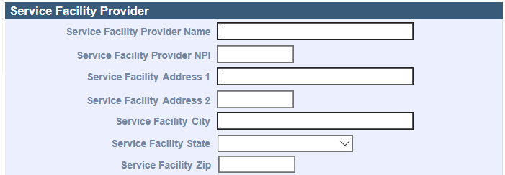

Error Messages

If the Service Facility Name field is entered but the Service Facility Location Address is not entered or is incomplete, the POSC will display one or more of the following error messages:

Error Message | Corrective Action
The Service Facility Address is incomplete. Please enter and submit. | Complete the required fields for the Service Facility Location Address (address 1, city, state, zip code)  *The claim will not proceed to adjudication if this requirement is not met
The Service Facility Address is incomplete. Please enter and submit. | Complete the required fields for the Service Facility Location Address (address 1, city, state, zip code)  *The claim will not proceed to adjudication if this requirement is not met

If the Service Facility Location Address is but the Service Facility Name is not entered, the POSC will display the following error message:

Error Message | Corrective Action
The Service Facility Name is required. Please enter and submit. | Complete the field for the Service Facility Name  *The claim will not proceed to adjudication if this requirement is not met 11

Supervising Physician

12

Supervising Physician

If entered on the claim, the Supervising Physician should be actively participating/enrolled with MassHealth at least as a nonbilling provider, and the NPI submitted must be valid.
These requirements apply to 837P and Professional DDE claim submissions. The loop and segment for Supervising Physician is: Loop (2310D) Segment (NM1).
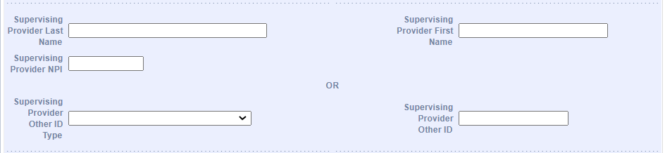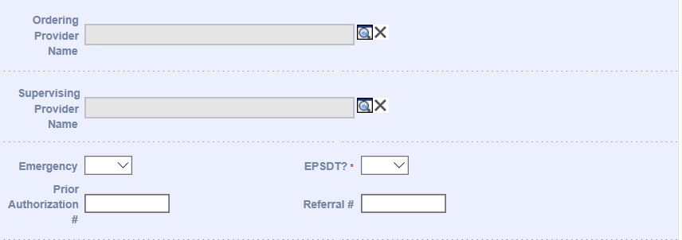
Billing and Service
Procedure
The Supervising Physician fields can be found in the Billing and Service tab (header of the claim) and the Procedure tab (detail of the claim) on the POSC.

*Note: The Supervising Physician fields already exist in the Billing and Service tab. The search function to add the Supervising Physician on the claim will be added to the Procedure tab on the implementation date, 03/14/2021.

Supervising Physician

Edit Codes and CARCs/RARCs

Below are the Edit Codes, Claim Adjustment Reason Codes (CARCs)/ Remittance Advice Remark Codes (RARCs) the provider may receive for a claim submitted with Supervising Physician information requirements, along with their descriptions.

These edits will temporarily be informational only. MassHealth will issue further guidance with advance notice before implementing denials for these specific edits.

Edit Code | CARC/RARC | Description
1042 – SUPERVISING PHYSICIAN ID INVALID | Adjustment Reason Code:  16 - CLAIM/SERVICE LACKS INFORMATION OR HAS SUBMISSION/BILLING ERROR(S).  Remark Code(s):  MA102 - MISSING/INCOMPLETE/INVALID NAME OR PROVIDER IDENTIFIER FOR THE RENDERING/REFERRING/ ORDERING/ SUPERVISING PROVIDER. | A SUPERVISING PHYSICIAN WAS SUBMITTED ON THE CLAIM BUT THE NPI IS NOT EXACTLY 10 NUMERIC DIGITS IS NO NPI SUBMITTED
1046 – DETAIL SUPERVISING PHYSICIAN ID INVALID | Adjustment Reason Code:  16 - CLAIM/SERVICE LACKS INFORMATION OR HAS SUBMISSION/BILLING ERROR(S).  Remark Code(s):  MA102 - MISSING/INCOMPLETE/INVALID NAME OR PROVIDER IDENTIFIER FOR THE RENDERING/REFERRING/ ORDERING/ SUPERVISING PROVIDER. | A SUPERVISING PHYSICIAN WAS SUBMITTED ON THE CLAIM BUT THE NPI IS NOT EXACTLY 10 NUMERIC DIGITS
1044 – SUPERVISING PHYSICIAN ID NOT ON FILE | Adjustment Reason Code:  208 - NATIONAL PROVIDER IDENTIFIER - NOT MATCHED.  Remark Code(s):  N297 - MISSING/INCOMPLETE/INVALID SUPERVISING PROVIDER PRIMARY IDENTIFIER. | THERE IS NO RECORD ON FILE FOR THE SUPERVISING PHYSICIAN SUBMITTED
1048 – DETAIL SUPERVISING PHYSICIAN NOT ON FILE | Adjustment Reason Code:  208 - NATIONAL PROVIDER IDENTIFIER - NOT MATCHED.  Remark Code(s):  N297 - MISSING/INCOMPLETE/INVALID SUPERVISING PROVIDER PRIMARY IDENTIFIER. | THERE IS NO RECORD ON FILE FOR THE SUPERVISING PHYSICIAN SUBMITTED

Supervising Physician
Edit Codes and CARCs/RARCs (con’t)

Edit Code | CARC/RARC | Description
1043 – NPI REQUIRED FOR SUPERVISING PHYSICIAN | Adjustment Reason Code:  16 – CLAIM/SERVICE LACKS INFORMATION OR HAS SUBMISSION/BILLING ERROR(S).  Remark Code(s):  N297 - MISSING/INCOMPLETE/INVALID SUPERVISING PROVIDER PRIMARY IDENTIFIER. | THE SUPERVISING PHYSICIAN IS SUBMITTED ON THE CLAIM WITH A PID/SL BUT THERE IS NO NPI SUBMITTED
1047 – NPI REQUIRED FOR DETAIL SUPERVISING PHYSICIAN | Adjustment Reason Code:  16 – CLAIM/SERVICE LACKS INFORMATION OR HAS SUBMISSION/BILLING ERROR(S).  Remark Code(s):  N297 - MISSING/INCOMPLETE/INVALID SUPERVISING PROVIDER PRIMARY IDENTIFIER. | THE SUPERVISING PHYSICIAN IS SUBMITTED ON THE CLAIM WITH A PID/SL BUT THERE IS NO NPI SUBMITTED
1045 – SUPERVISING PHYSICIAN IS NOT ELIGIBLE | Adjustment Reason Code:  B7 - THIS PROVIDER WAS NOT CERTIFIED/ELIGIBLE TO BE PAID FOR THIS PROCEDURE/SERVICE ON THIS DATE OF SERVICE.  Remark Code(s):  N297 - MISSING/INCOMPLETE/INVALID SUPERVISING PROVIDER PRIMARY IDENTIFIER. | A SUPERVISING PHYSICIAN IS SUBMITTED BUT IS NOT ACTIVE FOR THE DOS
1049 – DETAIL SUPERVISING PHYSICIAN IS NOT ELIGIBLE | Adjustment Reason Code:  B7 - THIS PROVIDER WAS NOT CERTIFIED/ELIGIBLE TO BE PAID FOR THIS PROCEDURE/SERVICE ON THIS DATE OF SERVICE.  Remark Code(s):  N297 - MISSING/INCOMPLETE/INVALID SUPERVISING PROVIDER PRIMARY IDENTIFIER. | A SUPERVISING PHYSICIAN IS SUBMITTED BUT IS NOT ACTIVE FOR THE DOS

Resources

Resources

  - Information about the upcoming changes and session registration link
    - www.mass.gov/service-details/trading-partner-education

  - Link for updated Companion Guides
    - www.mass.gov/lists/masshealth-hipaa-companion-guides

  - Testing
    - MassHealth providers may submit DDE test claims using their existing POSC login credentials on the MMIS Test Portal link below between March 1 – March 12, 2021.
mmis-portal-tptest.ehs.state.ma.us/EHSProviderPortal/providerLanding/providerLanding.jsf
    - Providers who would like to submit an 837 test file must contact MassHealth’s EDI department at edi@mahealth.net to arrange the test.

  - Provider Email Alerts
    - To sign up to receive email alerts when MassHealth issues new bulletins and transmittal letters, send a blank email to join- masshealth-provider-pubs@listserv.state.ma.us. No text in the body or subject line is needed.

  - MassHealth Customer Service

Contact | Long-Term Services and Supports Providers | All Other Provider Types
Phone | (844) 368-5184 (toll free) | (800) 841-2900; TTY: (800) 497-4648
Email | support@masshealthltss.com | providersupport@mahealth.net
Fax | (888) 832-3006 | (617) 988-8974

Information Sessions

MassHealth is conducting three general information sessions between January – March 2021 for providers, trading partners, and vendors. The final Information session will be hosted post implementation to recap and check in with providers.

Date | Details
January 27, 2021 | High-level overview of the upcoming changes
February 17, 2021 | Contains detailed information about the upcoming changes (screenshots, billing instruction & Companion Guide updates)
March 17, 2021 | Recap and check in post go live.

For more information regarding these changes and registration details, please visit: https://www.mass.gov/service-details/trading-partner-education

Questions?

