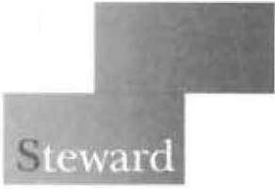
A STEWARD FAMILY HOSPITAL

March 30, 2023

VIA EMAIL

Stephen Davis, Director
Division of Health Care Facility Licensure and Certification Bureau of Health Care Safety and Quality
Department of Public Health 67 Forest Street
Marlborough, MA 01752

Re: Morton Hospital's Comprehensive Addiction Program ("MORCAP") Dear Mr. Davis:
We write on behalf of Morton Hospital located at 88 Washington Street, Taunton, MA 02780 (the “Hospital”). Pursuant to 105 CMR 130.122(B), the Hospital hereby provides the required ninety
(90) day notice to the Department of Public Health (“Department”) of its proposed relocation of MORCAP to Carney Hospital in Dorchester. This letter is in follow-up to the notices that were filed with the appropriate parties on March 1, 2023. We offer the following comments with respect to this matter.

The Hospital understands that although this is not a technical closure, the relocation of MORCAP to Dorchester will affect the Taunton community. MORCAP has 32 Level 4 substance use disorder (“SUD”) licensed beds, of which 18 beds are currently in service. The remaining 14 beds are utilized as med/surg beds in response to the public health emergency (“PHE”) and authorized by Department waivers. This means 14 MORCAP beds are temporarily out of service. Pursuant to a separate transfer of site filing, the Hospital will move 25 of the 32 beds to Carney Hospital and operate it as a satellite of the Hospital called the Carney Comprehensive Addiction Program (“CARCAP”). Of the 25 Level 4 beds that will be relocated, 18 are currently in service and 7 are out of service. The 7 out of service beds will close permanently. The relocation of MORCAP is critical to the Hospital's ability to continue providing inpatient medical/surgical services to Taunton and the community. By relocating 25 Level 4 SUD beds, the Hospital will continue to ensure access for patients.

In compliance with applicable requirements at 105 CMR 130.122(B), the Hospital provides this written notice of the planned discontinuance of the Services, i.e., relocation of 25 Level 4 SUD beds and closure of 7 beds. The following information is hereby provided for the Department's review:

Utilization rates (discharges) for MORCAP services (last 3 years and YTD).

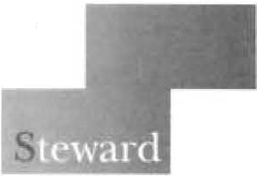
A STEWARD FAMILY HOSPITAL

Stephen Davis, Director
Division of Health Care Facility Licensure and Certification Bureau of Health Care Safety and Quality
Department of Public Health March 30, 2023
Page 2

Facility/Program | 2020¹ | 2021² | 2022 | 2023
Morton Hospital/MORCAP | 0 | 74 | 973 | 114

A description of the anticipated impact on individuals in the Hospital's service area following the closure of the Services.

The Hospital does not anticipate a significant negative impact to patients in the service area following the relocation of 25 of the 32 Level 4 SUD-licensed beds to Carney Hospital. The Hospital will continue to manage and oversee the CARCAP services at its new location. The Hospital will provide for transportation via ambulance to CARCAP for patients presenting to Steward hospital emergency departments.

Date for the closure of the Services.

The closure of MORCAP will occur on or about June 27, 2023 but is subject to the coordination with Carney Hospital for the relocation and reopening of the CARCAP services.

Names and addresses of any organized health care coalitions and community groups known to the Hospital when the notice is issued to DPH that would have an interest in the closure of the Services.

  - Community Counseling of Bristol County, 1 Washington Street, Taunton, MA 02780
  - Learn to Cope, 4 Court Street, Suite 110, Taunton, MA 02780
  - Manet Community Health Center, 1 Washington Street, Taunton, MA 02780
  - Plymouth County Outreach, 153 Central Street, East Bridgewater, MA 02333
  - SSTAR, 386 Stanley Street, Fall River 02720
  - Taunton Open Doors to Recovery, 61 Winthrop Street, Taunton, MA 02780
  - Taunton Opiate & Substance Use Task Force, 30 Olney Street, Taunton, MA 02780
  - Taunton Community Crisis Intervention Team, 1 Washington Street, Taunton, MA 02780

1 For service in 2020 no data is available as MORCAP was not approved by DoN until 2021.
2 The service was only operational for part of 2021.

A STEWARD FAMILY HOSPITAL

Stephen Davis, Director
Division of Health Care Facility Licensure and Certification Bureau of Health Care Safety and Quality
Department of Public Health March 30, 2023
Page 3

A detailed account of any community engagement and planning which has occurred prior to filing notice of the closure of the Services.

The Hospital has engaged in planning with Carney Hospital for the relocation 25 beds and opening of CARCAP. The Hospital continues to engage with local stakeholders such as City Councilors, Mayors, Senators and Representatives. The purpose of such community engagement is to identify concerns with the closure of the Services in Taunton and determine how they will be addressed. The following meetings have occurred.

Taunton
  - On February 24th, Heidi Taylor, (Morton Hospital, President), spoke with the following local legislators, to share intent to file the relocation plan:
Mayor O'Connell (Taunton) Senator Pacheco Representative Doherty Representative Haddad Representative Orrall

  - Email communication regarding intent to file was also sent out, on February 24th and 27th: All Morton Hospital staff and providers (Feb 24th)
Morton Hospital Patient Family Advisory Committee (Feb 24th) Morton Hospital Board of Directors (Feb 24th)
Mayor O'Connell (Taunton) (Feb 24th) Senator Pacheco (Feb 24th) Representative Doherty (Feb 24th) Representative Haddad (Feb 24th) Representative Orrall (Feb 24th)
Taunton City Council Board Members (Feb 27th)

  - Email communication was sent on March 1st, as a follow up to the communication above, to confirm that Morton Hospital filed relocation. plan with the Department of Public Health: All Morton Hospital staff and providers
Morton Hospital Patient Family Advisory Committee Morton Hospital Board of Directors
Mayor O'Connell (Taunton)

A STEWARD FAMILY HOSPITAL

Stephen Davis, Director
Division of Health Care Facility Licensure and Certification Bureau of Health Care Safety and Quality
Department of Public Health March 30, 2023
Page4

Senator Pacheco Representative Doherty Representative Haddad Representative Orrall
Taunton City Council Board Members

Boston
  - On February 24th, Stan McLaren (Carney Hospital, President) emailed and mailed an update regarding the initiative to relocate Morton Hospital's substance use disclosure (“SUD”) treatment Program to Dorchester to the following:
Mayor Wu (Boston)
Dr. Ojikutu, Director, Boston Public Health Commission Senator Collins
Senator Keenan Senator Miranda Representative Ayers
Representative Flukes-Oakley Representative Hunt Representative Holmes Councilor Baker
Councilor Worrell Councilor Louijeune Councilor Murphy

  - In addition, Mr. McLaren (Carney Hospital, President) spoke with the following officials:
Dr. Ojikutu (March 1st)
Senator Collins (February 28th) Representative Holmes (March 9th) Councilor Louijeune (March 7th) Councilor Worrell (March 21st)

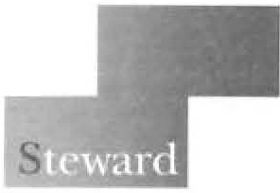
A STEWARD FAMILY HOSPITAL

Stephen Davis, Director
Division of Health Care Facility Licensure and Certification Bureau of Health Care Safety and Quality
Department of Public Health March 30, 2023
Page 5

Thank you for your attention to this matter. If you have any questions, please feel free to contact Andrew Levine, Esq., at 781-898-4379 or me.

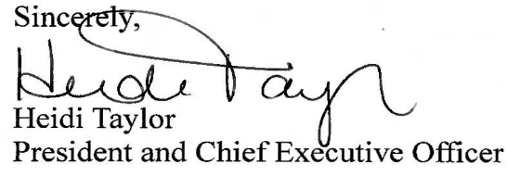

cc: J. Bernice, DPH
A. Bianco, EOHHS
D. Calvert, DPH
S. Carlson, DPH
R. Kaye, Esq., DPH
E. Kelley, DPH
W. Mackie, Esq., DPH
T. McNamara, DPH
A. Mehlman, Esq., DPH
E. Weil, DPH
A. Levine, Esq.
S. McLaren, Carney Hospital, Steward
M. Girard, M.D., Steward
N. Hibble, Esq., Steward
D. Mehegan, Steward
J. Weinstein, M.D., Steward

Health Policy Commission (HPC)
Office of the Attorney General (Massachusetts) Center for Health Information and Analysis (CHIA)
Executive Office of Labor and Workforce Development (EOLWD)

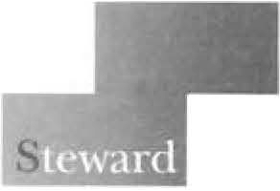
A STEWARD FAMILY HOSPITAL

Stephen Davis, Director
Division of Health Care Facility Licensure and Certification Bureau of Health Care Safety and Quality
Department of Public Health March 30, 2023
Page 6

Bureau of Substance Addiction Services (BSAS)

Community Counseling of Bristol County, 1 Washington Street, Taunton, MA 02780 Learn to Cope, 4 Court Street, Suite 110, Taunton, MA 02780
Manet Community Health Center, 1 Washington Street, Taunton, MA 02780 Plymouth County Outreach, 153 Central Street, East Bridgewater, MA 02333 SSTAR, 386 Stanley Street, Fall River 02720
Taunton Open Doors to Recovery, 61 Winthrop Street, Taunton, MA 02780 Taunton Opiate & Substance Use Task Force, 30 Olney Street, Taunton, MA 02780
Taunton Community Crisis Intervention Team, 1 Washington Street, Taunton, MA 02780

