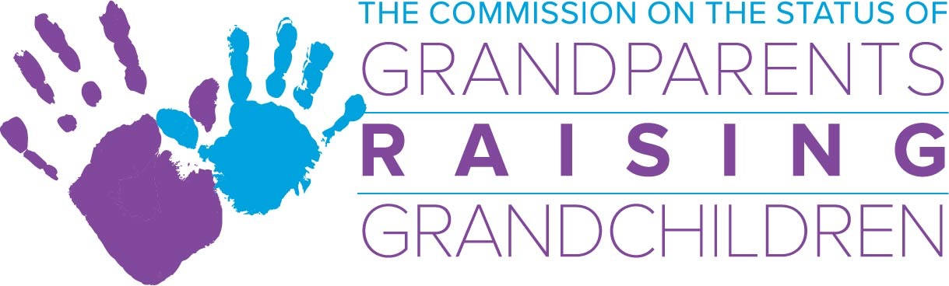

September 12, 2018 Special Commission Meeting, 2-4 p.m. .
One Ashburton Place 5th Floor Boston, Ma.
**New**Commission Bridge Number: 240-454-0887
Meeting Access Code: 731860817

Agenda

- Acceptance of August meeting minutes
*Action required

- Financial Report/Budget
- FY’19 Budget

- Updates:
  - Grandparents Study
  - Meeting with Congressman McGovern
  - Boston College Graduate School of Social Work Student Intern, Katrina Lund

- Sub-Committee Updates:
- Information and Referral Sub-Committee: Skip
- Support Group Sub-Committee: Margo/Deb
- Legal Sub-Committee: Lynn
- Resource Development Sub-Committee: Ilene

- Directors Report

- Chairwoman’s Report

- Other Business:

- Kerry’s family and collection for donation

