Commonwealth of Massachusetts
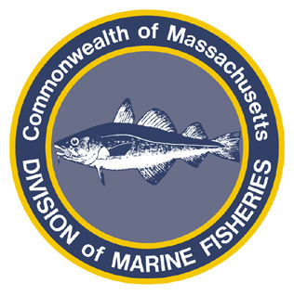
Paul J. Diodati
Director

Deval Patrick
Governor
Timothy P. Murray
Lt. Governor
Richard K. Sullivan, Jr.
Secretary
Mary B. Griffin
Commissioner

Division of Marine Fisheries
251 Causeway Street, Suite 400
Boston, Massachusetts 02114
(617)626-1520
fax (617)626-1509

September 29, 2011
MarineFisheries Advisory
CLOSURE OF ATLANTIC HERRING AREAS 1B AND 3

NOAA Fisheries has projected that 95% of the Atlantic herring Total Allowable Catch (TAC) allocated to Management Area 1B will be harvested by September 30, 2011, and that 95% of the Atlantic herring TAC allocated to Management Area 3 will be harvested by October 2, 2011. Amendment 2 to the Atlantic States Marine Fisheries Commission Interstate Fishery Management Plan for Atlantic Herring requires states to impose restrictions on the fishery when the harvest of herring is projected to reach 95% of the TAC allocated to an area. These restrictions will cease on January 1, 2012, when new quota becomes available. Therefore, the following restrictions for Area 1B and 3 have been enacted:

- Effective 00:01 October 1, 2011, it is unlawful to fish, take, transport, or land Atlantic Herring taken from Management Area 1B; and
- Effective 00:01 October 3, 2011, it is unlawful to fish, take, transport, or land Atlantic Herring taken from Management Area 3.
- Exemptions: Vessels may retain an incidental bycatch daily trip limit of sea herring from Areas 1B or 3, provided it does not exceed 2,000 lbs. Herring taken legally outside Areas 1B and 3 may be transported through the areas, only if all fishing gear has been stowed.

For further information regarding Atlantic sea herring management, please visit the Atlantic States Marine Fisheries Commission website (www.asmfc.org) and the Massachusetts MarineFisheries website (www.mass.gov/marinefisheries).

