Commonwealth of Massachusetts
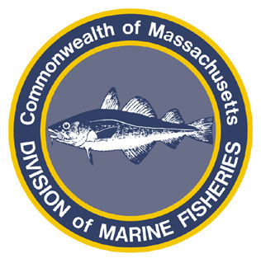
Paul J. Diodati
Director

Deval Patrick
Governor
Timothy P. Murray
Lt. Governor
Richard K. Sullivan, Jr.
Secretary
Mary B. Griffin
Commissioner

Division of Marine Fisheries
251 Causeway Street, Suite 400
Boston, Massachusetts 02114
(617)626-1520
fax (617)626-1509

September 29, 2011
MarineFisheries Advisory
COMMERCIAL TAUTOG FISHERY TO CLOSE EFFECTIVE TUESDAY, OCTOBER 4

The Division of Marine Fisheries (MarineFisheries) has projected that 100% of the 2011 commercial tautog quota will be taken by Monday, October 3, 2011. Consequently the commercial tautog fishery will close effective 0001 hours on Tuesday, October 4, 2011. The fishery is scheduled to re-open on April 16, 2012.
In an ongoing effort to conserve and rebuild local tautog stocks, MarineFisheries established a commercial tautog quota in 2007 with approval of the Marine Fisheries Advisory Commission. The 2011 commercial tautog quota is 54,189 lbs (reduced from the base quota of 64,753 lbs due to a harvest overage of 10,564 lbs in 2010). Regulations allocate 28% of the quota to the spring period fishery, beginning April 16, and the remainder of the quota to the fall period fishery, beginning September 1.

Commercial fishermen are reminded that monthly trip-level reports are due no later than the 15th of the following month, even if the permit was not fished. Failure to submit these reports for all months of the year in a timely manner may result in the non-renewal of your commercial permit in 2012. Trip level reports should be sent to DMF Statistics Project, 30 Emerson Avenue, Gloucester, MA 01930. Blank forms and instructions were mailed out prior to the beginning of the 2011 commercial fishing season and additional copies can be obtained at: http://www.mass.gov/dfwele/dmf/commercialfishing/trip_level.htm.

Dealers are reminded that it is unlawful to purchase tautog from Massachusetts commercial fishermen when the fishery is closed. Quota totals and regulations can be monitored through the MarineFisheries web site at: www.mass.gov/marinefisheries.

