# Massachusetts Department of Public Health

988 Implementation

Where we are in Massachusetts

Kelley Cunningham

Director for the Division of Violence & Injury Prevention

Danielle Bolduc

Acting Director, Suicide Prevention Program

# Agenda

* Overview
  + What is 988
  + 988 in MA
  + SAMHSA’s 5 year vision
  + How 988 Works in MA & with other systems
* Budget
* Marketing 988
* Technology
* Staffing and Workforce Issues
* Training
* Key Performance Metrics

# Overview – What is 988

* Federal law, passed in November 2020 creating 988 as the dedicated 3-digit number for callers looking for mental health or suicidal crisis support which **went live nationally on July 16, 2022**
  + Formerly the National Suicide Prevention Line (NSPL 1-800-273-8255)
  + Individual does not need to be suicidal to call this number
* Only centers who are members of the NSPL network answer 988 calls
  + Requires meeting accreditation and training requirements and following guidelines set forth through Vibrant Emotional Health (administrator of 988)
* Calls are distributed to the closest local center based on the caller’s area code
  + Geolocation is not available through 988 – this means if a caller with a MA area code is located in another state when they call 988 the call will go to the MA center
* Includes text/chat options and access for Deaf and Hard of Hearing
  + Deaf and Hard of Hearing – may use online chat function or TTY users may use their preferred relay service or dial 711 then 988. [To learn more about the online chat function, visit https://suicidepreventionlifeline.org/chat/.

# SAMHSA’s 5 Year Vision

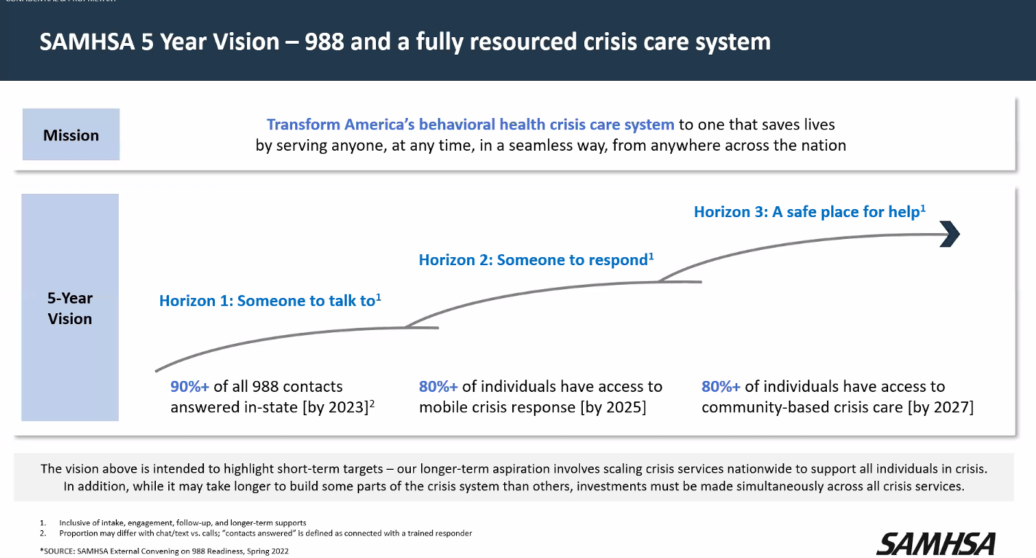

# 988 Vision: Anyone, Anywhere, Anytime

* Someone to talk to
  + Call 988 when in emotional distress or suicidal crisis (non-clinical)
* Someone to respond
  + Behavioral Health Help Line
  + Want to connect to treatment? Call/text the BHHL for clinical support
  + 833-773-2445
* A place to go
  + Visit a Community Behavioral Health Center instead of going to the Emergency Department
* All of this includes
  + Recovery
  + Peers
  + Trauma informed
  + Safer suicide care
  + Safety for all
  + Crisis response partnerships

# Overview – 988 in MA

* 5 Centers in MA part of the Lifeline network
  + Call2Talk (part of United Way of TriCounty, Mass211)
  + Samaritans of Cape Cod and the Islands
  + Samaritans, Inc (Boston)
  + Samaritans of Merrimack Valley (part of Family Services of Merrimack Valley)
  + Samaritans SouthCoast
* Call takers in MA offer non-judgmental, emotional support; are not licensed mental health clinicians
  + Connection to services such as: emergency service (behavioral health system), 911, other resources
  + Translation services offered
  + Centers receive calls from both 988 callers and callers using a local suicide prevention number
    - 988 Callers about 20% of the overall volume received by the statewide network in FY23
    - On track to receive **over 350,000 calls** this fiscal year (both 988 and local)
    - Projected overall increase in calls to 988 as shift to dialing 9-8-8 over existing 10-digit numbers and increased 988 awareness about 988

# How 988 Works in MA

* Caller hears a greeting message while their call is routed to the local Lifeline network crisis center (based on the caller’s area code)​
* Press 1 for Veterans; Press 2 for Spanish; Press 3 for LGBTQ+ Youth
* All callers are provided a suicide risk assessment
* If caller needs additional support – warm hand-off to Mobile Crisis Intervention (MCI) is offered
* 911 is called for any call deemed to be at imminent risk

988



911



911



911



911



911

Routing options based on assessment

# Budget

* FY23 funding
  + State
    - FY23 received $10M supplemental funding from FY22
  + Federal
    - SAMHSA 988 grant – April 30, 2022 – April 29, 2024
* Funding has supported:
  + Expansion of center operational hours (24/7/365)
  + Increased capacity through workforce and technology investments
  + Workforce training
  + Marketing and Communications Campaign (updated public transit awareness materials, workforce recruitment, and misinformation research)

# Marketing Campaign

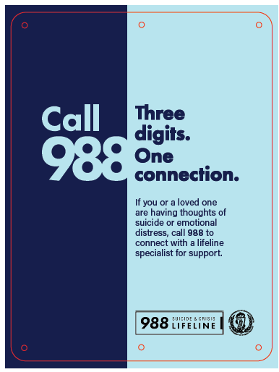

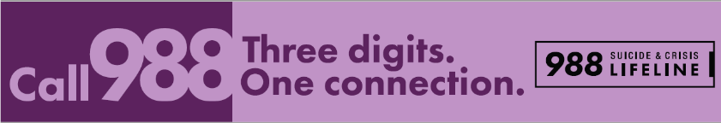

To learn more about 988 in Massachusetts, visit [Mass.gov/988](https://www.mass.gov/988-suicide-and-crisis-lifeline).

To learn more about 988 at the national level, visit [samhsa.gov/988](https://www.samhsa.gov/find-help/988?utm_source=SAMHSA&utm_campaign=034d881437-SAMHSA_Announcement_2022_03_15_1600881&utm_medium=email&utm_term=0_ee1c4b138c-034d881437-167806549).

# How does 988 connect with other lines?

* Warm hand-off to Mobile Crisis Intervention (MCI)
* Calls currently receive referral to BHHL but working towards warm hand-off
* 911 – only used for callers determined to be at imminent risk as required by the *Suicide Safety Policy* established by Vibrant

**Goal:** reduce the number of transfers between the caller and help

**Challenge:** How do we transfer calls from any of the above to 988?

# Technology

National

* Routes calls to local centers based on area code
* Veterans press 1, Spanish press 2, LGBTQ+ youth press 3
* 988 available by phone, text, chat
* National back up centers

Local

* Calls distributed to centers at county level
* In-state back up centers. If calls not answered locally then routed to national back up
* 4 of 5 centers answer calls remotely; virtual rooms (i.e. Zoom) used to provide support, monitoring, and supervision
* Centers have ability to prioritize calls (i.e. 988 vs. local calls)
* Centers use software to manage call records, staffing schedules, and resources

Caller Experience

* MA area code numbers answered by local centers
* Text/Chat answered by national centers

# Staffing model

Centers transitioned to hybrid workforce model; **132% increase in available FTEs**over the past year

# Workforce Challenges

* Challenge: Newer career opportunity
  + Solution/Need: Conducted several media campaigns to increase awareness and bolster recruitment
* Challenge: Recruiting the right candidates for this challenging work
  + Solution/Need:
    - Support from hiring firm to help centers with recruitment and screening of applicants.
    - Hiring firm also provided temp employees from May-Oct 2022 while centers increased FTEs. Some later shifted to permanent positions
* Challenge: Potential burnout from heavy mental and emotional toll
  + Solution/Need:
    - Ensuring adequate staffing levels
    - Supervision & support
* Challenge: Sustainable funding
  + Solution/Need: As volume increases so does the need for resources to maintain appropriate staffing levels, salaries, and operational needs
* Challenge: Low valued field/low wages
  + Solution/Need: Providing livable and competitive wages

# Required Trainings

National Administrator level (Vibrant)

* Establishes standards, policies, and best practices (incl. the Suicide Safety Policy and risk assessment standards)
* Maintains resources and continuing education portal (Network Resource Center)
* Requires 3 core trainings in addition to local training:
* Fundamentals of Crisis Counseling
* Essential Skills in Crisis Counseling
* Assessing Safety and Suicide Risk

State level (DPH)

* Emergency Services Program Warm Connection Policy and Training
* Assessing additional opportunities; waiting to understand Vibrant’s planning

# Required Trainings (continued)

Center level

* All centers must receive 3rd party accreditation as a condition of being a member of the network
* All MA centers are currently accredited through International Council of Helplines

Accreditation Standards

1. Governance and Leadership
2. Fiscal and Administrative
3. Facilities, Equipment, and Safety
4. Training
5. Program Management
6. Supervisions, Support, and Evaluation of Specialists
7. Suicide Prevention and Intervention
8. Management of Specific Contact Types

Onboarding Training Core Concepts

* Mission, vision, and purpose of organization
* Organization and helpline program policies and procedures
* Crisis intervention
* Empathy, active listening, and communication skills
* Good contact techniques
* Collaborative problem solving
* Grief and loss
* Isolation and loneliness
* Suicide awareness, intervention, and safety planning
* Mental illness, including symptoms and treatment
* Trauma-informed care
* Boundary setting and providing support to familiar individuals
* Addiction and substance use
* Interpersonal violence and human trafficking
* Child and dependent adult abuse and neglect
* Disaster management and mass violence
* Specific populations, including veterans, LGBTQIA and youth
* Cultural awareness
* NSSI
* Community resources
* Self-care

# Key Performance Metrics

Performance Outcomes (measured at both the national and local level; given the different vantage points there can be discrepancies in measurement)

* Calls Received
* Calls Answered
* Answer Rate
* Average Speed to Answer
* Abandonment Rate
* Rollover to Backup Center

Call Experience

* Anonymous & confidential service = No information is required to be provided to engage with the service
* Basic information about the call is captured through the caller’s story
* Working across network to standardize what & how core components are captured

Call Disposition and 3rd Party Involvement

* Supportive call
* Supportive call+ (resources, call backs, safety planning)
* 911 engagement

# How are calls handled?

**94%** of callers’ needs resolved through the **supportive encounter**.

**98%** of callers’ needs are met **within the crisis call center.**

# Calls Received vs. Answered

* There has been a **26% increase in 988 calls received and 96% increase in 988 calls answered in state**
* Calls not answered by a MA center are routed to the national backup centers

# Call Answer Rate

The average in-state answer rate has increased by 11 percentage points

# Massachusetts Department of Public Health

Thank you for the opportunity to present this information today.

Please direct any questions to:

Kelley Cunningham

Division Director

Bureau of Community Health and Prevention

Division of Violence and Injury Prevention

kelley.cunningham@mass.gov

Danielle Bolduc, MSW, MPH, LCSW

Acting Director, Suicide Prevention Program

Bureau of Community Health and Prevention

Division of Violence and Injury Prevention

danielle.bolduc@mass.gov