# HMA 988: Year One and Two Priorities and State Policies and Funding Highlights

* 988 Commission Meeting
* September 15, 2023
* Presenter: Moira Muir
* Copyright © 2023 Health Management Associates, Inc. All rights reserved. The content of this presentation is PROPRIETARY and CONFIDENTIAL to Health Management Associates, Inc. and only for the information of the intended recipient. Do not use, publish or redistribute without written permission from Health Management Associates, Inc.



# Agenda

1. Welcome and Introductions – 5 min
2. 988 – Year One Highlights and Year Two Priorities – 5 min
3. National Best Practices – 5 min
4. Highlights of State Policies and Funding – 5 min
5. Discussion – 15 min

# Year One Highlights and Year Two Priorities

# Year One Review

* Year one’s focus was on implementation, building awareness, recruiting staff.
* **National Data**
  + Since July 2022 launch, the 988 Lifeline has received nearly 5 million calls, texts and chats—2 million more than in the previous 12 months.
  + Veterans Crisis Line  (VCL) responded to approximately 1 million of the 5 million people seeking help.
    - To learn more about the Veterans Crisis Line, visit <https://www.veteranscrisisline.net/>
  + Compared with the previous 12 months:
    - Text contacts through the Lifeline increased by 1,135%
    - Chats answered increased by 141%
    - Calls answered increased by 46%
    - Average speed to answer decreased from 2 minutes, 39 seconds to 41 seconds
* “988 Suicide & Crisis Lifeline Adds Spanish Text and Chat Service Ahead of One-Year Anniversary.” SAMHSA, July 13, 2023.

# Year Two SAMHSA Priorities: Education and Equity

* A July 2023 NAMI poll showed that 82% of adult respondents were somewhat or completely unfamiliar with the 988 Suicide and Crisis Lifeline; only 17% were very or somewhat familiar with the service.*
* SAMHSA plans to prioritize education and equity going into the second year by educating more individuals about the lifeline and when it can be used **instead of a 911 or police assistance**.
* **Increased Support for Priority Populations**
  + SAMHSA and Vibrant Emotional Health, the nonprofit administrator and operator of the 988 Lifeline, intend to launch an awareness campaign this fall.
  + July 2023 Lifeline added text and chat features in Spanish, as well as specialized services for LGBTQI+ youth and young adults.
    - For more information about chat features, visit <https://988lifeline.org/es/chat/>
  + SAMHSA and Vibrant intend to roll out a video calling option for people with hearing impairments and who communicate through American Sign Language.
  + Outreach to people in rural areas, unhoused individuals, and tribal communities is needed.
* “As it heads into its second year of existence, the three-digit number for the country’s mental health crisis lifeline still has some hurdles to overcome when it comes to awareness, staffing and routing.”**
* * National Alliance on Mental Illness. New NAMI-Ipsos Poll Finds Low Familiarity of 988 Suicide & Crisis Lifeline but Broad Bipartisan Support for Federal Funding., July 13, 2023.
* **Howard J. and Viswanathan, G. One Year After Launch, 988 Mental Health Crisis Line Still Building Awareness and Staffing. CNN. July 13, 2023.

# Year Two SAMHSA Priorities Continued: Routing

* Currently, calls are routed to centers in the same geographic location as the user’s area code. So, a Massachusetts caller who has a California area code would reach a center in CA. The CA call center then would have to reroute the call to a MA 988 call center for local services and resources.
* 911 routes callers to their closest geographic location.
* SAMHSA and Vibrant will explore different ways of routing beyond the area code.

# NATIONAL BEST PRACTICES

# Best Practices Spotlight: 988, Call Center & Mobile Crisis Services Integration

Graphic depicting the Crisis response continuum of care.
(Continuum Source: WellBeing Trust)

# Best Practices Spotlight: Integrate 988, Call Center, and Mobile Crisis Services

* **Georgia Crisis and Access Line**
* **988 is the centralized call center for statewide mobile crisis services and dispatch.**
  + **Georgia Crisis and Access Line**(GCAL) is a call center integrated into the local healthcare system with 24-hour mobile crisis response coverage within 100 miles of every community. A nationally accredited Health Care Call Center, crisis center, and partner in the National Suicide Prevention Lifeline (NSPL).
  + GCAL has real-time access to available crisis and detox beds throughout Georgia. It also provides phone, text, and chat intervention services, follow-up, and will make urgent and emergent appointments for callers.
  + Other key functions:
    - 24/7/365 can **use GPS for Mobile Crisis Dispatch** for all state-funded behavioral health and developmental disability mobile crisis response teams
    - 24/7/365 single point of entry for state contracted **inpatient beds**
    - 24/7/365 preferred point of entry for **crisis stabilization units** and state hospitals
  + For more information, visit <https://www.georgiacollaborative.com/providers/georgia-crisis-and-access-line-gcal/>
* Behavioral Health Link, 2020.



# **Best Practices Spotlight: Integrate 988, Call Center, and Mobile Crisis Services**

* Georgia Crisis and Access Line Continued
* GCAL uses proprietary dispatch software developed in partnership with **Behavioral Health Link** (BHL), which provides crisis providers “with the ability to immediately locate and communicate with mobile teams in the field.” This capability enables providers to conduct secure, electronic assessments with or without an Internet connection, which is crucial for areas of the state where broadband connectivity may be unavailable.
* Financing
  + Medicaid Matching
    - To learn more, visit <https://www.nasmhpd.org/sites/default/files/2022-10/6.25.2022_FINAL_Financing988.pdf>
    - Georgia accesses **Federal Medicaid funding to help cover administrative costs** for their statewide crisis system that includes a hotline that dispatches mobile crisis teams. The state demonstrates the proportion of costs attributable to Medicaid beneficiaries by estimating the percent of residents with serious mental illness, addiction, and intellectual disabilities/developmental disabilities who are enrolled in Medicaid.
* Behavioral Health Link, 2020.



# Best Practices Spotlight: 988 Integration with Program Services

* Arizona
* **Arizona** has several crisis call centers that are leveraging and maximizing the use of technology, including:
  + Electronic health records that are customized for crisis calls
  + **Electronic dispatch of mobile teams that include sharing of clinical information and automatic collection of time stamp of activity with the press of a button**
  + **GPS technology to see the location of mobile teams in the community.**
  + Mobile teams have electronic tools (e.g., tablets) to receive dispatch, quick-press features to record time stamps and receive and send information regarding the crisis and intervention needed.
  + Call centers can support mobile teams in electronically setting up appointments with community-based providers
  + To watch a video about Arizona’s crisis call centers, visit <https://www.youtube.com/watch?v=ORq1MkODzQU&t=67s>
* Financing:
  + State Medicaid Agency (AHCCCS) is responsible for administering Medicaid and non-Medicaid behavioral health services.
  + AHCCCS contracts with a specialty health plan for persons with a serious mental illness and within that health plan contract they are responsible for a continuum of crisis services for all Medicaid and non-Medicaid that includes **crisis call center**, mobile response, and crisis walk-in and stabilization services.  Health plan receives a crisis capitation payment for all Medicaid eligibles and also receives other non-Medicaid funding including state funding earmarked for crisis services, federal block grant funding, and other federal cooperative agreements.  Health plan contracts with one statewide call center vendor, mobile crisis and crisis walk-in, and stabilization services



# Best Practices Spotlight: 988 Integration with Program Services

* Washington
* **Three statewide hubs** are Lifeline-certified call centers that receive all 988 calls for their covered regions
  + **Hub Services**
    - Provide emotional support
    - Conduct telephonic triage
    - **Dispatch mobile crisis teams**
    - Manage involuntary inpatient psychiatric hospital bed finding (through Open Beds application)
    - Coordinate bidirectionally with 911: Warm connections from 911 to 988 and active rescue protocols for acute crisis events that emerge
    - Refer moderate-risk callers for next day follow-up calls, outreach, and support
  + Financing:
    - Behavioral Health Administrative Services Organizations (BHASO) contract with the Crisis Call Hub that serves their service area
    - Telecommunication tax



# HIGHLIGHTS: STATE POLICIES AND FUNDING

# **Highlights State Policies & Funding**

* Sustainable funding is a factor in maintaining improved call response rates at local 988 crisis centers and states have the option to fund 988 similarly to 911, through telecom fees.
* Although federal investments support 988 nationally, states are responsible for long-term funding of the local 988 crisis call centers, which have historically received minimal funding from the federal government (typically between $2,500-$5,000 annually).
* Under the National Suicide Hotline Designation Act of 2020, states can collect cell phone fees to help sustainably fund their local 988 call centers 988 legislation authorized states to collect cell phone fees to help sustainably fund 988 and other crisis services.
* Trust funds and general funds appropriations have been set up by some states to support 988 crisis centers, but it is unclear whether these initiatives will sustainably support crisis centers’ long-term funding needs.
* Some states have considered billing Medicaid or other payers for crisis hotlines and other crisis services.
  + For more information about federal investments, visit <https://www.samhsa.gov/newsroom/press-announcements/20221216/hhs-announces-988-lifeline-grant-funding-under-bsca> or <https://appropriations.house.gov/sites/democrats.appropriations.house.gov/files/Labor%2C%20Health%20and%20Human%20Services%2C%20Education%2C%20and%20Related%20Agencies%20FY23%20Summary.pdf>
  + For information about 988 funding, visit <https://www.samhsa.gov/sites/default/files/988-appropriations-report.pdf>
  + For information about the National Suicide Hotline Designation Act of 2020, visit <https://www.congress.gov/bill/116th-congress/senate-bill/2661/text?q=%7B%22search%22%3A%5B%22National+Suicide+Hotline+Designation+Act+of+2019%22%5D%7D&r=2&s=1>
  + For more information about trust funds and general funds appropriations, visit <https://nashp.org/state-legislation-to-fund-and-implement-988-for-the-national-suicide-prevention-lifeline/>
  + For more information about billing for crisis hotlines and other crisis services, visit <https://www.kff.org/medicaid/issue-brief/behavioral-health-crisis-response-findings-from-a-survey-of-state-medicaid-programs/>
* Saunders, Heather. “Behavioral Health Crisis Response: Findings from a Survey of State Medicaid Programs.” KFF, May 25, 2023.
* Saunders, Heather. “Taking a Look at 988 Suicide & Crisis Lifeline Implementation One Year After Launch.” KFF, July 14, 2023.

# **Highlights: State Policies and Funding**

* Mental health advocates intend to push legislation that allows 988 to be funded the same way 911 is nationwide.
* The Wireless Communications and Public Safety Act of 1999 mandated 911 to be the country’s universal emergency number. Since then, users have automatically been charged—an average of about a dollar a month—on their monthly phone bills to fund it.
* Six states have imposed a similar tax for 988, and the governors of two states[—](https://www.delawarepublic.org/delaware-headlines/2023-06-28/bill-establishing-a-funding-source-for-988-crisis-helpline-heads-to-governors-desk-from-state-senate)Delaware and Oregon—have legislation calling for this tax on their desks.
* The FCC (Federal Communications Commission) has the authority to levy a nationwide tax but has yet to do so.
  + For more information about the Wireless Communications and Public Safety Act of 1999, visit <https://www.fcc.gov/general/9-1-1-and-e9-1-1-services>
  + For more information about 911 surcharges, visit [9-1-1 Surcharge - User Fees by State - National Emergency Number Association (nena.org)](https://www.nena.org/page/911RateByState)
  + For more about Delaware legislation, visit <https://www.delawarepublic.org/delaware-headlines/2023-06-28/bill-establishing-a-funding-source-for-988-crisis-helpline-heads-to-governors-desk-from-state-senate>
  + For more about Oregon legislation, visit <https://www.oregonlive.com/politics/2023/06/phone-fee-of-40-cents-per-month-to-fund-988-suicide-prevention-hotline-passes-oregon-legislature.html>
* Source: DeGuzman C. A Year With 988: What Worked? What Challenges Lie Ahead? *KFF Health News.* July 26, 2023. Available at[” https://kffhealthnews.org/news/article/a-year-with-988-what-worked-what-challenges-lie-ahead/?utm_campaign=KFF-2023-The-Latest&utm_medium=email&_hsmi=267914436&_hsenc=p2ANqtz--Nnw5VUahfMCfOL72nPGX0YcCmKfh9k0Re0GGp273NFtgqjzX0S_DPoT2PIruEvd6RyFugcaXAed6i3Xg_mxK_QDnSvw&utm_content=267914436&utm_source=hs_email](https://kffhealthnews.org/news/article/a-year-with-988-what-worked-what-challenges-lie-ahead/?utm_campaign=KFF-2023-The-Latest&utm_medium=email&_hsmi=267914436&_hsenc=p2ANqtz--Nnw5VUahfMCfOL72nPGX0YcCmKfh9k0Re0GGp273NFtgqjzX0S_DPoT2PIruEvd6RyFugcaXAed6i3Xg_mxK_QDnSvw&utm_content=267914436&utm_source=hs_email).

# Highlights: State Policies and Funding

* **State-level momentum for 988 telecom fees is gaining traction.**
  + **More than half the states (26) have enacted legislation to implement and fund 988.**
  + **Six states use telecommunication fees** (CA, CO, NV, VA, WA and recently MN).
    - VA and WA reported earning roughly $3.6M−$4.5M in telecom fees during FY21. Both were among the first states to implement telecom fees.
    - OR and DE are close to final legislative approval; soon will be eight states.
    - Three other states have pending legislation.
  + **13 states are appropriating general fund dollars** to 988.
* Historically, crisis call centers have received $2,500−$5,000 in federal funding annually (through Vibrant)
* **States must strategize on funding to keep the system sustainable.**
* Saunders, Heather. “Behavioral Health Crisis Response: Findings from a Survey of State Medicaid Programs.” KFF, May 25, 2023.
* Saunders, Heather. “Taking a Look at 988 Suicide & Crisis Lifeline Implementation One Year After Launch.” KFF, July 14, 2023.

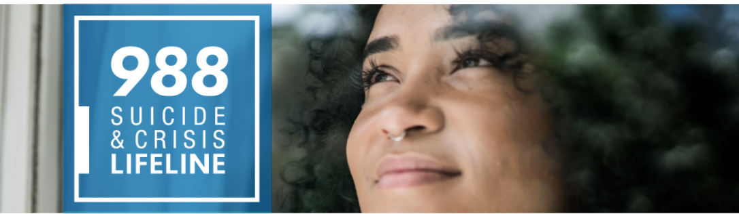

* NAMI – Reimage Crisis Response – 988 Legislative Map.

A map denoting states which have enacted or pending 988 implementation legislation.


1. Enacted Legislation to Fund 988 (26 States)

* National Academy for State Health Policy. State Legislation to Fund and Implement the 988 Suicide and Crisis Lifeline. June 6, 2023.

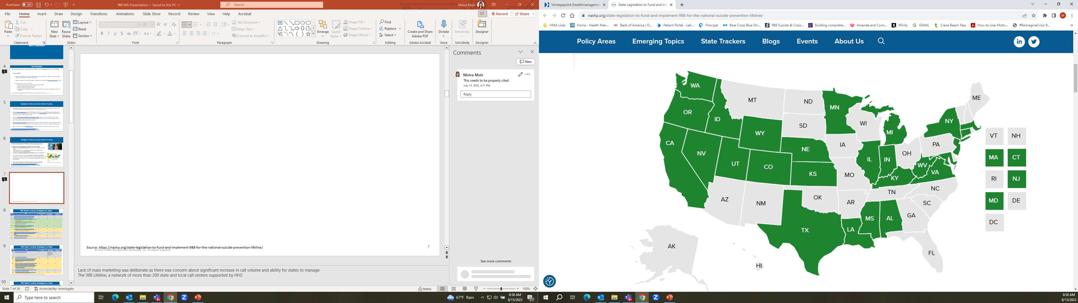

# 988 State Funding Strategies

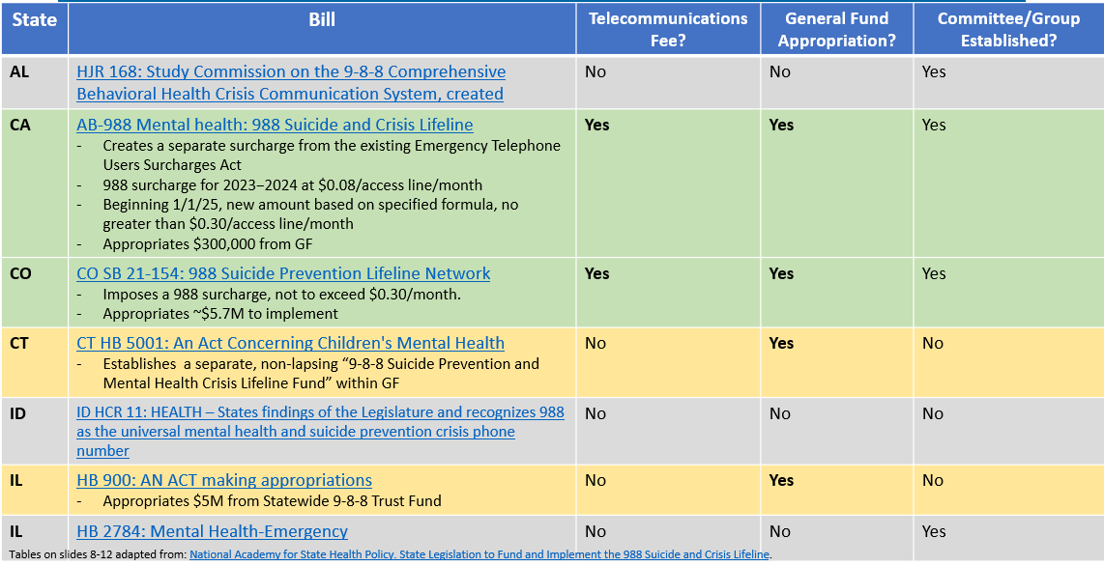

* Tables on slides 18-22 adapted from: National Academy for State Health Policy. State Legislation to Fund and Implement the 988 Suicide and Crisis Lifeline.
* For more information, visit <https://nashp.org/state-legislation-to-fund-and-implement-988-for-the-national-suicide-prevention-lifeline/>

# 988 State Funding Strategies

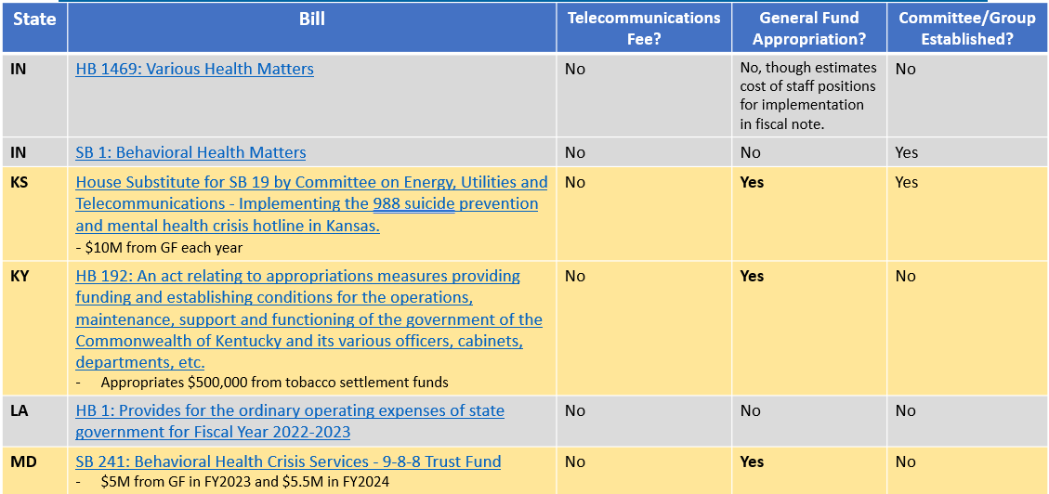

* Tables on slides 18-22 adapted from: National Academy for State Health Policy. State Legislation to Fund and Implement the 988 Suicide and Crisis Lifeline., June 6, 2023.
* For more information, visit <https://nashp.org/state-legislation-to-fund-and-implement-988-for-the-national-suicide-prevention-lifeline/>

# 988 State Funding Strategies by State

* Tables on slides 18-22 adapted from: National Academy for State Health Policy. State Legislation to Fund and Implement the 988 Suicide and Crisis Lifeline.
* For more information, visit <https://nashp.org/state-legislation-to-fund-and-implement-988-for-the-national-suicide-prevention-lifeline/>

# 988 State Funding Strategies by State

* Tables on slides 18-22 adapted from: <https://nashp.org/state-legislation-to-fund-and-implement-988-for-the-national-suicide-prevention-lifeline/>

# 988 State Funding Strategies by State

* Tables on slides 18-22 adapted from: National Academy for State Health Policy. State Legislation to Fund and Implement the 988 Suicide and Crisis Lifeline. June 6, 2023
* For more information, visit <https://nashp.org/state-legislation-to-fund-and-implement-988-for-the-national-suicide-prevention-lifeline/>

# References

* Centers for Medicare & Medicaid Services. All-State Medicaid and CHIP Call (slide deck). January 25, 2022. Available at: <https://www.medicaid.gov/sites/default/files/2022-01/covid19allstatecall01252022.pdf>.
* Behavioral Health Link. Mobile Crisis Response. 2020. Available at: <https://behavioralhealthlink.com/crisis-services/mobile-crisis-response/>.
* RIInternational.com. Crisis Now: Transforming Crisis Services in Arizona – Episode 1. (video) YouTube. February 24, 2017. Available at: <https://www.youtube.com/watch?v=ORq1MkODzQU>
* Howard J, Viswanathan, G. One Year after Launch, 988 Mental Health Crisis Line Still Building Awareness and Staffing. CNN, July 13, 2023. Available at: <https://www.cnn.com/2023/07/13/health/988-mental-health-awareness-staffing/index.html>
* “National Guidelines for Behavioral Health Crisis Care Best Practice Toolkit”. SAMHSA, 2020. <https://www.samhsa.gov/sites/default/files/national-guidelines-for-behavioral-health-crisis-care-02242020.pdf>
* National Alliance on Mental Illness. NAMI-Ipsos Poll Finds Low Familiarity of 988 Suicide & Crisis Lifeline but Broad Bipartisan Support for Federal Funding. July 13, 2023. Available at: <https://www.nami.org/Press-Media/Press-Releases/2023/New-NAMI-Ipsos-Poll-Finds-Low-Familiarity-of-988-Suicide-Crisis-Lifeline>.
* Saunders H. Behavioral Health Crisis Response: Findings from a Survey of State Medicaid Programs. Kaiser Family Foundation. May 25, 2023. Available at: <https://www.kff.org/medicaid/issue-brief/behavioral-health-crisis-response-findings-from-a-survey-of-state-medicaid-programs/>.
* Saunders H. Taking a Look at 988 Suicide & Crisis Lifeline Implementation One Year After Launch. Kaiser Family Foundation. Kaiser Family Foundation. July 14, 2023. Available at: [https://www.kff.org/mental-health/issue-brief/taking-a-look-at-988-suicide-crisis-lifeline-implementation-one-year-after-launch/#:~:text=Under%20the%20National%20Suicide%20Hotline,988%20and%20other%20crisis%20services.](https://www.kff.org/mental-health/issue-brief/taking-a-look-at-988-suicide-crisis-lifeline-implementation-one-year-after-launch/)
* Centers for Medicare & Medicaid Services, SHO 21-008 RE: Medicaid Guidance on the Scope of and Payments for Qualifying Community-Based Mobile Crisis Intervention Services. CMS, December 28, 2021. Available at: <https://www.medicaid.gov/sites/default/files/2021-12/sho21008.pdf>.
* National Academy for State Health Policy. State Legislation to Fund and Implement the 988 Suicide and Crisis Lifeline. June 6, 2023. Available at: <https://nashp.org/state-legislation-to-fund-and-implement-988-for-the-national-suicide-prevention-lifeline/>.
* Substance Abuse and Mental Health Services Administration. 988 Key Messages. July 20, 2023. Available at: <https://www.samhsa.gov/find-help/988/key-messages>.
* Substance Abuse and Mental Health Services Administration. 988 Suicide & Crisis Lifeline Adds Spanish Text and Chat Service Ahead of One-Year Anniversary. July 13, 2023. [https://www.samhsa.gov/newsroom/press-announcements/20230713/988-suicide-crisis-lifeline-adds-spanish-text-chat-service-ahead-one-year-anniversary?utm_source=SAMHSA&amp;utm_campaign=d269cc0aeb-EMAIL_CAMPAIGN_2023_07_13_03_37&amp;utm_medium=email&amp;utm_term=0_-d269cc0aeb-%5BLIST_EMAIL_ID%5D.](https://www.samhsa.gov/newsroom/press-announcements/20230713/988-suicide-crisis-lifeline-adds-spanish-text-chat-service-ahead-one-year-anniversary?utm_source=SAMHSA&utm_campaign=d269cc0aeb-EMAIL_CAMPAIGN_2023_07_13_03_37&utm_medium=email&utm_term=0_-d269cc0aeb-%5BLIST_EMAIL_ID%5D)

# THANK YOU!