# Community Behavioral Health Centers (CBHCs) and Mobile Crisis Intervention (MCI)

* Riverside Community Care
* July 31, 2023

# The five components of CBHC

* Community Behavioral Health Center (CBHC)
* Adult Mobile Crisis Intervention (AMCI)
* Youth Mobile Crisis Intervention (YMCI)
* Adult Community Crisis Stabilization (Adult CCS)
* Youth Community Crisis Stabilization (YCCS)

# What is Adult Mobile Crisis Intervention

* Mobile Crisis Intervention Programs (MCI) provide psychiatric evaluations, intervention, and stabilization for any perceived crisis.
* The Commonwealth has 25 different MCI catchment areas.
* The MCI provides 24-hour support, 365 days a year.
* Support can be provided face to face or through a telehealth platform.
* The Riverside Community Care MCI Programs geographically cover the Southern Worcester County area and South & West Suburban area.
* The MCI can assist individuals and families by making connections to community-based supports, as well as higher levels of care.
* The MCI will respond to requests from individuals, families, police, community providers, schools, residential programs and hospitals.
* BHHL and 988

# What is Youth Mobile Crisis Intervention?

* Youth Mobile Crisis Intervention (YMCI) is the youth component of an MCI.
* Any person under the age of 21 with a MassHealth (Medicaid) insurance product qualifies to receive support through YMCI.
* YMCI utilizes a team approach to providing crisis intervention and stabilization.
* Our MCI team consists of a child trained clinician, a Young Adult Peer Mentor, and a Family Partner.
* A Family Partner is someone that has first- hand experience navigating the mental health system on behalf of their own family.
* The YMCI team can help to stabilize a crisis by working with a family for up to 7 days.

# What Does MCI Provide?

* MCI Services provide the following:
  + Onsite, home-based, or community-based face-to-face crisis intervention, (including suicide assessment) and short-term solution-focused counseling.
  + Referrals and linkages to all medically necessary behavioral health services and supports, including access to appropriate services along the behavioral health continuum of care.
  + Crisis Plans are developed in collaboration with behavioral health providers and/or natural supports to expedite a person-centered disposition based on the experience gained from past treatment interventions.

# Riverside Community Care: Core Service Area

* Specialized Child and Family Services:
  + Outpatient Centers
  + Child Day Services and School
  + Child Day Services
  + Community Service Agency, In-Home Therapy, Therapeutic Mentoring
  + In-Home Therapeutic Mentoring
  + Emergency Services

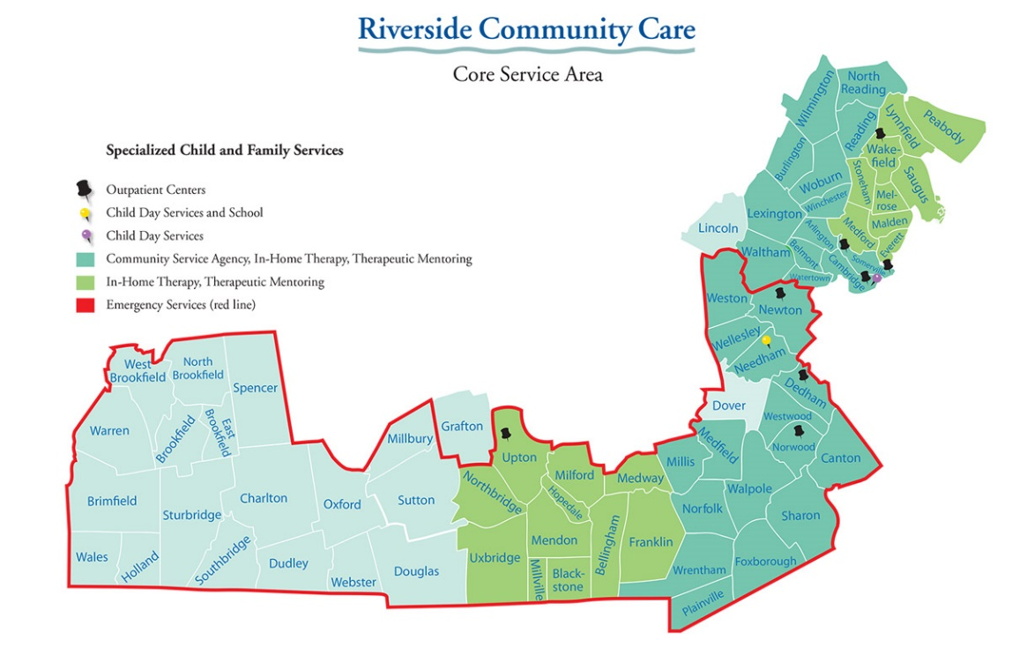

# Locations and Contact Info

1. South County

* 176 West Street, Milford, MA
* 800-294-4665 or 508-634-3420
* Bellingham, Blackstone, Brimfield, Brookfield, Charlton, Douglas, Dudley, East Brookfield, Franklin, Holland, Hopedale, Medway, Mendon, Milford, Millville, Northbridge, North Brookfield, Oxford, Southbridge, Sturbridge, Sutton, Upton, Uxbridge, Wales, Warren, Webster, and West Brookfield

1. South and West Suburban

* 190 Lenox St, Norwood MA
* 800-529-5077 or 781-769-8674
* Canton, Dedham, Dover, Foxboro, Medfield, Millis, Needham, Newton, Norfolk, Norwood, Plainville, Sharon, Walpole, Wellesley, Weston, Westwood, Wrentham

# Workflow: When requesting an evaluation

* Call
  + Call the 800 # or the local number associated with your town to request support 24 hours a day.
  + Statewide number: 1-877-382-1609
* Request
  + Our staff will request demographic, insurance, and background information to determine an appropriate response.
* Provide
  + Clinician will provide solution-focused counseling and support with a goal to help avoid unnecessary trips to the ER by trying to utilize and/or connect the person / family served to community resources.
* Receive
  + Through MCI, the person served and their family can receive ongoing/daily support for (typically) up to 7 days.

# BHHL and 988 referrals

* Calls from BHHL and 988 are tracked and prioritized
* Workflow:

1. Call the Riverside 800#
2. Tell the Riverside triage clinician that you’re doing a warm handoff.
3. Remain on the call with the caller until the Riverside triage team has scheduled an appointment for evaluation.
4. The Riverside MCI team will prioritize a response.

# Potential Outcomes

* Community-Based Dispositions
  + CBHC
  + Individual outpatient therapy
  + Outpatient Psychiatry
  + In-Home Therapy
  + Intensive Care Coordination
  + Partial Hospitalization Program (PHP)
  + Structured Outpatient Addiction Program
* Connections with resources including:
  + Self-help groups
  + Peer supports
  + Recovery Learning communities
  + Clubhouses
* 24-hour Levels of Care
  + Community-Based Acute Treatment (CBAT/ICBAT)
  + Inpatient Hospital
  + Adult CCS
  + YCCS
  + Inpatient Detox