# 988 Commission Annual Report - DRAFT

Executive Office of Health and Human Services

March 1, 2024

## Table of Contents

* Background
* Overview of the Development and Implementation of 988 and the Behavioral Health Help Line
* Evaluation
* Current Funding Sources
* Overview of the National Landscape and Funding Mechanisms
* Plans for 2024
* Commission Recommendations

## Table of Contents

* **Background**
* Overview of the Development and Implementation of 988 and the Behavioral Health Help Line
* Evaluation
* Current Funding Sources
* Overview of the National Landscape and Funding Mechanisms
* Plans for 2024
* Commission Recommendations

## Background: Definitions

* **988 Suicide & Crisis Lifeline:** Formerly known as the National Suicide Prevention Line (NSPL), this is a national network of call centers overseen by the Substance Abuse and Mental Health Services Administration (SAMHSA) and administered by Vibrant Emotional Health.
* **Behavioral Health Access and Crisis Intervention Trust Fund (BH Trust):** Funds from an all-payer surcharge on commercial insurers that supports the statewide, payor-agnostic community behavioral health crisis system.
* **Behavioral Health Help Line (BHHL):** A 10-digit phone line that connects individuals and families to the full range of clinical treatment services for mental health and substance use offered in Massachusetts. Anyone in Massachusetts can call, text, or chat at any time to receive individualized support, clinical assessment, and personalized treatment referrals.
* **Community Behavioral Health Center (CBHC):** An entity that serves as a hub of coordinated and integrated behavioral health disorder treatment for individuals of all ages, including routine and urgent behavioral health outpatient services, mobile crisis services for adults and youth, and community crisis stabilization services for adults and youth.
* **Community Crisis Stabilization (CCS):** A community-based program that serves as a medically necessary, less-restrictive alternative to inpatient psychiatric hospitalization when clinically appropriate and provides short-term staff-secure, safe, and structured crisis stabilization and treatment services for individuals with mental health and substance use disorders; services for adults and youth.
* **Mobile Crisis Intervention (MCI):** A community-based behavioral health service available 24/7/365 that provides short-term mobile, on-site, face-to-face crisis assessment, intervention, and stabilization for people experiencing a behavioral health crisis. Services may be provided in community-based settings outside the CBHC, at the CBHC, or in emergency department sites of services to support stabilization for transition into the community, when necessary; services for adults and youth.

## Background: 988 Commission Statute Language

**Legal Authority: *Chapter 177 of the Acts of 2022***

**Summary**

(1)  There shall be a state 988 commission within the executive office of health and human services to provide ongoing strategic oversight and guidance in all matters regarding 988 service in the commonwealth.

(2)  The commission shall review national guidelines and best practices and make recommendations for implementation of a statewide 988 suicide prevention and behavioral health crisis system, including any legislative or regulatory changes that may be necessary for 988 implementation and recommendations for funding that may include the establishment of user fees. The commission shall also advise on promoting the 988 number including, but not limited to, recommendations for including information about calling 988 on student identification cards and on signage in locations where there have been known suicide attempts.

(3)  The commission shall consist of:

* The secretary of health and human services or the secretary’s designee, who shall serve as chair;
* The secretary of public safety and security or the secretary’s designee;
* The commissioner of mental health or the commissioner’s designee;
* The commissioner of public health or the commissioner’s designee;
* The executive director of the Massachusetts Behavioral Health Partnership or the executive director’s designee;
* The executive director of the state 911 department or the executive director’s designee;
* The executive director of Mass 2-1-1 or the executive director’s designee;
* A representative designated by the Massachusetts Chapter of the National Association of Social Workers, Inc.;
* A 911 dispatcher designated by the Massachusetts Chiefs of Police Association Incorporated;
* An emergency medical technician or first responder nominated by the Massachusetts Ambulance Association, Incorporated;

## Background: 988 Commission Statute Language

**Legal Authority: *Chapter 177 of the Acts of 2022***

**Summary *(continued)***

* And the following members to be appointed by the chair:
  + 1 representative from an emergency service provider, nominated by the Association for Behavioral Healthcare, Inc.;
  + 1 representative from the Association for Behavioral Healthcare, Inc.;
  + 1 representative from a suicide prevention hotline in the commonwealth, nominated by the Samaritans, Inc.;
  + 1 representative from the Riverside Community Care, Inc. MassSupport program;
  + 1 representative from the Massachusetts Coalition for Suicide Prevention;
  + 1 representative from the Children’s Mental Health Campaign;
  + 1 representative from the INTERFACE Referral Service at William James College, Inc.;
  + 1 representative from the National Alliance on Mental Illness of Massachusetts, Inc.;
  + 1 representative from the Parent/Professional Advocacy League, Inc.;
  + 1 representative from the Massachusetts Association for Mental Health, Inc.;
  + 1 representative from the Boston branch of the National Association for the Advancement of Colored People;
  + 1 representative from the American Civil Liberties Union of Massachusetts, Inc.;
  + 1 representative from the mental health legal advisors committee; and
  + 3 persons who are or have been consumers of mental health or substance use disorder supports or services.

Every reasonable effort shall be made to ensure representation from all geographic areas of the Commonwealth.

(4)  Annually, not later than March 1, the commission shall submit its findings and recommendations to the clerks of the senate and house of representatives, the joint committee on mental health, substance use and recovery and the joint committee on health care financing.

## Table of Contents

* Background
* **Overview of the Development and Implementation of 988 and the Behavioral Health Help Line**
* Evaluation
* Current Funding Sources
* Overview of the National Landscape and Funding Mechanisms
* Plans for 2024
* Commission Recommendations

## Overview of the Development and Implementation: 988

* Federal law created 988 in November 2020 as the dedicated 3-digit national number for mental health or suicidal crisis support
  + 988 went live on July 16, 2022
  + This was formerly the National Suicide Prevention Line (NSPL): 1-800-273-8255
  + This line is overseen by the Substance Abuse and Mental Health Services Administration (SAMHSA) and administered by Vibrant Emotional Health
  + Call takers offer non-judgmental, emotional support and are not licensed mental health clinicians
  + A caller does not need to be suicidal to call this number
* Only centers that are members of the NSPL network can answer 988 calls
  + Five (5) Call Centers in Massachusetts are part of the NSPL Network:
  + Call2Talk (part of United Way of TriCounty, Mass211)
  + Samaritans of Cape Cod and the Islands
  + Samaritans, Inc. (Boston)
  + Samaritans of Merrimack Valley (part of Family Services of Merrimack Valley)
  + Samaritans SouthCoast
  + Membership requires meeting accreditation and training requirements and following guidelines set forth by Vibrant
  + Centers receive calls from both 988 callers and callers using the local suicide prevention number; text/chat is answered by the national centers
* Calls are distributed to the closest local center based on the caller’s area code
  + Geolocation is not available through 988, which means that if a caller with a Massachusetts area code is in another state when they call 988, the call will go to a Massachusetts call center
* Functionality includes text and chat options, as well as access for the Deaf and Hard of Hearing
  + The Deaf and Hard of Hearing may use their preferred relay service or dial 711, then 988
  + In addition to the relay service, there is also a video option in American Sign Language (ASL)

## Overview of the Development and Implementation: Behavioral Health Help Line and the MA Crisis System

* Through a reform effort called the [Roadmap for Behavioral Health Reform](https://www.mass.gov/roadmap-for-behavioral-health-reform), the Commonwealth has reimagined the crisis system for all residents, regardless of insurance.
* The Behavioral Health Help Line (BHHL) is a single, insurance-blind, multi-channel entry point for people in the Commonwealth in search of mental health and substance use disorder (SUD) treatment). The BHHL is the front door for the MA behavioral health crisis system. Crisis services are delivered by Community Behavioral Health Centers, which are connected to the BHHL.
* Key elements include:
  + Multi-channel access
    - Available 24/7/365
    - Multi-lingual, live response
    - Phone, text, chat
    - Includes informative website
  + Knowledgeable clinical team
    - MA- and BA-level clinicians, Peer Specialists
    - Expertise in appropriate crisis identification and action, de-escalation, and stabilization
  + Clinical assessment and triage
    - Formalized assessment tool supports appropriate triage pathway
    - Rapid determination of immediate crisis and completion of appropriate handoff
  + Referral match and warm hand-off
    - Staff search for and identify providers with appropriate expertise
    - Warm hand-off to referring provider whenever possible and appropriate
  + Consistent follow-up
    - Process to ensure individual is successfully connecting with the right services
    - Within 48 hours for crisis hand-offs
    - Within 14 days for outpatient referrals

## Overview of the Development and Implementation: 988 Required Training

* Required trainings for 988:
  + National Administrator level (Vibrant)
    - Establishes standards, policies, and best practices, including the Suicide Safety Policy and risk assessment standards
    - Maintains resources and continuing education portal (Network Resource Center)
    - Requires 4 core trainings:
      1. Fundamentals of Crisis Counseling
      2. Essential Skills in Crisis Counseling
      3. Assessing Safety and Suicide Risk
      4. Imminent Risk of Suicide
  + State level (DPH)
    - Emergency Services Program Warm Connection Policy and Training
    - Assessing additional opportunities; waiting to understand Vibrant’s planning
  + Center level (third-party accreditation; MA centers accredited through International Council of Helplines)
* Governance and Leadership
* Fiscal and Administrative
* Facilities, Equipment, and Safety
* Training
* Program Management
* Supervisions, Support, and Evaluation of Specialists
* Suicide Prevention and Intervention
  + - Management of Specific Contact Types
  + Onboarding training: 21 core elements

## Overview of the Development and Implementation: BHHL Required Training

* Clinical
  + Telephone Procedures, log-ons, passwords
  + No-Hold Conference function
  + Setting up Voice Mail
  + Sending Emails to Members (SOP if needed)
  + Setting up Signatures in Email
  + VCC Overview PPT
  + Verbal Scripts Tip Sheet/Note Templates/Coding Cheat Sheet
  + HIPAA Training (recorded)
  + State By State Minor Chart
  + Flags, Attachment, Where to find form
  + Building Temp Member File
  + Voiance Language Translation Services
  + Engagement Tip Sheets
  + Assessment and Referral
  + Columbia Videos
  + Practice Assessment and Referrals in Training Environment
  + Observing staff taking live calls
  + RR Follow – UP
  + Managing Risk and Risk Ratings PPT
  + Urgent Emergent Workflow
  + Reviewing the Urgent Emergency Folder on SharePoint
  + Safety Planning with voiceover
  + MD Consult SOP
  + Quality of Care and Complaints Training
  + Handling Difficult Calls PPT
  + Supervisor Call Backs
  + Complaints Process SOP
  + Audits and NICE overview
  + Account Specific Trainings
  + Backline 911
  + CALM training SPRC website – after completion, email certificate to trainer
  + Kansas – Accessing Mobile Crisis and uploading forms
  + NH CT Suites Training
  + OPEN Beds Training
  + 3 Lifeline Simulation Trainings (this is assigned in a different platform)
  + Final Competency Assessment Role Play
* Cultural Humility
  + Sensitivity and Engagement Training
  + Transgender 101: A Psychosocial Perspective
  + Working More Effectively with the LGBTQ+ Community
  + Building a Multicultural Care Environment
* Suicide Prevention
  + Suicide: Assess and Intervene Confidently
  + Preventing Suicide through effective postvention
  + Addressing Suicide in Adolescents and Transition Age Youth
* Youth Specific
  + Addressing the Needs of Transition Age Youth
  + Positive Behavior Support for Children
  + Traumatic Stress Disorder in Children and Adolescents
  + Calming Children in Crisis
* SUD
  + An Overview of Substance Use Disorders
  + Confidentiality in the Treatment of Substance Use Disorders
  + Advanced Practice in Treating
  + Individuals with Co-Occurring Disorders
* Self-Care
  + Disease and Self-Management
  + Mindfulness, Meditation, and Spirituality in Recovery
* MBHP Specific
  + Fire Setting – Childhood Pathology?
  + Living and Accessing Services with a Disability
  + English Language Proficiency
  + Signing up for MBHP Services
  + Relapse Prevention with SUD
* Policy and Procedures
  + Password Management
  + Agency Reporting Responsibilities
  + Identification of Community Referral Resources
  + Confidentiality of Protected Health Information (PHI)
  + Verification of Identity
  + Permitted Uses and Disclosure of Protected Health Information
  + EAP/HPS and Notice of Privacy Practices
  + Member’s Rights and Responsibilities
  + Language and Communications
  + Member Risk Assessment and Triage
  + Dealing with Explicit Threats
  + Internal Potential Quality of Care
  + Member Complaints and Complaint Appeals
  + Conflict of Interest
  + Inquiry Call Documentation
  + Cultural and Linguistic Literacy
  + ADA Compliance

## Overview of the Development and Implementation of 988 and the Behavioral Health Help Line

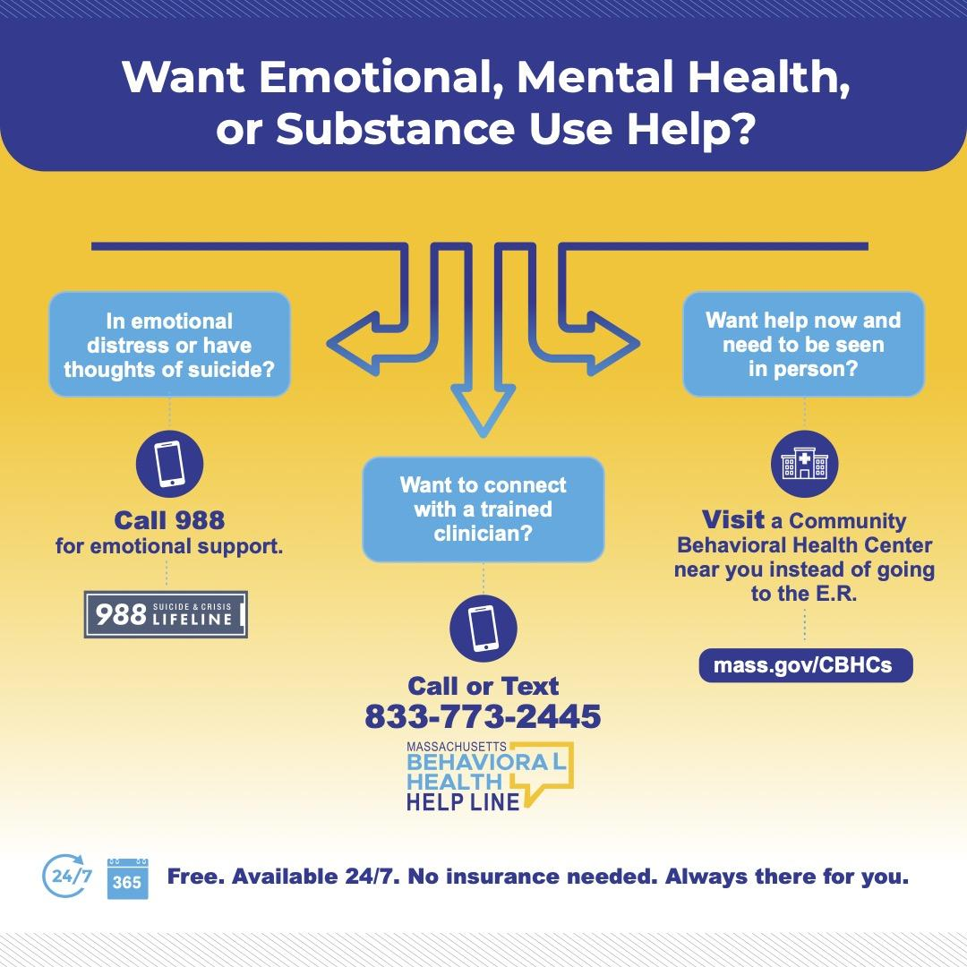

* Call 988 for emotional support
* Call or text the BHHL at 833-773-2445 to connect with a trained clinician
* Visit a CBHC to get help and be seen now in person instead of going to the ER

## Overview of the Development and Implementation of 988 and the Behavioral Health Help Line

SAMHSA 5-year vision: Transform America’s behavioral health crisis care system to one that saves lives by serving anyone, at any time, in a seamless way, from anywhere in the nation.

* Someone to talk to
  + Service: 988
  + SAMHSA 988 goal: 90%+ calls answered in-state
  + MA: 88% calls answered in-state (as reported by Vibrant, the 988 vendor, in December 2023)
  + 97% calls answered in-state (as reported by DPH in December 2023)
  + Deadline: 2023
* Someone to respond
  + Service: Behavioral Health Help Line (BHHL) for clinical assessment and connection to services
  + SAMHSA 988 goal: 80%+ individuals have access to mobile crisis response
  + MA: 100% of individuals *who call the BHHL or call/visit a local CBHC* have *the opportunity to* access to mobile crisis response
  + Deadline: 2025
* A safe place for help
  + Service: Community Behavioral Health Centers
  + SAMHSA goal: 80%+ individuals have access to community-based crisis care
  + MA: 100% of individuals *live within one of the 26 CBHC catchment areas and* have access to community-based crisis care (i.e., CBHCs and Community Crisis Stabilization)
  + Deadline: 2027

## Table of Contents

* Background
* Overview of the Development and Implementation of 988 and the Behavioral Health Help Line
* **Evaluation**
* Current Funding Sources
* Overview of the National Landscape and Funding Mechanisms
* Plans for 2024
* Commission Recommendations

## Evaluation: 988 Key Performance Indicators

* MA 988 Suicide & Crisis Lifeline: November 2023 Key Performance Indicators
  + Calls Received
    - KPI Target: n/a
    - November 2023: 5,803
  + Answer Rate
    - KPI Target: > 90%
    - November 2023: 89%
    - There is currently an 8pp discrepancy between nationally (89%) and locally (97%) measured answer rate
  + Abandoned Calls
    - KPI Target: < 5%
    - November 2023: 11%
  + Rollover Rate
    - KPI Target: < 10%
    - November 2023: 0.80%
  + Average Speed to Answer
    - KPI Target: < 20 seconds
    - November 2023: 30 seconds
  + Date Source: Vibrant 988 Broad State Metric Report, November 2023

## Evaluation: 988 Lifeline Awareness Campaign Reporting

* ThinkArgus, a marketing firm, enlisted a variety of research tactics to better understand the target audience and how to best connect with them. This included an environmental scan, digital ethnography, quantitative, and qualitative research. Based on the research findings, ThinkArgus developed four marketing objectives and a campaign position to inform the strategy and measurements for success.
* Marketing Objectives
  + Raise awareness of 988 while setting realistic expectations for the experience and outcomes
  + Lift the perceived value of the 988 experience - “calling is worth it”
  + Lower the barriers of entry including stigma, mistrust, and irrelevance
  + Differentiate 988 from other mental health and crisis support services
* **Campaign Dates:** 7/25/23 - 1/7/24
* **Tactics:** Digital display ads, social media (Facebook/Instagram), out-of-home (billboards, transit, convenience store posters, wildpostings)
* **Highlights:**
  + Digital click-to-call ads delivered 228 calls to the lifeline
  + Ads delivered 34k+ visits to the website
* Tactic: Digital display
  + Impressions: 9,720,561
  + Clicks: 29,180
  + Click Through Rate: 0.30%
* Tactic: Social media (Facebook/Instagram)
  + Impressions: 3,580,074
  + Clicks: 46,819
  + Click Through Rate: 1.31%
* Tactic: Out-of-home
  + Impressions: ~116,000
  + Clicks: -
  + Click Through Rate: -
* Total Impressions: ~129,300,635
* Total Clicks: 75,999
* Total Click Through Rate: 0.57%
* Reporting as of 12/3/23
* Impressions are the number of times an ad or another form of media appears on a user’s screen
* Click Through Rate or how many times something is clicked compared to how many times it is shown

## Evaluation: Behavioral Health Help Line Data

* January 1 – December 9, 2023
* Incoming/Outbound Call Volume
* Incoming Calls Handled: 39,942
* Incoming Texts/Chats: 17,694
* Outbound Calls: 45,253

## Evaluation: Behavioral Health Help Line Data

* January 1 – December 9, 2023
* BHHL Call County Distribution
* Franklin: 1%
* Berkshire: 2%
* Hampshire: 2%
* Barnstable: 3%
* Hampden: 7%
* Bristol: 8%
* Plymouth: 8%
* Norfolk: 9%
* Essex: 11%
* Worcester: 14%
* Suffolk: 14%
* Middlesex: 21%

## Evaluation: Behavioral Health Help Line Data

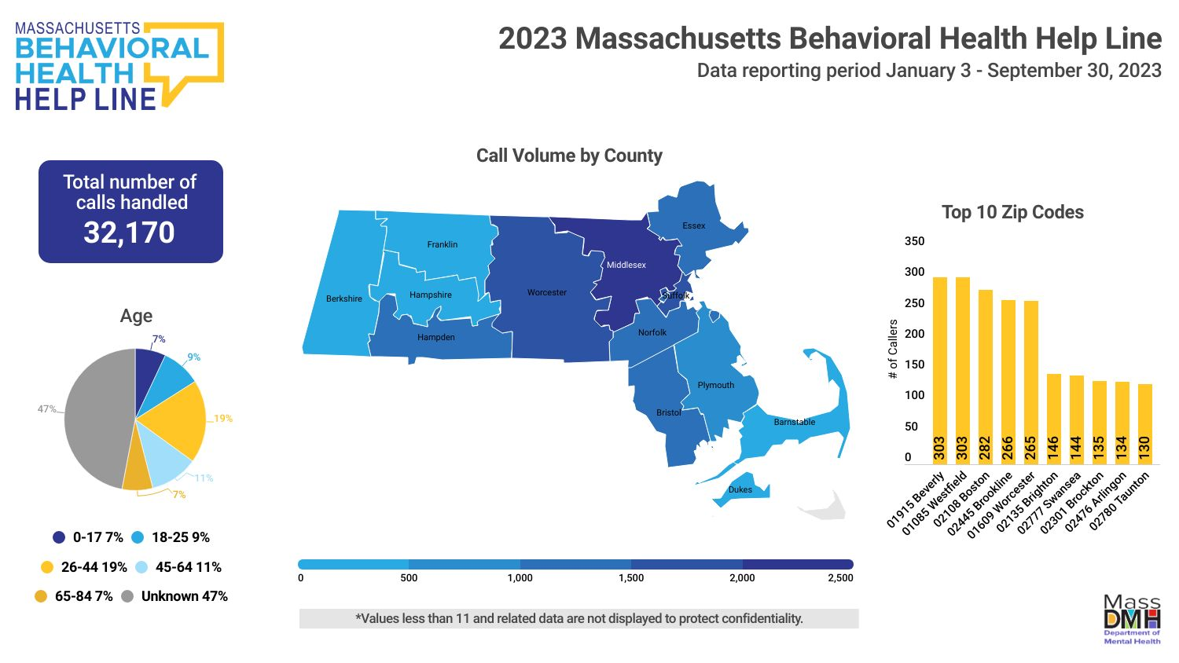

## Evaluation: Behavioral Health Help Line Data

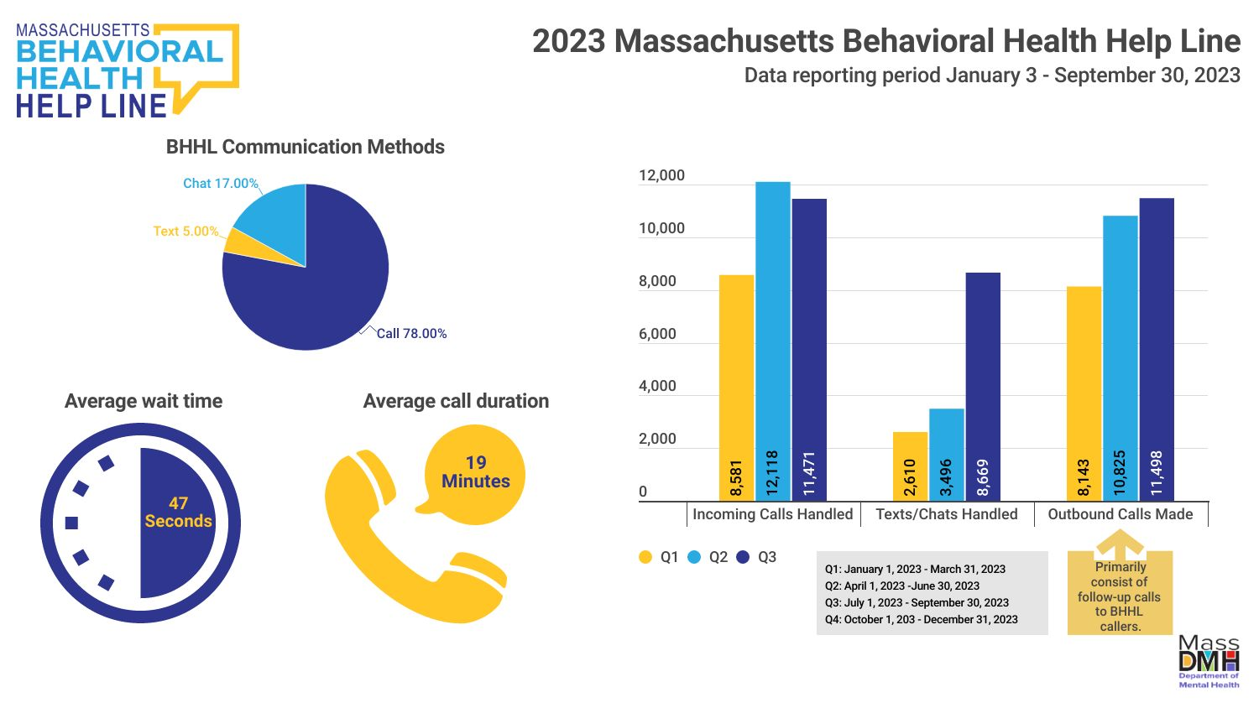

## Evaluation: Behavioral Health Help Line Data

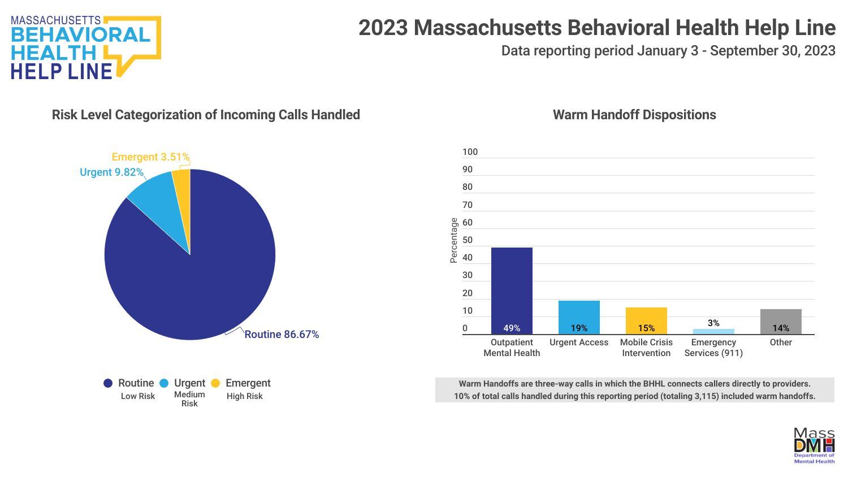

## Evaluation: Behavioral Health Help Line Data

* Performance benchmarks and improvement targets continue to be developed based on industry standards, Year 1 results and evaluation, and input from advisory groups. Data and reporting period January 3, 2023 – December 31, 2023.
* Year 1 metrics
  + Projection: 115,000 contacts; Actual: 107,383 contacts (calls, texts, chats, outbound calls)
  + Performance metrics in year 1
    - 95% of calls will be answered live within 15 seconds
      * Actual: 70%
    - 100% of assessed need for crisis intervention have a documented completed warm hand off in accordance with the approved protocols.
      * Actual: 100%
    - 95% of Clients calling the Help Line and requiring language services will be connected to language concordant Help Line staff or an interpreter within 45 seconds.
      * Average connection time = 18 seconds (currently unavailable as % of callers)
    - The Contractor shall ensure that systems are available 24/7/365 with 99.9% uptime and limited maintenance window.
      * 100% uptime for calls; 99.5% uptime for text/chat

## Table of Contents

* Background
* Overview of the Development and Implementation of 988 and the Behavioral Health Help Line
* Evaluation
* **Current Funding Sources**
* Overview of the National Landscape and Funding Mechanisms
* Plans for 2024
* Commission Recommendations

## Current Funding Sources

* **988 FY23 funding**
  + **State:** $10 million supplemental funding
  + **Federal:** $3.5 million SAMHSA grant (April 30, 2022 – April 29, 2024) (across multiple FYs)
* **988 Funding supports:**
  + Expansion of center operational hours (24/7/365)
  + Increased capacity through workforce and technology investments
  + Workforce training
  + Marketing and Communications Campaign (updated public transit awareness materials, workforce recruitment, and misinformation research)
* **988 FY24 funding**
  + **State:** FY24 received $1 million in the state budget
  + **Federal:** $4.1 million SAMHSA grant (September 30, 2023 – September 29, 2026)
* **BHHL FY24 funding**
  + **State:** $18.7M funded partly by the Behavioral Health Access and Crisis Intervention Trust Fund and state appropriation through the DMH budget

## Current Funding Sources

**Community Based Crisis Intervention funding**

* Crisis intervention at non-hospital, community locations through Mobile Crisis Intervention (MCI) is provided by Community Behavioral Health Centers (CBHCs).
* Crisis services and post-crisis stabilization are covered by MassHealth and most commercial payers.
  + **Chapter 177** mandates commercial payors to cover MCI and Adult Community Crisis Stabilization services, including follow-up crisis services. Link available at: malegislature.gov/laws/sessionlaws/acts/2022/chapter177
* **For people not covered for these services through their insurance, services are funded otherwise:**
  + **The FY23 budget** created a $33.7 million surcharge on commercial insurers to fund the Behavioral Health Access and Crisis Intervention Trust Fund (BH Trust).
  + Funding enables the BHHL and 24/7 mobile and community-based crisis intervention services to be accessible for all comers.
  + The BH Trust is authorized through FY24 and will require reauthorization to continue covering uninsured and underinsured people.
  + The FY23 budget requires the Health Policy Commission (HPC), in collaboration with EOHHS and CHIA, to issue a report on the use of the BH Helpline and BH crisis services and make recommendations for equitable and sustainable funding. The report must be submitted to the legislature by January 15, 2025.
* **A recommendation** is being made to maintain current funding levels to ensure all people are covered for crisis services in the community.

## Table of Contents

* Background
* Overview of the Development and Implementation of 988 and the Behavioral Health Help Line
* Evaluation
* Current Funding Sources
* **Overview of the National Landscape and Funding Mechanisms**
* Plans for 2024
* Commission Recommendations

## Overview of the National Landscape and Funding Mechanisms

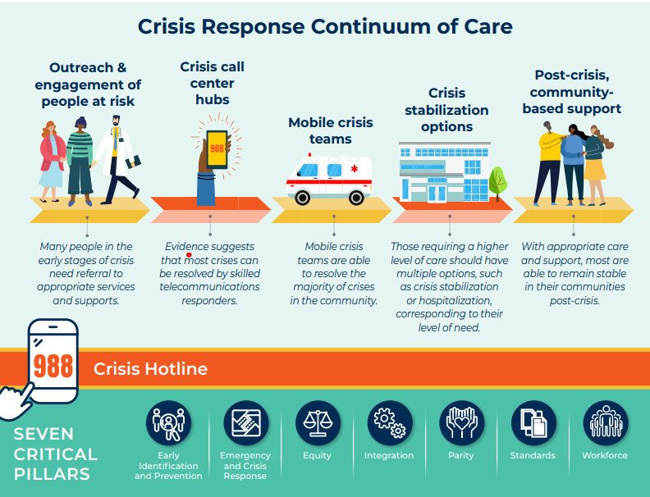

Consensus Approach and Recommendations for the Creation of a Comprehensive Crisis Response System (November 2021)

## Overview of the National Landscape and Funding Mechanisms

In its first year, the Commission heard presentations regarding national best practices. While there are state-specific differences leading to variability in overall models, the Massachusetts model includes common national best practices while addressing the state’s unique population and geography.

**Best Practices: Georgia**

* Georgia Crisis and Access Line (GCAL) is a call center integrated into the local healthcare system with 24-hour mobile crisis response coverage within 100 miles of every community.
* GCAL has real-time access to available crisis and detox beds throughout Georgia. It also provides phone, text, and chat intervention services, follow-up, and will make urgent and emergent appointments for callers.
* A 24/7/365 single point of entry exists for Mobile Crisis Dispatch, state contracted inpatient beds, and crisis stabilization units and state hospitals.

**Best Practices: Arizona**

* Arizona has several crisis call centers that leverage and maximize the use of technology, including:
* Electronic health records that are customized for crisis calls;
* Electronic dispatch of mobile teams that include sharing of clinical information and automatic collection of time stamp of activity;
* GPS technology to see the location of mobile teams in the community;
* Mobile teams have electronic tools to receive dispatch, record time stamps, and receive and send information regarding the crisis and intervention needed; and
* Call centers can support mobile teams in electronically setting up appointments with community-based providers.

## Overview of the National Landscape and Funding Mechanisms (continued)

**Best Practices: Washington state**

* Washington has three statewide hubs that receive all 988 calls for their covered regions and provide emotional support, conduct telephonic triage, dispatch mobile crisis teams, manage involuntary inpatient psychiatric hospital bed finding, coordinate bidirectionally with 911, and refer moderate-risk callers for next day follow-up calls, outreach, and support.

**Best Practices in the 988 Massachusetts model:**

* Phone, text, and chat
* 988 has a bi-directional connection with the BHHL, the front door for the MA 24/7/365 behavioral health crisis system, including Community Behavioral Health Centers covering every city and town in the Commonwealth, which can provide Mobile Crisis Intervention (MCI) in the community or at the site.
* Community Crisis Stabilization (CCS) units are 24/7, non-hospital beds.
* 988 can make warm hand-offs to the BHHL for MCI, urgent, and emergent appointments.
* Both 988 and the BHHL can make a warm hand-off to a caller’s local 911 department (if the caller’s location is known).

## Overview of the National Landscape and Funding Mechanisms

* Federal investments support some but not all costs to operationalize 988, and states are responsible for long-term funding and sustainability. While demonstrated best practices for financial sustainability have not yet emerged, the following summarizes current approaches to date.
* Although [federal](https://www.samhsa.gov/newsroom/press-announcements/20221216/hhs-announces-988-lifeline-grant-funding-under-bsca) [investments](https://appropriations.house.gov/sites/democrats.appropriations.house.gov/files/Labor%2C%20Health%20and%20Human%20Services%2C%20Education%2C%20and%20Related%20Agencies%20FY23%20Summary.pdf) support 988 nationally, states are responsible for long-term funding of the local 988 crisis call centers, which have historically received [minimal funding](https://www.samhsa.gov/sites/default/files/988-appropriations-report.pdf) from the federal government (typically between $2,500-$5,000 annually).
* Under the [National Suicide Hotline Designation Act of 2020](https://www.congress.gov/bill/116th-congress/senate-bill/2661/text?q=%7B%22search%22%3A%5B%22National+Suicide+Hotline+Designation+Act+of+2019%22%5D%7D&r=2&s=1), states can collect cell phone fees to help sustainably fund their local 988 call centers 988 legislation authorized states to collect cell phone fees to help sustainably fund 988 and other crisis services.
* [The Wireless Communications and Public Safety Act of 1999](https://www.fcc.gov/general/9-1-1-and-e9-1-1-services) mandated 911 to be the country’s universal emergency number; since then, users have automatically been charged [an average of about a dollar a month](https://www.nena.org/page/911RateByState) on their monthly phone bills to fund it.
* [Trust funds and general funds](https://nashp.org/state-legislation-to-fund-and-implement-988-for-the-national-suicide-prevention-lifeline/) appropriations have been set up by some states to support 988 crisis centers, but it is unclear whether these initiatives will sustainably support crisis centers’ long-term funding needs.
* Some states have considered [billing Medicaid](https://www.kff.org/medicaid/issue-brief/behavioral-health-crisis-response-findings-from-a-survey-of-state-medicaid-programs/) or other payers for crisis hotlines and other crisis services.
* 26 states have enacted legislation to fund 988; 13 states are appropriating general fund dollars
* Eight of these states have imposed a telecommunications fee (CA, CO, DE, MN, NV, OR, VA, WA).
* The FCC (Federal Communications Commission) has the authority to levy a nationwide tax but has yet to do so.

Saunders, Heather. “Behavioral Health Crisis Response: Findings from a Survey of State Medicaid Programs.” KFF, May 25, 2023.

Saunders, Heather. “Taking a Look at 988 Suicide & Crisis Lifeline Implementation One Year After Launch.” KFF, July 14, 2023.

DeGuzman C. A Year With 988: What Worked? What Challenges Lie Ahead? *KFF Health News.* July 26, 2023. Available [here](https://kffhealthnews.org/news/article/a-year-with-988-what-worked-what-challenges-lie-ahead/?utm_campaign=KFF-2023-The-Latest&utm_medium=email&_hsmi=267914436&_hsenc=p2ANqtz--Nnw5VUahfMCfOL72nPGX0YcCmKfh9k0Re0GGp273NFtgqjzX0S_DPoT2PIruEvd6RyFugcaXAed6i3Xg_mxK_QDnSvw&utm_content=267914436&utm_source=hs_email.).

## Table of Contents

* Background
* Overview of the Development and Implementation of 988 and the Behavioral Health Help Line
* Evaluation
* Current Funding Sources
* Overview of the National Landscape and Funding Mechanisms
* **Plans for 2024**
* Commission Recommendations

## Plans for 2024

* 988
  + Planning phase and implementation for local text and chat (supported by 2023-26 grant) (national text and chat already available)
* BHHL
  + Launch BHHL Treatment Connection Resource Directory (incorporating Massachusetts Association for Mental Health’s (MAMH) Network of Care and Massachusetts Behavioral Health Partnership’s (MBHP) Massachusetts Behavioral Health Access [MABHA])
  + Adding staff dedicated to conducting follow-up calls (e.g., bridge support between treatment visits, checking on referrals, etc.)
  + ForHealth Consulting (UMass Chan School of Medicine) evaluation reports due in 2024

## Table of Contents

* Background
* Overview of the Development and Implementation of 988 and the Behavioral Health Help Line
* Evaluation
* Current Funding Sources
* Overview of the National Landscape and Funding Mechanisms
* Plans for 2024
* **Commission Recommendations**

## Commission Recommendations – DRAFT for discussion

**Commission recommendations are based on the goal to ensure that the consumer experience is seamless, meets each caller’s needs, is equitable, and is continuously improving through quality assurance.**

* Conduct a feasibility assessment of technology-supported information sharing, in compliance with state and federal privacy laws, to ensure a coordinated technology-supported interface between 988 and the crisis system
* Implement a technology solution to enable one-touch, bi-directional transfer between the BHHL/crisis systems and 988.
* Stand up a system-wide evaluation process that solicits information from both 988 and the crisis system that includes:
  + Feedback from call-takers/staff about quality improvement opportunities.
  + Caller feedback
    - Direct feedback while ensuring compliance with the anonymous nature of 988
    - Aggregated consumer feedback through engagement with stakeholder and consumer advocacy groups that represent individuals who use 988 and the crisis system (e.g., KIVA center, NAMI, PPAL).
* Implement a feedback process with quality improvement activities for both 988 and the BHHL crisis system, and streamline input from the feedback QR codes, mailboxes, ombuds, advisory groups so there is a system-wide perspective on improvement opportunities.
* Develop a singular, streamlined directory to support all phone lines (988, BHHL, 211, etc.) so that there is a single source of truth for public information.
* Establish an ongoing process to review incidents of police dispatch to 988 and BHHL callers to ensure that dispatch is only happening when necessary and appropriate.
* Reauthorize funding through budget appropriation with consideration to any increased cost or new expenses.
* Stand up an evaluation process to explore whether there is fiscal efficiency in streamlining any aspect of 988 with any aspects of other call support and service lines, such as the BHHL.
* Require an EOHHS cross-agency point person to ensure cross department oversight of the 988 and crisis response system occurs, and policies, operations and funding are overseen centrally.
* Continuously involve consumer voices as an ongoing role in all evaluation, planning, and implementation decisions of 988 and the MA crisis system.

## Appendix: Commission Recommendations from MAMH (1/3)

* Establish **an entity, staffed at EOHHS, responsible for coordinating the crisis services reform work of** **MassHealth, DMH, DPH, EOPSS, and Statewide 911** regarding **988/the BHHL/CBHCS/911/mobile crisis/crisis stabilization units/other crisis lines/regional responders**.**\***,**
  + This entity oversees, for purposes of integration of the Commonwealth’s behavioral health crisis response, all matters related to the 988 service system and other crisis response elements.
  + This entity addresses 988 implementation, marketing and community engagement, financing, data collection, and workforce.
  + This entity oversees 988 workgroups and councils, but its creation does not change existing reporting structures.
  + This entity reports regularly to the 988 Commission.
* **988 Implementation Workgroup:** Establish **an interagency workgroup** **on 988 implementation.**
  + To **ensure full 988 integration within the crisis system** so that persons contacting 988 receive the most appropriate service whether from 988 or another service.
  + To pursue a standardized framework and coding definitions for screening, triaging, and reporting behavioral health calls across 988, the Behavioral Health Help Line, the Substance Use Helpline, and PSAPs.**
  + To ensure 988 is able to offer services by **call, text, chat, and video-conference.**
  + To **streamline and improve** the client experience.
  + To **establish, review, and update** **988 quality assessment measures,** including through processes to collect, review, and respond to
  + process data, using standardized measures aligned with other crisis responders*, **
  + outcome data, including longer-term outcome data, using standardized measures aligned with other crisis responders*, **
  + consumer feedback, and
  + complaints.

*We note that a similar recommendation appears in the *Crisis Services in the Commonwealth* Report of the Community Policing and Behavioral Health Advisory Council.

**We note that a similar recommendation appears in the *Massachusetts 911 Call Study: Assessing the Potential to Divert Behavioral Health Calls to Alternative Responses* Report of EOHHS and EOPSS.

## Commission Recommendations from MAMH (2/3)

* To work towards establishing cross-system data collection requirements/standards to assess and inform the capacity and performance of crisis services, including a statewide BH crisis dashboard that is public-facing and integrates 988, BHHL, MCI, hospital, and co-response data.*
* To review and update **training requirements** for the 988 workforce, in conjunction with other state agencies providing crisis services and with the participation of people with lived experience.** Training should address:
  + cultural competence;
  + issues of gender identity and sexual orientation;
  + implicit bias and other BIPOC issues;
  + developmentally appropriate responses to different age callers;
  + youth, adolescent, young adult, adult, and older adult behavioral health issues and family support; and
  + how to serve people with diverse behavioral health disabilities, particularly as such persons face situations which may not involve potential for suicidal.
* To improve the **service directory** supporting 988.
* To establish a process to **review cases of police dispatch** to persons contacting 988, to ensure that dispatch is occurring only when necessary and appropriate.
* To monitor and ensure **988 system alignment with national guidelines**, including those of SAMHSA, National Association of State Mental Health Program Directors, and Technical Assistance Center TAC, including planning to integrate the three pillars of 988 (someone to call, someone to respond, safe place to go).

 *We note that a similar recommendation appears in the *Crisis Services in the Commonwealth* Report of the Community Policing and Behavioral Health Advisory Council.

**We note that a similar recommendation appears in the *Massachusetts 911 Call Study: Assessing the Potential to Divert Behavioral Health Calls to Alternative Responses* Report of EOHHS and EOPSS.

## Appendix: Commission Recommendations from MAMH (3/3)

* **Marketing and Community Engagement**
  + Establish **an interagency workgroup** **on marketing and community engagement**
    - To develop an evaluation plan for consumer feedback, including from persons who decline to use 988 services, and identify gaps or opportunities for quality improvement.
    - To review the 2023 evaluation of the 988 marketing plan.
    - To make recommendations regarding efforts to reach communities most in need.
    - To make recommendations regarding non-suicide related calls to 988.
  + **Establish a consumer advisory council** to advise on marketing and community engagement.
    - The council includes representation of people: from BIPOC communities; from historically underserved or marginalized communities; who identify as LGBTQ; with lived experience of behavioral health conditions; who work in the positions being addressed by the workgroup; and who work in the position of a certified peer support specialist.
    - A single council member may not fill the requirement for more than one of these specially designated categories.
    - Representation on the council should also include both persons who have experienced crisis related to suicide and persons who have experienced other types of crises.
* **Financing**
  + Establish an **interagency workgroup on financing** **of 988**
    - To identify and report on one-time, ongoing, and potential **costs** associated with the 988 service system and its long-term sustainability.
    - To identify and report on current and potential **funding sources for the 988 service system**, including but not limited to a telephony tax, including through review of other states’ models for funding and an analysis of what might constitute an appropriate telephonic tax and how the funds from such a tax would be used.
    - To evaluate funding of other MA crisis and service lines to inform funding decisions regarding 988.
    - To evaluate potential means to achieve **fiscal efficiency**, such as by streamlining any aspects of the 988 Suicide and Crisis Lifeline with any aspects of other call support and service lines.

*We note that a similar recommendation appears in the *Crisis Services in the Commonwealth* Report of the Community Policing and Behavioral Health Advisory Council.

**We note that a similar recommendation appears in the *Massachusetts 911 Call Study: Assessing the Potential to Divert Behavioral Health Calls to Alternative Responses* Report of EOHHS and EOPSS.