# State 911 Overview and Implementation of Section 6-8 & 81 of Chapter 177 of the Acts of 2022

* 988 Commission Meeting
* June 26, 2023

## Overview of the State 911 Department

* Operates under Executive Office of Public Safety
  + Executive Director
  + Commission consisting of 22 members (as of November 2022) chaired by EOPSS
* Commission provides strategic oversight and guidance to the Department and advises the Department relative to its annual budget and all material changes thereto and in all matters regarding enhanced 911 service in the Commonwealth

## Commission Seats

* Secretary of Public Safety & Security (Chair)
* Colonel, State Police
* Commissioner, Commission for the Deaf/Hard of Hearing
* Department of Public Health
* Director, Information Technology Division
* Director, State Office on Disabilities
* MA Ambulance Association
* MA Chiefs of Police Association
* MA Communications Supervisors Association
* MA Emergency Medical Care Adv. Board
* MA Fire Chiefs Association (2)
* MA Major City Chiefs Association
* MA Police Association
* MA Sheriff’s Association
* MA Municipal Association
* Professional Fire Fighters of MA
* Police Commissioner, Boston
* State Fire Marshall
* Department of Mental Health
* Association for Behavioral Healthcare, Inc
* Individual with lived experience with behavioral health conditions & interactions with police

## Overview of the State 911 Department

* Responsible for coordinating, administering and maintaining Enhanced 9-1-1 for the Commonwealth
  + Funding provided by a monthly 9-1-1 surcharge on all devices that can access the 9-1-1 system.
  + Developing regulations and standards to ensure a consistent statewide approach to for the use and operation of Enhanced 9-1-1 including:
    - Technical standards
    - Operational standards
    - Training standards
* Massachusetts State 911 Department
  + 151 Campanelli Drive, Suite A, Middleborough, MA
  + Phone: 508-828-2911
  + Fax: 508-828-2587

## Role of the State 911 Department

* Oversee and maintain the statewide 9-1-1 system for emergency services.
  + Efficient and reliable 9-1-1 system for all residents and visitors of the Commonwealth.
* Helps support the efforts of the Public Safety Answering Points (PSAPs)
  + Through programs and grant funding, including equipment, training and certification of telecommunicators.
* Provides specialized telephone equipment for individuals with disabilities
  + Massachusetts Equipment Distribution Program (MassEDP)
  + Oversight of contracted services with MassRelay

## Grants Programs

* **Development Grant**
  + Designed to support the development and startup of regional public safety answering (PSAPs) or regional emergency communication centers (RECCs) to maximize effective 9-1-1 services.
* **Support & Incentive Grant**
  + Designed to assist PSAPs and RECCs with operational support in providing enhanced 9-1-1 service.

## Grants Programs continued

* **Training Grant**
  + Through this program, governmental entities hosting primary and regional PSAPs or RECCs are eligible to receive reimbursement for training-related costs associated with the 9-1-1 system.
* **Emergency Medical Dispatch (EMD) Grant**
  + Through this program, governmental entities hosting primary and regional PSAPs or RECCs are eligible to receive reimbursement for training-related costs associated with the 9-1-1 system.
* **PSAP Leadership Scholarship Program**
  + Recipients of the scholarship will have the opportunity participate in the Certified Public-Safety Executive (CPE) Course or the Communications Center Manager (CCM) course, or other State 911 Department approved executive development and leadership program.

## What is a Public Safety Answering Point (PSAP)?

* Critical connection point
* Receives emergency requests – calls and texts to 9-1-1
* Process emergency request according to specific operational procedures
* Dispatching resources such as Police Officers, Firefighters, and Emergency Medical Services (EMTs/Paramedics)

## Types of PSAPs in Massachusetts

* **211 PSAPs in Massachusetts**
  + Operated by/in Police, Fire and Emergency Medical Service (EMS) agencies; or Independently as an Emergency Communications Center (ECC)
* Types of PSAPs include:
  + Primary PSAPs for individual cities and towns
  + Regional PSAPs for multiple towns
  + Regional Emergency Communication Centers (RECCs) for multiple towns and all emergency town services
  + Secondary PSAPs which receive calls when transferred

## A Map of PSAPs in Massachusetts

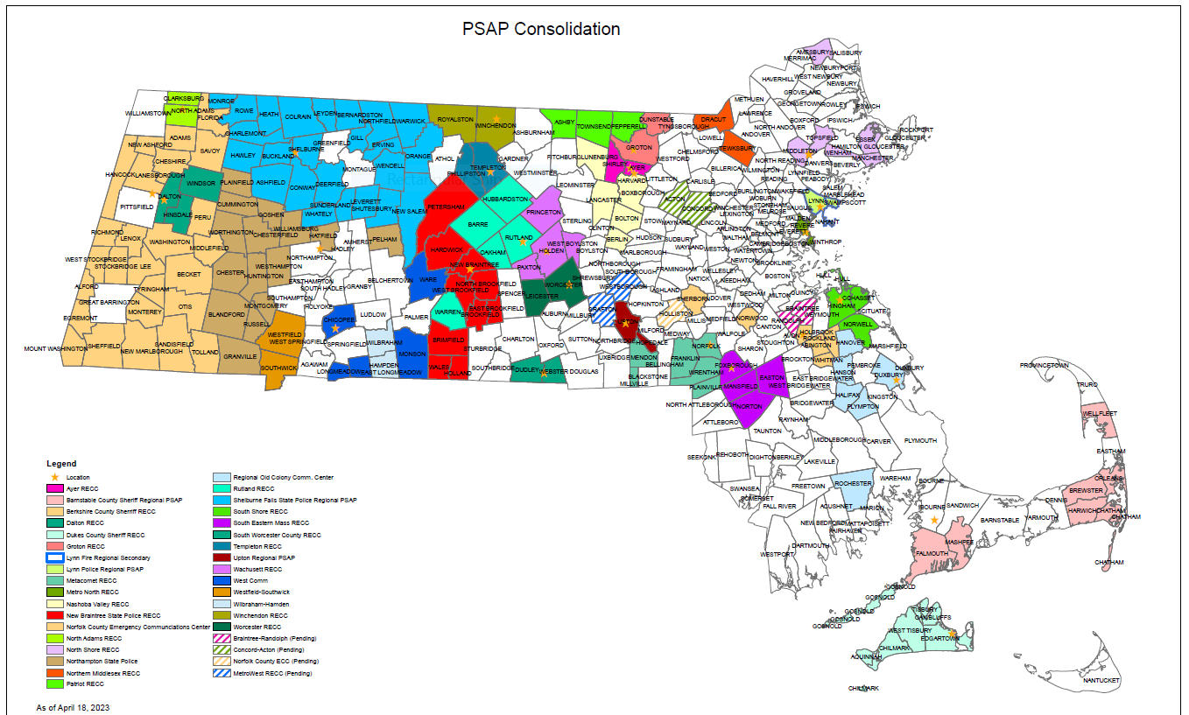

## State 911 Programs Overview

* The State 911 Department oversees a variety of different programs including:
  + Telecommunicator Certification Training for PSAP personnel
  + Public Safety Communications Academy for PSAP personnel
  + Telecommunicator Certification Program for civilians in Massachusetts
  + Public Education Program
  + Massachusetts Equipment Distribution Program (MassEDP)
  + Oversight of Mass Relay contracted services
  + Grants Programs
  + PSAP Operations
  + Compliance
  + TERT

## What is a Telecommunicator?

* **Telecommunicator** is a trained professional
* Works in a **PSAP**
* Receives, assess and prioritizes emergency requests
  + Including Police, Fire and Emergency Medical Services
  + Other local services

## Telecommunicator Certification Requirements

* **For NEW Enhanced 9-1-1 Telecommunicators**
  + Minimum of two days of 9-1-1 equipment/software and basic telecommunicator training
  + Minimum of forty hours of basic telecommunicator training
* **For Existing Certified Enhanced 9-1-1 Telecommunicators**
  + Sixteen hours of Department-approved continuing education
  + Beginning in 2024, a **minimum of two hours** will be required for behavioral health education
  + PSAPs are required to complete Annual Certification of Compliance

## Emergency Medical Dispatch (EMD)

* EMD is a systematic program of handling medical emergency requests.
  + Using predetermined protocols to dispatch the correct resources
  + Give instruction prior to the arrival of resources
* Telecommunicators certified in EMD receive specialized training through a vendor protocol system
* EMD for calls is provided using either of the following:
  + Certified emergency medical dispatchers at the PSAP
  + Certified EMD Resource, contracted services who provide pre-arrival instructors

## 988 Partnership with the Massachusetts PSAPs

* The State 911 Department began working with the 988 team in July of 2021 to determine the best way to assist with calls being made to 988
* 988 call centers were provided with the ten-digit numbers for every municipality in the Commonwealth so they could connect directly to first responders when needed
* 988 went live on July 16, 2022
* Education on 988 was and continues to be part of the training curriculum for newly hired telecommunicators

## Behavioral Health Help Line (BHHL) in Partnership with Massachusetts PSAPs

* November 2022:
  + The State 911 Department began working with the BHHL team
* December 2022:
  + PSAPs were notified that the BHHL would be going live in January of 2023
  + A BHHL job aid was created and distributed to all PSAPs
  + The BHHL team was provided with the ten-digit numbers for every municipality in the Commonwealth
* January 2023:
  + A one-button transfer titled “Behavioral Health Help Line” was added to every NG9-1-1 position at every PSAP
  + BHHL went live on January 3, 2023
* State 911 continues to work with the BHHL team on continued education and training

## Chapter 177 of the Acts of 2022

* Chapter 6A, Section 18B was amended by Chapter 177 of the Acts of 2022:
* Section 6: Additional state 911 Commission membership: (1) the Commissioner of Mental Health; (2) a representative of the Association for Behavioral Healthcare, Inc. with experience in delivering psychiatric emergency services; and (3) an individual with lived experience with behavioral health conditions and interactions with police. (1) and (2) have been appointed, (3) is vacant.

## Chapter 177 of the Acts of 2022

* Section 7: Support Grant allocation of funds to primary PSAPs provided under this grant that dispatch police, fire protection, emergency medical services and mobile behavioral health crisis response services, taking into account if any such services are provided by a private safety department. This grant was approved by the DTCC June 2023.
* Section 8: Each primary and regional PSAP shall be equipped with a system approved by the department for processing of requests for emergency services from persons with mental health or substance use conditions. This has been completed in 2023.

## Chapter 177 of the Acts of 2022

* Section 81: The state 911 department shall update the 560 CMR 5.00 to integrate training on identification of and response to callers experiencing behavioral health crises, which may include crisis intervention training and training on the appropriate diversion of people with behavioral health conditions away from law enforcement response to appropriate behavioral health treatment and support, into the certification standards for certified enhanced 911 telecommunicators. The CMR update was approved by the State 911 Commission and is now in the statutory process towards promulgation by the end of 2023.