MassHealth Technical Refresh
999 Acknowledgement

MassHealth will issue 999 Acknowledgements in response to inbound transactions in the following manner:

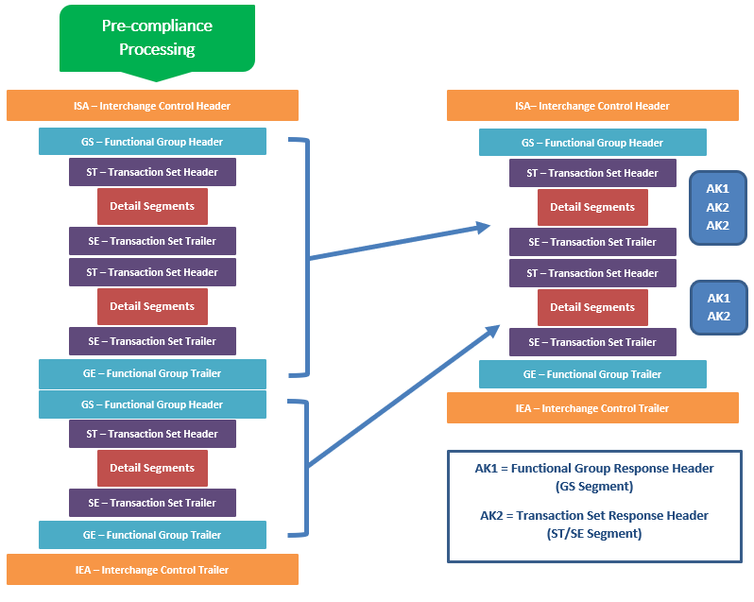

Transactions submitted with multiple Interchange Headers/Trailers and Functional Group Headers/Trailers, will receive a 999 Acknowledgement that contains a single Interchange Header/Trailer with one Functional Group Header/Trailer that contains multiple Transaction set Headers/Trailers
