A Profile of Family Planning Among Massachusetts Adults
2008–2010

Results from the Behavioral Risk Factor Surveillance System

Health Survey Program
Division of Research and Epidemiology
Bureau for Health Information,
Statistics, Research, and Evaluation
Massachusetts Department of Public Health



March 2014

Massachusetts Department of Public Health
Health Survey Program

Family Planning Program
Division of Primary Care and Health Access
Bureau of Community Health and Prevention

Health Survey Program
Division of Research and Epidemiology
Bureau of Health Information, Statistics, Research, and Evaluation

A Profile of Family Planning Among Massachusetts Adults
2008–2010

Results from the Behavioral Risk Factor Surveillance System

Deval L. Patrick, Governor
John Polanowicz, MBA, Secretary of Health and Human Services
Cheryl Bartlett, RN, Commissioner, Department of Public Health

Bureau of Community Health and Prevention
Carlene Pavlos, Director
Ned Robinson-Lynch, MA, Director, Division of Primary Care and Health Access

Bureau of Health Information, Statistics, Research and Evaluation
Gerald F. O’Keefe, JD, Director
Bruce Cohen, PhD, Director, Division of Research and Epidemiology

March 2014

Acknowledgements

The staff of the Family Planning Program and Health Survey Program prepared this report:

Family Planning Program
Bridget Larson, MPH, Epidemiologist
Jill Clark, MPH, Assistant Director
Lenore Tsikitas, MPH, Health Access and Promotion Coordinator
Karen Edlund, RN, Director

Health Survey Program
Bertina Backus, MPH, Epidemiologist
Maria McKenna, MPH, Epidemiologist
Diane Gonsalves, MS, MPH, Epidemiologist
Helen Hawk, PhD, Director

We wish to express our gratitude to the residents of Massachusetts who participated in this survey, and to Abt SRBI, Inc. and the dedicated interviewers who helped make this survey possible.

Thanks also to Olivia Sappenfield, CSTE Fellow, for her careful review of this report.

For further information about this report, about the Behavioral Risk Factor Surveillance System, or the Health Survey Program, please contact: Bruce Cohen, Interim Director of the Health Survey Program, Bureau of Health Information, Statistics, Research and Evaluation, Massachusetts Department of Public Health, 250 Washington Street, 6th floor, Boston, MA 02108-4619. Telephone: (617) 624-5635.
Email: Bruce.Cohen2@state.ma.us. Website: http://www.mass.gov/dph/hsp

For further information about the Family Planning Program, please contact: Karen Edlund, Family Planning Program Director, Bureau of Community Health and Prevention, Massachusetts Department of Public Health, 250 Washington Street, 5th floor, Boston, MA 02108-4619. Telephone: (617) 624-6012. Email: Karen.Edlund@state.ma.us. Website: http://www.mass.gov/dph/familyplanning

Table of Contents
Massachusetts Department of Public Health i
Acknowledgements i
Table of Contents ii
Introduction 1
About this report 1
About Massachusetts BRFSS 2
Terms and Definitions 2
Data Notes 3
1. Unintended Pregnancy 6
Background 6
1.1 Demographic Characteristics 7
Age 7
Race/Ethnicity 8
Education 8
Income 9
1.2 Geographic Region 10
1.3 Additional Risk Factors 10
1.4 Access to Health Care and Impact of Health Care Reform on Unintended Pregnancy 11
2. Birth Control 13
Background 13
2.1 Types of Birth Control Methods 13
2.2 Demographics 15
Age 15
Race/Ethnicity 15
Education 16
Income 17
Language 18
2.3 Geographic Region 19
2.4 Additional Risk Factors 19
2.5 Not Using Contraception 19
Women Not Wanting More Children 20
2.6 Access to Health Care and Impact of Health Care Reform on Contraception Use 21
2.7 Emergency Contraception 21
Conclusion 22
Boston 24
Fall River 25
Lawrence 25
Lowell 26
New Bedford 27
Springfield 27
Worcester 28
Appendix II: State Detailed tables 30
Appendix III: EOHHS Regions 36
Appendix IV: References 37

List of Figures
Figure 1: Unintended Pregnancy among Women ages 18-44 in Massachusetts 1998-2010, BRFSS 1998-2010 (N=1068) 6
Figure 2: Unintended Pregnancy among Women ages 18-44 in Massachusetts by Age Group, BRFSS 2008/2010 (N=739) 7
Figure 3: Unintended Pregnancy among Women ages 18-44 in Massachusetts by Race/Ethnicity, BRFSS 2008/2010 (N=714) 8
Figure 4: Unintended Pregnancy among Women ages 18-44 in Massachusetts by Education, BRFSS 2008/2010 (N=738) 9
Figure 5: Unintended Pregnancy among Women ages 18-44 in Massachusetts by Income, BRFSS 2008/2010 (N=678) 9
Figure 6: Unintended Pregnancy among Women ages 18-44 in Massachusetts by Massachusetts Region, BRFSS 2008/2010 (N=739) 10
Figure 7: Unintended Pregnancy among Women ages 18-44 in Massachusetts by Smoking Status, BRFSS 2008/2010 (N=737) 11
Figure 8: Birth Control Method Used by Type among Women ages 18-44 in Massachusetts, BRFSS 2008/2010 (N=1165) 13
Figure 9: Birth Control Method Used by Category among Women ages 18-44 in Massachusetts, BRFSS 2008/2010 (N=1165) 14
Figure 10: Any Birth Control Use among Women ages 18-44 in Massachusetts by Age Group, BRFSS 2008/2010 (N=1646) 15
Figure 11: Any Birth Control Use among Women ages 18-44 in Massachusetts by Race/Ethnicity, BRFSS 2008/2010 (N=1599) 16
Figure 12: Any Birth Control Use among Women ages 18-44 in Massachusetts by Education, BRFSS 2008/2010 (N=1643) 16
Figure 13: Birth Control Use among Women ages 18-44 in Massachusetts by Income and Method Type, BRFSS 2008/2010 (N=1056) 17
Figure 15: Birth Control Use and Emergency Contraception (EC) Awareness among Women ages 18-44 in Massachusetts by Language, BRFSS 2008/2010 18
Figure 16: Any Birth Control Use among Women ages 18-44 in Massachusetts by EOHHS Region, BRFSS 2008/2010 (N=1642) 19
Figure 17: Contraception Method Used by Women ages 18-44 in Massachusetts Who Do Not Want to Have a Child Any Time in the Future, BRFSS 2008/2010 (N=691) 20
Figure 18: Selected Health Indicators among Women in Boston ages 18-44, BRFSS 2008/2010 24
Figure 19: Selected Health Indicators among Women in Fall River ages 18-44, BRFSS 2008/2010 25
Figure 20: Selected Health Indicators among Women in Lawrence ages 18-44, BRFSS 2008/2010 26
Figure 21: Selected Health Indicators among Women in Lowell ages 18-44, BRFSS 2008/2010 26
Figure 22: Selected Health Indicators among Women in New Bedford ages 18-44, BRFSS 2008/2010 27
Figure 23: Selected Health Indicators among Women in Springfield ages 18-44, BRFSS 2008/2010 27
Figure 24: Selected Health Indicators among Women in Worcester ages 18-44, BRFSS 2008/2010 28

List of Tables
Table 1: Contraception Categories 14
Table 2: Reason given for Not Using Contraception by Women ages 18-44 in Massachusetts, BRFSS 2008/2010 (N=355) 20
Table 3: Detailed City Tables, Massachusetts BRFSS 2008/2010 29
Table 4: Demographic Characteristics of Women ages 18-44 in Massachusetts, BRFSS 2008/2010 30
Table 5: Demographic Characteristics of Women ages 18-44 in Massachusetts Reporting an Unintended Pregnancy, BRFSS 2008/2010 31
Table 6: Unintended Pregnancy among Women ages 18–44 in Massachusetts by Year, BRFSS 2008/2010 32
Table 7: Type of Birth Control Currently Used among Women ages 18–44 in Massachusetts by Type, BRFSS 2008/2010 32
Table 8: Type of Birth Control Currently Used among Women ages 18–44 in Massachusetts by Category, BRFSS 2008/2010 32
Table 9: Demographic Characteristics of Women Reporting Use of a Birth Control Method among Women ages 18–44 in Massachusetts, BRFSS 2008/2010 33
Table 10: Women ages 18-44 in Massachusetts That Are Not Using Birth Control by Income Group, BRFSS 2008/2010 33
Table 11: Birth Control Use and Knowledge among Women ages 18–44 in Massachusetts by Language, BRFSS 2008/2010 33
Table 12: Health Care Access Indicators among Women ages 18–44 in Massachusetts by Language, BRFSS 2008/2010 34
Table 13: Comparison of Health Care Access Indicators among Women ages 18–44 in Massachusetts by Year, BRFSS 2004/2006 and BRFSS 2008/2010 34
Table 14: Birth Control and Emergency Contraception Use and Knowledge Changes among Women ages 18–44 in Massachusetts by Survey Year, BRFSS 2008, 2010 34
Table 15: Access to Care Indicators among Men and Women in Massachusetts by Survey Year, BRFSS 2008, 2010 34
Table 16: Unintended Pregnancy among Women ages 18–44 in Massachusetts by Health Care Access Indicators, BRFSS 2008/2010 35
Table 17: Birth Control Use among Women ages 18–44 in Massachusetts by Health Care Access Indicators, BRFSS 2008/2010 35

Introduction

About this report
The Massachusetts Department of Public Health Family Planning Program (FPP) and the Health Survey Program collaborated on this report to examine reproductive health data from the Behavioral Risk Factor Surveillance System (BRFSS). The FPP promotes and provides comprehensive family planning and reproductive health care services to uninsured Massachusetts residents under 300% of the Federal Poverty Level (FPL) as well as confidential services to adolescents at any income level. Other services provided by the FPP include education and technical assistance, outreach, and supportive services to promote access to clinical services in communities with high-risk populations. Through these services, the FPP seeks to prevent unintended pregnancy and sexually transmitted diseases, promote sexual and reproductive health, and provide access to reproductive health services for low-income and uninsured populations throughout Massachusetts. Utilizing data from the BRFSS about health knowledge and behavior of adults in Massachusetts, this report provides detailed reproductive health information for policy development and program planning. This report updates a previous report covering 2006-2008 data.¹

Family planning and reproductive health questions have been included in the BRFSS since 1998. These questions have changed over time, reflecting current legislative priorities and the changing health care landscape. For this report, we focused on the family planning questions asked in the 2008 and 2010 surveys. These data are sufficiently recent to be relevant for program planning and policy development, and sufficiently comparable to allow aggregation of responses across years. Of note, these two years are the first to include statewide data on reproductive health following the implementation of Massachusetts health care reform.

Chapter 58 of the Acts of 2006, An Act Providing Access to Affordable, Quality, Accountable Health Care was landmark health care reform legislation intended to improve access to comprehensive health care by increasing health insurance coverage, restoring previously cut programs, expanding access to Medicaid, and improving health care quality. Reform in the Commonwealth includes fines for employers of 11 or more employees who do not offer health insurance to their employees, expansion of public programs, insurance market reforms, the launch of publicly subsidized private insurance for those under 300% of the FPL, and a mandate that all residents have health insurance (if they can afford it) or face a penalty. By July 2007, all Massachusetts residents were obligated to obtain health insurance or apply for a hardship waiver exempting them from this requirement. The data included in this report focus on the period after Massachusetts reform implementation.

The data available for this report cover a wide range of family planning and reproductive health related issues, including pregnancy intention, contraceptive use, and access to health care. When sample sizes are sufficient, these questions have been analyzed to examine differences in sex, race and ethnicity, income, age, educational attainment, geography, and preferred language. Additional risk factors for poor health were also included in the analysis, such as use of tobacco, alcohol, and other substances; obesity; presence of comorbid chronic health conditions; and disability status. This level of detail allows program managers to tailor their efforts to meet the needs of those populations most at risk for poor reproductive health outcomes. For additional data on the demographics and health status of the population studied, see the 2010 BRFSS Annual Report.²

About Massachusetts BRFSS
The BRFSS is a continuous, random-digit-dial, landline-only telephone survey of adults ages 18 and older and is conducted in all states as a collaboration between the Centers for Disease Control and Prevention (CDC) and state departments of health. The survey has been conducted in Massachusetts since 1986. The BRFSS collects data on a variety of health risk factors, preventive behaviors, chronic conditions, and emerging public health issues. The information obtained in this survey assists in identifying the need for health interventions, monitoring the effectiveness of existing interventions and prevention programs, developing health policy and legislation, and measuring progress toward attaining state and national health objectives.

Each year, the BRFSS includes a core set of questions developed by the CDC. In 2008 and 2010, these questions addressed health status, health care access and utilization, overweight and obesity status, asthma, diabetes, immunizations, tobacco use, alcohol consumption, HIV/AIDS testing, and other selected public health topics.

In addition to the core CDC questions, the Massachusetts Health Survey Program, in collaboration with Massachusetts Department of Public Health programs, added a number of topics to the surveillance instrument including environmental tobacco exposure, cancer, disability and quality of life, sexual violence, sexual behavior and other selected topics. Family planning is included as a state-added topic on the survey in even numbered years.

Interviews were administered in the respondents’ preferred language when possible, with a choice of English, Spanish, or Portuguese. In 2008, 20,559 interviews were conducted; and in 2010, 16,311 interviews were conducted. To increase the number of respondents who belong to racial and/or ethnic minority groups, BRFSS consistently oversampled the cities of Boston, Worcester, Springfield, Lawrence, Lowell, Fall River, and New Bedford between 2006 and 2010.

Massachusetts sample design includes three distinct versions of the questionnaire (or “splits”), to allow for an increase in the number of questions asked without an increase in the length of the survey. Family planning questions are asked of a third of all respondents, or in one “split” of the survey. In 2008, this split contained 6,812 respondents; in 2010, it contained 5,452 respondents.

Terms and Definitions
Disability was defined as having one or more of the following conditions for at least one year: (1) impairment or health problem that limited activities or caused cognitive difficulties; (2) used special equipment or required help from others to get around; or (3) reported a disability of any kind.

Race-ethnicity categories in this report include White, Black, and Hispanic. All respondents reporting Hispanic ethnicity are included in the Hispanic category regardless of race. Therefore, when referring to White or Black respondents, only non-Hispanic White and Black respondents are included in the analysis. Data are not presented on Asian/Pacific Islanders, American Indians/Alaska Natives, or Other race due to insufficient sample size.
Unintended pregnancy:
All women ages 18–44 who were currently pregnant or had been pregnant in the past five years were asked if they had wanted to be pregnant sooner, later, or not at all. Unintended pregnancy was defined as wanting to be pregnant later or not at all.
Use birth control:
Women ages 18–44, who had not had a hysterectomy and were not currently pregnant, were asked whether they or their partners were now doing anything to keep from getting pregnant. Those who responded yes were considered to be using birth control.
Not using a method:
Women were classified as not using a birth control method if:
- The woman was not doing anything to keep from getting pregnant,
- She had a partner/was sexually active,
- She was not currently pregnant,
- She had not had a hysterectomy,
- She did not have a same sex partner,
AND
- The answer to the question “what is the main reason you or your partner are not doing anything to keep from getting pregnant?” was NOT ‘want a pregnancy’, ‘tubes tied’, ‘vasectomy’, ‘hysterectomy’, or ‘currently pregnant.’
In the BRFSS survey, women ages 18–50 were asked questions that allowed classification to using/not using a birth control method categories.

Men were classified as not using a birth control method if:
- The man was not doing anything to keep his partner from getting pregnant,
- He had a partner/was sexually active,
- His partner was not currently pregnant,
- He had not had a vasectomy,
- He did not have a same sex partner,
AND
- The answer to the question “what is the main reason you or your partner are not doing anything to keep from getting pregnant?” was NOT ‘want a pregnancy’, ‘tubes tied’, ‘vasectomy’, ‘hysterectomy’, or ‘currently pregnant.’
In the BRFSS survey, men ages 18–59 were asked questions that allowed classification to using/not using a birth control method categories.

Data Notes
The BRFSS data are weighted to take into account differences in probabilities of selection due to the telephone number, the number of telephone lines in a household, and the number of adults in a household. Adjustments are also made to account for non-response and non-coverage of households without landline telephones. All the weighting factors are multiplied together and are adjusted to state population by gender, age and race/ethnicity to get the final weight for each respondent so that the weighted BRFSS data represents the adult population of Massachusetts. Details on the demographics of the sampled population used in this report can be found in Appendix II. Since 2008, additional weights have been calculated for use with questions that are asked on only one version (“split”) of the questionnaire. The intent of these “split weights” is to obtain a more accurate estimate of prevalence for health indicators that are asked of only a portion of the survey respondents.

The crude percentage is the weighted proportion of respondents in a particular category. When percentages are reported in the text of this report, they are referring to crude percentages. The crude percentage of respondents used in this report reflects the burden of a certain health status indicator in a specific group of the population (age group, gender, etc).

The underlying sample size (N) in each cell of the presented tables is the number of people who answered “yes” or “no” to the corresponding question. The crude proportion is a weighted ratio of those who answered “yes” to the corresponding question versus all who responded to the question. Those who responded “don’t know” or refused to respond to a question were excluded from the analysis of that question except when otherwise indicated.

The 95% confidence interval (95% CI) is a range of values determined by the degree of variability of the data within which the true value is likely to lie. The confidence interval indicates the precision of a calculation; the wider the interval, the less precision in the estimate. Smaller population subgroups or smaller numbers of respondents yield less precise estimates.

Statistical significance (at the 95% probability level) was considered as a basis when we used the terms “more likely” or “less likely” or “higher” or “lower” to compare percentages. We considered the difference between two percentages to be statistically significant (p<0.05) if the 95% confidence intervals surrounding the two percentages do not overlap, which is a conservative estimation for determining statistical significance.³ Confidence intervals were used when determining statistical significance for all graph and charts in this report.

In order to increase the precision of determining a statistically significant difference between two estimates we used chi-square statistical test with one degree of freedom when corresponding confidence intervals were slightly overlapped.

Additionally, if the chi-square statistical test resulted in a p-value <0.05, then the two estimates were considered statistically significantly different. The p-value describes the probability of finding an estimate at least as extreme as the observed estimate produced by a given statistical test, assuming the null hypothesis is true. The probability of the p-value can be any value 0 to 1, where 1 indicates the probability that the null hypothesis is true is 100%. In the case of the chi-square statistical test, the null hypothesis poses that the two estimates are the same. Some demographic data that are not presented in this report were analyzed using chi-square statistical testing.

Suppression of the presented estimates:
- Estimates and their 95% confidence intervals are not presented in the tables if the underlying sample size is less than 50 respondents.
- Following recommendations of the National Center for Health Statistics, data are not presented in the tables if a ratio of standard error to the estimate itself exceeds 30% (relative standard error of greater than 30%). Standard error of the estimate is a measure of its variability. Bigger standard errors yield wider confidence intervals and less reliable estimates.⁴

Analysis by income:
The federal poverty level (FPL) is used to determine eligibility for multiple programs in Massachusetts, including MDPH-subsidized family planning services. Historically, MDPH has reimbursed family planning clinics for services provided to residents below 200% of the federal poverty level. In July of 2008, this was increased to 300% to reflect eligibility for other state programs created by health care reform legislation, such as Commonwealth Care, a subsidized insurance program for low-income residents of the Commonwealth.

BRFSS income categories, however, do not correspond with the yearly estimates of FPL issued by the U.S. Department of Health and Human Services (HHS). FPL was thus approximated based on reported household income of the respondent and the number of adults and children living in the household. BRFSS respondents were assigned to “low-income” or “higher-income” categories which correspond to an approximation of above or below 300% of the federal poverty level.

HHS uses two different measures to determine poverty: income thresholds (which are used by statisticians to approximate numbers of people living in poverty) and income guidelines (which determine eligibility for assistance programs). Since we were interested in assessing health risks among women who were eligible for family planning programs, we decided to use the guidelines to approximate FPL instead of the thresholds. Below are tables detailing the criteria used for categorizing respondents into low- or higher-income categories:

Estimating 300% of HHS Poverty Level, 2008
Family Size | Income at 300% of HHS FPL ($) | BRFSS Income Used to Estimate 300% of FPL($)
1  2  3  4  5+ | 31,200  42,000  52,800  63,600  74,400 (for 5 people) | Less than 25,000  Less than 35,000  Less than 50,000  Less than 50,000  Less than 75,000

Estimating 300% of HHS Poverty Level, 2010
Family Size | Income at 300% of HHS FPL ($) | BRFSS Income Used to Estimate 300% of FPL ($)
1  2  3  4  5+ | 32,490  43,710  54,930  66,150  77,370 (for 5 people) | Less than 25,000  Less than 35,000  Less than 50,000  Less than 50,000  Less than 75,000

Estimating income from the BRFSS presents several limitations. Income categories on the BRFSS do not directly align with those of the federal poverty level such that there are most likely more people who are <300% FPL than can be included in this income category (see table). Furthermore, some respondents did not provide a household income level and/or did not report number of children living in the household (answer categories “don’t know,” “refused,” or “missing”) and were thus excluded from the income analysis, as total household income or total household size could not be determined. In 2008, 13.2% of respondents were missing household income and/or household size and were excluded from the analysis; in 2010, 16.2% of respondents were missing this information and excluded from analysis.

Unintended Pregnancy

Background
An unintended pregnancy refers to a pregnancy that was either not wanted at all, or not wanted at that particular time.⁵ Unintended pregnancies are associated with poor health outcomes for infants and mothers, and have negative social and economic implications for society as a whole. Mothers with unintended pregnancies are less likely to seek prenatal care in the first trimester, are more likely to drink alcohol and smoke tobacco during pregnancy, are less likely to breastfeed, and are more likely to suffer from depression.⁶⁻⁷ Children born to women who did not plan on becoming pregnant are more likely to be low birth weight and small for gestational age, are at an increased risk for child abuse, and have fewer developmental resources available such as positive interactions with their mothers or opportunities for skill development.⁶⁻⁸ Unintended pregnancy is also expensive; in 2006 the total public expenditures in the United States for births resulting from unintended pregnancies were estimated at $11 billion, of which $182 million could be attributed to births in Massachusetts.⁹

Massachusetts has been using the BRFSS to monitor unintended pregnancy since 1998. Since that time the proportion of pregnancies that were unintended has significantly declined from a high of 30.9% in 1998 to 18.6% in 2010 (Figure 1). These numbers are far lower than national estimates of unintended pregnancy (49% in 2006)¹⁰ and are also well within the benchmarks set by Healthy People 2020 (44.0%).¹¹

Figure 1: Unintended Pregnancy among Women ages 18-44 in Massachusetts 1998-2010, BRFSS 1998-2010 (N=1068)
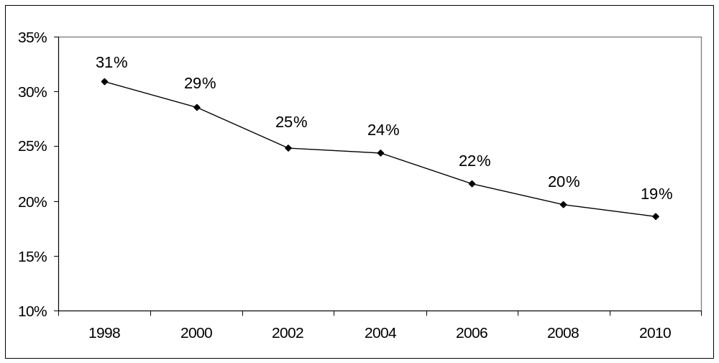
Although Massachusetts has made noteworthy progress in addressing unintended pregnancy, there are still populations in the Commonwealth that experience higher rates of unintended pregnancies than others. The following portion of this report highlights differences in demographic characteristics and their relationship with unintended pregnancy.
A note about unintended pregnancy data sources in Massachusetts

In Massachusetts there are two major data sources for identifying unintended pregnancy: the BRFSS and the Pregnancy Risk Assessment Monitoring System (PRAMS). The BRFSS asks women about pregnancies within the last 5 years, whereas PRAMS is administered within 6 months of delivery. Because of the difference in methodology, these two surveys may produce slightly different estimates of unintended pregnancy. PRAMS began collecting data in Massachusetts in 2007. For more information on PRAMS go to: http://www.mass.gov/dph/prams

1.1 Demographic Characteristics

Age
The percentage of unintended pregnancies was significantly higher among women ages 18–24 compared to women ages 35–44 (62.0% vs. 14.1%, Figure 2).

Figure 2: Unintended Pregnancy among Women ages 18-44 in Massachusetts by Age Group, BRFSS 2008/2010 (N=739)
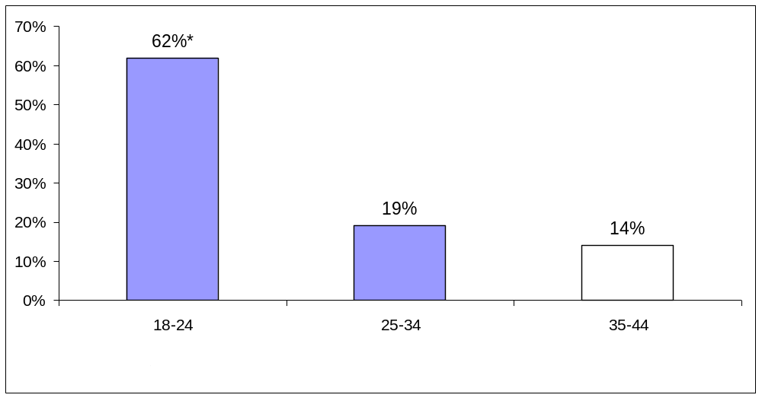

Race/Ethnicity
The highest percentage of unintended pregnancies occurred in Black women (38.8%; Figure 3) followed by Hispanic women (36.6%) compared to White women (15.8%).

Figure 3: Unintended Pregnancy among Women ages 18-44 in Massachusetts by Race/Ethnicity, BRFSS 2008/2010 (N=714)
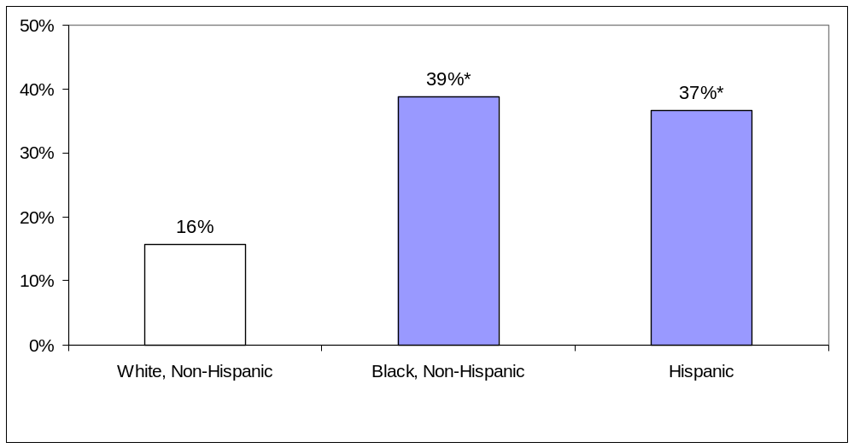

Education
Women’s education level was associated with pregnancy intention (Figure 4). The highest percentage of unintended pregnancies occurred in women without a high school diploma (47.4%); the percentage of unintended pregnancies was lower among high school graduates (33.4%) and nearly half that in women who attended college for 1–3 years (22.4%). The lowest percentage of unintended pregnancies occurred in women with at least a bachelor’s level college degree (12.1%), which was significantly lower than the groups that had not completed any college, but not significantly different from those who had attended college for 1-3 years .

Figure 4: Unintended Pregnancy among Women ages 18-44 in Massachusetts by Education, BRFSS 2008/2010 (N=738)
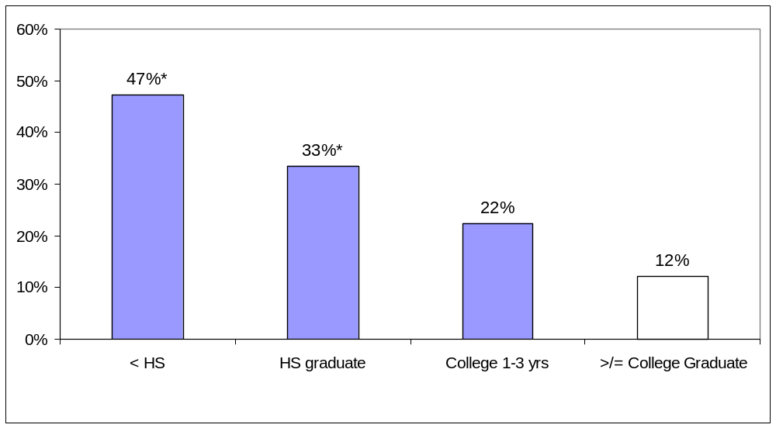

Income
Low income Massachusetts residents had higher rates of unintended pregnancy than higher income women (31.0% vs. 12.5%, Figure 5). (For a discussion on income estimates and the federal poverty level, see the Data Notes section of this report).

Figure 5: Unintended Pregnancy among Women ages 18-44 in Massachusetts by Income, BRFSS 2008/2010 (N=678)
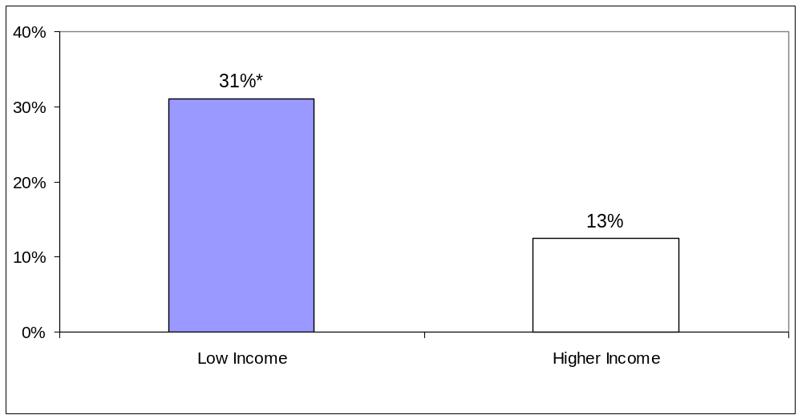

1.2 Geographic Region
To monitor health on a regional basis, the Executive Office of Health and Human Services has divided the Commonwealth into 6 regions, which are shown on a map in Appendix III. Regional variation in health indicators can be due to a variety of factors, including the proximity of individuals to health care services, the availability of primary care services in a region, or demographic characteristics of the local population.

Although there are variations in unintended pregnancy rates between regions, Region 1 (Western) is the only region that is significantly different than the average unintended pregnancy rate in Massachusetts (Figure 6). For a discussion on city-specific data, see Appendix I.

Figure 6: Unintended Pregnancy among Women ages 18-44 in Massachusetts by Massachusetts Region, BRFSS 2008/2010 (N=739)
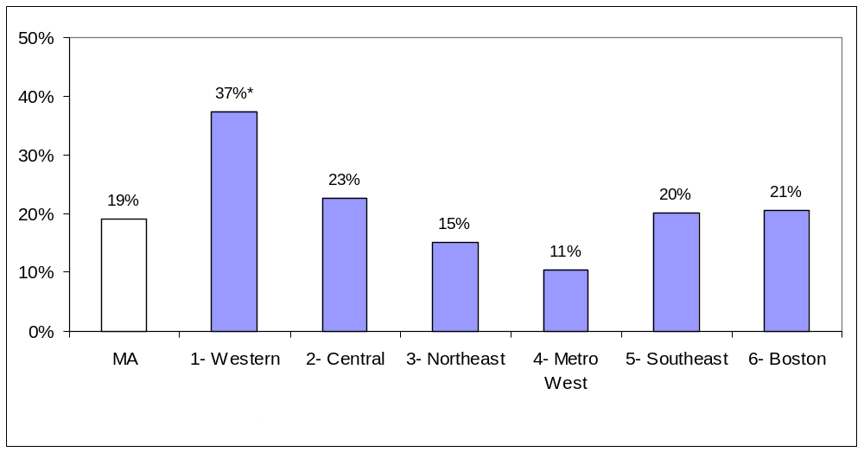

1.3 Additional Risk Factors
In addition to demographic characteristics, we examined other factors that have been previously associated with unintended pregnancy, including obesity,¹²⁻¹³ disability status,¹⁴ and a history of sexual violence.¹⁵ Factors that could affect the outcome of a pregnancy such as smoking or binge alcohol consumption were also examined. The only factor that was significantly associated with unintended pregnancy was smoking status, where the prevalence of unintended pregnancies was twice as high in current smokers (35.4%) versus non-smokers (16.2%) (Figure 7).

Figure 7: Unintended Pregnancy among Women ages 18-44 in Massachusetts by Smoking Status, BRFSS 2008/2010 (N=737)
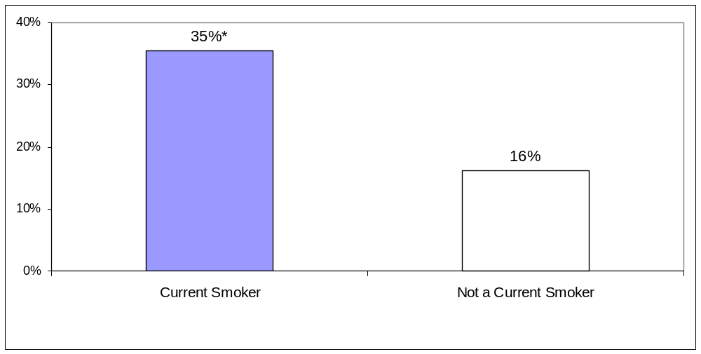

The greater likelihood of current smokers having an unintended pregnancy has significant public health implications. Women who smoke during pregnancy are at increased risk for premature delivery and their infants are more likely to be born underweight and to die of Sudden Infant Death Syndrome (SIDS).¹⁶ In 2004, the estimated cost of neonatal care attributable to smoking in Massachusetts was $1.8 million dollars.¹⁷
A note on smoking and pregnancy in Massachusetts
In Massachusetts, current smokers (someone who smokes cigarettes either some days or every day) are more likely to live in households with an annual income less than $25,000 per year, to have no more than a high school education, and be under the age of 34.² These factors are also associated with unintended pregnancy, therefore the relationship between unintended pregnancy and smoking is most likely a reflection of multiple factors, and not smoking alone. Regardless, the fact that current smokers report significantly higher rates of unintended pregnancies than non-smokers has important implications for both program developers and clinicians taking care of women.

Women with unintended pregnancies discover their pregnancies later than those who intend to become pregnant, potentially prolonging any attempt to quit smoking motivated by pregnancy status.¹⁸ Furthermore, women with unintended pregnancies are less likely to quit smoking than women with intended pregnancies, making family planning and birth control counseling that much more important among smokers of reproductive age.¹⁸

1.4 Access to Health Care and Impact of Health Care Reform on Unintended Pregnancy
To assess the relationship between health care access and unintended pregnancy, combined 2008/2010 data were used to examine insurance status, employment status, inability to visit a physician in the past 12 months due to cost, and the presence of a personal doctor. Even with the combined data set, there were insufficient data to evaluate the impact of insurance status and the presence of a personal doctor on unintended pregnancy. However, among the remaining access indicators there were no significant associations with unintended pregnancy. This means that women who were employed, or who did not have cost barriers to access a physician were just as likely to experience an unintended pregnancy as women who were unemployed or did have cost barriers to access a physician.

We then examined the change in unintended pregnancy rates before and after the implementation of Massachusetts health care reform by comparing combined 2004/2006 data with combined 2008/2010 data. The major components of Massachusetts health care reform were implemented in 2007, including the individual mandate to have insurance and the introduction of new government-subsidized health insurance programs. Between the two time periods, the proportion of women aged 18–44 reporting they were uninsured dropped significantly, from 6.6% in 2004/2006 to 2.3% in 2008/2010. However, the rate of unintended pregnancy did not significantly change between the two time periods (23.6% in 2004/2006 vs. 19.1% in 2008/2010). More years of observations may be needed to draw any conclusion about the impact of health care reform.

Birth Control

Background
Contraception is critical to the health of women, their families, and their partners. Women spend nearly 30 years of their lives preventing pregnancy, making this a major health concern for women of reproductive age.¹⁹ Using birth control consistently and correctly allows women to decide when and if they will become pregnant, and is key to reducing unintended pregnancies in Massachusetts. Nationwide, nearly half (48%) of all unintended pregnancies occur among women who were using a contraceptive method.¹⁰ The following portion of this report examines those factors in Massachusetts associated with contraceptive use, as well as the relationship between a woman’s stated reproductive health goals and current contraceptive use.

2.1 Types of Birth Control Methods
The most common forms of birth control used by women in Massachusetts are birth control pills, condoms, male and female sterilization (Figure 8).

Figure 8: Birth Control Method Used by Type among Women ages 18-44 in Massachusetts, BRFSS 2008/2010 (N=1165)
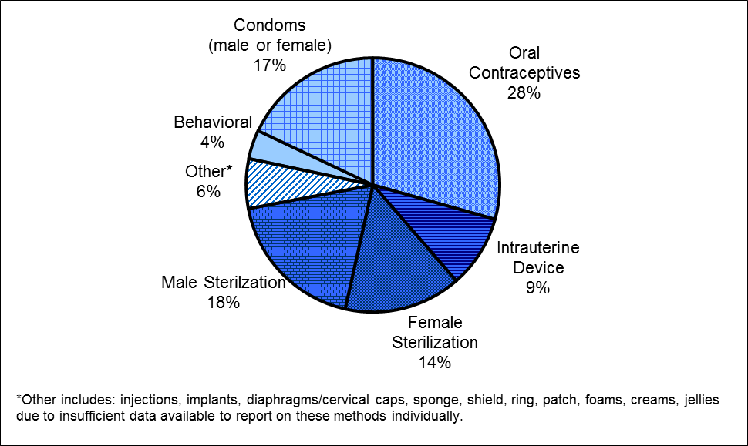

Methods were grouped into broader categories based on their efficacy and duration of action (Table 1). Shorter acting methods include those that require attention on a daily, monthly, or quarterly schedule. These are presented here separately as short acting hormonal (includes oral contraceptives, patches, and injections) and barrier methods (male and female condoms, diaphragms/cervical caps, cervical rings, sponge, shield). Conversely, long acting reversible methods only require attention every few years. This distinction is important, because women using longer acting methods have better compliance than women using shorter acting methods, which can lead to improved overall clinical efficacy.²⁰ When evaluated by these categories, the most popular types of methods used by women in Massachusetts are female and male sterilization (33.4%); short-acting hormonal methods (31.7%); and barrier methods (20.6%). A small portion of women are using long-acting methods (10.6%) and even fewer (3.7%) are using behavioral methods (Figure 9).

Table 1: Contraception Categories
Contraception Category | Definition
Behavioral | Periodic abstinence or withdrawal
Barrier | Male and female condoms, diaphragms/cervical caps, cervical rings, sponge or shield, other method (foam, jelly, cream)
Short-acting hormonal | pills, shots, patches, emergency contraception
Long-acting | contraceptive implants and IUDs
Sterilization | tubal ligation (“tubes tied”), hysterectomy, vasectomy

Figure 9: Birth Control Method Used by Category among Women ages 18-44 in Massachusetts, BRFSS 2008/2010 (N=1165)
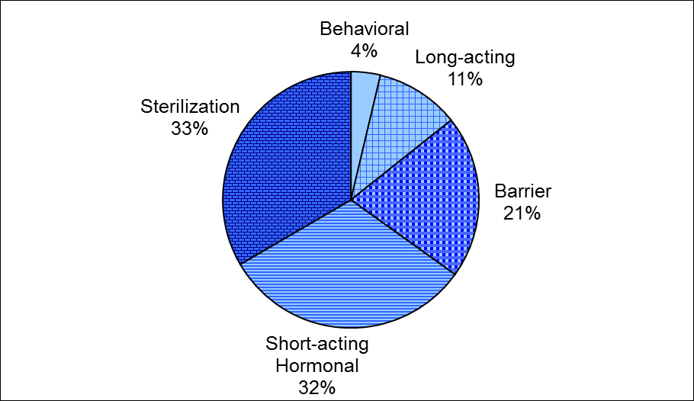

2.2 Demographics

Age
Although fewer women ages 18–24 reported using birth control compared to women ages 25–34 and 35–44, there were no significant differences by age group (Figure 10). Additionally, no significant differences by age were found after excluding the women who were not using birth control because they wanted to become pregnant (data not shown).

Figure 10: Any Birth Control Use among Women ages 18-44 in Massachusetts by Age Group, BRFSS 2008/2010 (N=1646)
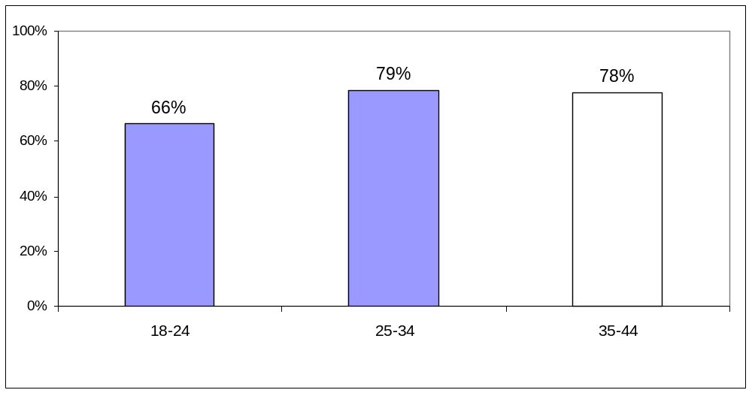

Race/Ethnicity
Although fewer women who identified as Hispanic and Black, Non-Hispanic reported using birth control compared to women who identified as White, Non-Hispanic, there were no significant differences by race/ethnic group (Figure 11). Additionally, no significant differences by race/ethnic group were found after excluding the women who were not using birth control because they wanted to become pregnant (data not shown).

Figure 11: Any Birth Control Use among Women ages 18-44 in Massachusetts by Race/Ethnicity, BRFSS 2008/2010 (N=1599)
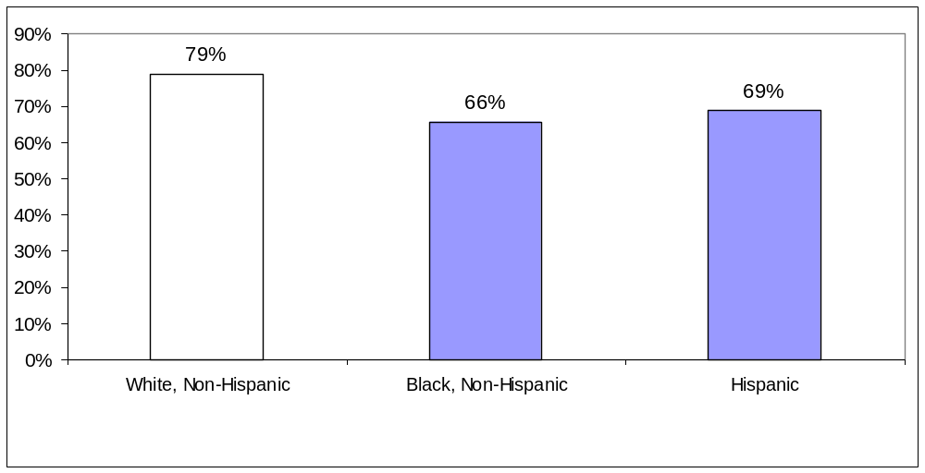

Education
Though use of any birth control method appears to increase with higher levels of education, there were no significant differences found by education attainment relative to women with at least a bachelor’s level college degree (Figure 12). Additionally, no significant differences were found by education after excluding the women who were not using birth control because they wanted to become pregnant (data not shown).

Figure 12: Any Birth Control Use among Women ages 18-44 in Massachusetts by Education, BRFSS 2008/2010 (N=1643)
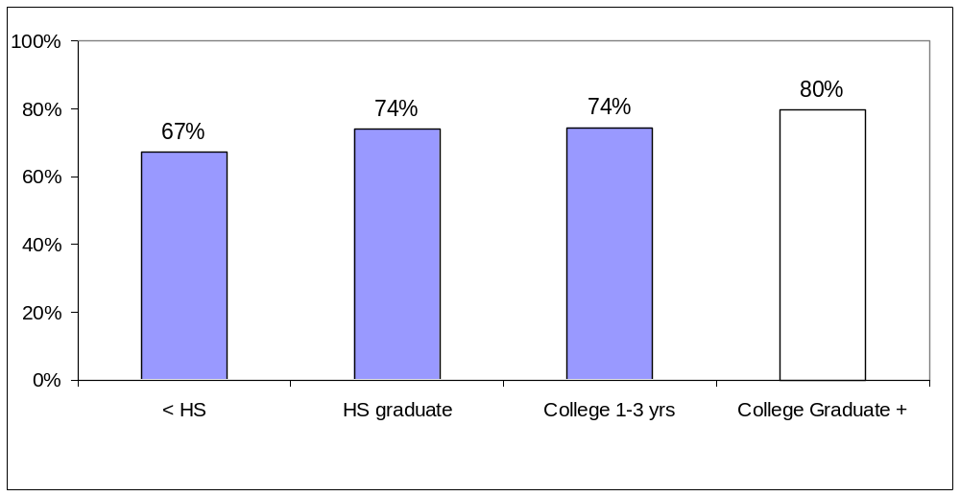

Income
Although there are slight variations in the type of birth control used by low-income (<300% FPL) and higher-income women (>300% FPL), these differences are not significant (Figure 13). Additionally, no significant differences were found by income after excluding the women who were not using birth control because they wanted to become pregnant (data not shown).

Figure 13: Birth Control Use among Women ages 18-44 in Massachusetts by Income and Method Type, BRFSS 2008/2010 (N=1056)
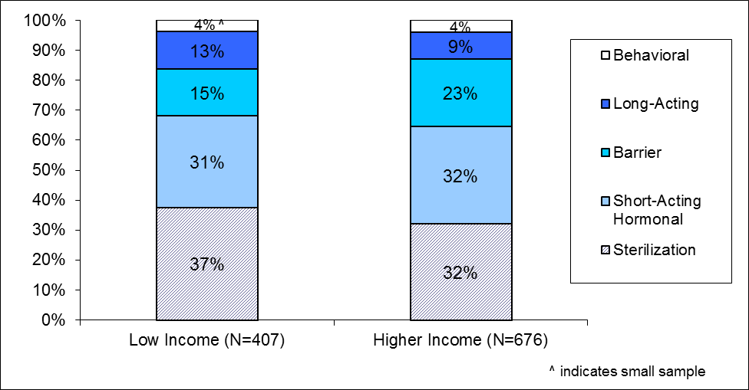

Lower income was associated with reporting nonuse of birth control for any reason. Among low-income women, 30.4% reported not using a birth control method versus 18.8% of higher-income women (Figure 14). However, there is no significant difference by income level when comparing women who don't use birth control for reasons other than wanting to become pregnant (data not shown).

Figure 14: Women ages 18-44 in Massachusetts Not Using Birth Control by Income Group, BRFSS 2008/2010 (N=1509)
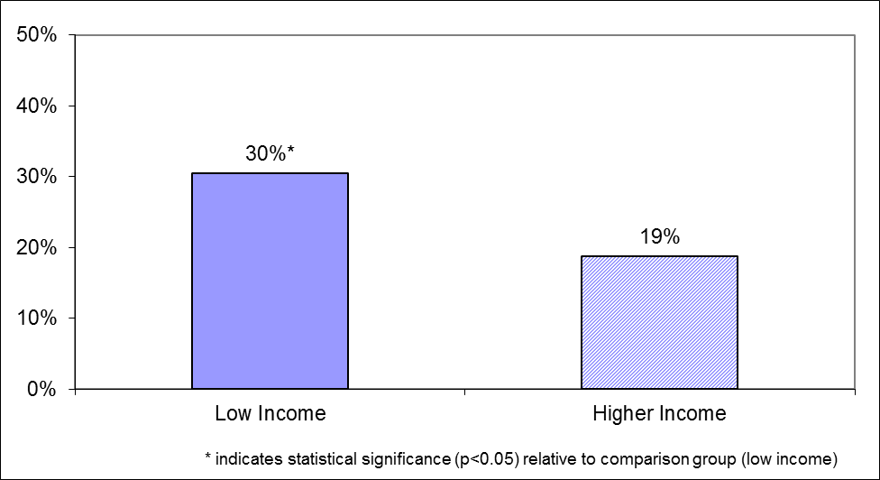

Language
Between 2008 and 2010 over 1.3 million (21.5%) Massachusetts residents reported speaking a language other than English at home; of these, 41.1% reported speaking English less than “very well.”²¹ Limited English skills are associated with multiple health disparities, including reduced access to a usual source of care, inconsistent use of contraception, and access to emergency contraception.²²⁻²⁴ To assess the impact of language on birth control use in Massachusetts, we compared birth control use and awareness of emergency contraception between English- and Spanish-speaking women.

In Massachusetts, Spanish-speaking women were less likely than English-speaking women to have heard of emergency contraception (59.5% vs. 92.3%). Compared to English-speaking women, fewer Spanish-speaking women reported current use of birth control, but this difference was not significant (Figure 15). This may be linked to their access to health care in general. Spanish-speaking women were less likely to report having a personal doctor than English-speaking women (66.4% vs. 91.7%, data not shown); there were too few respondents to assess whether they were also less likely to report being able to see a physician in the past year due to cost.

Figure 15: Birth Control Use and Emergency Contraception (EC) Awareness among Women ages 18-44 in Massachusetts by Language, BRFSS 2008/2010
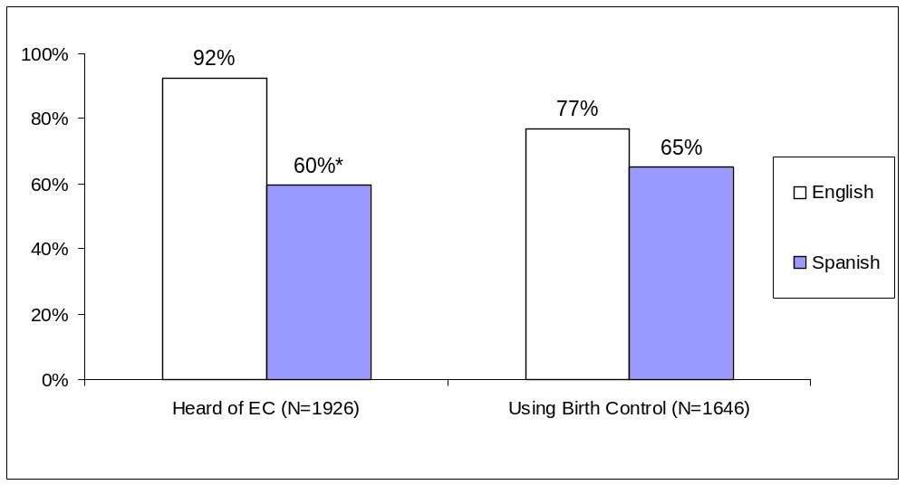

2.3 Geographic Region
There was no significant variation by EOHHS region in use of birth control. When compared to the state average, women in all regions of Massachusetts were equally as likely to be using a birth control method (Figure 16). For specifics on city data, see Appendix I.

Figure 16: Any Birth Control Use among Women ages 18-44 in Massachusetts by EOHHS Region, BRFSS 2008/2010 (N=1642)
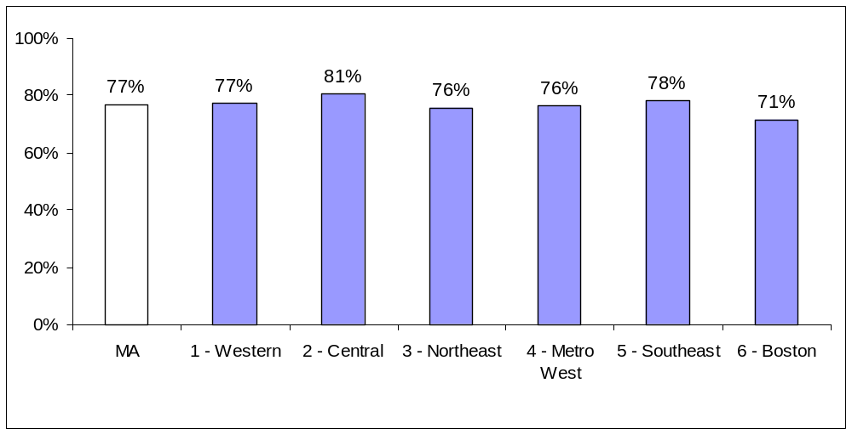

2.4 Additional Risk Factors
We also examined the relationship between contraception use and two risk factors for unintended pregnancy: history of sexual violence and disability status. There was no association between either of these two factors and contraception use.

2.5 Not Using Contraception
Among women aged 18 to 44, the most common reason for not using birth control was she wanted to be pregnant (30.4%). The next most frequent response was that she didn’t know or wasn’t sure about the reason (11.7%). A smaller number of women reported that they were not planning on having sex (7.1%), that they didn’t think they could get pregnant (7.0%), or that she or her partner was sterilized (6.1%) (Table 2).

Table 2: Reason given for Not Using Contraception by Women ages 18-44 in Massachusetts, BRFSS 2008/2010 (N=355)
Reason for Not Using Contraception | % of Respondents
Want a Pregnancy | 30.4
Don't Know / Not Sure | 11.7
Not Planning on Having Sex / No Regular Partner | 7.1
Don't Believe at Risk for Pregnancy | 7.0
Sterilized (male and female) | 6.1
Refused to Answer | 5.3
Chose Not to Use Birth Control | 4.0
Don’t Care About Pregnancy | 3.7
Other | 24.7

Women Not Wanting More Children
Choosing and successfully using a birth control method that meets one’s reproductive goals is important both for patient satisfaction and for preventing unintended pregnancies. About half of women who say they do not want any more children in the future are using sterilization (43.1%) or a long acting, reversible birth control method (10.4%). The rest of women not wanting any more children are either using a short-acting hormonal method (24.2%) or coital-specific methods (methods that are used just before or during sexual intercourse) such as barrier (14.9%) or behavioral methods (3.4%, Figure 17).

Figure 17: Contraception Method Used by Women ages 18-44 in Massachusetts Who Do Not Want to Have a Child Any Time in the Future, BRFSS 2008/2010 (N=691)
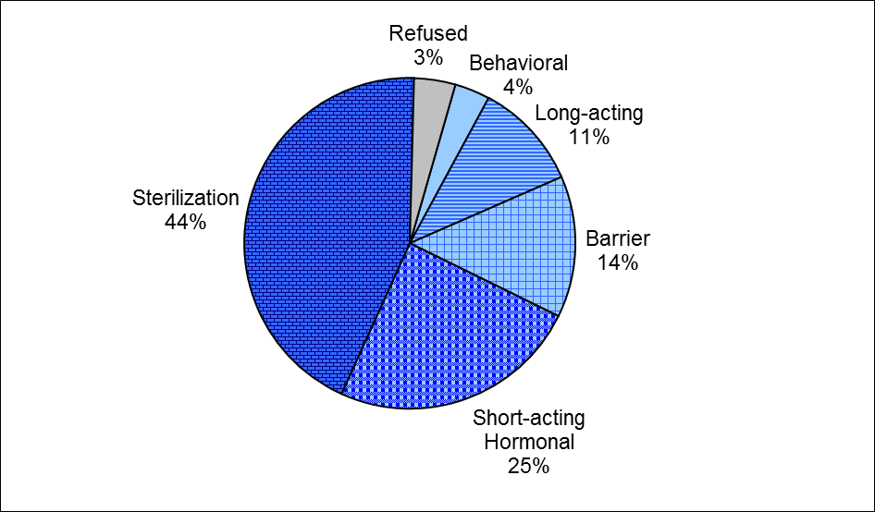

2.6 Access to Health Care and Impact of Health Care Reform on Contraception Use
As with unintended pregnancy, contraceptive use was evaluated by health care access indicators using combined 2008/2010 data. There was no significant difference in the use of birth control by insurance status, employment status, being unable to visit a physician in the past 12 months due to cost, or presence of a personal doctor.

To evaluate the impact of health care reform on contraceptive use, we again compared combined 2004/2006 data and combined 2008/2010 data to assess the impact of the 2007 implementation of the major components of Massachusetts health care reform. As noted above, the percentage of women reporting that they were uninsured declined significantly between the two time periods (6.6% in 2004/2006 vs. 2.3% in 2008/2010). However, the percentage of women using contraception did not significantly change over this time period (75.5% in 2004/2006 vs. 76.7% in 2008/2010).

2.7 Emergency Contraception
Emergency contraception (EC) is a birth control method approved by the Food and Drug Administration that can be used up to 120 hours (5 days) after unprotected sex. It can be used if a regular birth control method fails (for example a condom break or missed oral contraceptive pills), after sex without any birth control, or in cases of sexual assault. Between 2005 and 2008 significant policy changes aimed at increasing access to EC occurred at both the state and national level. In 2005 Massachusetts passed legislation allowing pharmacists with special training to dispense EC without a prescription. Pharmacists began providing this service in 2006. Later the same year the Food and Drug Administration changed the status of EC from prescription to over-the-counter for people ages 18 and older. Each of these developments was accompanied by significant media coverage, and it was expected that there would be an increase in both knowledge and use of EC over this time period.

Combined datasets of 2004/2006 and 2008/2010 were compared to represent the time period surrounding the legislative and policy changes described above. There was no significant difference in the number of women who had heard of EC (92.3% in 2004/2006 vs. 91.3% in 2008/2010) or had used EC (11.6% in 2004/2006 vs. 9.9% in 2008/2010) between the two time periods.

Conclusion
The data presented in this report highlight several important health disparities in Massachusetts. Eliminating health disparities is a primary goal of the Massachusetts Family Planning Program and highlighted as part of Healthy People 2020. Addressing health disparities was also central to Massachusetts’ 2006 health care reform legislation, as well as one of the Commissioner of Public Health’s top priorities. Below, we highlight several health disparities identified in this report and suggest a number of strategies for addressing unintended pregnancy, improving sexual and reproductive health, and reducing health disparities overall.

Although unintended pregnancy continues to decline in Massachusetts, young women, women of color, women with lower levels of education, low-income women, women who reside in the Western region of the state, and women who are current smokers are more likely to experience an unintended pregnancy. A variety of strategies could reduce unintended pregnancies and improve birth outcomes for both intended pregnancies as well as unintended pregnancies that result in a live birth:
- Culturally relevant materials should be developed for Hispanic populations, in both English and Spanish, to address the issue of unintended pregnancy as well as strategies to prevent pregnancy. These materials could be provided to health and non-health organizations that work with Hispanic populations through specific outreach efforts.
- Health service and safety-net agencies working to prevent unintended pregnancy that are located in areas of the state where higher-risk groups are more likely to be found should be prioritized for local, state, and federal funding and support.
- Education campaigns and materials related to unintended pregnancy and smoking cessation should incorporate messages on both health topics, not only to decrease unintended pregnancy among current smokers but also to encourage women who are pregnant or contemplating pregnancy to quit smoking.

Few of these disparities remain when looking at contraceptive use among women in Massachusetts, which represents movement towards narrowing disparities in contraceptive use. This is an important finding and supports the ongoing work being done in Massachusetts to expand access and promote use of contraception. However, the continued existence of disparities in unintended pregnancies in light of this finding could indicate several needs.
- While disparities are decreasing in use of contraceptive methods in Massachusetts in general, it remains unknown whether there is variation in consistency or effective use of these methods. Strategies to address this include: adding items to the BRFSS module to evaluate differences in the extent to which various subpopulations use contraceptive methods correctly and consistently; and broadly promoting contraceptive methods that are minimally user-dependent, such as intrauterine devices and hormonal implants.
- The standard definition of an unintended pregnancy may not be consistently applied across populations, which may lead to some measurement error. Adding items to the BRFSS module that allow for a more comprehensive assessment of pregnancy intentions may illuminate more nuanced patterns.
- Continuing to ensure the availability of low-cost and free contraceptive methods for low-income women, especially women who have erratic insurance coverage or who are ineligible for insurance coverage despite Massachusetts health care reform (e.g., undocumented immigrants) will be imperative to narrowing disparities in effective use of contraception even further.

Although health care reform has successfully expanded insurance coverage in Massachusetts, between 2006 and 2010 there was no significant change in overall unintended pregnancy rates or contraceptive use. The widespread availability of safety net services in Massachusetts prior to health care reform, such as family planning clinics and Free Care (now Health Safety Net), could be contributing to this apparent lack of impact. Trends should continue to be observed in years to come.

Recent research also sheds light on the intersection of health care reform and the ability of women in Massachusetts to access reproductive health services.²⁵ Interviews with family planning providers and focus groups with low-income women in Massachusetts found that for many women, access to affordable insurance and the ability to obtain prescription contraception at a pharmacy of their choice has increased their ability to access care. However, in spite of their overall support for health care reform, women and providers also identified new barriers to obtaining reproductive health services under reform, including burdensome paperwork requirements, unfamiliarity with the prescription drug benefits, and in some cases an inability to afford co-pays. Furthermore, certain populations such as immigrants, teens, and those with unstable employment or experiencing common life changes such as pregnancy were identified as being “left out” of health care reform, making access to reproductive health services difficult for these women.

Similar findings came from focus groups with young adults as a part of the Reproductive Empowerment and Decision Making for Young Adults (REaDY) Initiative.²⁶ REaDY is a coalition of Massachusetts health service providers, advocates, and researchers collaborating on a unique, statewide project to reduce unintended pregnancy among young adults in the wake of health care reform. Women taking part in the study were confused about the types of health plans available and what contraceptive and reproductive health services the plans covered. Some women had limited access to prescription contraception due to enrollment in health plans with religious restrictions or enrollment in a non-prescription Young Adult Plan. These data highlight the relevance of this and other similar projects, which should continue to be supported to further investigate the impact of health care reform on family planning health outcomes.

In this report we suggest strategies that provide a starting place for the development and expansion of family planning and reproductive health programs, allocation of scarce resources for the maximum benefit and reduction of health disparities, and implementation of policies to support shared goals. We hope that these data provide a valuable tool for supporting and implementing these and other strategies for improving sexual and reproductive health in Massachusetts.
Appendix I: City-Specific Data and Detailed Tables, 2008/2010
To increase the number of respondents who belong to racial and/or ethnic minority groups BRFSS consistently oversampled the cities of Boston, Worcester, Springfield, Lawrence, Lowell, Fall River, and New Bedford in 2008 and 2010. Selected reproductive health outcomes as well as health care access indicators are shown below for each of the oversampled cities. To identify local variation in these outcomes, the data are presented relative to Massachusetts-wide averages. This analysis will help local program managers identify priorities and develop programs that meet the specific needs of their communities.

Boston
Respondents from Boston were significantly less likely to report being unable to afford a visit to a doctor within the past 12 months (Figure 18). The remainder of the health indicators assessed did not significantly differ for Boston compared to Massachusetts as a whole.

Figure 18: Selected Health Indicators among Women in Boston ages 18-44, BRFSS 2008/2010
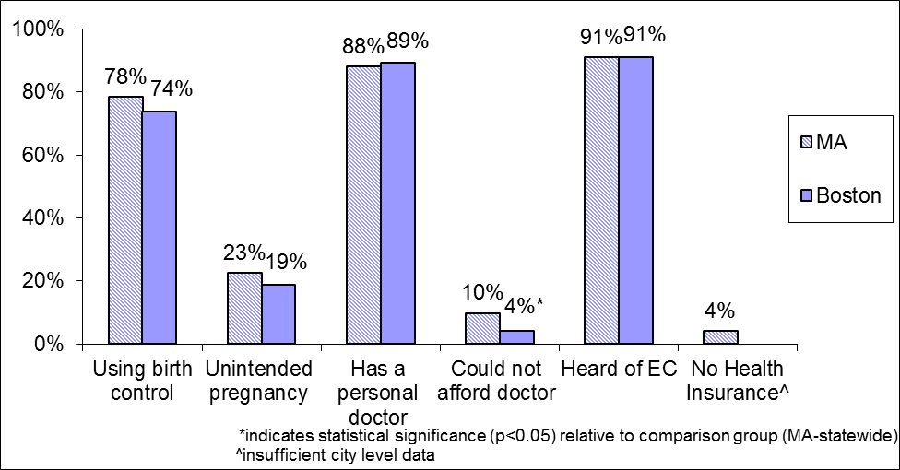

Fall River
Compared to women in Massachusetts, women in Fall River were more than twice as likely (20.2% vs. 9.7%) to report not being able to afford a visit to a doctor within the past 12 months (Figure 19). Additionally, significantly fewer women (79.4% vs. 91.0%) in Fall River have heard of emergency contraception.

Figure 19: Selected Health Indicators among Women in Fall River ages 18-44, BRFSS 2008/2010
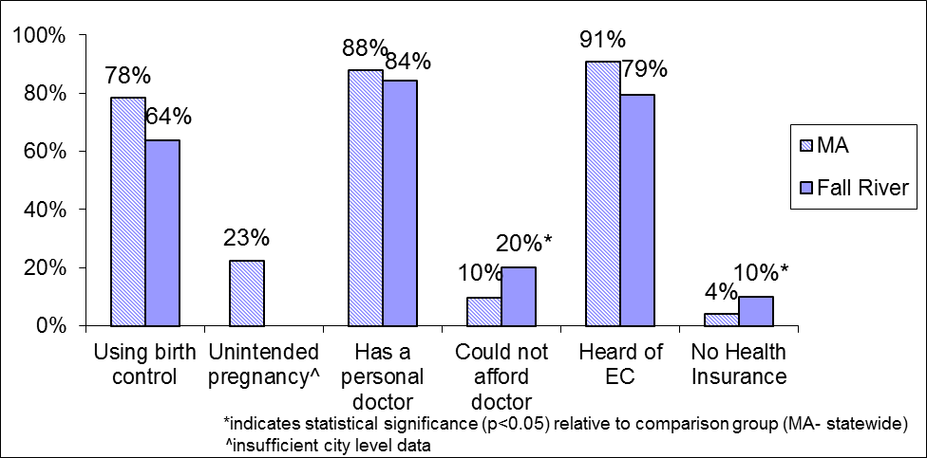

Lawrence
Most of the health outcomes examined were significantly poorer for women in Lawrence when compared to Massachusetts as a whole (Figure 20). A smaller proportion of women in Lawrence reported using birth control (56.1% vs. 78.3%), having a personal doctor (79.0% vs. 87.9%) and having heard of emergency contraception (65.5% vs. 91.0%). Additionally, a larger proportion of women in Lawrence reported not being able to see a physician in the past 12 months due to cost (16.7% vs. 9.7%) and not having health insurance (11.5% vs. 4.1%). There was no statistically significant difference in the rates of unintended pregnancy.

Some of the disparities seen in Lawrence may be partially explained by the unique demographics of the city. When compared to Massachusetts as a whole, a significantly higher proportion of Lawrence residents report being Hispanic (69.7 vs. 8.4%) achieving less than a high school education (33.3% vs. 7.5%), and having an annual household income of less than $25,000 (55.1% vs. 20.4%).²⁷ These factors have all been associated with less contraceptive use, lack of a personal doctor, inability to see a doctor due to cost, and not having insurance (only associated with ethnicity and education) and are most likely contributing to the disparities seen in Lawrence.¹⁸

Furthermore, when compared to Massachusetts as a whole, a significantly higher proportion of people in Lawrence speak Spanish at home and report speaking English “less than very well” (34.5% vs. 3.1%).²¹ Speaking Spanish has been associated with less awareness of EC, and may be affecting women’s knowledge of EC in Lawrence.²⁴

Figure 20: Selected Health Indicators among Women in Lawrence ages 18-44, BRFSS 2008/2010
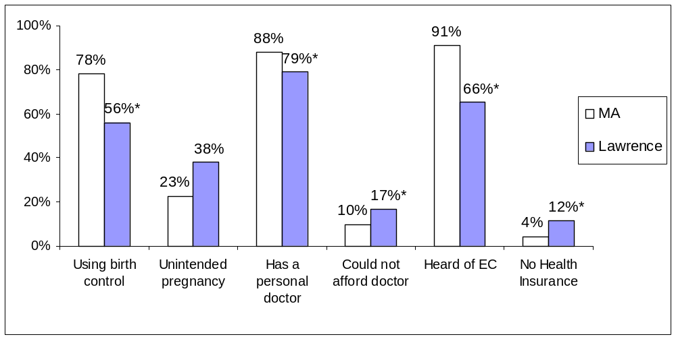

Lowell
No significant differences were found when comparing these health indicators of women in Lowell to all women in Massachusetts (Figure 21).

Figure 21: Selected Health Indicators among Women in Lowell ages 18-44, BRFSS 2008/2010
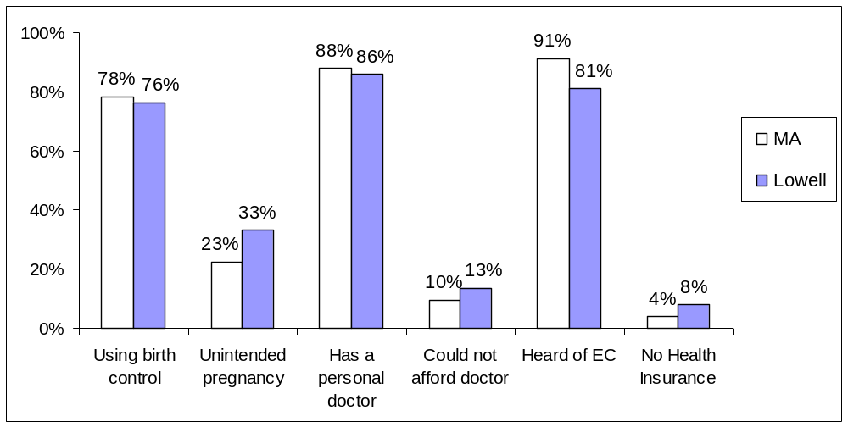

New Bedford
No significant differences were found when comparing these health indicators of women in New Bedford to all women in Massachusetts (Figure 22).

Figure 22: Selected Health Indicators among Women in New Bedford ages 18-44, BRFSS 2008/2010
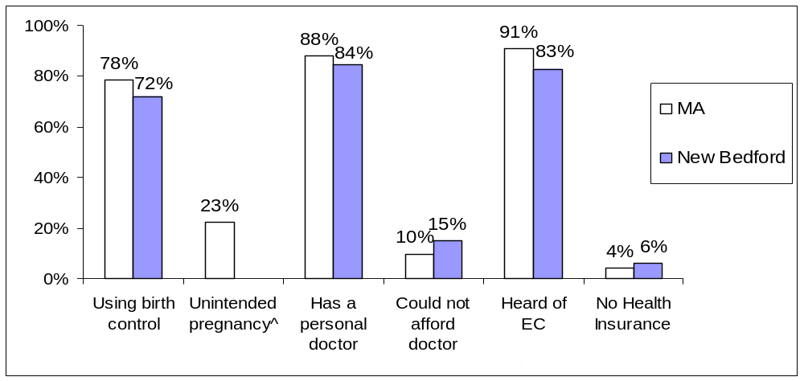

Springfield
Of the health indicators examined (Figure 23); the only significant difference between Springfield and the rest of Massachusetts was unintended pregnancy, which was twice as high in Springfield as in Massachusetts (49.0% vs. 22.5%).
Figure 23: Selected Health Indicators among Women in Springfield ages 18-44, BRFSS 2008/2010
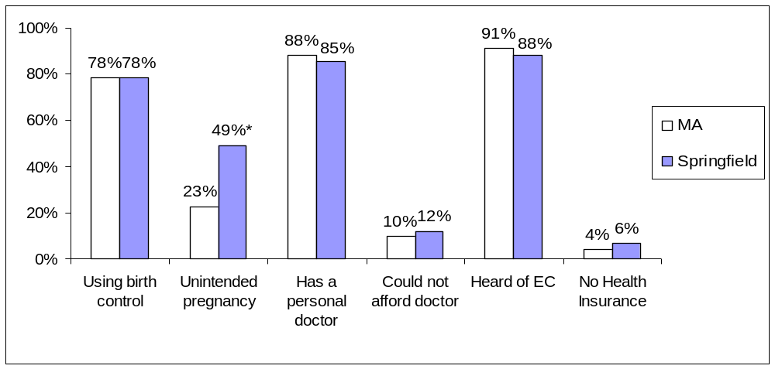

Worcester
No significant differences were found when comparing these health indicators of women in Worcester to all women in Massachusetts (Figure 24).

Figure 24: Selected Health Indicators among Women in Worcester ages 18-44, BRFSS 2008/2010
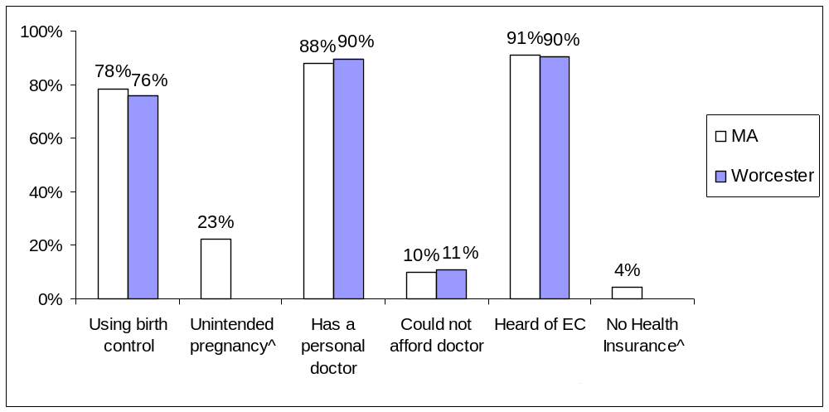
Table 3: Detailed City Tables, Massachusetts BRFSS 2008/2010
 | N | % | 95% CI
Boston
Using birth control | 203 | 73.9 | 66.5 | – | 81.2
Unintended pregnancy | 73 | 18.7 | 9.9 | – | 27.6
Has a personal doctor | 250 | 89.1 | 84.3 | – | 93.9
Could not afford doctor | 249 | 4.0 | 1.8 | – | 6.2
Heard of EC | 227 | 91.0 | 86.0 | – | 96.0
No Health Insurance^
Fall River
Using birth control | 115 | 63.7 | 51.6 | – | 75.9
Unintended pregnancy^
Has a personal doctor | 362 | 84.4 | 78.8 | – | 90.1
Could not afford doctor | 366 | 20.2 | 14.4 | – | 26.0
Heard of EC | 132 | 79.5 | 68.9 | – | 90.0
No Health Insurance | 366 | 10.0 | 5.0 | – | 14.9
Lawrence
Using birth control | 111 | 56.1 | 41.6 | – | 70.6
Unintended pregnancy | 50 | 38.0 | 15.6 | – | 60.5
Has a personal doctor | 389 | 79.0 | 72.3 | – | 85.7
Could not afford doctor | 388 | 16.7 | 12.0 | – | 21.3
Heard of EC | 137 | 65.5 | 53.8 | – | 77.3
No Health Insurance | 388 | 11.5 | 5.8 | – | 17.3
Lowell
Using birth control | 121 | 76.2 | 67.0 | – | 85.4
Unintended pregnancy | 52 | 33.5 | 18.9 | – | 48.0
Has a personal doctor | 403 | 86.0 | 81.5 | – | 90.6
Could not afford doctor | 402 | 13.5 | 9.6 | – | 17.4
Heard of EC | 142 | 81.0 | 72.4 | – | 89.7
No Health Insurance | 404 | 8.1 | 4.2 |  | 12.0
New Bedford
Using birth control | 98 | 72.2 | 59.1 | – | 85.3
Unintended pregnancy^
Has a personal doctor | 331 | 84.4 | 78.7 | – | 90.0
Could not afford doctor | 332 | 15.1 | 10.4 | – | 19.8
Heard of EC | 111 | 82.8 | 74.2 | – | 91.4
No Health Insurance | 331 | 6.2 | 3.0 | – | 9.4
Springfield
Using birth control | 126 | 78.4 | 70.2 | – | 86.6
Unintended pregnancy | 59 | 49.0 | 33.3 | – | 64.8
Has a personal doctor | 451 | 85.2 | 80.4 | – | 89.9
Could not afford doctor | 453 | 12.1 | 8.0 | – | 16.1
Heard of EC | 161 | 87.9 | 80.4 | – | 95.5
No Health Insurance | 454 | 6.4 | 3.2 | – | 9.7
Worcester
Using birth control | 115 | 75.8 | 66.9 | – | 84.6
Unintended pregnancy^
Has a personal doctor | 422 | 89.8 | 86.4 | – | 93.2
Could not afford doctor | 421 | 10.6 | 6.5 | – | 14.7
Heard of EC | 137 | 90.4 | 84.5 | – | 96.3
No Health Insurance^
^insufficient city-level data
Appendix II: State Detailed tables
Table 4: Demographic Characteristics of Women ages 18-44 in Massachusetts, BRFSS 2008/2010
 | Unweighted Sample Size (N) | Weighted %
Age Group
18–24 | 614 | 9.1
25–34 | 2123 | 30.4
35–44 | 3665 | 60.5
Race/Ethnicity
White, not Hispanic | 4423 | 80.7
Black, not Hispanic | 455 | 4.6
Hispanic | 1100 | 10.8
Education
< High School | 499 | 4.5
High School Graduate | 1360 | 19.2
College 1–3 Years | 1588 | 23.3
>/= College Graduate | 2923 | 53.0
Income
Low-Income | 815 | 31.0
Higher-Income | 1120 | 69.0
Region
I-Western | 931 | 15.0
II-Central | 851 | 13.8
III-Northeast | 1618 | 17.4
IV-Metro West | 725 | 25.4
V-Southeast | 1400 | 19.2
VI-Greater Boston | 828 | 9.2

Table 5: Demographic Characteristics of Women ages 18-44 in Massachusetts Reporting an Unintended Pregnancy, BRFSS 2008/2010
 | N | % | 95% CI
Massachusetts | 739 | 19.1 | 15.3 | – | 22.9
Age
18–24 | 66 | 62.0 | 42.3 | – | 81.7
25–34 | 335 | 19.2 | 13.9 | – | 24.6
35–44 | 338 | 14.1 | 9.4 | – | 18.7
Race/Ethnicity
White, not Hispanic | 494 | 15.8 | 11.5 | – | 20.0
Black, not Hispanic | 50 | 38.8 | 20.1 | – | 57.6
Hispanic | 134 | 36.6 | 23.9 | – | 49.2
Education
< High School | 55 | 47.4 | 22.0 | – | 72.7
High School Graduate | 143 | 33.5 | 21.9 | – | 45.0
College 1–3 Years | 175 | 22.4 | 13.9 | – | 31.0
>/= College Graduate | 365 | 12.1 | 8.2 | – | 15.9
Income
Low-Income | 305 | 31.0 | 23.3 | – | 38.6
Higher-Income | 373 | 12.5 | 8.5 | – | 16.6
Region
Region 1 - Western | 101 | 37.5 | 23.5 | – | 51.5
Region 2 - Central | 93 | 22.7 | 12.2 | – | 33.1
Region 3 - Northeast | 184 | 15.2 | 7.8 | – | 22.5
Region 4 - Metro West | 111 | 10.6 | 5.1 | – | 16.1
Region 5 - Southeast | 169 | 20.2 | 12.0 | – | 28.4
Region 6 - Boston | 79 | 20.6 | 8.3 | – | 32.9
Obesity
Obese | 148 | 24.8 | 15.7 | – | 33.9
Not obese | 554 | 17.4 | 13.2 | – | 21.6
Disability
Disabled | 96 | 20.3 | 10.0 | – | 30.5
Not disabled | 619 | 18.9 | 14.8 | – | 23.1
Sexual Violence
Sexual violence ever | 122 | 24.5 | 13.8 | – | 35.3
No sexual violence | 541 | 17.6 | 13.4 | – | 21.7
Binge Drinking
Binge drinker | 100 | 30.7 | 18.6 | – | 42.9
Not binge drinker | 636 | 17.7 | 13.8 | – | 21.7
Smoking
Current smoker | 135 | 35.4 | 23.3 | – | 47.6
Not a current smoker | 602 | 16.2 | 12.5 | – | 20.0

Table 6: Unintended Pregnancy among Women ages 18–44 in Massachusetts by Year, BRFSS 2008/2010
 | 2008 |  |  |  |  | 2010
 | N | % | 95% CI |  |  | N | % | 95% CI
Unintended pregnancy | 434 | 19.7 | 14.6 | – | 24.7 | 305 | 18.6 | 13.0 | – | 24.1

Table 7: Type of Birth Control Currently Used among Women ages 18–44 in Massachusetts by Type, BRFSS 2008/2010
 | N | % | 95% CI
Tubes tied | 206 | 14.3 | 11.6 | – | 17.0
Vasectomy (male sterilization) | 181 | 17.8 | 14.7 | – | 20.9
Pill, all kinds | 320 | 28.2 | 24.7 | – | 31.8
Condoms (male or female) | 205 | 17.2 | 14.3 | – | 20.2
Intrauterine device (IUD/IUS) | 112 | 8.9 | 6.7 | – | 11.1
Not having sex at certain times | 41 | 3.0 | 1.8 | – | 4.3
Shots (Depo-Provera) | 23 | 2.2 | 1.1 | – | 3.3
Other method (foam, jelly, cream, etc.) | 27 | 1.4 | 0.6 | – | 2.1

Table 8: Type of Birth Control Currently Used among Women ages 18–44 in Massachusetts by Category, BRFSS 2008/2010
 | N | % | 95% CI
Sterilization  Tubal ligation ("tubes tied"), Vasectomy | 387 | 33.4 | 29.6 | – | 37.2
Long-Acting  Contraceptive implants, Intrauterine device (IUD/IUS) | 137 | 10.6 | 8.2 | – | 12.9
Short-Acting Hormonal Pills, Shots (Depo-Provera), Patch, Emergency contraception | 344 | 31.7 | 28.0 | – | 35.5
Barrier  Male/Female condoms, Diaphragm, Cervical ring/cap, NuvaRing*, other | 247 | 20.6 | 17.4 | – | 23.8
Behavioral  Withdrawal, Not having sex at certain times | 50 | 3.7 | 2.4 | – | 5.1
*NuvaRing was incorrectly included in this category in 2008 even though it is a short-acting hormonal method. This error was corrected in 2010, but analyses and tables in this report included NuvaRing in the barrier method category to maintain consistency with earlier reports and the 2008 data.

Table 9: Demographic Characteristics of Women Reporting Use of a Birth Control Method among Women ages 18–44 in Massachusetts, BRFSS 2008/2010
 | N | % | 95% CI
Massachusetts | 1646 | 76.7 | 73.9 | – | 79.6
Age
18–24 | 176 | 66.3 | 55.5 | – | 77.1
25–34 | 533 | 78.5 | 73.2 | – | 83.8
35–44 | 937 | 77.7 | 74.1 | – | 81.3
Race/Ethnicity
White, not Hispanic | 1155 | 79.0 | 75.8 | – | 82.3
Black, not Hispanic | 116 | 65.7 | 53.3 | – | 78.1
Hispanic | 268 | 69.0 | 60.6 | – | 77.4
Education
< High School | 99 | 67.2 | 52.6 | – | 81.8
High School Graduate | 349 | 74.0 | 67.1 | – | 80.8
College 1–3 Years | 441 | 74.3 | 68.1 | – | 80.4
>/= College Graduate | 754 | 79.6 | 75.7 | – | 83.4
Region
Region 1 - Western | 243 | 77.2 | 70.0 | – | 84.4
Region 2 - Central | 193 | 80.6 | 73.5 | – | 87.8
Region 3 - Northeast | 427 | 75.7 | 69.0 | – | 82.4
Region 4 - Metro West | 202 | 76.4 | 69.8 | – | 83.0
Region 5 - Southeast | 359 | 78.0 | 71.4 | – | 84.6
Region 6 - Boston | 218 | 71.4 | 63.4 | – | 79.4
Sexual Violence
Sexual violence ever | 284 | 75.5 | 68.3 | – | 82.6
No sexual violence | 1167 | 79.0 | 75.7 | – | 82.2
Disability
Disabled | 261 | 74.1 | 66.1 | – | 82.1
Not disabled | 1319 | 77.1 | 73.9 | – | 80.3

Table 10: Women ages 18-44 in Massachusetts That Are Not Using Birth Control by Income Group, BRFSS 2008/2010
 | N | % | 95% CI
Low-income | 628 | 30.5 | 24.9 | – | 36.0
Higher-income | 881 | 18.8 | 15.3 | – | 22.2

Table 11: Birth Control Use and Knowledge among Women ages 18–44 in Massachusetts by Language, BRFSS 2008/2010
 | Spanish |  |  |  |  | English
 | N | % | 95% CI |  |  | N | % | 95% CI
Heard of EC | 110 | 59.5 | 37.0 | – | 82.1 | 1799 | 92.3 | 90.6 | – | 94.0
Using birth control | 90 | 65.0 | 51.7 | – | 78.2 | 1541 | 76.9 | 73.9 | – | 79.8

Table 12: Health Care Access Indicators among Women ages 18–44 in Massachusetts by Language, BRFSS 2008/2010
 | Spanish |  |  |  |  | English
 | N | % | 95% CI |  |  | N | % | 95% CI
No Health Insurance | 129 | 17.8 | 0.0 | – | 40.3 | 1992 | 1.7 | 0.9 | – | 2.6
Has Personal Doctor | 129 | 66.4 | 46.1 | – | 86.7 | 1990 | 91.7 | 90.0 | – | 93.5
Did not see a physician in the past 12 months due to cost | 130 | 22.9 | 1.5 | – | 44.3 | 1993 | 8.1 | 6.3 | – | 9.8

Table 13: Comparison of Health Care Access Indicators among Women ages 18–44 in Massachusetts by Year, BRFSS 2004/2006 and BRFSS 2008/2010
 | 2004/2006 |  |  |  |  | 2008/2010
 | N | % | 95% CI |  |  | N | % | 95% CI
No health insurance | 303 | 6.6 | 5.5 | – | 7.8 | 50 | 2.3 | 1.1 | – | 3.4
Unintended pregnancy | 293 | 23.6 | 20.2 | – | 26.9 | 196 | 19.1 | 15.4 | – | 22.9
Used birth control | 1979 | 75.5 | 73.0 | – | 78.0 | 1212 | 76.7 | 73.9 | – | 79.6
Heard of emergency contraception | 1098 | 92.3 | 90.2 | – | 94.4 | 1719 | 91.3 | 89.5 | – | 93.1
Used emergency contraception | 91 | 11.6 | 7.9 | – | 15.2 | 195 | 9.9 | 8.0 | – | 11.9

Table 14: Birth Control and Emergency Contraception Use and Knowledge Changes among Women ages 18–44 in Massachusetts by Survey Year, BRFSS 2008, 2010
 | 2008 |  |  |  |  | 2010
 | N | % | 95% CI |  |  | N | % | 95% CI
Using birth control | 997 | 78.4 | 74.9 | – | 81.9 | 649 | 74.9 | 70.3 | – | 79.6
Heard of EC | 1164 | 89.9 | 87.5 | – | 92.4 | 762 | 92.7 | 89.9 | – | 95.5
Has Used EC | 1158 | 7.4 | 5.1 | – | 9.7 | 751 | 12.6 | 9.3 | – | 15.9

Table 15: Access to Care Indicators among Men and Women in Massachusetts by Survey Year, BRFSS 2008, 2010
Females, age 18 - 44 | 2008 |  |  |  |  | 2010
Females, age 18 - 44 | N | % | 95% CI |  |  | N | % | 95% CI
Not insured | 1274 | 1.5 | 0.7 | – | 2.2 | 866 | 3.1 | 0.9 | – | 5.2
Personal doctor | 1273 | 90.2 | 88.0 | – | 92.5 | 865 | 91.8 | 89.0 | – | 94.7
Did not see a physician in the past 12 months due to cost | 1274 | 9.0 | 6.7 | – | 11.3 | 868 | 8.3 | 5.4 | – | 11.2
Males, age 18 - 59 | 2008 |  |  |  |  | 2010
Males, age 18 - 59 | N | % | 95% CI |  |  | N | % | 95% CI
Not insured | 1577 | 3.4 | 1.9 | – | 4.8 | 1240 | 2.9 | 1.5 | – | 4.3
Personal doctor | 1576 | 85.5 | 82.8 | – | 88.2 | 1240 | 89.0 | 86.3 | – | 91.7
Did not see a physician in the past 12 months due to cost | 1581 | 4.9 | 3.6 | – | 6.2 | 1240 | 8.2 | 5.7 | – | 10.6

Table 16: Unintended Pregnancy among Women ages 18–44 in Massachusetts by Health Care Access Indicators, BRFSS 2008/2010
Access Indicators | N | % with unintended pregnancy | 95% CI
Employment Status
Employed | 486 | 18.6 | 14.0 | – | 23.1
Unemployed | 252 | 20.2 | 13.4 | – | 26.9
Cost of Care
Able to afford physician visit | 678 | 17.3 | 13.7 | – | 20.9
Did not see a physician in the past 12 months due to cost | 60 | 38.4 | 19.2 | – | 57.7
Insurance Status
Insured | 726 | 18.6 | 15.0 | – | 22.3
Uninsured | 13 | 41.5 | 0.0 | – | 84.6
Personal Physician
Have a personal physician | 676 | 18.6 | 14.8 | – | 22.5
Does not have a personal physician | 58 | 25.8 | 7.5 | – | 44.1

Table 17: Birth Control Use among Women ages 18–44 in Massachusetts by Health Care Access Indicators, BRFSS 2008/2010
Access Indicators | N | % using birth control | 95% CI
Employment Status
Employed | 1184 | 77.2 | 73.8 | – | 80.5
Unemployed | 458 | 76.5 | 70.9 | – | 82.1
Cost of Care
Able to afford physician visit | 1482 | 76.6 | 73.6 | – | 79.7
Did not see a physician in the past 12 months due to cost | 164 | 77.9 | 68.8 | – | 87.1
Insurance Status
Insured | 1605 | 77.1 | 74.2 | – | 80.0
Uninsured | 39 | 63.7 | 38.3 | – | 89.2
Personal Physician
Have a personal physician | 1492 | 77.6 | 74.6 | – | 80.6
Does not have a personal physician | 150 | 68.2 | 57.7 | – | 78.7

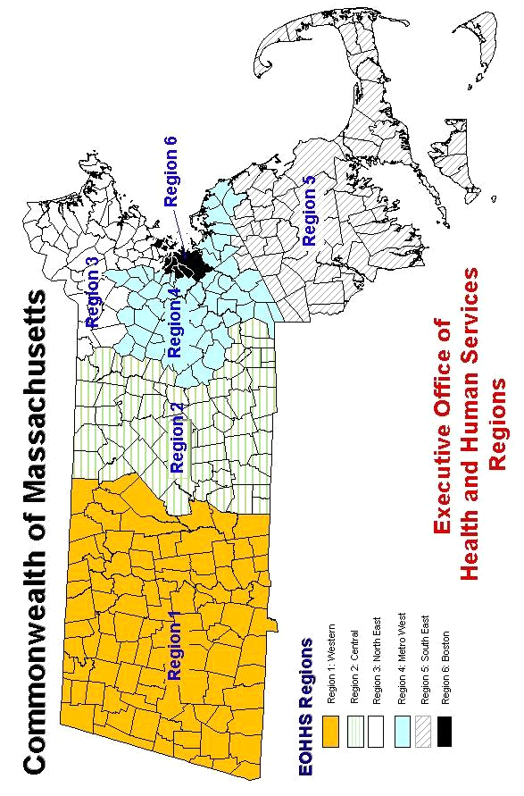
Appendix III: EOHHS Regions

Appendix IV: References
- Massachusetts Department of Public Health. A Profile of Family Planning Among Massachusetts Adults, 2006–2008. Available at: http://www.mass.gov/eohhs/docs/dph/behavioral-risk/family-planning-06-08.pdf. Accessed October 28, 2013.
- Massachusetts Department of Public Health. A Profile of Health Among Massachusetts Adults, 2010. Available at: http://www.mass.gov/eohhs/docs/dph/behavioral-risk/report-2010.pdf. Accessed June 4, 2013.
- Rosner, B. Fundamentals of Biostatistics, 6th Ed. Pacific Grove, CA: Duxbury Press; 2005.
- National Center for Health Statistics. Reliability of Survey Estimates. Available at: http://www.cdc.gov/nchs/about/major/ahcd/reliability.htm. Accessed June 4, 2013.
- Santelli J, Rochat R, Hatfield-Timajchy K, et al. The measurement and meaning of unintended pregnancy. Perspect Sex Reprod Health. Mar-Apr 2003;35(2):94-101.
- Brown SS, Eisenberg L, Institute of Medicine (U.S.). Committee on Unintended Pregnancy. The best intentions: Unintended pregnancy and the well-being of children and families. Washington, D.C.: National Academy Press; 1995.
- Kost K, Landry DJ, Darroch JE. The effects of pregnancy planning status on birth outcomes and infant care. Fam Plann Perspect. Sep-Oct 1998;30(5):223-230.
- Baydar N. Consequences for children of their birth planning status. Fam Plann Perspect. Nov-Dec 1995;27(6):228-234, 245.
- Guttmacher Institute. State facts about unintended prengnacy: Massachusetts. 2012. Avaialble at: http://www.guttmacher.org/statecenter/unintended-pregnancy/MA.html. Accessed May 16, 2013.
- Finer LB, Zolna MR. Unintended pregnancy in the United States: incidence and disparities, 2006. Contraception. Nov 2011;84(5):478-485.
- U.S. Department of Health and Human Services. Healthy People 2020: Family planning objectives. 2011. Available at: http://healthypeople.gov/2020/topicsobjectives2020/default.aspx. Accessed June 4, 2013.
- Lopez LM, Grimes DA, Chen-Mok M, Westhoff C, Edelman A, Helmerhorst FM. Hormonal contraceptives for contraception in overweight or obese women. Cochrane Database Syst Rev. 2010 Jul 7;7:CD008452.
- Society of Family Planning, Higginbotham S. Contraceptive considerations in obese women: release date 1 September 2009, SFP Guideline 20091. Contraception. 2009 Dec;80(6):583-90.
- Servais L. Sexual Health Care in Persons with Intellectual Disabilities. Mental Retardation and Developmental Disabilities Research Reviews. 2006;12:48-56.
- Williams CM, Brett KM, Abma JC. Coercive first intercourse and unintended first births. Violence Vict. 2009;24(3):351-63.
- Centers for Disease Control and Prevention. Preventing Smoking and Exposure to Secondhand Smoke Before, During, and After Pregnancy. Available at: www.cdc.gov/nccdphp/publications/factsheets/prevention/pdf/smoking.pdf. Accessed June 4, 2013.
- Centers for Disease Control and Prevention. Maternal and Child Health Smoking-Attributable Mortality, Morbidity, and Economic Costs. Available at: https://apps.nccd.cdc.gov/sammec/mch_exp_comp.asp. Accessed June 4, 2013.
- Dott M, Rasmussen SA, Hogue CJ, Reefhuis J. Association between pregnancy intention and reproductive-health related behaviors before and after pregnancy recognition, National Birth Defects Prevention Study, 1997-2002. Matern Child Health J. May 2010;14(3):373-381.
- Alan Guttmacher Institute, United States. Dept. of Health and Human Services, Open Society Institute. Fulfilling the promise: Public policy and U.S. family planning clinics. New York, N.Y.: The Alan Guttmacher Institute; 2000.
- Stoddard A, McNicholas C, Peipert JF. Efficacy and safety of long-acting reversible contraception. Drugs. 2011;71(8):969-80.
- U.S. Census Bureau, 2008-2010 American Community Survey. Available at: http://factfinder2.census.gov/faces/nav/jsf/pages/index.xhtml. Accessed March 2013.
- Fiscella K, Franks P, Doescher MP, Saver BG. Disparities in health care by race, ethnicity, and language among the insured: findings from a national sample. Med Care. Jan 2002;40(1):52-59.
- Galvin SL, Fagan EB. Knowledge, attitudes, and use of emergency contraception among Hispanic women of North Carolina. South Med J. Jan 2009;102(1):17-20.
- Sampson O, Navarro SK, Khan A, et al. Barriers to adolescents' getting emergency contraception through pharmacy access in California: differences by language and region. Perspect Sex Reprod Health. Jun 2009;41(2):110-118.
- Ibis Reproductive Health and Massachusetts Department of Public Health (MDPH) Family Planning Program. Low-income women’s access to contraception after Massachusetts health care reform. MA: Ibis Reproductive Health and MDPH Family Planning Program, September 2009.
- Bessett D, Prager J, Havard J, Murphy D, Agénor M, Foster A. Young adults, health insurance & access to contraception in the wake of health care reform: Results from focus group discussions in the Commonwealth of Massachusetts. Cambridge, MA: Ibis Reproductive Health, 2010.
- Massachusetts Department of Public Health. A Profile of Health Among Massachusetts Adults In Selected Cities, 2008. Available at: http://www.mass.gov/eohhs/gov/departments/dph/programs/health-stats/health-survey/brfss/. Accessed April 2013.

In 2008, cervical rings were included with diaphragms and cervical caps as a survey response option, and thus are included in Table 2.1 as a Barrier method. In 2010, cervical rings were offered as a separate survey response option, but are included in the Barrier method categories throughout this section to maintain consistency with the 2008 data.
English-speaking or Spanish-speaking is determined by the language in which the survey was conducted. All surveys are begun in English, and if the respondent cannot complete the survey it is offered in either Spanish or Portuguese.
It is important to note that the small sample size of the BRFSS limits our ability to conduct extensive analysis of family planning indicators by geographic region, contributing to the lack of statistical significance.

