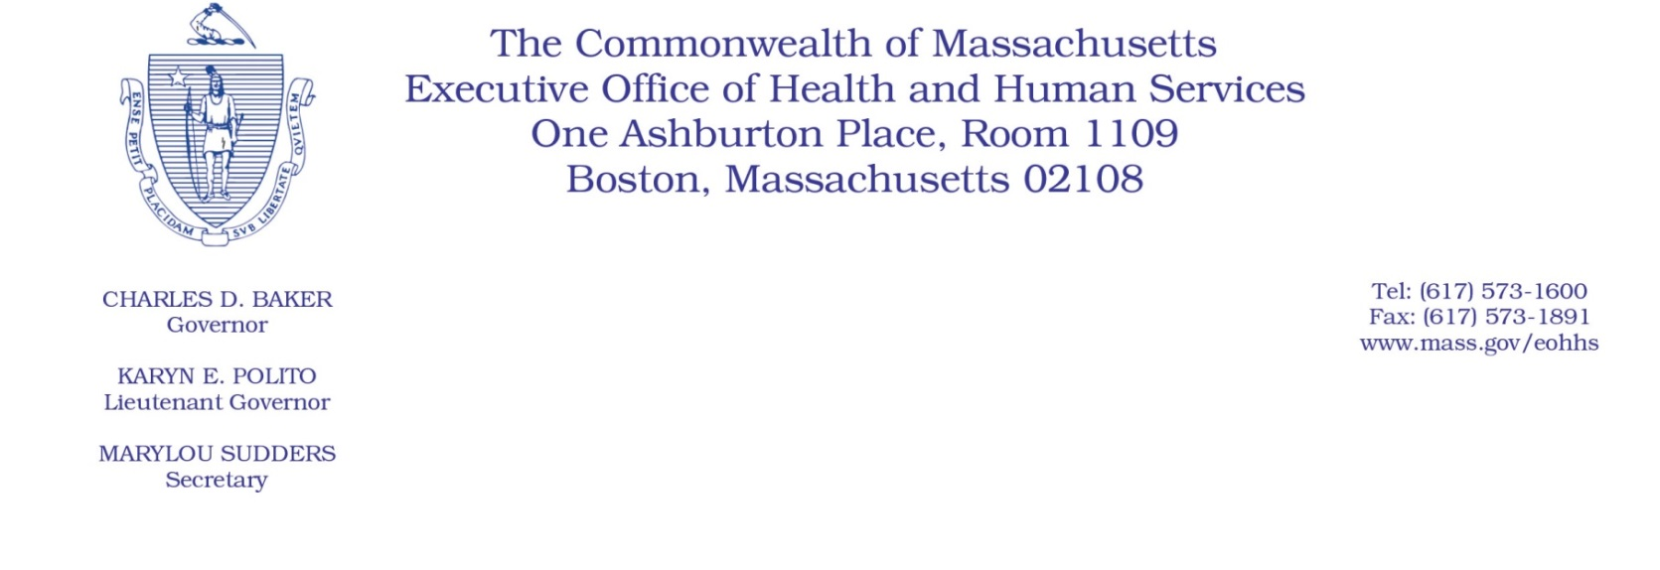
Administrative Bulletin 20-45
101 CMR 322.00: Durable Medical Equipment, Oxygen, and Respiratory
Therapy Equipment
Effective May 11, 2020

Procedure Code Update Applicable to Distribution Services by Durable Medical Equipment (DME) Providers Related to Coronavirus Disease 2019 (COVID-19) Public Health Emergency

Purpose, Scope, and Effective Period
The Executive Office of Health and Human Services (EOHHS) is issuing this bulletin pursuant to authority under COVID-19 Order #20: Order Authorizing the Executive Office of Health and Human Services to Adjust Essential Provider Rates During the COVID-19 Public Health Emergency and Executive Order 591: Declaration of State of Emergency to Respond to COVID-19. In light of the state of emergency declared in the Commonwealth due to COVID-19, EOHHS, which administers the Massachusetts Medicaid program known as “MassHealth,” is establishing a rate for the distribution of personal protective equipment (PPE) by MassHealth-enrolled Durable Medical Equipment and Supplies (DME) Providers, as further described in this administrative bulletin.
This administrative bulletin is effective for dates of service on or after April 1, 2020, and shall remain effective for the duration of COVID-19 Order No. 20: Order Authorizing the Executive Office of Health and Human Services to Adjust Essential Provider Rates During the COVID-19 Public Health Emergency.
Disclaimer: This Bulletin is not authorization for a provider’s use of the updated rate or provision of the new service. Authorization for the provision of, and billing and payment for, these services is governed by an executed special conditions amendment to a MassHealth DME provider’s Provider Contract.

Background
Certain MassHealth members receive essential care in their residences, including personal care attendant services and independent nurse services, which enable these members to remain within the community. During the public health emergency, access to PPE is essential to enable the continued care of these vulnerable members in the community and to protect the health and welfare of both the member and the care provider, especially when the member is suspected to have, or has tested positive for COVID-19. Accordingly, EOHHS is establishing a rate to pay authorized DME providers for the PPE distribution services.
Rate for Personal Protective Equipment Distribution Services
Effective for dates of service beginning April 1, 2020, the following rate is established for PPE distribution services:

Code | Rate | Description
E1399 U9 | $40.00 | Durable medical equipment, miscellaneous. (Used for PPE distribution services, specifically the packaging, preparing, and delivering or shipping of a 2-week supply PPE kit to an authorized individual during the COVID-19 public health emergency)

Public Comment
EOHHS will accept comments on the rate methodology established via this bulletin through May 25, 2020. Individuals may submit written comments by emailing: ehs-regulations@state.ma.us. Please submit written comments as an attached Word document or as text within the body of the email with the name of this administrative bulletin in the subject line. All submissions of comments must include the sender’s full name, mailing address, and organization or affiliation, if any. Individuals who are unable to submit comments by email may mail written comments to EOHHS, c/o D. Briggs, 100 Hancock Street, 6th Floor, Quincy, MA 02171.
EOHHS may adopt a revised version of this administrative bulletin taking into account relevant comments and any other practical alternatives that come to its attention.

