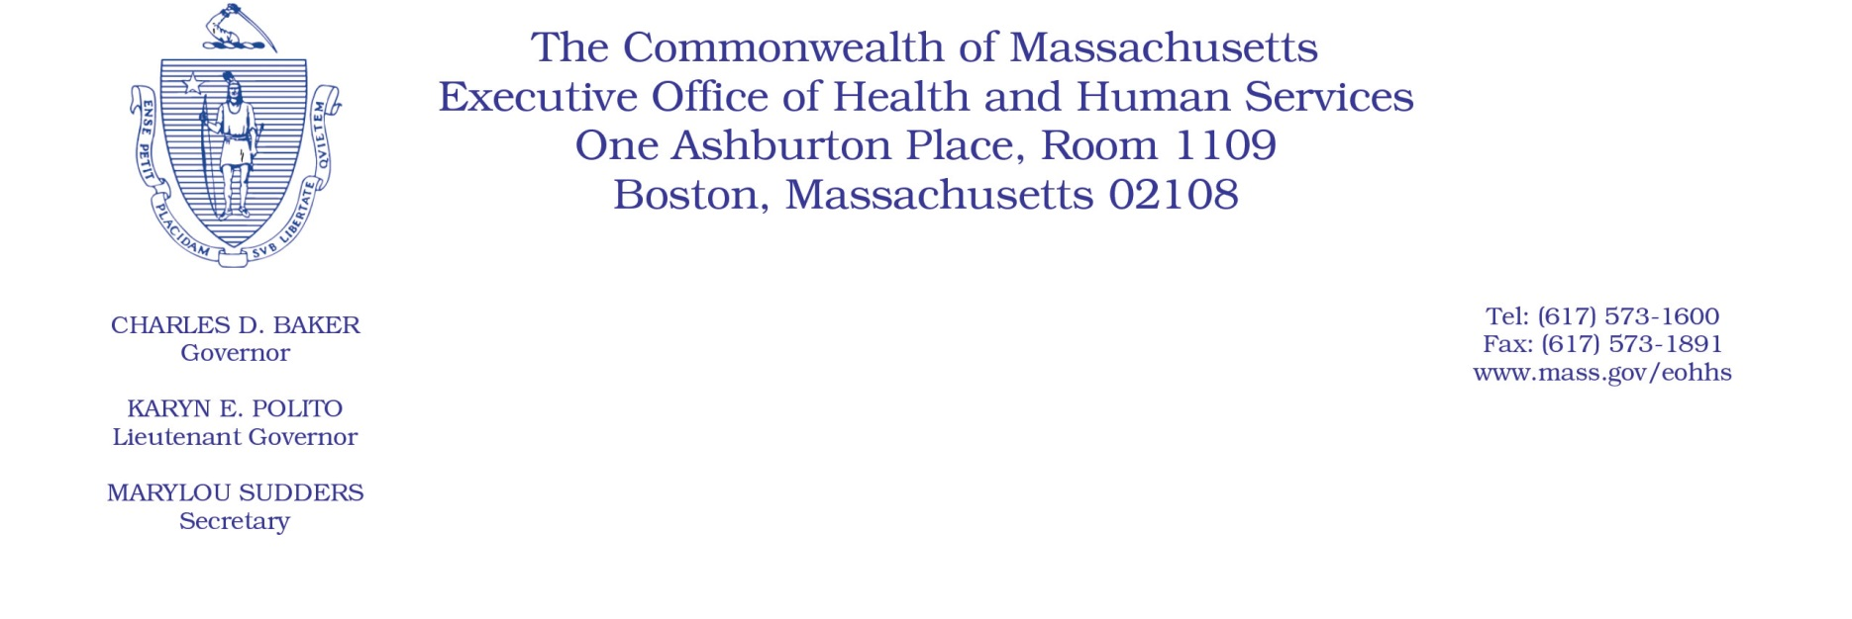

Administrative Bulletin 20-59

101 CMR 349.00: Rates for Early Intervention Program Services
Effective June 16, 2020
Additional Rate Provision Applicable to Early Intervention Program Services Purchased by the Department of Public Health to Compensate for Costs Associated with Coronavirus Disease 2019 (COVID-19)

Purpose and Effective Period
The Executive Office of Health and Human Services (EOHHS) is issuing this administrative bulletin pursuant to the authority of COVID-19 Order No. 20: Order Authorizing the Executive Office of Health and Human Services to Adjust Essential Provider Rates During the COVID-19 Public Health Emergency and Executive Order 591: Declaration of State of Emergency to Respond to COVID-19. In light of the state of emergency declared in the Commonwealth due to COVID-19, EOHHS is establishing increased rates for the purchase of early intervention services as social service programs purchased by the Department of Public Health (DPH) to address costs associated with COVID-19, and as further described in this administrative bulletin. If a rate is not being updated pursuant to this administrative bulletin, the rate remains at the rate established in the rate regulation at 101 CMR 349.00 or in relevant administrative bulletins.
This administrative bulletin is effective as of June 16, 2020, and contains rates of payment for certain DPH-covered early intervention services effective for dates of service from June 1, 2020, through June 30, 2020.
This administrative bulletin will remain effective for the duration of COVID-19 Order No. 20: Order Authorizing the Executive Office of Health and Human Services to Adjust Essential Provider Rates During the COVID-19 Public Health Emergency.
Disclaimer: This administrative bulletin is not authorization for a provider’s use of the COVID-19 rates. Governmental units that purchase services with rates established in the regulations listed below are responsible for authorizing and determining the use of these rates.

Background
Providers of social service programs, as defined in M.G.L. Chapter 118E, Section 8A, may be experiencing increased staffing and equipment costs as a result of the COVID-19 public health emergency. EOHHS seeks to promote continued delivery of critical services to its clients through providing financial relief to providers for these additional costs. Accordingly, EOHHS is establishing these rates for services provided under 101 CMR 349.00 to address the increased costs related to COVID-19. Governmental units purchasing services pursuant to rates established in 101 CMR 349.00: Rates for Early Intervention Program Services may utilize the COVID-19 rates to compensate providers that have incurred increased costs associated with COVID-19.

Rates to Address Costs Associated with COVID-19
To support early intervention providers during the COVID-19 emergency, effective for dates of service from June 1, 2020, through June 30, 2020, EOHHS establishes the following rates for certain DPH-covered early intervention services.
Code | Service Description | Rate
H2015 | Child visit - day care | $25.28
H2015 | Child visit - hospital | $25.28
H2015 | Child visit | $25.28
T1015 | Center-based individual | $21.15
96165-U1 | EI-only child group (15-minute rate) | $7.37
96164-U1 | EI-only child group (30-minute rate) | $14.74
96165-U2 | Community child group (15-minute rate) | $9.68
96165-U2 | Community child group (30-minute rate) | $19.36
T1027 | Parent-focused group | $9.46
T1023 | Screening | $29.49
T1024 | Assessment | $33.84

Public Comment
EOHHS will accept comments on the rate established via this bulletin through June 30, 2020. Individuals may submit written comments by emailing ehs-regulations@mass.gov. Please submit written comments as an attached Word document or as text within the body of the email with the name of this administrative bulletin in the subject line. All submissions of comments must include the sender’s full name, mailing address, and organization or affiliation, if any. Individuals who are unable to submit comments by email may mail written comments to Kara Solimini, Director of Purchase of Services, Executive Office of Health and Human Services, 100 Hancock Street, 6th Floor, Quincy, MA 02171.
EOHHS may adopt a revised version of this administrative bulletin taking into account relevant comments and any other practical alternatives that come to its attention.

