Odor Investigation

Abbot Elementary School
25 Depot Street
Westford, Massachusetts

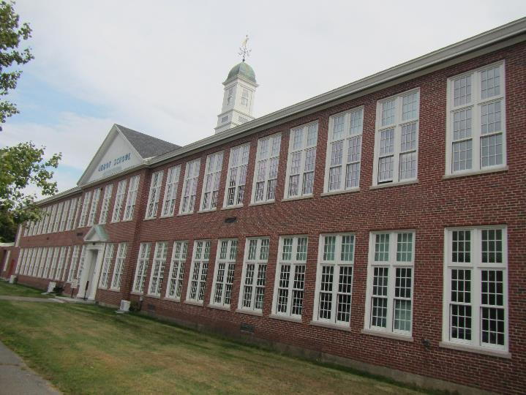

Prepared by:
Massachusetts Department of Public Health
Bureau of Environmental Health
Indoor Air Quality Program
October 2019

Background
Building: | Abbot Elementary School (AES)
Address: | 25 Depot Street Westford, MA
Assessment Coordinated Through: | Paul Fox, Director of Facilities, Town of Westford & Public Schools
Reason for Request: | Complaints of odors described as sewer gas in a small instructional suite and office
Date of Assessment: | October 7, 2019
Massachusetts Department of Public Health/Bureau of Environmental Health (MDPH/BEH) Staff Conducting Assessment: | Jason Dustin, Environmental Analyst/Inspector, Indoor Air Quality (IAQ) Program
Building Description: | The AES is a two story brick school building built in 1955; the suite inspected formerly served as the main office and now contains an instructional room, office, hall and abandoned restroom.
Windows: | Windows are openable in the space.

Methods
Please refer to the IAQ Manual and appendices for methods, sampling procedures, and interpretation of results (MDPH, 2015).

Results and Discussion
The following is a summary of indoor air testing results (Table 1).
- Carbon dioxide measurements were below the MDPH recommended level of 800 parts per million (ppm) in all areas surveyed, indicating adequate air exchange at the time of assessment.
- Temperature was within the MDPH recommended range of 70°F to 78°F in all areas assessed.
- Relative humidity was above the MDPH recommended range of 40 to 60% in all areas tested which was reflective of outside humidity due to open windows.
- Carbon monoxide levels were non-detectable (ND) in all areas tested.
- Particulate matter (PM2.5) concentrations measured were below the National Ambient Air Quality (NAAQS) level of 35 μg/m³ in all areas tested.
- Total Volatile Organic Compounds (TVOCs) were ND in all areas assessed.

Ventilation
A heating, ventilating and air-conditioning (HVAC) system has several functions. First it provides heating and, if equipped, cooling. Second, it is a source of fresh air. Finally, an HVAC system will dilute and remove normally-occurring indoor environmental pollutants by not only introducing fresh air, but also filtering the airstream and ejecting stale air to the outdoors via exhaust ventilation. Even if an HVAC system is operating as designed, point sources of respiratory irritants may be present and produce symptoms in sensitive individuals.
The instructional suite (formerly the main office) currently has no means of mechanical supply ventilation but relies on open windows for the introduction of fresh air. The former restroom contains an exhaust vent, which appeared to be drawing air at the time of assessment.
Facilities staff reported that the old supply air handler for the AES is in disrepair but funding for a new HVAC system has just been approved. The system will likely be designed and installed in the coming months. Facilities staff also reported that two of the three main exhaust fans are typically used in combination with open windows during temperate weather to facilitate air exchange.

Odors
Slight sewer odors were noted in the instructional suite but were strongest in the former restroom. The plumbing fixtures had been abandoned and capped years prior to this visit. Occupants noted that sewer-like odors were detected intermittently for approximately one and a half years. BEH/IAQ staff noted that the thin-walled copper fitting used to cap the old sink drain appeared damaged in some areas (Picture 1). The plastic plug used to cap the abandoned toilet drain line was in place but did not appear to have any locking mechanism to properly secure the plug to the toilet drain flange. In addition, no sealant (e.g., silicone) appeared to be used around the plug to ensure an airtight seal within the old toilet drain line (Picture 2). Further, BEH/IAQ staff noted several gaps in the concrete block wall around the water/drain lines (Picture 3).
It is likely that sewer odors are being drawn from openings around the old caps of the abandoned drain lines. Other odors may enter the instructional suite through breaches leading to the wall cavity. With exhaust only ventilation, the building is depressurized which exacerbates these conditions. This was evident by the feeling of strong airflow coming from the gaps around the plumbing lines in the wall.
Additional open holes/breaches were also observed in the ceiling tile system and in the wall of the instructional area (Pictures 4 and 5). These breaches are not likely to be the source of the reported odors but rather could serve as pathways for odors to travel to other areas of the building.

Other Concerns
Several water-damaged ceiling tiles were noted within the instructional suite. These tiles were reported by Facilities staff to be historic in nature. The AES has recently installed a new roof and no active leaks were reported in this space. These ceiling tiles should be replaced and the area should be monitored for further leaks.

Conclusions and Recommendations
In view of the findings, the following recommendations were made at the time of the visit and are reiterated below:
- Work with a plumber to properly reseal the abandoned toilet drain and sink drain lines. Use best practices to obtain an airtight seal and secure connection to the drain lines.
- Seal all holes/breaches around the plumbing lines in the wall and floor of the former bathroom.
- Seal all holes/breaches in the ceiling tiles and walls of the instructional suite which may serve as pathways.
- Ensure local exhaust vents are operable in active restrooms but consider consulting with an HVAC contractor to reduce the strong building-wide depressurization until supply air ventilation is introduced to balance/slightly pressurize the building.
- Continue to use openable windows to supplement fresh air during temperate weather. Ensure all windows are tightly closed at the end of the day.
- Should the odors return after following the above procedures, more invasive methods of inspecting for cracks or corrosion in the old plumbing drains may be necessary (e.g., opening wall cavity). Other techniques such as smoke tests, etc. may also be used during unoccupied hours. Make further repairs as necessary and seal all openings to occupied areas following any demolition.
- Replace any historic water-damaged ceiling tiles in this suite.
- Thoroughly clean the instructional suite following repairs and prior to occupant use of this space.
- Refer to resource manual and other related IAQ documents located on the MDPH’s website for further building-wide evaluations and advice on maintaining public buildings. These documents are available at http://mass.gov/dph/iaq.

References
MDPH. 2015. Massachusetts Department of Public Health. Massachusetts Department of Public Health Indoor Air Quality Manual: Chapters I-III. Available at: http://www.mass.gov/eohhs/gov/departments/dph/programs/environmental-health/exposure-topics/iaq/iaq-manual/.
Picture 1
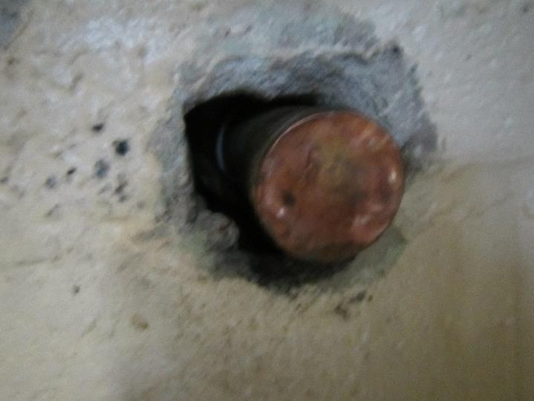
Abandoned sink drain showing damaged, thin-walled cap
Picture 2
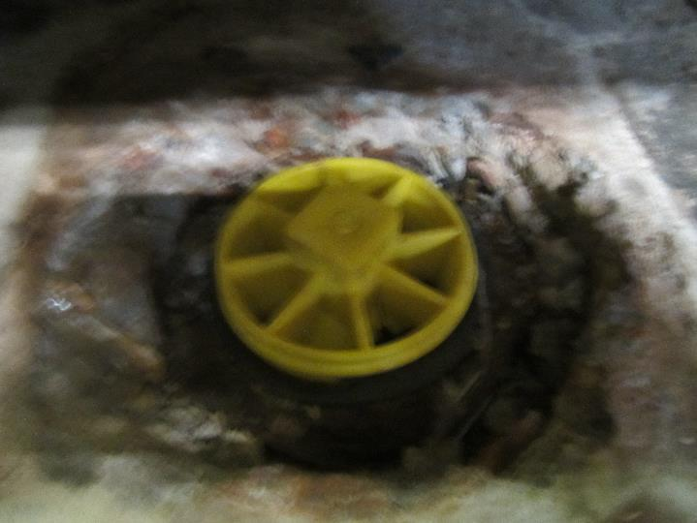
Plastic plug blocking abandoned toilet drain; note apparent lack of sealant and locking mechanism
Picture 3
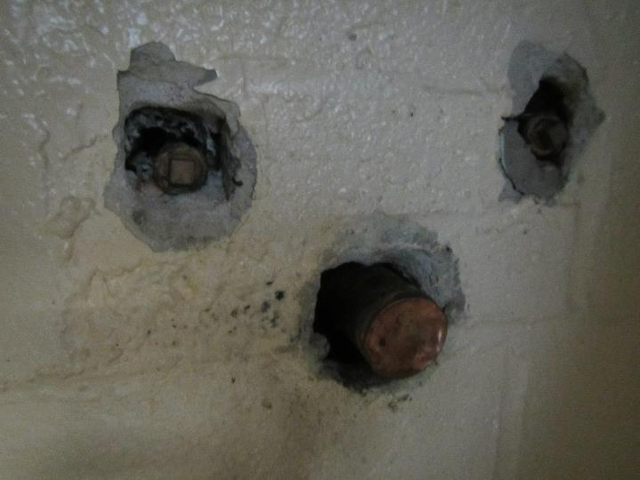
Note gaps/breaches in wall around utilities leading to unconditioned wall cavity
Picture 4
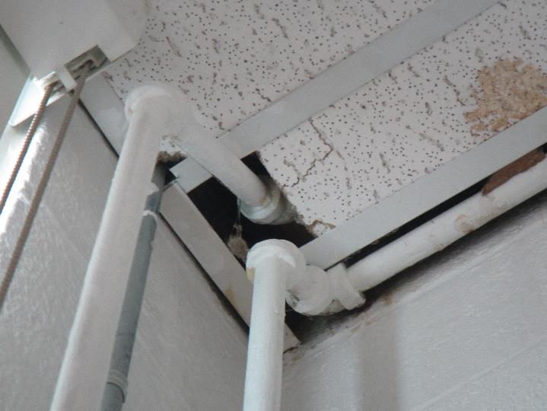
Breaches in the ceiling tile around utilities serve as pathways
Picture 5
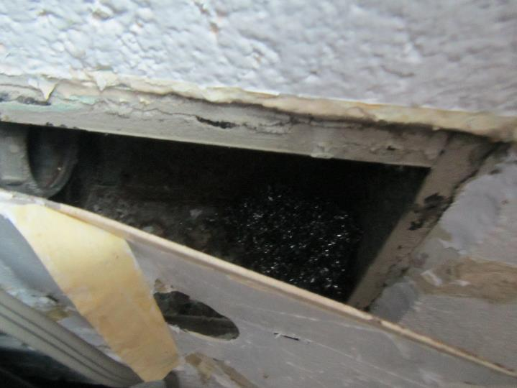
Abandoned electrical box/conduit in wall may serve as pathway

Location | Carbon  Dioxide  (ppm) | Carbon Monoxide  (ppm) | Temp  (°F) | Relative  Humidity  (%) | PM2.5  (µg/m³) | TVOCs  (ppm) | Occupants  in Room | Windows  Openable | Ventilation |  | Remarks
 |  |  |  |  |  |  |  |  | Supply | Exhaust
Background (outside) | 407 | ND | 70 | 72 | 6 | ND | - | - | - | - | Overcast, humid, windy
Instructional space (formerly Main office) | 487 | ND | 71 | 66 | 1 | ND | 3 | Y open | N | Y | Exhaust in closet (former bathroom), Historic WD CTs, pathways in CTs and wall, slight sewer odor detected upon entering room, radiators
Common hall area | 494 | ND | 71 | 67 | 2 | ND | 2 | N | N | N | PC, printer
Closet (former bathroom) | 477 | ND | 71 | 68 | 2 | ND | 1 | N | N | Y | Sewer odor noted to be stronger when door was opened, exhaust fan drawing strongly, gaps/breaches around abandoned plumbing, air rushing in breaches in wall due to depressurization, old caps on toilet drain & sink drain appear to have gaps/damage
Inner office | 412 | ND | 71 | 69 | 1 | ND | 1 | Y open | N | N | Historic WD CTs

