This job aid is only to be used by DTA and MRC providers.
How will providers receive the information they need to enroll clients in ESM?
For some programs such as CIES, agencies will send providers referral and/or service authorization forms on clients for whom services have been authorized. These forms will contain the information required to enroll clients in ESM. If there is information missing, contact your Agency Contract Manager.
Search for a Client
1. | In order to locate or create a client record, a user must complete a search in EIM/ESM Client Module.  Search for a client:  - Select the Client module and then Client Search from the navigation bar.  - Enter your search criteria in at least one of the following fields:  - First and/or Last Name  - ID and ID Type (must fill in both)  - Date of birth  - Click [Search].  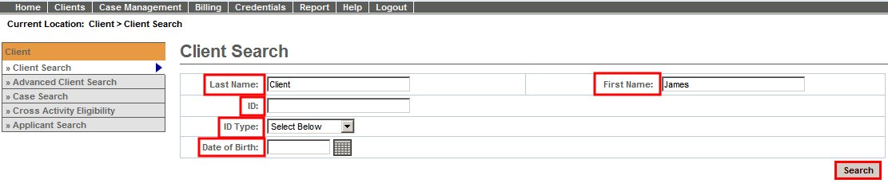  If search results are found, click on the Last name link to open client record.  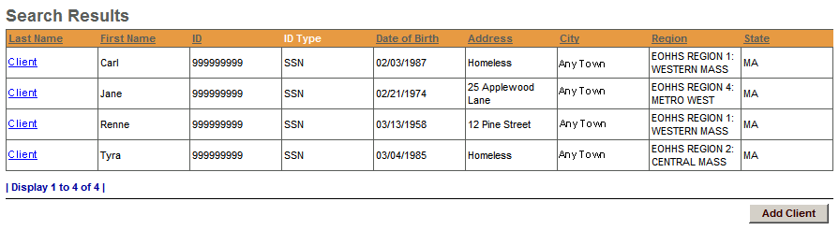
Add a Client
2. | Add a client: Face Sheet  - Start at the Client Search page.  - Enter both a [First Name] and [Last Name].  If no search results are found,  - Click the Add a Client link.  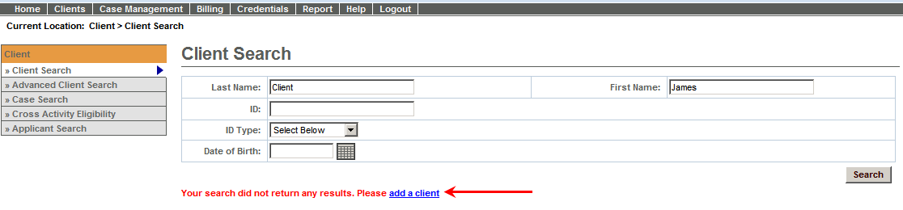  - Enter Required Information:  - First Name  - Last Name  - Date of Birth (Format: mm/dd/yyyy)  - Gender  - Social Security Number (Format: xxx-xx-xxxx)  - Click [Save New Client].  Note: You are required to complete fields marked with a red asterisk (*).  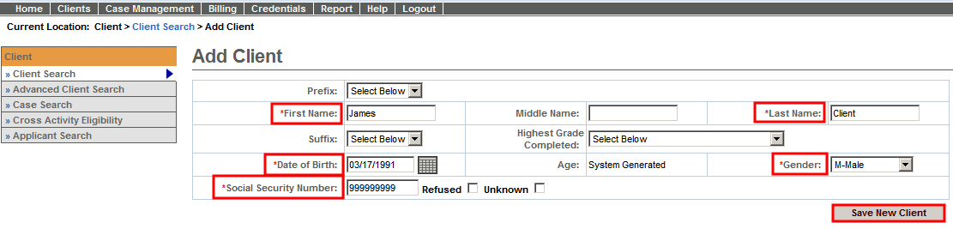  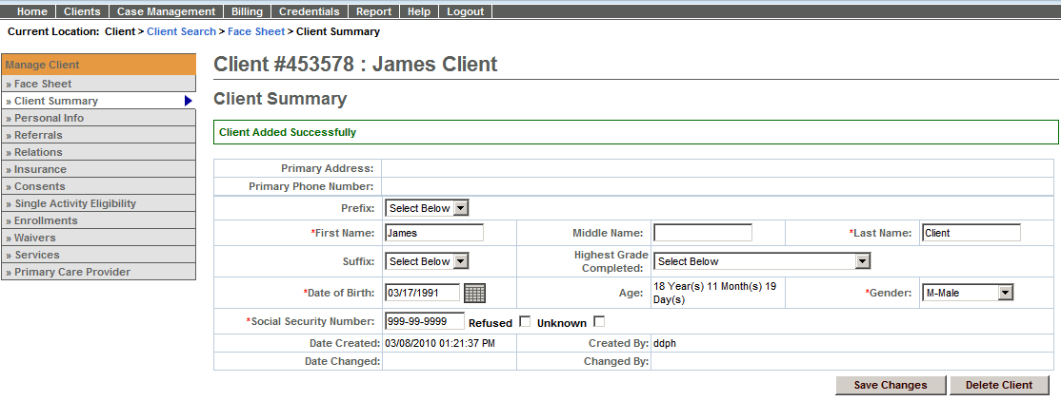  Note: The message “Client Added Successfully” will appear at top of page.
Eligibility to Enrollment:
3. | In order to ensure the client is eligible for this activity, users must complete an eligibility determination.  Determine Eligibility:  - Start at the client’s Face Sheet.  - Click Single Activity Eligibility from the navigation bar.  - Select Activity from the radio buttons and click [Select Activity].  - Select Contract from the drop down and click [Select Contract].  - Select Enrolling Organization from the drop down and click [Determine Eligibility].  - Click [Create Enrollment].  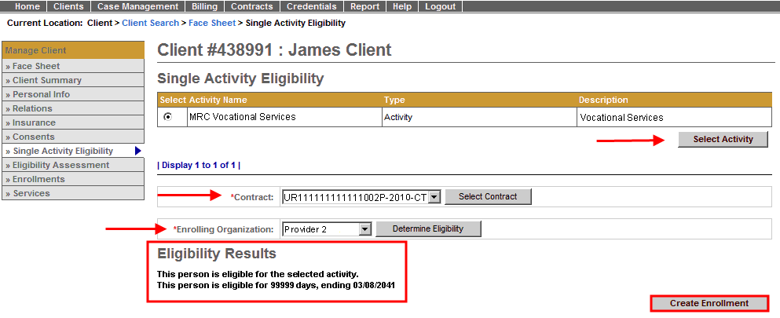  Note: The system will display a message indicating eligibility status. For eligible clients, users proceed to create an enrollment.
4. | After determining eligibility, proceed with creating the enrollment.  Create Enrollment:  - Enter [Enrollment Period Start Date].  - Click [Calculate Timeframe].  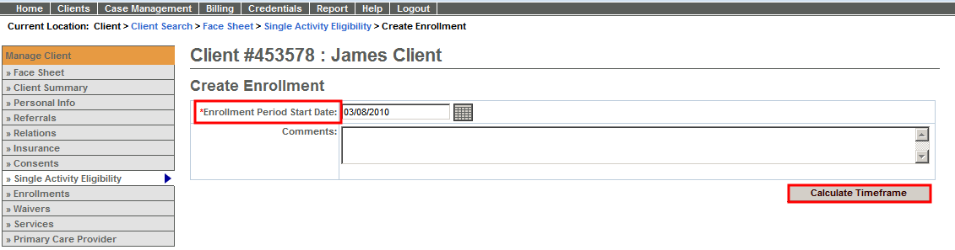
5. | Confirm Enrollment:  - Enter [Agency Enrollment ID].  - Click [Confirm Enrollment].  Note: Without completing this step, the enrollment will not be saved in ESM.  Important Information Regarding the Agency Enrollment ID field:  MRC CIES Providers should use the MRCIS ID number when completing the Agency Enrollment ID field. This is a required field for all MRC CIES Providers.  DTA CIES Providers should use the Service Authorization Number when completing the Agency Enrollment ID field. This is a required field for all DTA CIES Providers.  MRC ABI Providers should use the MassHealth ID Number when completing the Agency Enrollment Field in ESM. This is a required field for all MRC ABI Providers.  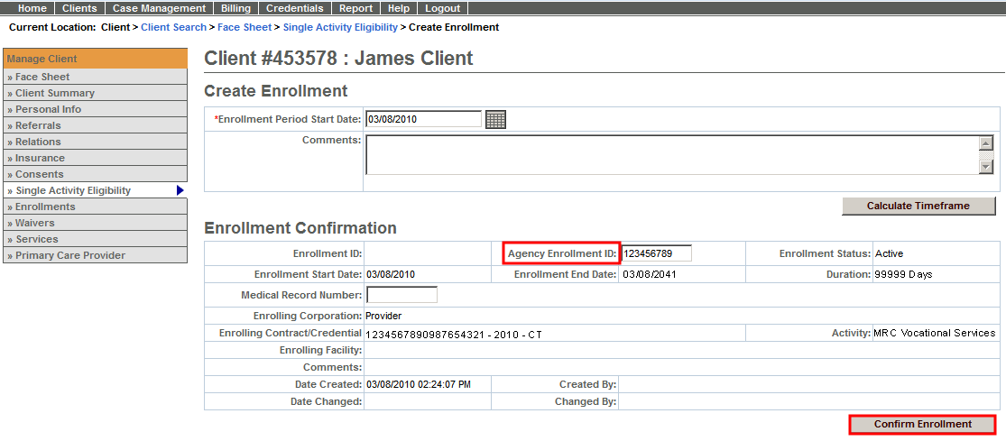  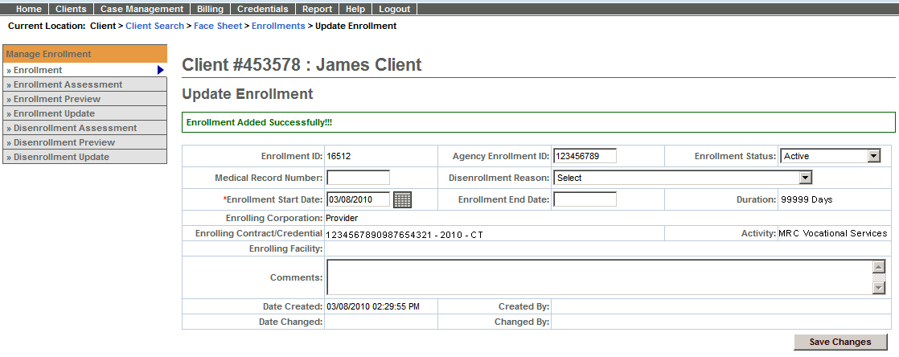  Note: The message “Enrollment Added Successfully” will appear at top of page.

How to Close a Client Enrollment
Enrollments need to be closed for a number of reasons, including:
- Client enrolled to the wrong contract.
- Client has completed a service and is no longer receiving services.
- Duplicate enrollments have been created for a client.
To close a client enrollment in ESM,
- Select the [Clients] module.
- Search and locate client.
- From Client Facesheet Summary page, select [Enrollments] from left navigation menu.
- Click on [Enrollment ID] for enrollment that needs to be closed.
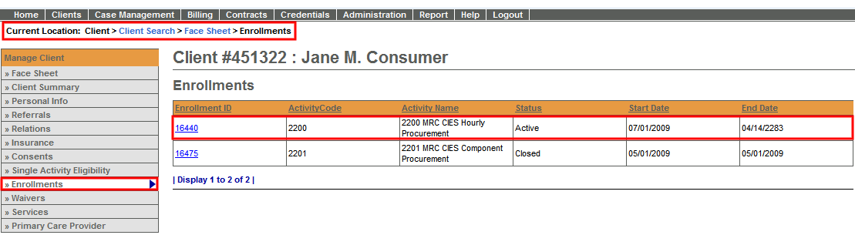
- From the Update Enrollment page,
  - Select [Closed] from the Status drop-down menu.
  - Select [Disenrollment Reason] from Disenrollment Reason drop-down menu.
  - Enter [Enrollment End Date]. (Format: mm/dd/yyyy)
Note: If this is an incorrect enrollment, enter the same date as the Enrollment Start Date. The client will still show on the SDR for this one month.
  - Click [Save Changes] button
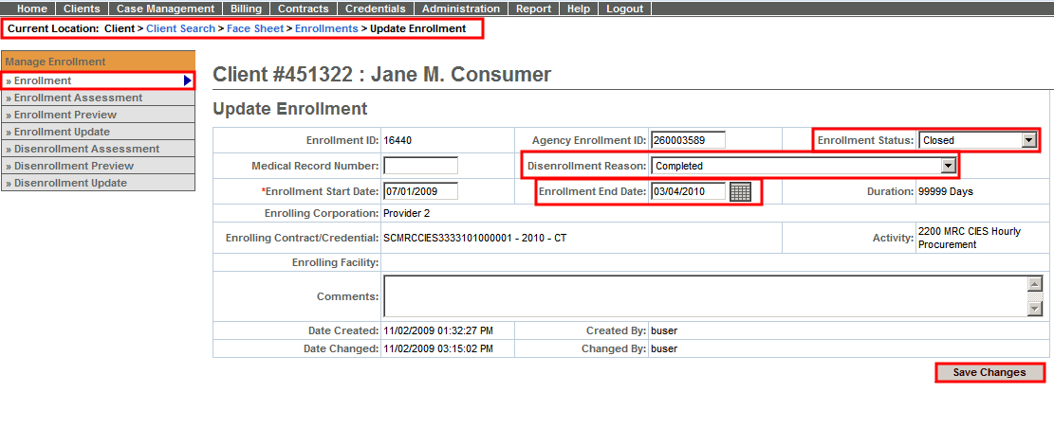
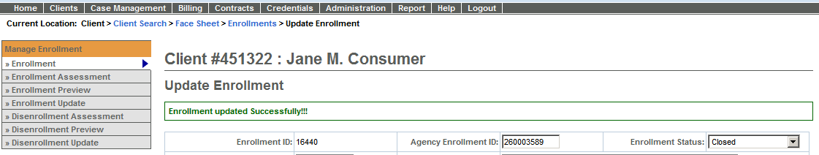
Note: The message “Enrollment updated Successfully” will appear at top of page.
How to Edit a Client Enrollment
At times, enrollments will need to be updated in ESM. Common items to be edited in on an enrollment include:
- Agency Enrollment ID (i.e., MRCIS ID, Beacon Service Authorization #, MassHealth ID Number)
- Enrollment End Date
To edit a client enrollment in ESM,
- Select the [Clients] module.
- Search and locate client.
- From Client Facesheet Summary page, select [Enrollments] from left navigation menu.
- Click on [Enrollment ID] for enrollment that needs to be updated.
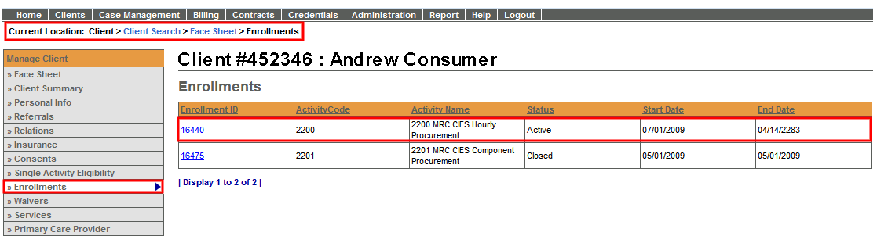
- From the Update Enrollment page,
- Edit any of the editable fields:
  - Agency Enrollment ID (i.e., MRCIS ID, Beacon Service Authorization #, MassHealth ID Number)
  - Enrollment End Date
- Click [Save Changes] button
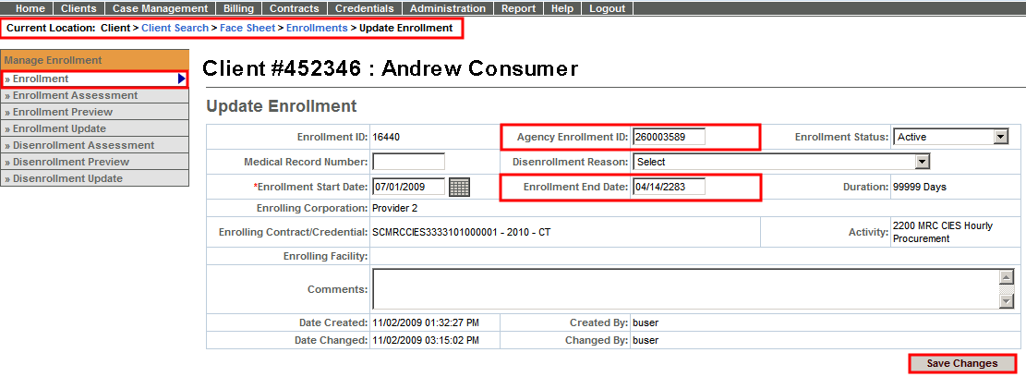

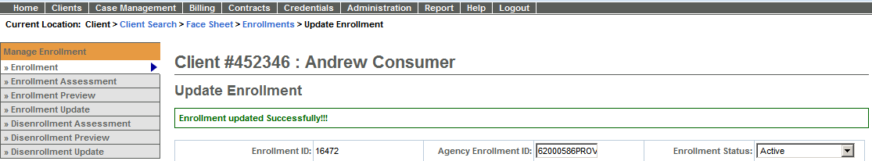
Note: The message “Enrollment updated Successfully” will appear at top of page.
Duplicate Client Information - Client is entered incorrectly
There should only be one client record per client. If a client record is entered incorrectly or a duplicate record for the same client has been created, the client record cannot be deleted. The duplicate/ incorrect client record may, however, be marked as incorrect so it is not used. To do so follow the steps below.
- Search and locate incorrect client record.
- On the Client Summary page , replace the First and Last Name fields with the following:
  - First Name: Type the first and third initials of the First Name, the Middle initial, first and third initials of the Last Name (Example: James L. Client = JMLCI)
  - Last Name: Type the first and third initials of the First Name, the Middle initial, first and third initials of the Last Name (Example: James L. Client = JMLCI)
Note: In order to avoid instances of duplicate clients, only legal names should be entered in ESM and not nicknames. If the name is too short or if there is no middle name, substitute an "X" in those positions. (Example: James Client = JMXCI)
- Click [Save Changes] button.
Questions or need assistance?
Call Virtual Gateway Customer Service
1-800-421-0938
(617-847-6578 - TTY for the deaf and hard of hearing)
8:30 am to 5:00 pm Monday through Friday

