The Bureau of Community Health and Prevention (BCHAP) is part of the Massachusetts Department of Public Health (MDPH). MDPH falls under the Executive Office of Health and Human Services.
Mission
The mission of BCHAP is to promote the well-being of everyone in Massachusetts, with attention on populations disproportionately impacted by health inequities. We aim to reduce social and structural barriers that lead to poor health by working with communities, people and partners across the Commonwealth. BCHAP commits to transforming the systems that maintain racial and social inequities and owns its responsibility as part of the government to prevent these injustices.
Vision
BCHAP envisions a Commonwealth in which community members live, work, and play with equitable opportunities for good health and where racism is no longer a determinant of health.

Racial Equity “Why” Statement
The history of structural racism – the public
Our Values
Our values guide everything we do. We aim to:

policies, institutional practices, and social norms that together maintain racial hierarchies – and its impact across the country and within the Commonwealth is often overlooked or unacknowledged, yet it is pervasive and unmistakably harmful to everyone. The social marginalization and inequities that racism cultivates in housing, education, employment, the built and social environments, and health care are felt across generations, most acutely in communities of color.
BCHAP recognizes that systems of cultural oppression need to be acknowledged and repaired by entities that helped create them. BCHAP is committed to improving the quality of life for all Commonwealth residents,
while working towards eliminating the marginalization and inequities that threaten the lives of communities of color.
CHALLENGE RACISM FIRST
Start with racism explicitly, not exclusively.
FOCUS ON ROOT CAUSES
Center solutions on the systems that create unjust outcomes.
PROMOTE BELONGING
Value all lived experiences and make space for staff and partners to show up as their authentic selves.
BE ACCOUNTABLE
Fulfill our commitments to communities, partners, and team members.
INFORM WITH DATA
Use data and storytelling to identify the needs of communities and build policies – and share out what is learned.
PARTNER WITH COMMUNITIES
Listen to community needs. Develop solutions WITH, not FOR,
communities.

DRAFT FEBRUARY 2023. 1

Health Determinants
Access to Care
Medical Services
90%
Other
10%

94%
6%

Other
National Health Expenditures
$2.6 Trillion

More than 80% of what determines our health happens outside of healthcare settings.
However, 90% of US health spending goes to healthcare settings.

Access to healthy food, opportunities to be physically active, live without fear of violence, and take part in decisions that affect our lives are a bulk of what keep us healthy.
Because of this, BCHAP builds the capacity of partners to improve social and structural conditions, with an explicit racial justice lens.

The Health Tree (below) shows the relationship between health outcomes and the root causes of health. Inequities persist in the structural and social environments around us,
like policies, systems, and social norms, and these conditions influence our ability to engage in healthy behavior. BCHAP’s programs and policies work to address these root causes of inequitable and poor health outcomes through a systemic approach. While we understand that addressing root causes has a greater impact on health outcomes than individual behavior, we also know that people can make decisions to improve their own health.
Many BCHAP programs also provide direct services and outreach to individuals to support healthy decisions.

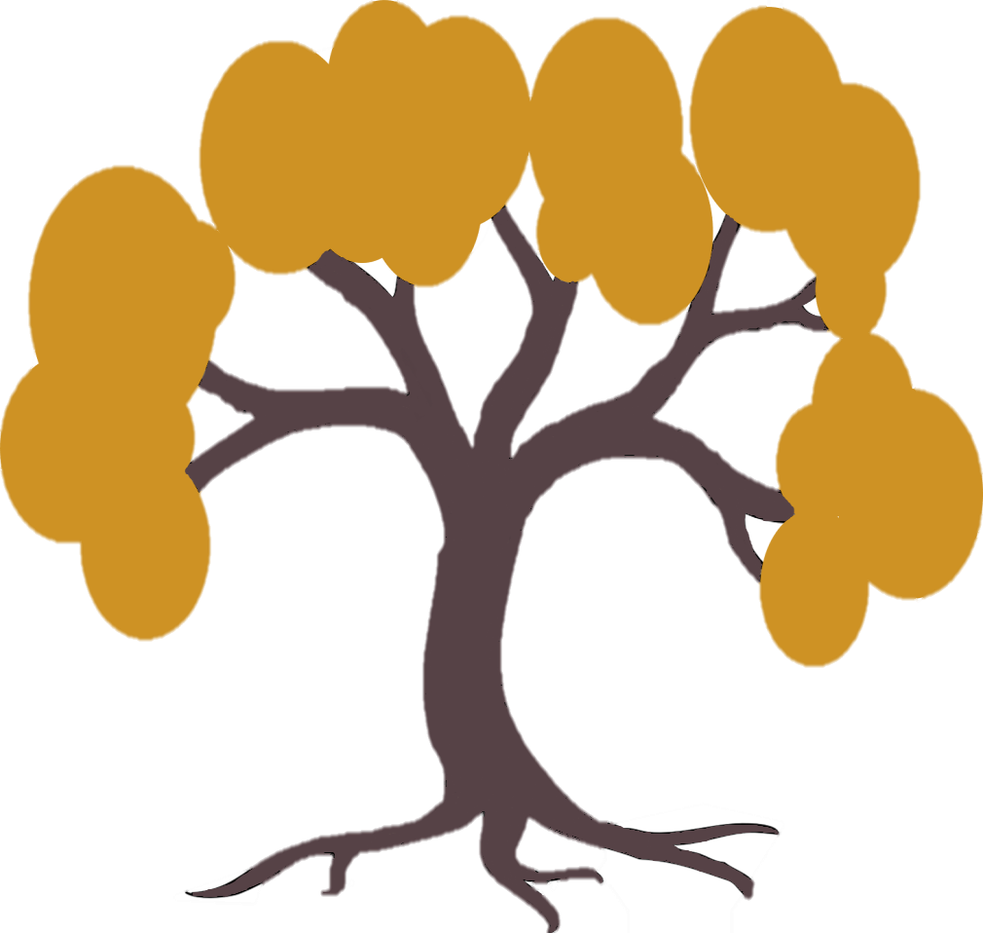
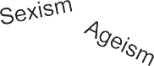



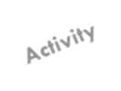
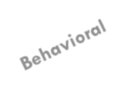

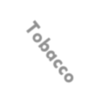




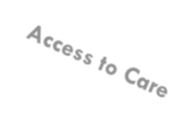


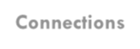
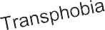
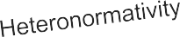


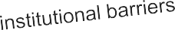
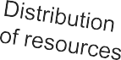
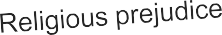

Helth Outcomes
Cardiovascular
Asthma
Cancer
Disease
Domestic Violence
Sexual Violence
Unintended
Pregnancy
Diabetes
Sexually Transmitted Infections
Connections
Community Violence
Education Built Environment Violence and Trauma
Public Safety
Employment Housing
Injury
Social Environment Economic Stability
Structural &
Classism

Tree Leaves
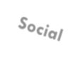

Health Behaviors
Tree Branches
Social Determinants of Health
Tree Trunk
Root Causes
of Health
Tree Roots
Underlying Systems of Dominant Culture and Narratives
Soil

CHART : NEHI & UCSF, 2013
HEALTH TREE: ADAPTED BY HEALTH RESOURCES IN ACTION FROM THE HUMAN IMPACT PARTNERS PUBLISHED FEBRUARY 2023. 2

BCHAP’s community-based prevention strategies are sourced from and informed by the community. Our work spans the public health continuum:

Address institutional and social inequities that persist across systems and drive health outcomes
e.g., Policy change for walkable streets
Increase equitable access to care and improve living conditions
e.g., Train youth as Community Ambassadors for violence prevention outreach
Treat disease and injury and support behavior change
e.g., Coordinating trauma- informed sexual assault services
System-Level
Community-Level
Individual-Level

We understand that unfair differences in health outcomes are rooted in system level inequities. BCHAP staff apply this understanding in everything we do, across the continuum, to achieve sustained results for Massachusetts communities.
The team’s innovative strategic approach is grounded in BCHAP’s Values (pg. 1) and
leverages the following key methods to address public health issues:

Community Partnerships


Equitably

Healthy Policies
Capacity
Building Outreach & Education

Transfer
Data-To- Action

Collect,

Grant- Making

engage partners & priority populations in change strategies
Enact policies proven to create environments that support healthy living
knowledge and power to communities to support their health needs
Increase health access and public awareness of accurate health information
evaluate, and use data to ensure the work makes a difference
Use procurement as a vehicle for community empowerment

PUBLISHED FEBRUARY 2023. 3

Our Organization
The organization chart below demonstrates BCHAP’s internal structure.
Healthy Youth, Violence and Injury Prevention
Prevention and Wellness

Operations and Support Services
Bureau of Community Health and Prevention
Division of Health Protection and Promotion
Division of Violence and Injury Prevention
Division of Sexual and Domestic Violence
Sexual Assault Nurse Examiner Program
Division of Child/Adolescent Health and Reproductive Health
Division of Community Based Prevention and Care
Statistics and Evaluation
MA Tobacco Cessation and Prevention Program
Policy and Communication
Division of Community Health Planning and Engagement
Administration and Finance

By the Numbers
$274 million
Bureau Budget for FY23
240
Staff Members
325
Contracted Partners

Follow Us
Find us on the MDPH website for more information: mass.gov/orgs/bureau-of-community-health-and-prevention


PUBLISHED FEBRUARY 2023. QUANTITATIVE DATA PULLED OCTOBER 2022. 4

