**Absences**



## Basics and Policies Explained



Updated: 2/4/2015

# Policies regarding absences have not changed, but CCFA now calculates whether or not to pay based on accumulated absences documented in the past 6 months from all providers

* **Explained absence, the parent or guardian has provided a reason for the absence**
  + EEC policy documents are being updated

# Unexplained absence, no communication regarding the reason for absence is obtained

* **The absence history follows the child, regardless of placement, the exception is a new DCF referral**
  + Once a new DCF referral is entered, you will create new authorizations and placements for the child
  + The 6 month absence total will be reset to zero

# EEC allows up to 30 paid absences in a rolling 6 month period

* **The subsidy administrator may terminate the placement due to excessive absences**
  + Terminating the placement will allow you to be paid during the two week notice period, make sure the terminate date is 2 weeks after notice

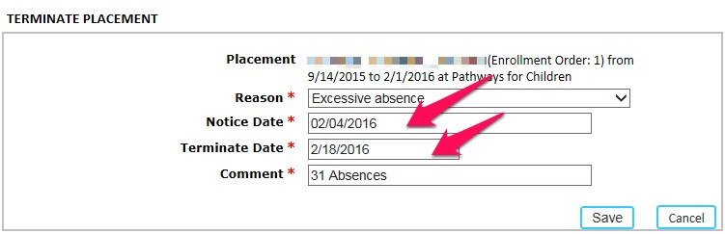

# If the subsidy administrator does not issue a two-week termination notice, the provider will not be paid for any additional absences past the 30th absence accumulated during the 6 month rolling period

* + Note that you will be paid for attendance
  + If the month changes and the 6 month absence total is less than 30, you will be paid for absences again 3

# Any consecutive unexplained absences over 3 days will not be paid for unless there is a termination on the 4th consecutive unexplained absence

* + On 4th absence, provider may send termination notice, paid

during 2 week notice period

* + Obtain a new DCF referral from case worker, if Supportive child

# If the Placement is 4 day Flex (Regular or Intermittent), the subsidy administrator must enter 4 days of attendance values for the child each week

* + If child does not ‘use’ a day, mark as Absent
  + May warrant reassessment of service need (e.g., if regularly

scheduled absences based on Flex schedule)

# When Provider terminates a family the placement is extended to cover the 2 week notice.

* **What if the family terminates voluntarily: how do I get paid for 2 weeks after termination?**
  + Change the end date of the Authorization to 2 weeks after the

termination date

* + Change the end date of the Placement to 2 weeks after the termination date
  + Contract Providers may use V for Vacancy during the two week period after termination, if the child no longer attends during the notice period

# Absence during Appeal Process

* + CCFA currently does not provide the functionality to create paid

absences after the two week termination notice period

* + Mark all absences as appropriate
  + Work with the Administering Organization and EEC to Obtain payment for absences documented during the appeal
  + CCFA has requested a modification to the business rules to support this functionality
* **Early Release by Provider**
  + CCFA does not currently support ½ day closures as the terms of the subsidy contracts (i.e., IE, Priority Pops, and Voucher Agreements) require programs to be open full day/full year except for approved closure schedules, which are submitted annually
  + If a child is not present due to early release, the provider should enter Attendance as **Provider Refused**
  + The provider will not be reimbursed unless it is an approved EEC

emergency closure

# When documenting absences, refer to the Attendance Codes Cheat Sheet to ensure that the proper codes are used

* **If the child is Absent because Transportation did not show up**
  + The Administering Organization should create a paid closure day
  + The provider will enter the Transportation Closure Code (CF0) in

both Transportation and service attendance

# Documenting Before or After School absence for a Before and After School child

* + If the child attends before and after school programs and is absent from only one, you will use the before or after school (BS or AS) explained or unexplained absence(EA or UA) with Transportation (0, 1 way or 2 way) using the following codes:
    - BSUA0, BSUA1, BSUA2 - before school unexplained absence 0,

1, or 2 way Trans.

* + - BSEA0, BSEA1, BSEA2 - explained
    - ASUA0, ASUA1, ASUA2 – after school unexplained absence 0, 1, or 2 way Trans.
    - ASEA0, ASEA1, ASEA2 -explained

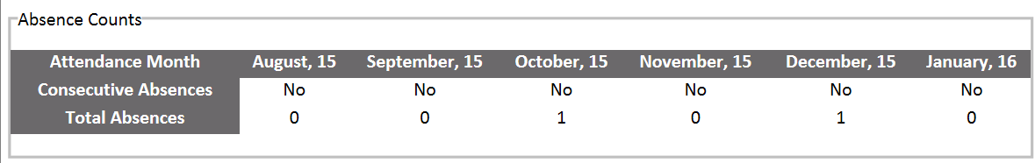

* **Attendance Page**
  + Able to see 6M, 6MAS, 6MBS totals
  + Note: These totals currently have some known issues

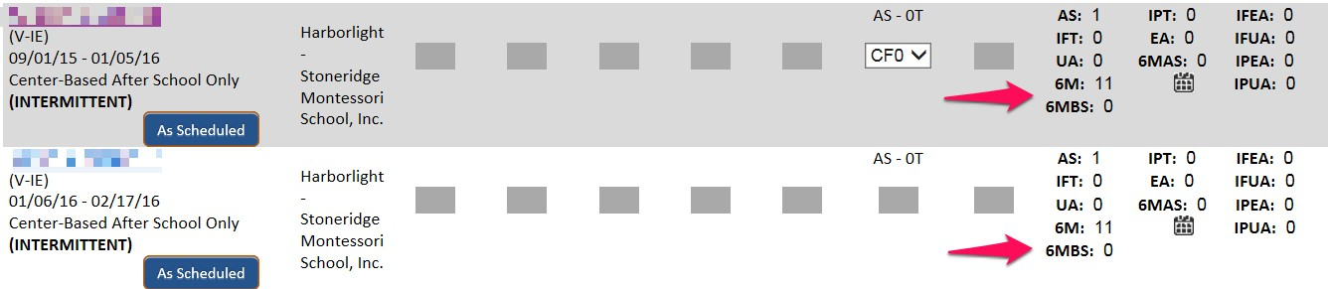

# Family Details

* + Select a family
  + Under the family members section on the right, select the child link
  + For scenarios where the child has more than one absence type, like Before and After School absences, the total number of absences is displayed
* **Select Reports + > General Reports + > Days Absent Report**
  + Select Service Month
  + CCRRs will Select Provider (s)
  + Enter Minimum Days Absent
  + Select Generate

# This report provides

* + A list of all beneficiaries for the selected providers, who have

been absent the Minimum Days Absent or greater

* + - Family Name
    - Child Name
  + Total number of absences in the past 6 months as of the Service Month Selected
  + Total number of (current or within the past 6 months?) providers for the child in CCFA

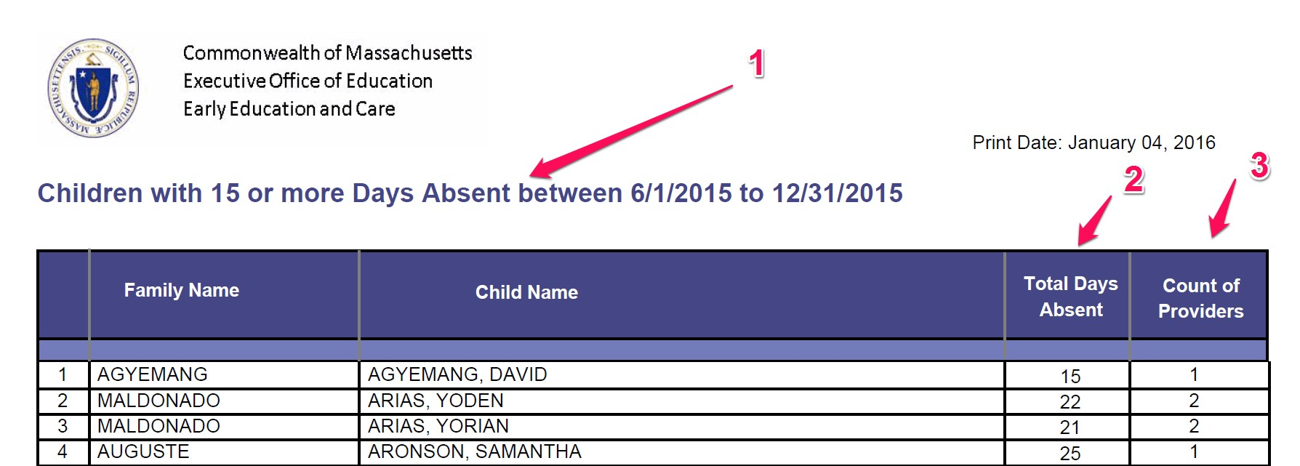

# The heading displays the search criteria used

* **Total days absent = 6M or 6 MAS or 6 MBS**

– If a child is BAS and absent from either BS or AS or both, it is counted as 1 Absence. Absence from the Before or After program only is reflected in 6MAS and 6BAS