The Disabled Person Persons Protection Commission
Abuser Registry User Guide
The Disabled Persons Protection Commission
Abuser Registry
300 Granite Street, # 404, Braintree, MA 02184
DPPCRegistry@mass.gov
(857) 403-0295

Table of Contents

About The Disabled Persons Protection Commission Abuser Registry 3
Primary screens and areas 4
Dashboard 4
Search 4
Search the DPPC Abuser Registry 5
Batch Searches 7
Understand your search results 10
Search Result and Status 11
Search History 12
Pending Reviews 12
Upload Documents 13
Reset a User Password 14
Employer Account Management 15
How to access the DPPC Abuser Registry portal 15
Updating information 15
Employer Account Management (Authorized Access Administrators only) 15
User Account Management 16
How Users Obtain Access to the DPPC Abuser Registry 16
Creating a new user (AAAs only) 17
Deactivating and reactivating users (AAAs only) 17
Viewing Users (AAAs only) 18
Scenarios 19
I’m a new user 19
Search record result is “Pending” 20
Search record result is “Incomplete” 20
Frequently Asked Questions (FAQ) 1. What is a “substantiated finding of registrable abuse”? 21

About The Disabled Persons Protection Commission Abuser Registry
The Disabled Persons Protection Commission (“DPPC”) is the state agency whose mission is to protect adults with disabilities between the ages of 18 and 59 from the abusive acts or omissions of their caretakers through investigation, oversight, public awareness, and prevention. In 2020, Massachusetts enacted a law requiring the DPPC to “establish and maintain a registry of care providers against whom the [DPPC] has made a substantiated finding of registrable abuse.” The DPPC Abuser Registry became effective
July 31, 2021, and is intended to protect individuals with intellectual or developmental disabilities (“I/DD”) by barring Care Providers against whom the DPPC has made a substantiated finding of registrable abuse from working with persons with I/DD. A Care Provider is an individual responsible for the health and welfare of a person with I/DD by providing for or directly providing assistance in meeting a Daily Living Need, which cannot otherwise be performed by the person with I/DD without assistance; and who is employed by, or contracts with, the Department of Developmental Services (“DDS”) or an Employer to provide these services or supports. DDS, or Employers who have a contract or agreement with DDS, a license from DDS, or are funded by DDS, MUST check the DPPC Abuser Registry before employing or contracting with a Care Provider.

Primary screens and areas

Dashboard
The dashboard is the screen that a user sees after they successfully login. From the dashboard a user can:
- View their organization’s search statistics
- View a list of their organization’s pending searches
- View their organization’s 10 most recent search records

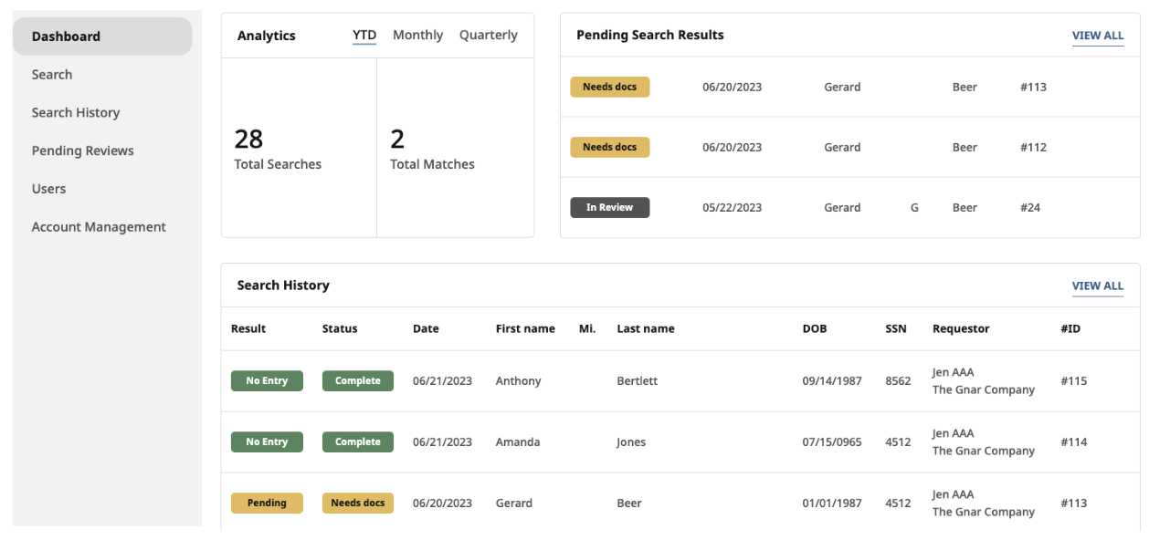

Search
The Search screen is accessible from the side navigation bar. The Search screen is where the user enters the prospective care provider’s information to conduct a search. The user is also able to download a model consent form. Employers are required to obtain written consent from the prospective care provider prior to completing a search.

Search the DPPC Abuser Registry

- Click the Search tab in the side navigation to begin a new search.
- Enter the prospective or current employee’s identifying information into the corresponding fields.
  - Please do not include any extra spaces, punctuation marks (for example, use “Ohara” instead of “O’hara” and “Smith Johnson” instead of “Smith-Johnson”), or suffixes (such as Jr., III, etc.) as part of your search. The use of these characters may affect the accuracy of your search results.
- Check the box confirming that you received signed consent and supporting identification documentation from the prospective or current employee.

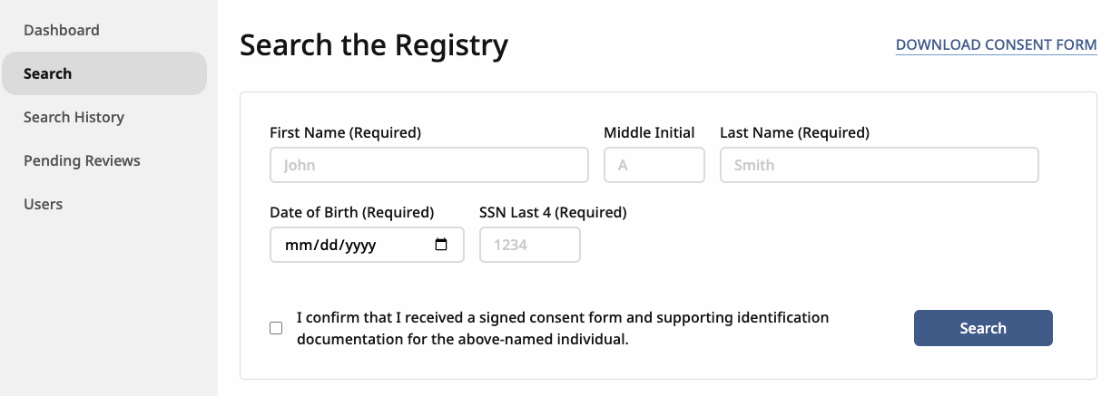

- If you are missing information that is required for the search, you will see an error message. Here is an example for a missing SSN.

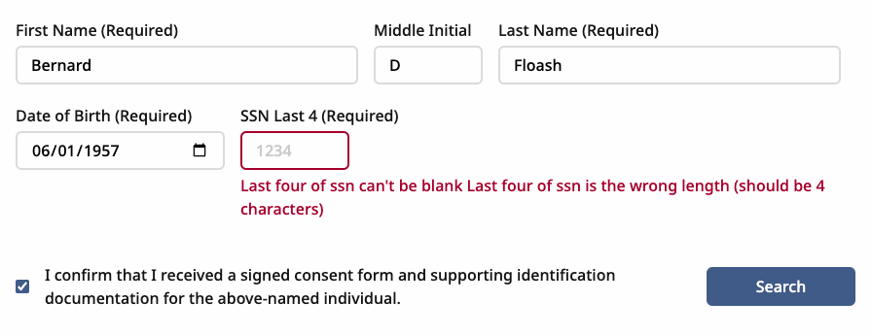
- Once all required information has been entered, click the Search button to submit the search.

- Results of your search will appear on a new page. The results will also appear in your search history.

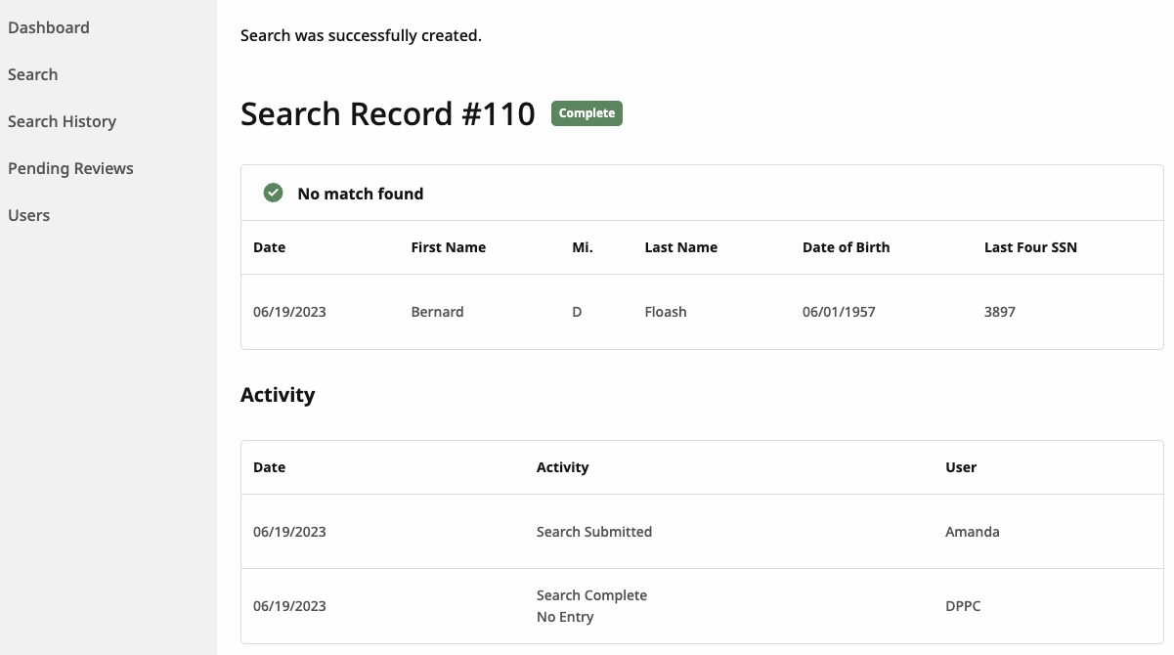
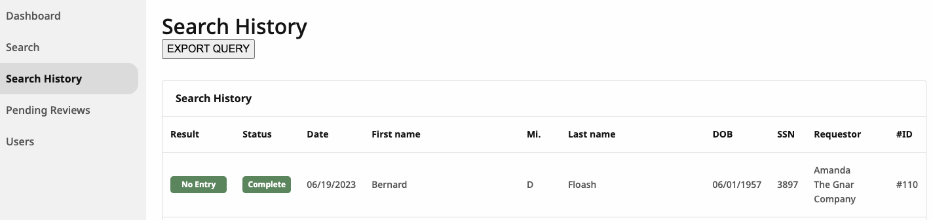

Batch Searches
Users are able to submit more than one search at a time by uploading a CSV with the required information.

1. Go to the search tab and click the Batch Search button in the top right corner.
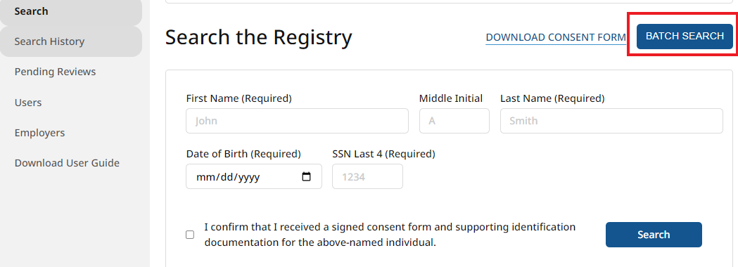

2. Click the Batch Search Template button to download a copy of the csv file.

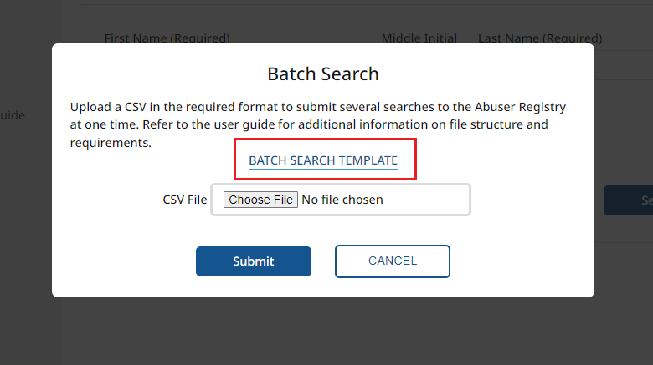

3. Complete the csv file by adding the required information to the file. Users need to submit the same information that is required for a single search.
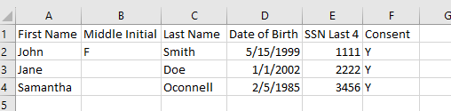

Please see the table below for formatting details. Rows marked with an asterisk (*) are required.

Field | Format | Example | Note
First Name * | text | John
Middle Initial | text | F
Last Name * | text | Smith
Date of Birth * | MM/DD/YYYY | 05/15/1978 | Enter a valid date with ‘/’ separating the month, day, and year.
SSN Last 4 * | 4 digits | 7265 | Must be 4 digits
Consent * | Single character | Y | Anything other than a ‘Y’ will register as not having consent and the search will fail

4. Once the csv file is complete, return to the DPPC Abuser Registry portal, upload the completed csv file and click submit.
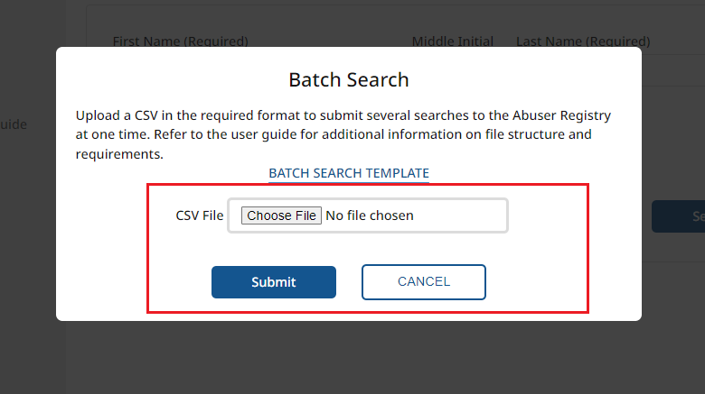
5. Once the CSV has been processed, the user will receive an email noting how many searches were submitted and how many may have failed. A user will need to review the search results in the platform. Searches that are completed successfully will be viewable in the search history listing.

Why did a batch search fail?
- Make sure that you are using the CSV template to minimize risk. There can be no extra columns. The header row must be included.
- Ensure that required columns are populated
  - First Name, Last Name
  - Date of Birth
  - SSN Last 4
  - Consent
- Any value other than a ‘Y’ in the consent column will prevent that search from processing correctly.
- Confirm that your SSN has 4 digits. During some Excel to CSV conversions, a 0 as the first or last digit could be truncated.

Understand your search results
Each search initiated in the DPPC Abuser Registry can be viewed individually to see more detail. This permission is available to any user within an employer’s organization.
Each search record will display the inputs used to query the DPPC Abuser Registry as well as the record status and result.
The Activity section will be populated automatically when specific events or actions are taken on a search record. For each activity listed, there will be a date and user associated with the line item.
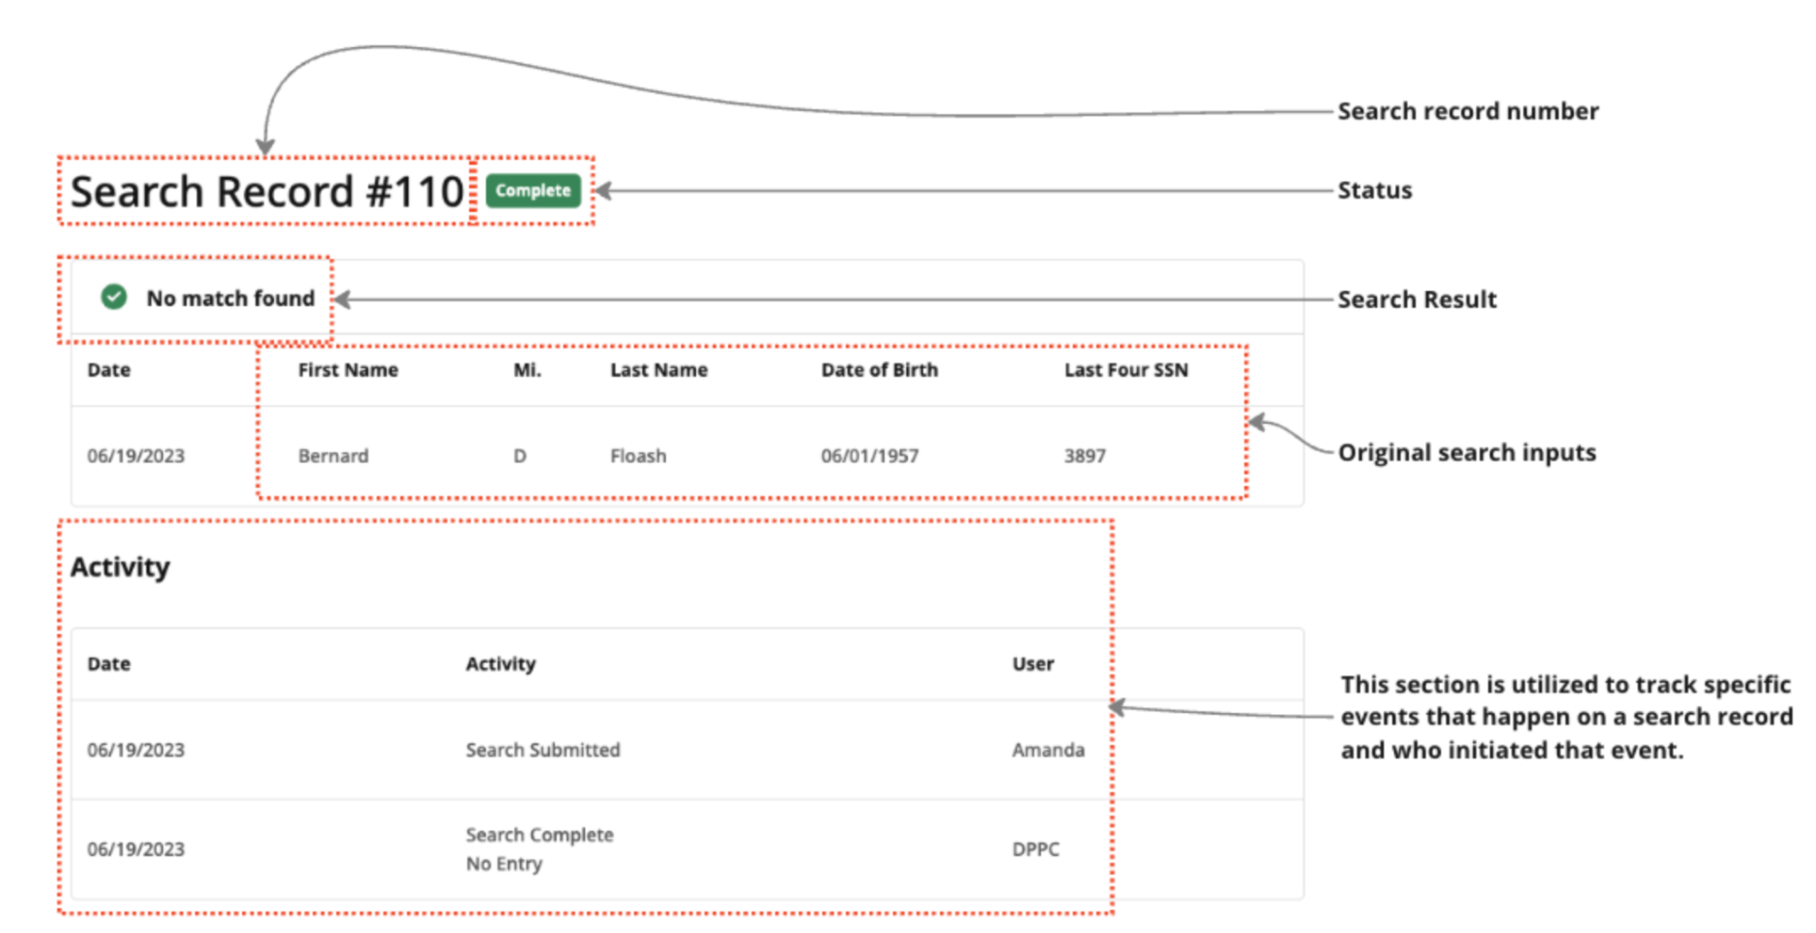

Search Result and Status
Each search record has a “result” and a “status”.
- Result → whether or not the prospective care provider was found on the registry

Match found. Listed on Registry. Restricted from Employment.
Additional Information Required. Identity documentation needed to make determination.
No entry found for your search.
Closed without determination.

- Status → indicates what action, if any, is needed on a search record

No action is required. The search record is complete.
User needs to upload identity documentation to the search record.
The supporting documentation supplied is being reviewed by a member of DPPC.
DPPC has closed this search record due to not receiving requested supporting documentation.

Search History
The history of your organization’s previous searches can be accessed from two places: Recent History on the dashboard and Search History on the side navigation bar. Users can see all searches completed by their organization. This means that if a user performs a search, every user within their organization will see it listed in Search History. Users also have the ability to export the records shown to an Excel CSV file by clicking the “Export Query” button.

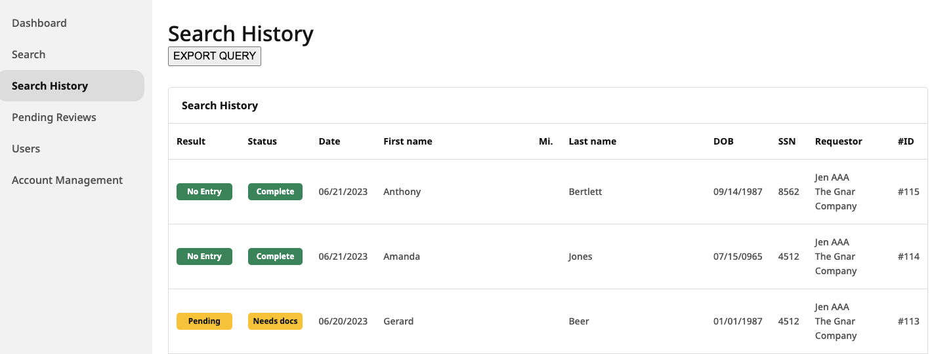

Pending Reviews
In the event that a search record requires additional documentation, it will receive a result of “Pending”. All records with this result can be viewed via the Pending Reviews tab in the side navigation. The 3 most recent pending reviews will also be displayed on the dashboard.

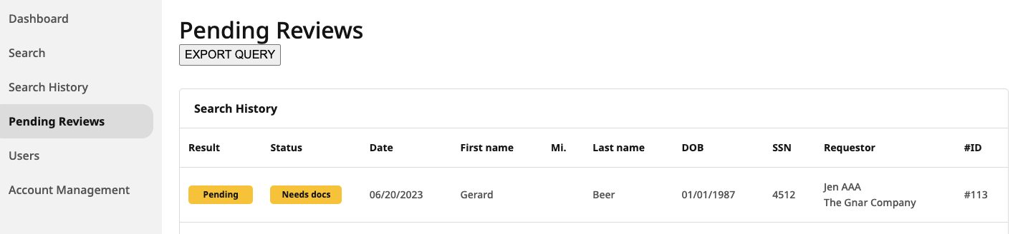

Upload Documents
A user will need to upload supporting documents when a search record result is “Pending” and the status is “Needs docs”. When this occurs, there will be a section on the search record for a user to upload a file.
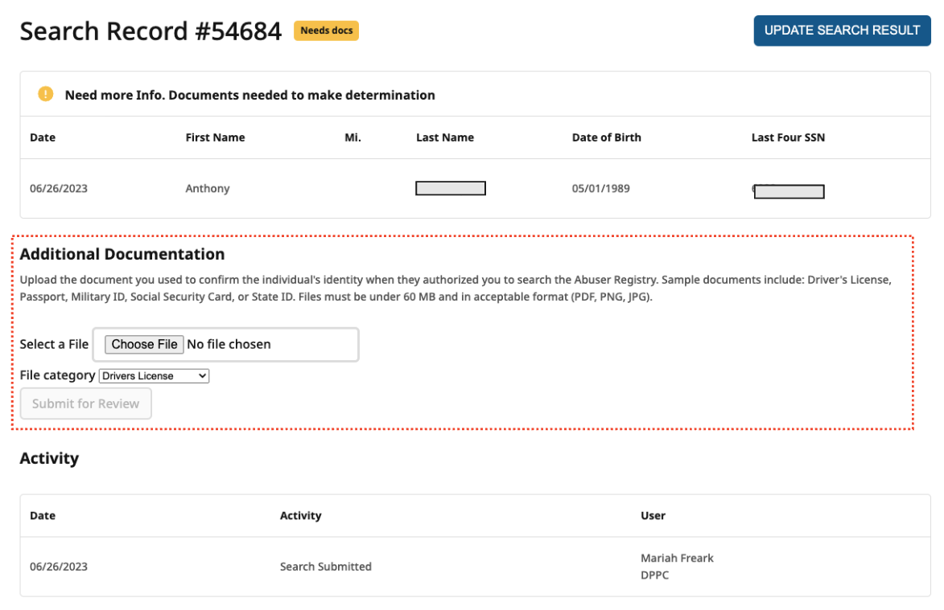
A user will be able to upload a single document for review. Files will need to be under 60 MB and may be a PDF, PNG, or JPG. When a user is uploading a document, they will need to specify what type of file they are submitting.
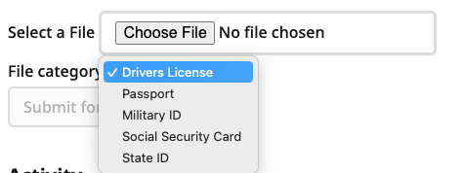

Reset a User Password
Within the DPPC Abuser Registry, users have the ability to reset their own password without AAA or DPPC assistance.
- To change your user password you must be logged out of the platform.
- Go to the login page and select the link to “Forgot your password?”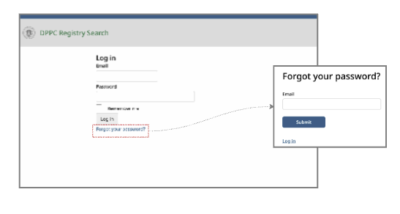
- Enter the email address associated with your account. You will receive an email at this address with a specific link to reset your password.
- Once you have received the email, click the link to “Change my password” in the email. You will be redirected to the password reset page
- Enter your new password in the “Password” and “Confirm Password” boxes. Your password must meet the following requirements:
  - At least 8 characters long
  - At least 1 numeric character
  - At least 1 special character
  - At least 1 uppercase character
  - At least 1 lowercase character
- Click the Submit button. If your proposed password does not meet the requirements, you will see an error message.
- You will now be able to login with the new password.

Employer Account Management

How to access the DPPC Abuser Registry portal
An employer organization needs to be approved before it can access the DPPC Abuser Registry. If your organization does not have a DPPC Abuser Registry account, please visit https://www.mass.gov/info-details/dppc-abuser-registry for information about eligibility and instructions to request access to the DPPC Abuser Registry.

Updating information
It is important that information about your employer account is kept up to date and accurate. The AAA can make updates to information via the Account Management tab.

Employer Account Management (Authorized Access Administrators only)
Each organization’s Authorized Access Administrator (“AAA”) has the ability to update the organization’s contact information within the DPPC Abuser Registry portal. It is important that this information is kept current. AAA users can access this screen from the side navigation bar.

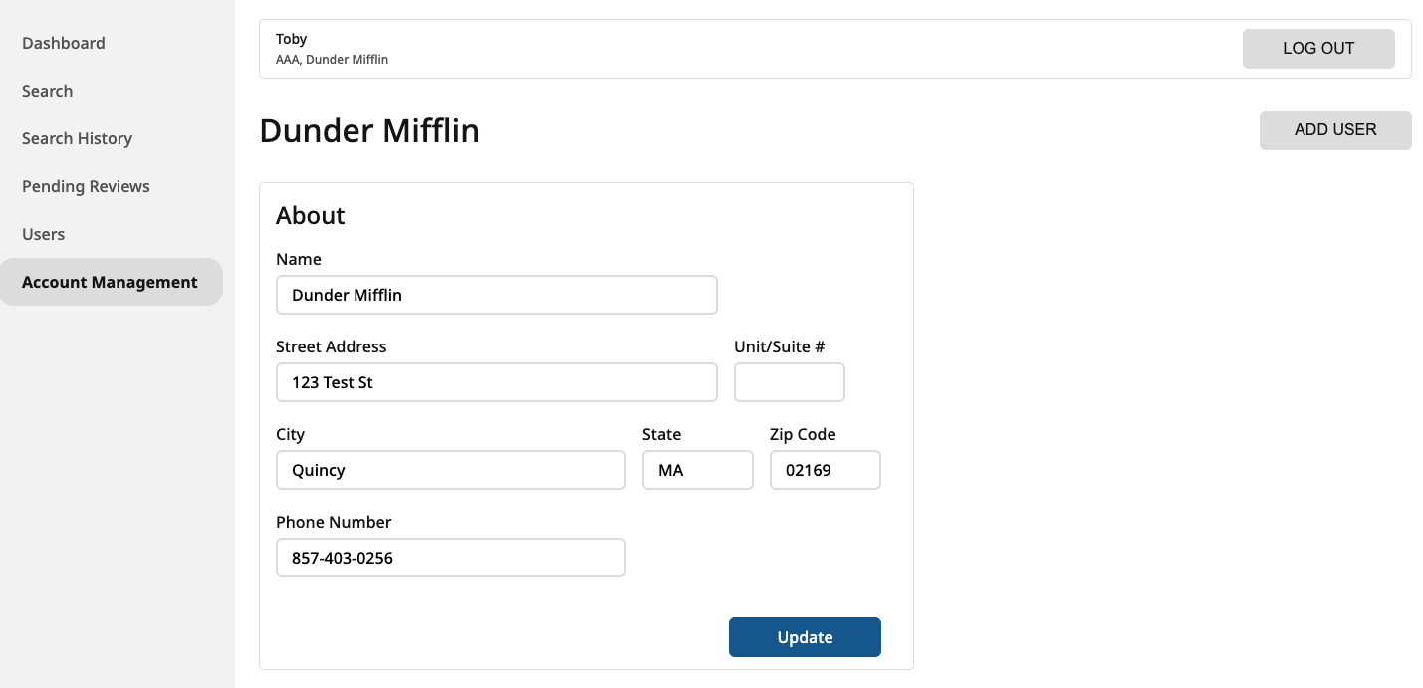

User Account Management

How Users Obtain Access to the DPPC Abuser Registry
AAAs are responsible for managing access to their organization’s DPPC Abuser Registry account. The AAA is the only user who has the account permission necessary to create, deactivate, and update user accounts. There is only one AAA per employer.
From the Users screen, the AAA can see a list of users within their organization as well as when each user last signed in. AAAs can access this screen from the side navigation bar.
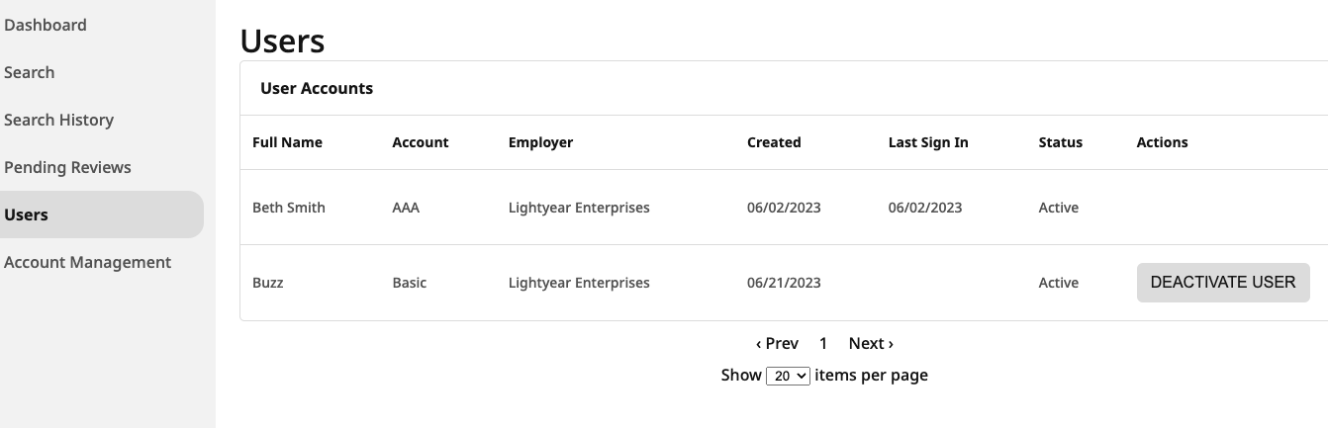

Creating a new user (AAAs only)
AAAs can create a new user by selecting the Account Management screen from the side navigation and then clicking the Add User button. The only piece of information needed to create a user account is a valid email address.
- Once an AAA has entered an email address, an invitation will be sent to the user’s email address to complete the process.
- If an email address is already assigned to a user account, the AAA will see an error message.

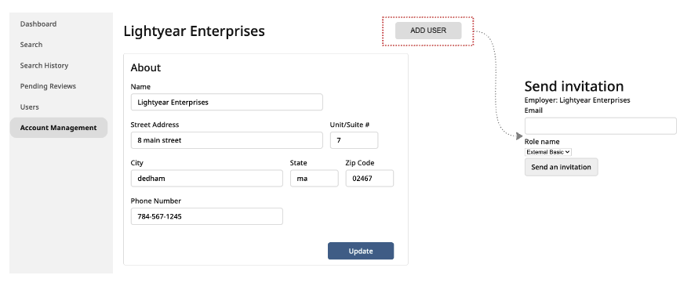

Deactivating and reactivating users (AAAs only)
AAA users have the ability to deactivate users who no longer need access to the DPPC Abuser Registry. This function can be completed via the Users screen. The AAA also has the ability to reactivate users who have previously been deactivated.
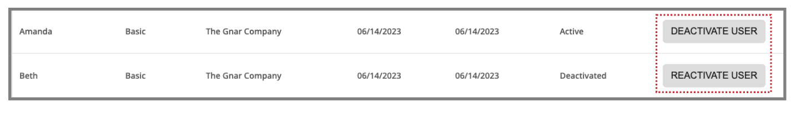

Viewing Users (AAAs only)
AAAs can view all the users in their organization by selecting the Users screen from the side navigation.

In the example below, there are 2 users within the organization. The basic user has finished account setup but not yet signed in.

Scenarios

I’m a new user
When a new user account has been created by the employer’s AAA, a user will receive an email with directions on how to complete their account setup.

When the user clicks the link in the email, they will be directed to a page where they are required to:
- Create a password
- Enter their full name
- Enter their phone number
- Enter their job title

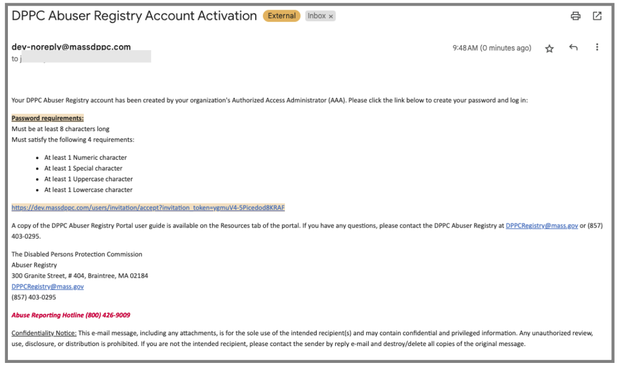

Search record result is “Pending”
A search record will have a result of “pending” when the DPPC needs more information to make a determination. In this event, a user will need to upload supporting documentation. The status field is leveraged to show what action, if any, is needed for a “Pending” record.

A user will be sent two reminder notices to upload supporting documentation after a record has a “Pending” result. For the example below, the record needs supporting documentation.

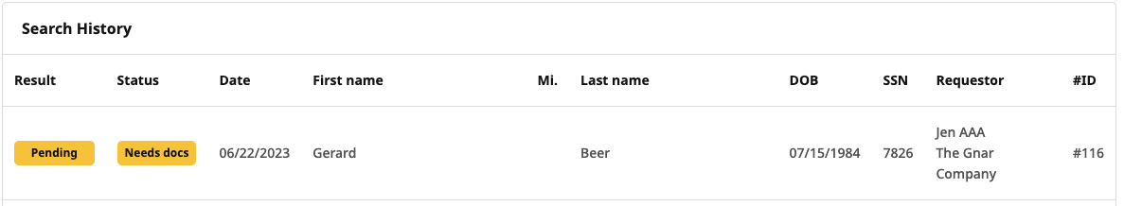

Search record result is “Incomplete”
A search record will have a result of “incomplete” when the DPPC has not received sufficient supporting documentation after the user has been sent two reminder notices. When a record has a status of “closed”, then the user will receive an email notifying them of the status change.

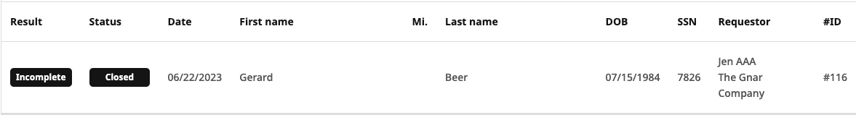

Frequently Asked Questions (FAQ)
1. What is a “substantiated finding of registrable abuse”?
A substantiated finding of registrable abuse is a finding by the DPPC that a care provider abused a person with I/DD. For additional statutory definitions click here.
2. Who is a care provider?
A care provider is a person who is employed by, or contracts with, the Department of Developmental Services (“DDS”) or an Employer who provides services or treatment to persons with I/DD between the ages of 18-59. Care providers include all current and prospective caretakers in any program licensed, contracted, or funded by DDS to provide services and support to persons with intellectual or developmental disabilities. Care providers can include volunteers, interns, work-study participants, or any other similar unpaid positions.
3. Who has access to the DPPC Abuser Registry?
The DPPC Abuser Registry is not a public registry. This information is not considered a “public record” for purposes of M.G.L. c. 66 and all information regarding care providers listed on the DPPC Abuser Registry is confidential. By law, the DPPC Abuser Registry can only be accessed by DDS or Employers who are funded by, contract with, or are licensed by DDS. Employers are required to create verified accounts to check whether employees or prospective employees are on the DPPC Abuser Registry.
4. Who is required to check the DPPC Abuser Registry?
DDS and agencies defined as Employers by the law must check the registry. For purposes of the DPPC Abuser Registry, Employer means any agency that provides services or treatment to people with I/DD pursuant to:
a. A contract or agreement with DDS;
b. Funding administered by DDS; or
c. A license issued by DDS.
5. I work for a human services agency that provides services or treatment to people with disabilities, but we do not have a contract or agreement with DDS, are not licensed by DDS, and are not funded by DDS. Can I still access the DPPC Abuser Registry?
No. At this time, the law only permits DDS or Employers who provide services or treatment to persons with I/DD pursuant to a contract or agreement with DDS, a license from DDS, or funding from DDS.

6. When do I need to check the DPPC Abuser Registry?
DDS or Employers who have a contract or agreement with DDS, a license from DDS, or are funded by DDS MUST check the DPPC Abuser Registry before employing or contracting with a care provider (a care provider is someone who is or will be working for you and may provide services or treatment to people with I/DD between the ages of 18-59).

7. Do I have to check the DPPC Abuser Registry before hiring a new care provider, or is it optional?
Checking the DPPC Abuser Registry is MANDATORY. All Employers MUST check the DPPC Abuser Registry before hiring or contracting with any care provider who may be providing services or treatment to a person with I/DD between the ages of 18-59.
8. What types of employees do I need to check on the DPPC Abuser Registry? Employers must screen everyone seeking to be hired as a care provider, or anyone who may be called on to function in a care provider role. Employers should determine whether staff hired to support the Employer’s operations would ever be required to act as care providers for people with I/DD such as during an unforeseen incident or emergency.
By law, if you fail to comply with the requirement to check the DPPC Abuser Registry before hiring care providers, or if you hire as a care provider someone listed on the DPPC Abuser Registry, you may be fined up to $5,000, have your license revoked or downgraded, forfeit your state contract, or a combination of any of these penalties.
9. How can I register my organization to obtain access to the DPPC Abuser Registry? If you are an Employer who runs a program that is licensed, contracted, or funded by DDS and your organization has not previously received an email informing you that your organization has been registered, please click here to fill out the Employer Access Authorization Form and send it to the DPPC by email to DPPCRegistry@mass.gov. The DPPC may also request documentation to confirm that you meet the definition of Employer pursuant to M.G.L. c.19C (ex., DDS contract, DDS funding agreement, etc.). Additionally, your organization will be required to provide contact information for one individual to act as an Authorized Access Administrator. The Authorized Access Administrator will be responsible for creating the user accounts for employees of your organization who will be searching the DPPC Abuser Registry.
10. The prospective care provider has already successfully completed the DDS Fingerprint Background Check. Do I still need to check the DPPC Abuser Registry?
Yes. Completing a search of the DPPC Abuser Registry is required for every prospective care provider, regardless of other steps you take in order to ensure the care provider’s suitability for employment. A search of the DPPC Abuser Registry does not relieve you of your obligation to follow all other employment requirements of your organization, including DDS’s Fingerprint Background Check.
11. Do I need permission from a care provider or prospective care provider to check their name on the DPPC Abuser Registry?
Yes. The law requires that Employers receive signed consent from the care provider or prospective care provider. Click here for an example of a consent form.

12. Am I allowed to check the DPPC Abuser Registry regularly or randomly after I have employed or contracted with a care provider?
Yes. Agencies are permitted to check the DPPC Abuser Registry on a regular or random basis, or if they have reason to believe one of their care providers has been listed on the registry since the last time a check was completed. A regular or random search still requires signed consent. Click here for an example of a consent form.
13. What if I want to hire someone whose name is listed on the DPPC Abuser Registry? If you are DDS or an agency that provides services or treatment to people with I/DD under a contract, agreement, or license with DDS, or funding administered by DDS, you are prohibited from hiring someone whose name is listed on the DPPC Abuser Registry to work as a care provider. There are NO exceptions.
14. What information will I get when I check someone’s name on the DPPC Abuser Registry? Do I see a list of people who are on the DPPC Abuser Registry?
Employers will be required to input identifying information for a potential care provider and the result will inform the Employer whether the information entered resulted in a match to a care provider listed on the DPPC Abuser Registry. At no time will an Employer receive a list of care providers who appear on the DPPC Abuser Registry.
15. Are Employers notified of registrable abuse cases or proceedings?
Yes. By law, DPPC is required to notify DDS and the care provider’s last known Employer of investigation findings substantiating a care provider for registrable abuse and any further actions related to the findings, such as appeals and decisions on appeals.
Links to related documents/agencies:
- Massachusetts General Laws c. 19C
- DPPC regulations, 118 CMR
- Employer Access Authorization Form
- DPPC Abuser Registry login portal
- DPPC Abuser Registry consent form
- Division of Administrative Law Appeals
- Department of Developmental Services National Criminal Background Check
Terms relevant to the DPPC Abuser Registry (See 118 CMR 2.02 for all definitions)
Care Provider. A Caretaker who is employed by, or contracts with, the Department or an Employer to provide services or supports to a Person with an Intellectual Disability or a Person with a Developmental Disability. Care Providers include all Caretakers in any program licensed, contracted, or funded by the Department; and any Caretaker who provides services on behalf of any program licensed, or funded by or contracted with the Department. A Care Provider shall be considered to be contracting with the Department or Employer irrespective of whether the Care Provider is receiving compensation for services, including volunteers, interns, work-study participants, or any other similar unpaid position.

Employer. An entity that provides services or treatment to a Person with an Intellectual Disability or a Person with a Developmental Disability pursuant to: (i) a contract or agreement with the Department [of Developmental Services]; (ii) funding administered by the Department [of Developmental Services]; or (iii) a license issued pursuant to M.G.L. c. 19B, § 15 or 15A. An entity shall be considered an Employer if any part of its operations are funded or licensed by the Department or contracted with the Department.
Registrable Abuse. An Act or Omission of a Care Provider that results in Serious Physical Injury or Serious Emotional Injury or constitutes Abuse Per Se of a Person with an Intellectual Disability or a Person with a Developmental Disability between the ages of 18 and 59. Registrable Abuse shall not include instances in which the Commission, after review of an objection under 118 CMR 14.02 (3), issues a decision pursuant to 118 CMR 14.02 (4) (b) 2, that upon weighing the conduct of the Care Provider and its outcome, the Commission determines that the incident was isolated and unlikely to reoccur and that the Care Provider is fit to provide services or supports to persons with intellectual or developmental disabilities.

