
Accelerating Capital Investments with Pay-As-You-Go Funding

Executive Office for Administration and Finance

Accelerating Critical Investments in the Commonwealth’s Infrastructure
Investing in the physical infrastructure of Massachusetts is a priority of the Healey-Driscoll Administration. As demonstrated in the FY24-FY28 Capital Investment Plan, over $14 billion in capital upgrades through renovation, repair, and new construction are planned over the next five years. The Administration’s first capital plan makes historic investments in housing production and preservation, fully commits to meeting the Commonwealth’s climate goals, provides essential resources to drive economic development, preserves and modernizes our state infrastructure, invests in cities and towns from Pittsfield to Provincetown, and makes government more efficient and effective for its residents.
Despite these bold investments, there remains a significant need for investment in deferred maintenance across the state’s asset portfolio. Long-term commitments of substantial funding are required to address the state’s deferred maintenance backlog, beyond the capacity of the current capital plan. Additional pay-as-you-go (PAYGO) funding, as proposed, would accelerate the state’s ability to make these critical investments and reduce the long-term need for debt issuance to support state assets.

Leveraging the Commonwealth’s Resources with PAYGO
PAYGO capital funding is a critical component of most states’ capital programs and has historically also been used in Massachusetts. From 1997 to 2010, the Capital Investment Trust Fund was used to make PAYGO investments in capital infrastructure across the state. PAYGO is a best practice in capital budgeting, enabling governments to reduce reliance on long-term debt and make timely investments in critical infrastructure.
Currently, Massachusetts utilizes a diverse mix of funding sources to make capital investments. As detailed in the below table from the FY24-FY28 Capital Investment Plan, the Commonwealth primarily utilizes general obligation bonds to fund capital investments. The capital plan also heavily leverages federal funds and includes some current-year revenues – mainly for transportation investments funded by tolls and other MassDOT revenue.

Capital Funding Source | FY24  ($ millions) | FY24–FY28  ($ millions)
General Obligation (G.O.) Bonds | 2,905 | 14,525
Federal Funds | 1,515 | 8,013
Special Obligation Bonds | 390 | 1,639
Other Contributions | 229 | 1,034
Current-Year Revenues | 345 | 1,508
Project / Self-Funded | 130 | 406
Capital Investment Plan Total | 5,513 | 27,125

Reinstating the role of PAYGO in the Commonwealth’s capital strategy creates substantial benefits, including reducing the state’s reliance on debt to fund deferred maintenance and accelerating capital renewal to address liabilities and systemic risks. As inflationary pressures drive increased construction costs, the ability to fund additional capital needs with a dedicated funding stream creates savings for the state in both the short and long-term.

Establishing the PAYGO Capital Fund
The Commonwealth’s prudent investments in long-term stabilization in recent years, combined with increasing interest rates, have resulted in newly significant interest earnings on the balance of the state’s Stabilization Fund. With the Fund balance now at an all-time high of approximately $8 billion, FY23 interest earnings are estimated to be approximately $270 million. Interest earnings in less recent history were not as robust, creating an opportunity for the Commonwealth to leverage new resources to address long-term liabilities. One such liability is the state’s deferred maintenance needs.
The Healey-Driscoll Administration proposes using interest earnings on the Stabilization Fund to establish a permanent PAYGO Capital Investment and Debt Reduction Fund. Importantly, the PAYGO Capital Fund will only be funded with interest earnings; the principal amount of the Stabilization Fund will remain preserved for mitigating the impacts of a substantial, unanticipated reduction in revenues that cannot be managed with normal budgetary reductions and savings measures.
The PAYGO Capital Fund may be used for three purposes: leveraging federal grant opportunities under IIJA, IRA, and CHIPS, PAYGO investments in state assets as previously authorized by the General Court, and debt management strategies that generate savings for the state.
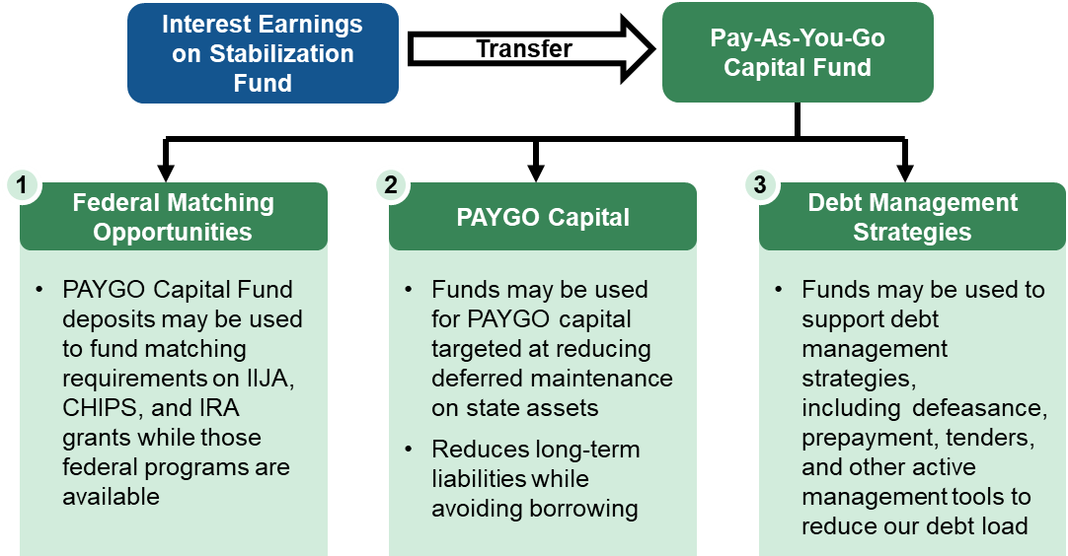

PAYGO Capital Fund Uses
Federal Match
Establishing a dedicated pool of state resources to match federal grant awards maximizes the Commonwealth’s competitiveness during the short window in which competitive grants established by the Infrastructure Investment and Jobs Act (IIJA), the Inflation Reduction Act (IRA), and the CHIPS and Science Act (CHIPS) are available. Making PAYGO Capital Fund resources available during the approximately three years in which IIJA, IRA, and CHIPS grants are available will help unlock federal funding for key investments in transportation, housing, climate, economic development, and technology. All commitments for matching funds must meet high return on investment targets established and approved by A&F, with unused matching funds remaining in the PAYGO Capital Fund at the conclusion of the federal programs – available for other investments in state assets.
PAYGO Capital
By reducing the reliance on debt to fund deferred maintenance and accelerating investment timing, PAYGO will support necessary improvements to physical infrastructure across the state. By requiring funds to be spent on state assets, PAYGO also supports risk mitigation strategies, including decarbonization, cybersecurity, and climate resilience. Resources in the PAYGO Capital Fund may only be used for projects previously authorized by the Legislature through bond bills. This ensures a whole-of-government approach to investment decisions from this new resource.
Debt Management Strategies
As part of the state’s active management of long-term debt, periodically, opportunities become available to reduce long-term liabilities and create savings for the Commonwealth. At times, these opportunities, such as defeasance, prepayment, tender opportunities, and interest cost reductions, require upfront investments to create long-term savings. By allowing PAYGO Capital Fund resources to be used for these debt management strategies, the state can leverage savings to make additional investments in the Commonwealth.

Fiscal Responsibility
Utilizing interest earned on our savings puts the state's money to work while reducing long-term liabilities and protecting the Stabilization Fund for when it is needed. While interest earnings will vary from year to year, commitments from the PAYGO Capital Fund will only be made when funds are available. Because the Fund does not rely on future projections, no spending will occur beyond what has already been transferred to the Fund. Unlike debt issuances, PAYGO uses are flexible and can be reduced or suspended if interest earnings decrease or economic conditions deteriorate. Additionally, should the Stabilization Fund balance decrease for any reason, interest transfers to the PAYGO Capital Fund will be suspended until the principal balance again increases year over year and exceeds 10% of budgeted revenues, ensuring the long-term sustainability of the Commonwealth’s reserves.

