Determination of Need Document Submission Accessibility Guidelines
Updated February 2023

Purpose
The purpose of this guidance is to advise Determination of Need (DoN) applicants on how to draft and submit documents that are consistent with web accessibility standards.
Following these instructions helps the Department of Public Health (DPH) process applications more quickly and with fewer follow-up questions to applicants. Although applicants who do not adhere to the following guidelines may experience delays in the application process, adherence to these guidelines has no bearing on the ultimate disposition of applications submitted to DoN.

What is Accessibility?
Web accessibility means that websites are designed so people with disabilities can use them, regardless of auditory, cognitive, neurological, physical, speech, or visual disability. The Americans with Disabilities Act requires agencies like DPH to maintain websites that adhere to accessibility standards (for additional background on web accessibility, please visit the World Wide Web Consortium’s website). This includes any and all documentation provided on our websites.

DoN Applicant Accessibility Guidelines
- Please submit digital documents (Word files) instead of scans of printed documents. If you must submit scanned documents, please provide a high-resolution scan for effective converting.
- Please ensure images are captioned with appropriate alternative text and are formatted “inline” with text (as opposed to “wrapped” with text). Please visit Microsoft’s site on alternative text for suggestions on writing effective alternative text.
- Please refrain from placing any text within text boxes. If it is necessary to emphasize text, please place it within a 1x1 table.
- Black text against white background is highly preferred for all documents. If color is necessary, please ensure all colored text meets the WCAG AA contrast minimum by using WebAIM’s contrast checker.
- When creating tables in Word, please use the “Insert Table” feature to create “simple” tables, with a single header row, a single header column, and no merged cells. An extended definition of a “simple table” can be found at UPenn’s Accessibility site. Please also ensure tables are labeled and blank columns and rows are omitted to the extent possible.
- Please refrain from including shapes, images, icons, etc. (“decorative elements”) that do not contribute to the substance of the application. Such decorative elements slow down accessibility review. If decorative marks are necessary, please pre-mark any shapes or decorative images as decorative (refer to Microsoft’s site on alternative text for guidance).
- If you are required to submit a Community Health Needs Assessment (CHNA) report with your application, please simply provide a URL to a copy of your CHNA in your application materials. Do not include the actual report in your application.
- If you are required to submit the following forms to DPH's Community Health Initiative (CHI) to complete your application, please do so, but do not include these forms in your DoN application materials:
- Community Health Initiative CHNA/CHIP Self Assessment
- Community Engagement Plan
- Community Health Implementation Plan
- If you are required to submit corporate documents (such as articles of incorporation) with your application, please provide a URL to a copy of these documents in your application materials. Do not include the actual documents in your application.
- Prior to submitting documents, applicants should run Word’s “accessibility checker,” available under the Review heading on the control ribbon. While the checker does not capture all accessibility issues, it is a helpful starting point.
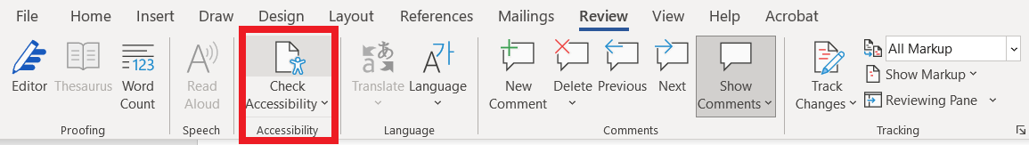
Reference material
- Text/background contrast checker
- Microsoft: Make your Word documents accessible to people with disabilities
- Mass. Executive Office of Technology Services and Security: Web Accessibility Standards

“Justice Department Issues Web Accessibility Guidance Under the Americans with Disabilities Act,” U.S. Department of Justice, March 18, 2022. Retrieved June 22, 2022 from https://www.justice.gov/opa/pr/justice-department-issues-web-accessibility-guidance-under-americans-disabilities-act

