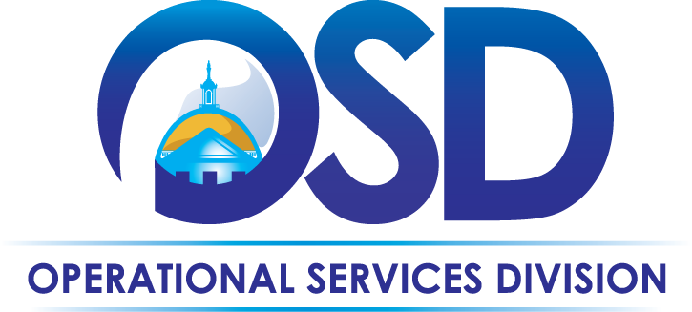
The Commonwealth of Massachusetts
Operational Services Division
Office of Vehicle Management

Accident Procedures Overview

Executive Branch vehicles up to 10,000 GVW are automatically enrolled in the Fleet Response Accident Management Program. In the event of an accident, Drivers must attempt to protect themselves, passengers, and others, as well as prevent further accidents/injuries from occurring at the scene.

It is the responsibility of the Agency to report to Fleet Response all accidents and incidents involving a state vehicle.

Fleet Response offers:
- Management of accident repairs including scheduling, estimate evaluation, tracking repair progress and expediting parts
Fleet Response
1-800-338-0619
Accident Reporting & Emergency Services available 24/7
  - Network of authorized shops across the Commonwealth (National Account vendors, dealers and repair shops)
- 24-Hour Roadside Assistance, including tow service
- Subrogation services for recoverable claims
- Direct billing of all expenses to the Agency
Important! There is an additional charge to Agencies for using an Out-of-Network vendor

At the Scene:
Unless incapacitated due to injury, state drivers shall:
- Call 911 to:
- Request emergency assistance if they or another party are injured or the accident involves a fire
- Notify the police (if this is not immediately possible, Driver must notify the police as soon as they are able)
- Obtain all information necessary to fully complete an accident report with Fleet Response
- Give identifying information ONLY to the other party(s) involved and the police, but make no comments about assuming responsibility, fault or blame
- If able, take pictures of the accident location, any vehicle damage (all vehicles involved) or property damage
- Request a tow, if necessary, through Fleet Response, unless law enforcement has arranged one to ensure local safety

Injury to Driver or Other State Employee:
If driver or any other State employee is injured, report details to the supervisor, Agency Fleet Manager and OVM.
Reporting to OVM is for informational purposes only. OVM is not responsible for relaying this information to other entities.

License Revocation, Restriction or Suspension:
Drivers must report any revocation, suspension, or restriction imposed on their license, for any reason, to his/her manager and OVM immediately. Driving privileges for state vehicles are immediately suspended, pending further review by OVM.

After the Accident:
- Report details to Fleet Response within 24 hours, no matter how minor they may be
  - Fleet Response will complete an electronic Automobile Loss Notice based on the call details
  - Fleet Response will email a copy of the Automobile Loss Notice to OVM and the Agency Fleet Manager
    - NOTE: Driver is responsible for obtaining all information needed to fully complete the Automobile Loss Notice
  - Fleet Response will provide assistance and give direction regarding repairs
- All accidents must be reported to the local police and a police report must be filed (no matter how minor)
If incapacitated due to injury, supervisor or manager must report the accident to Fleet Response and Law Enforcement
- Report the accident to supervisor/manager within 48 hours

Accident in a Rental:
If an accident occurs while in a rental vehicle that a state driver is utilizing during state business:
- Report accident to the police, rental agency, supervisor, Agency Fleet Manager and OVM
  - Rental agency will coordinate tow and/or repairs, as needed
- If able, take pictures of the accident location, any vehicle damage (all vehicles involved) or property damage

Repairing a State Vehicle:
- Vehicle MUST be inspected and have an estimate of repair costs prepared by a Fleet Response Network Auto Body Shop within thirty (30) days of the accident
  - If not completed within the required timeframe, vehicle may be subject to removal from that Agency’s fleet
- If repairs are approved by the Agency Fleet Manager, Fleet Response should be notified repairs should be scheduled within thirty (30) days of repair approval
- When the driver picks up the vehicle, he/she must verify all work
  - If the work is not complete, or is unsatisfactory, driver should call Fleet Response for assistance in ensuring the work is completed satisfactorily
Agency is responsible for providing vehicle decals/signage to the repair shop, if necessary

Cosmetic Damage:
Drivers must take care to limit cosmetic damages to state vehicles. These would include small dings/dents and scratches. OVM recognizes this type of damage may happen, however, severe cosmetic damage must be reported to Fleet Response immediately.

Stolen Vehicle:
- Immediately report stolen vehicles to local law enforcement
  - Identify the OVM Fleet Director (Alex Giannantonio) as the contact for follow-up regarding retrieval of the vehicle
- Immediately upon discovering a vehicle is missing, notify the Agency Fleet Manager, Department Head, and the OVM Fleet Administrator
- If vehicle is recovered, police will notify the OVM Fleet Director, then OVM will notify the Agency Fleet Manager
  - If the employee or Department is notified that the vehicle has been recovered, they must notify OVM immediately
- If vehicle is recovered in damaged condition, it should be repaired in accordance with OVM accident repair procedures
Personal belongings that are stolen, damaged, or destroyed in a state vehicle are the responsibility of the driver’s personal insurance policy and will not be covered by the state

Rental for Accident Repairs:
If a state vehicle is not available due to extensive accident repairs, and another state vehicle is not available, a short-term rental may be requested with Agency approval. A contract is in place for rental vehicles; OVM09 Short-Term Rental of Various Light Duty Vehicles. View the Contract User Guide on the OSD website at www.mass.gov/osd.
A rental vehicle used as a replacement for a state vehicle that is in the shop is considered a state vehicle for the purpose of policy compliance. For example, all personal commuting in a rental vehicle must be reported as fringe benefit income and the driver is responsible for any tickets or violations incurred.

