Summary of Job Aid
You use AR/Service Delivery Reports (SDRs) to bill against Accommodation contracts. The AR Invoice is used to bill for the total amount due for that month services. If you have AR contracts with the Department of Developmental Services (DDS), you also need to submit a monthly SDR along with the AR invoice. The SDR contains a roster of clients, each with a service delivery calendar to report services on for the month. You can bill for more than one service on the same day by using the multiple calendar functionality in the SDR. Billing for clients is completed by filling out attendance information for each month.
When the information is complete, the provider reports the SDR and then authorizes and submits the AR invoice to EIM, where the service lines are validated.
This reference guide provides users with the steps to successfully bill for AR/SDR contracts in EIM/ESM.
Note: This job aid has been updated to reflected EIM/ESM system enhancements that will become effective as of May 19, 2013.
Table of Contents
Logon to Virtual Gateway 1
Adding an Accommodation Rate Invoice 1
Updating a Line Item (Daily or Monthly) 1
Adding an Accommodation Rate Service Delivery Report (SDR) 3
Report Single Client Attendance 4
Report Multiple Client Attendance (Apply Pattern) 7
Reporting the SDR 10
Saving, Deleting, and Releasing an Accommodation Rate Invoice 10
Disapproving and Authorizing an Accommodation Rate Invoice 12
Searching for an Accommodation Rate Invoice 13
Supplemental Accommodation Rate Invoice 14
Supplemental Accommodation Rate Service Delivery Report (SDR) 15
Reporting Services on a Supplemental SDR – SDR Not Reported 16
Frequently Asked Questions (FAQs) 18
Additional Learning Opportunities 19
Need Assistance? 19

Logon to Virtual Gateway
In order to use the EIM/ESM application, you must logon to the Virtual Gateway (go to www.mass.gov/vg and click the link “Logon to Virtual Gateway”) and select the Enterprise Management and Enterprise Service (EIM/ESM) business service.
Note: See Logon Assistance Job Aid for more information on accessing the Virtual Gateway.

Adding an Accommodation Rate Invoice
- Select the Billing module.
Figure 1: Image of the EIM/ESM Module bar with a red box surrounding the 'Billing' module.
- Select Accommodation Rate Invoice Search from the navigation bar.
Figure 2: Image of the Accommodation Rate Invoice Search page.
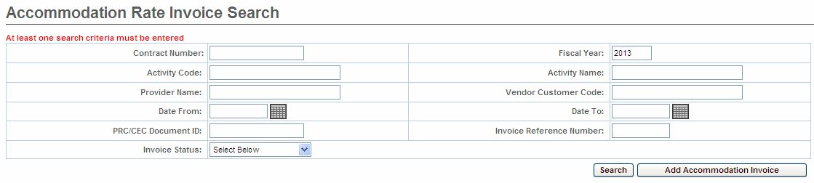
- Select the [Add Accommodation Invoice] button.
- Pick a [Contract] from the drop down menu.
- Select the [Contract] button.
Figure 3: Image of the Add Accommodation Rate Invoice page with selected contract displayed.
- Enter [*Invoice Reference Number].
- Enter [*Billing Period From] date. (Note: Use MM/DD/YYYY format.)
- Enter [*Billing Period To] date. (Note: Use MM/DD/YYYY format.)
- Select the [Save New Invoice] button.
Note: Asterisk (*) symbol indicates that the field is required.
Figure 4: Image of the Add Accommodation Rate Invoice page with required fields completed: Billing Period From, Billing Period To, and Invoice Reference Number.
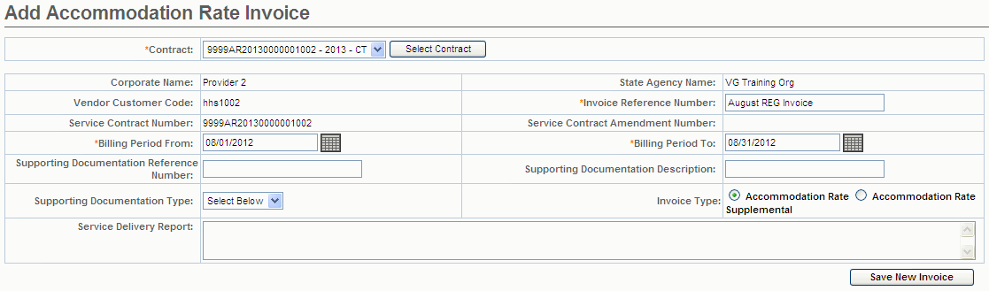
Tips:
- Invoices must be submitted sequentially by month (July, August, September, etc …).
- If an organization needs to submit more than one invoice a month, a Supplemental invoice can be created.

Updating a Line Item (Daily or Monthly)
From the Accommodation Rate Invoice Summary page.
- Enter [Units] (Daily = Enter total number of billing days in month; Monthly = Enter 1 for the entire month). Note: Depending on the contract you will enter daily or monthly unit(s). Locate the Unit type field on the Invoice page to see whether you will daily or monthly.
Figure 5: Image of the Unit Type displayed as Daily.
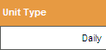
Figure 6: Image of the Unit Type displayed as Monthly.
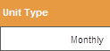
- Select [Save Invoice].
Figure 7: Image of Accommodation Rate Invoice page with success message 'Invoice Updated Successfully' displayed.
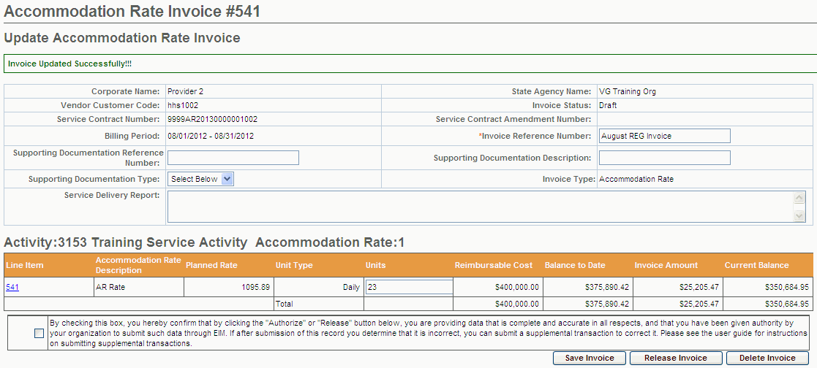

Adding an Accommodation Rate Service Delivery Report (SDR)
Important Note for DDS Providers: DDS Providers are required to include an SDR with their AR Invoice.
All Other Providers: Contact your Agency Contract Manager to see if you need to include an SDR with your AR Invoice.
Note: The SDR must be included with the AR Invoice in order for the payment to generate in EIM. If the SDR is not created as part of the AR/SDR, you will not be paid for services. Agency may deny invoice if SDR is not included.
After saving the invoice you now need to add the SDR before releasing/authorizing this invoice.
From the Update Accommodation Rate Invoice page,
- Select [Accommodation Rate SDR] from the navigation bar.
- Select [Add New Accommodation Rate SDR] button.
- Select [Activity] from drop-down list.
- Select the [Select Activity] button.
Figure 8: Image of the Accommodation Rate Service Delivery Report page.
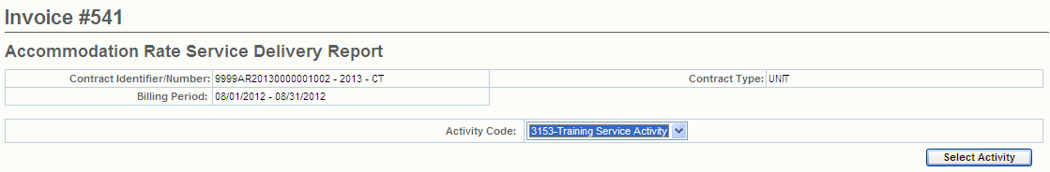
Important Note: Reminder: The SDR should remain in “Draft” status until all client attendance is reported. If you are not finished reporting attendance, you should select the “Return to Draft” button. Once the AR invoice has been ‘authorized’ you cannot edit the SDR. You will need to enter and submit a Supplemental AR/SDR if additions or corrections to the SDR are needed after the AR invoice is has been authorized.
Figure 9: Image of the Accommodation Rate Service Delivery Report page.
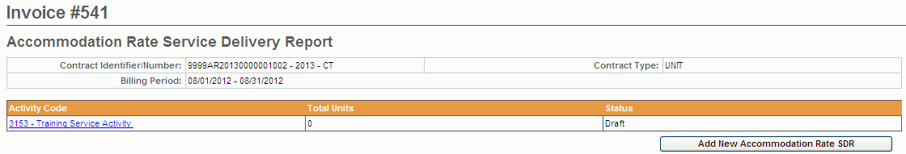

Report Single Client Attendance
Important Note for DDS Providers: DDS Providers are required to include an SDR with their AR Invoice.
All Other Providers: Contact your Agency Contract Manager to see if you need to include an SDR with your AR Invoice.
The SDR has a monthly attendance calendar for each client that is used to report services when billing. Service delivery information may be entered in a single session or throughout the billing period and reported at the end of the month.
If services were delivered to a client during the billing month, a service delivery calendar needs to be updated on the dates service was provided on. If there were no delivered services to a client, the service delivery calendar should remain blank for that client and will be reported as ‘No Delivered Services”.
Each SDR has a default Core Service Delivery calendar to report services on. If additional service codes need reporting, EIM allows up to four (4) core service delivery calendars in a billing month on a regular AR/SDR. If additional core calendars are needed, a supplemental AR/SDR will need to be submitted for the additional services. In addition to reporting the service code, the SDR also reports the attendance status code.
From the Accommodation Rate SDR page
- Select the [Activity Code] link.
Figure 10: Image of the Accommodation Rate Service Delivery Report page.
The Accommodation Rate Service Delivery Summary page appears. This page displays a summary of all enrolled clients associated with the contract.
Figure 11: Image of the Accommodation Rate Service Delivery Summary page.
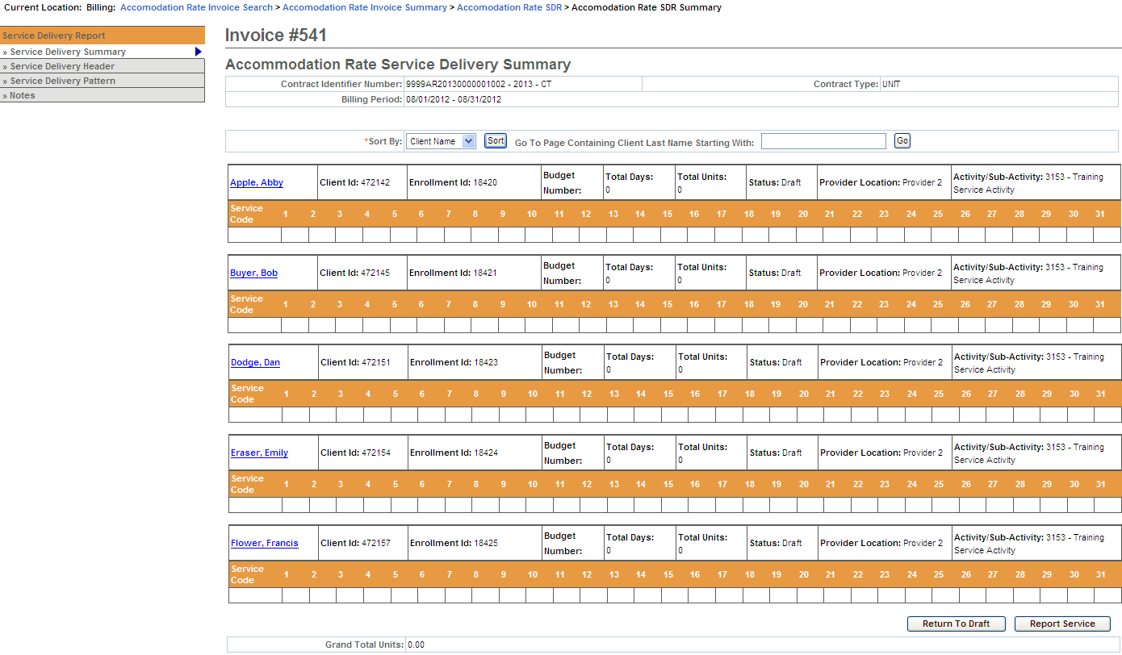
Important Tips:
- You can sort the SDR by Client ID, Enrollment ID, Client Name, and Provider Location. If sorting by Provider Location and you do not see a client record, check the Provider Organization Parent level location. All new or updated interfaced client enrollment records come into EIM at the Parent level of the organization from the agency enrolling system, i.e. Meditech. If providers want a client enrollment associated to a specific billing location, they need to make this association in ESM. Refer to online course 159: Manage Enrollment Locations for more information on this function.
- If you want to go to a page containing a specific client record, you can use the [Go To Page Containing Client Last Name Starting With] field. Simply enter all or part of a client’s last name, select the [Go] button and you will be brought to the page containing that record. You may need to scroll down to see it. Using this feature will “over-ride” any previous sorts.
- When you are finished entering information, always select the [Save Changes] button. If you do not save changes, you will lose the data you entered.
Information Regarding Client Enrollments:
- AR contracts with DDS or DMH: If a client enrollment is missing or should no longer appear on the SDR, contact your agency contract manager.
- AR contracts with DPH, DTA or MRC: If a client enrollment is missing or should no longer appear on the SDR, contact your organization contract manager or the point person for client enrollments in EIM/ESM.
- Select the [Client Name] link to view the client SDR calendar.
The Record Service Delivery page with the Core Service Delivery Calendar #1 displayed.
Figure 12: Image of the Record Service Delivery page with attendance calendar displayed.
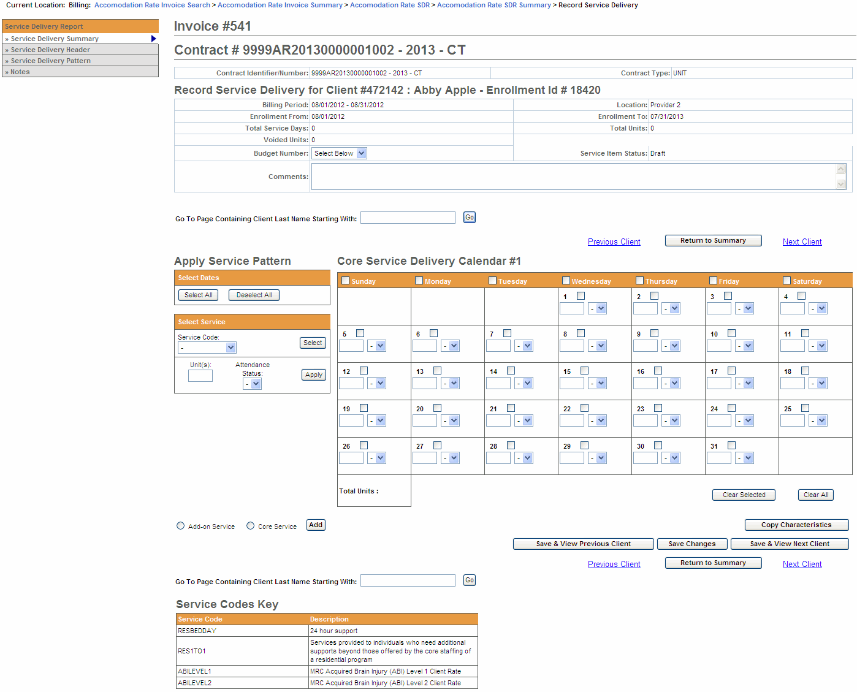
- Using the Select Service section, enter service information on the client record:
  - Place a checkmark next to the individual billing date(s) or use the [Select All] button if you need to bill all dates for the billing month.
Tips:
If you are billing for every day in the month, use the Apply Service Pattern and select the [Select All] button. This will place a checkmark on each day of the client service delivery calendar.
If you selected all days on the client service delivery calendar and wish to remove them, select the [Deselect All] button. This will remove all checkmarks on the client service delivery calendar.
  - Select the [Service Code] drop down menu to choose the service code and select the [Select] button.
  - Enter the [Unit(s)].
  - Select the [Attendance Status] from the drop down menu options.
  - Select the [Apply] button.
- Select the [Save Changes] button. A message appears, “Record has been updated successfully.”
Figure 13: Image of the Core Service Delivery Calendar #1 displayed.
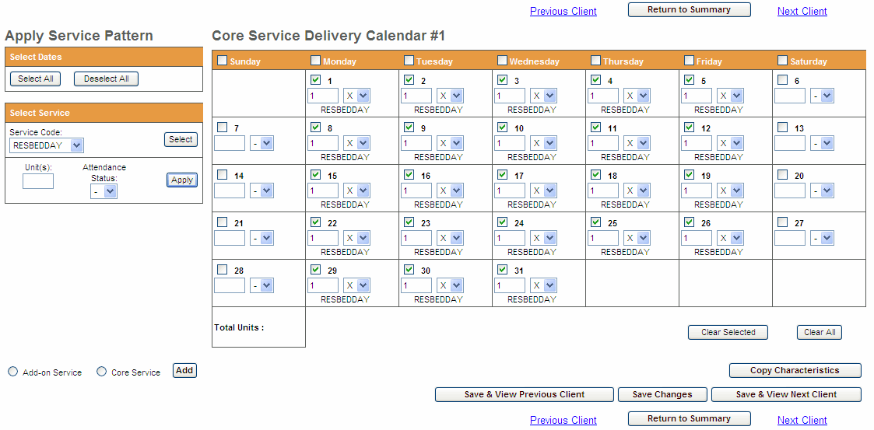
If additional Core calendars are needed,
- Select the radio button next to [Core Service] and select the [Add] button.
Note: At this time AR/SDR does not use Add-on Service calendars.
- Repeat steps above to report other servicers the client had for this billing month.
You repeat the above steps for each client that you need to bill for in the given month. If you have multiple clients whose attendance follows the same pattern, you can use the Service Delivery Pattern option. Refer to Report Multiple Client Attendance (Apply Pattern) section of this job aid for instructions.

Report Multiple Client Attendance (Apply Pattern)
Apply a Service Delivery Pattern:
- Select Service Delivery Pattern from the left navigation menu.
Figure 14: Image of the Accommodation Rate Service Delivery Summary page.
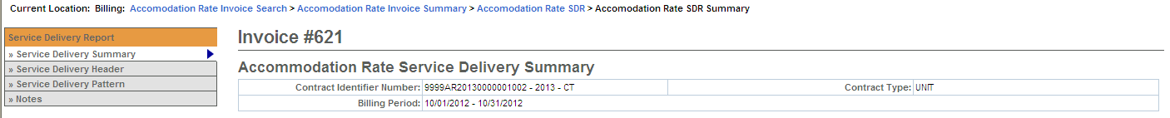
The Service Delivery Pattern page appears. You will note that this page displays the Core Service Delivery Pattern #1 (default) and also displays all of the enrolled clients on the SDR.
Figure 15: Image of the Service Delivery Pattern page.
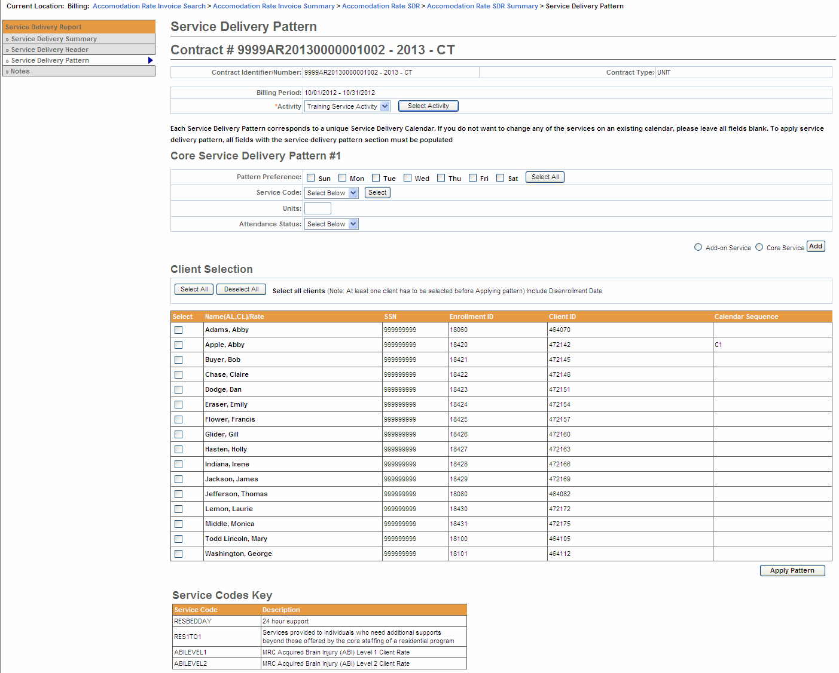
- Select the [Activity Code] from the drop-down menu options and select the [Select Activity] button. If only one activity code exists, the system will default to it, but you need to still select the [Select Activity] button.
Figure 16: Image of the Service Delivery Pattern page with the Activity section displayed.
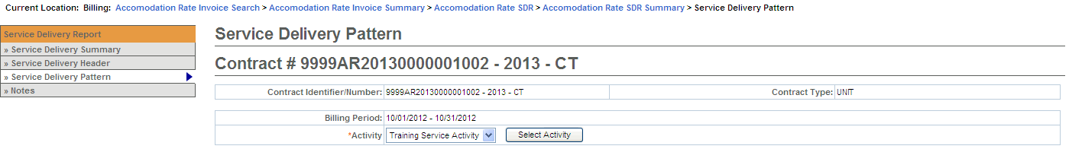
- Under the Core Service Delivery Pattern #1,
- Place a checkmark next to the [Pattern Preference] to indicate the days of the week that you need to report billing on. (If you bill for all seven days, you can select the [Select All] button and it place the checkmarks in the checkboxes for you.)
- Select the [Service Code] drop down menu to choose the service code and select the [Select] button.
- Enter the [Unit(s)].
- Select the [Attendance Status] from the drop down menu options.
Figure 17: Image of a completed Core Service Delivery Pattern #1 with Pattern Preference, Service Code, Unit and Attendance Status filled in.
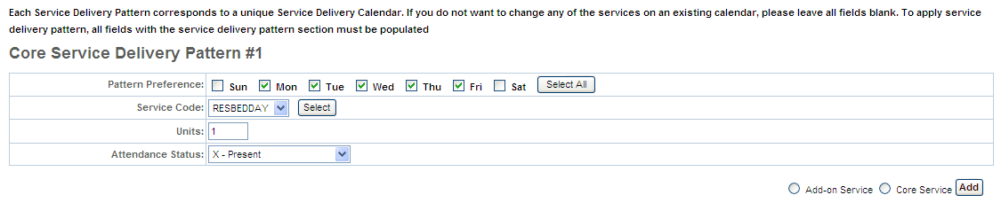
- Under Client Selection,
- Select the [Select All] if all clients on this SDR are reporting the same attendance pattern.
OR
- Place a checkmark next to each client that is reporting the same attendance pattern.
Note: If the Disenrollment Date needs to be included, remember to check the checkbox.
Figure 18: Image of the Service Delivery Pattern page with the Client Selection section displayed.
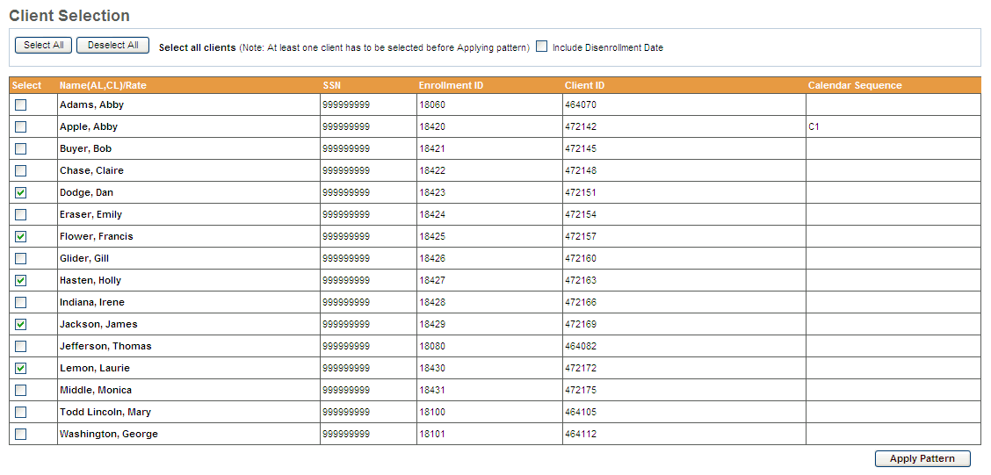
- Select the [Apply Pattern] button. Once the pattern has been applied, the system returns you to the Service Delivery Summary page.
Figure 19: Image of the Accommodation Rate Service Delivery Summary page.
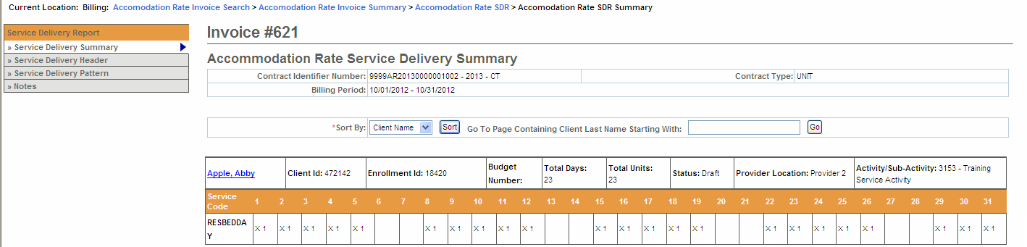
Important Note: After applying a pattern, services can never be removed, they can only be added. The pattern is irreversible. To adjust services, you must edit client records individually.

Reporting the SDR
Once all of the attendance information has been added for the billing month and you are sure that everything is stated correctly and accurately, the SDR needs to be ‘Reported’.
From the Service Delivery Summary page,
- Select the [Report Service] button.
Reminder: The SDR should remain in “Draft” status until all client attendance is reported. If you are not finished reporting attendance, you should select the “Return to Draft” button. Once the AR invoice has been ‘authorized’ you cannot edit the SDR. You will need to enter and submit a Supplemental AR/SDR if additions or corrections to the SDR are needed after the AR invoice is has been authorized.
Figure 20: Image of the Accommodation Rate Service Delivery Summary page with the 'Return to Draft' and 'Report Service' buttons displayed at the bottom of the page.
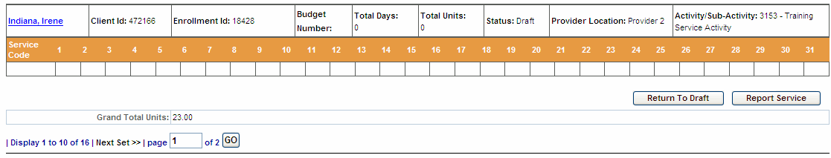
EIM automatically returns you to the Accommodation Rate Service Delivery Report page and shows that the SDR has been “Reported”.
Figure 21: Image of the Accommodation Rate Service Delivery Report page with the SDR in a Reported status.
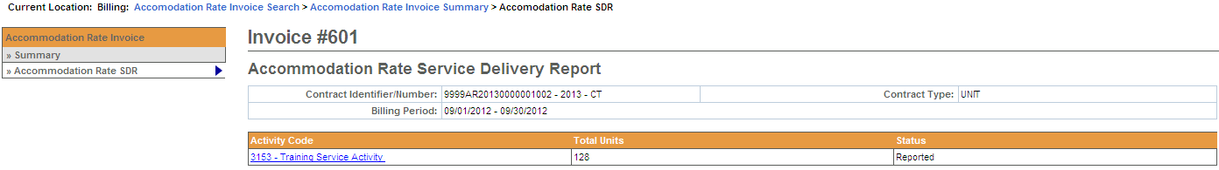
The final status for an SDR attached to an Accommodation Rate invoice is “Reported.”

Saving, Deleting, and Releasing an Accommodation Rate Invoice
Save an Invoice:
If you have updated the invoice and want to save it:
- Access the Accommodation Rate Invoice Summary page.
- Update the [Units], as necessary.
- Select the [Save Invoice] button. You will receive a confirmation message at the top of the page.
Figure 22: Image of the Accommodation Rate Invoice Summary page with the message 'Invoice Updated Successfully' displayed.
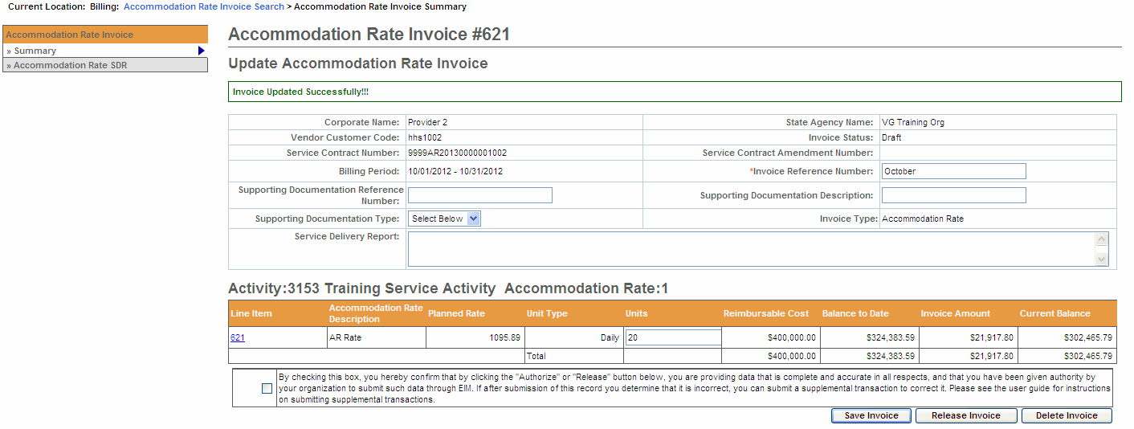
Delete an Invoice:
If you have to delete an invoice:
- Access the Accommodation Rate Invoice Summary page.
- Select the [Delete Invoice] button.
A message will appear at the top of the page “Are you sure you want to delete this record? Please click “Confirm Delete” to delete the record or “Cancel Delete” to cancel the operation.”
- Select the [Confirm Delete] button to delete this invoice.
Note: If you want to cancel the delete action, select the [Cancel Delete] button.
Figure 23: Image of the Accommodation Rate Invoice Summary page with the delete message 'Are you sure you want to delete this record? Please click “Confirm Delete” to delete the record or “Cancel Delete” to cancel the operation' displayed.
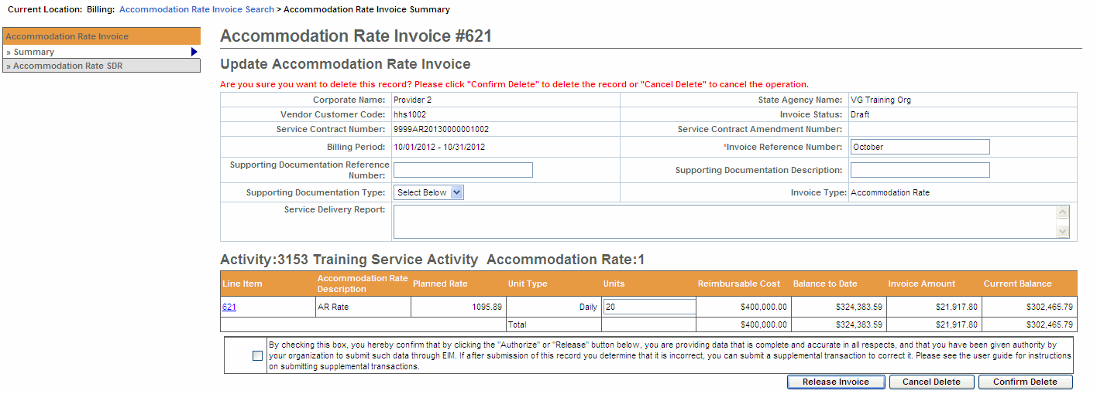
Release an Invoice:
If the invoice is ready to be released (if it is correct and ready to be authorized):
- Access the Accommodation Rate Invoice Summary page.
- Select the checkbox to confirm data is complete and accurate.
By selecting the checkbox you are complying with legal requirements on releasing an invoice.
- Select the [Release Invoice] button. You will receive a confirmation message at the top of the page.
Figure 24: Image of the Accommodation Rate Invoice Summary page with the message 'Invoice Released Successfully' displayed.
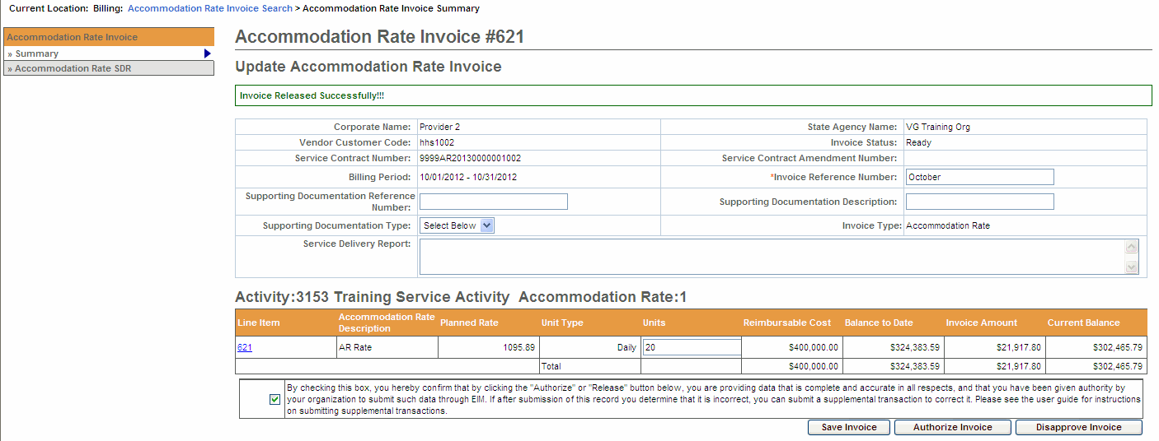

Disapproving and Authorizing an Accommodation Rate Invoice
Disapprove an Invoice:
To change the status of an invoice with an error from ready to draft:
- Access the Accommodation Rate Invoice Summary page of a released invoice.
- Select the [Disapprove Invoice] button. This will return the invoice to a Draft status.
Figure 25: Image of the Accommodation Rate Invoice Summary page with the Disapprove Invoice button displayed.
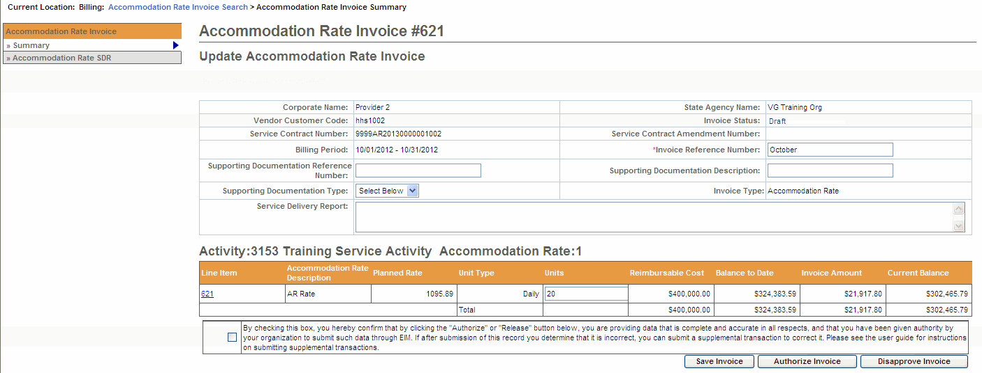
Authorize an Invoice:
If the invoice is ready to be authorized and submitted:
- Access the Accommodation Rate Invoice Summary page of a released invoice.
- Select the checkbox to confirm data is complete and accurate.
By clicking the checkbox you are complying with legal requirements on authorizing an invoice.
- Select the [Authorize Invoice] button. You will receive a confirmation message at the top of the page.
Figure 26: Image of the Accommodation Rate Invoice Summary page with the message 'Invoice Authorized Successfully' displayed.
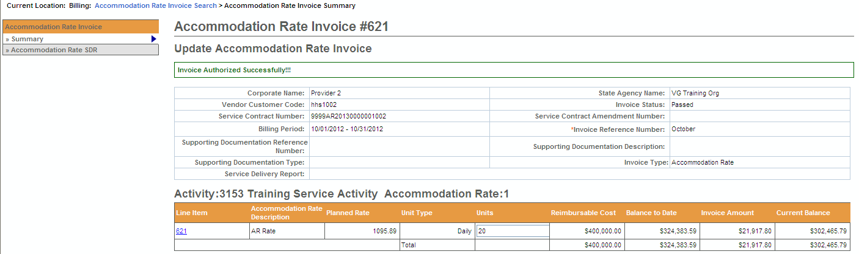

Searching for an Accommodation Rate Invoice
Search for an Accommodation Rate Invoice/SDR:
- Select the [Billing] module.
- Select the [Accommodation Rate Invoice Search] from the left navigation menu.
The Accommodation Rate Invoice Search page appears.
Figure 27: Image of the Accommodation Rate Invoice Search page.
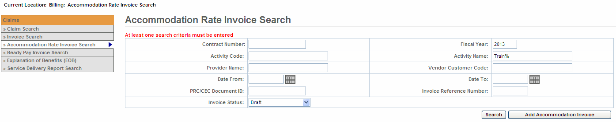
- Enter your search criteria in any of the following fields (must include at least one).
Tip: Use the wildcard % to search for records beginning with or ending with a text string or use partial criteria by entering the beginning letters or text string.
- Select the [Search] button.
Figure 28: Image of the Accommodation Rate Invoice Search page with results displayed.
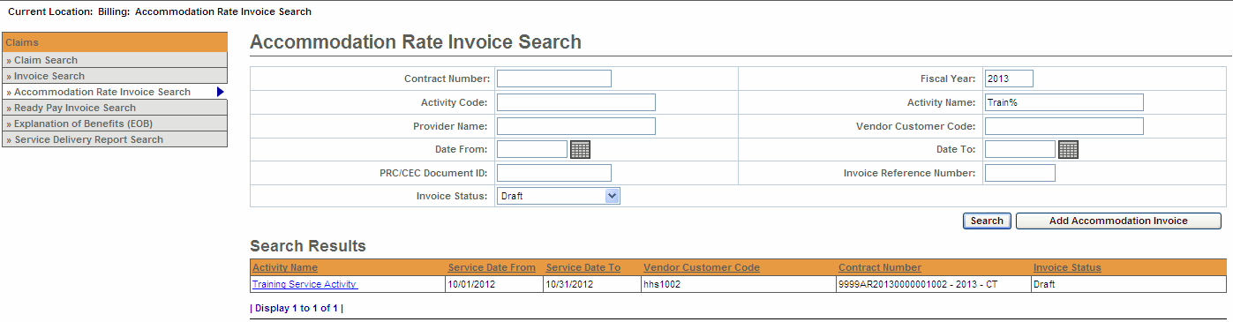
- Select the [Activity Name] link.
The Accommodation Rate Invoice Summary page appears including information about the invoice you selected.
Figure 29: Image of the Accommodation Rate Invoice Summary page.
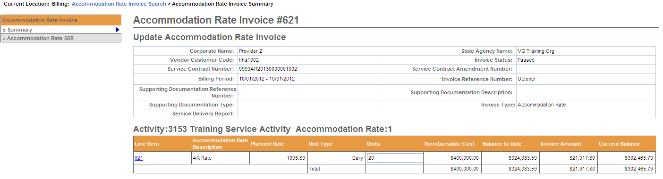
Reminder: To view the SDR, select Accommodation Rate SDR from the left navigation menu.

Supplemental Accommodation Rate Invoice
Adding a Supplemental Accommodation Rate Invoice:
- Select the [Billing] module.
- Select [Accommodation Rate Invoice Search] from the left navigation bar.
Figure 30: Image of the Accommodation Rate Invoice Search page.
- Select the [Add Accommodation Invoice] button.
- Pick a [Contract] from the drop down menu.
- Select the [Contract] button.
Figure 31: Image of the Add Accommodation Rate Invoice page with selected contract displayed.
- Enter [*Invoice Reference Number].
- Enter [*Billing Period From] date. (Note: Use MM/DD/YYYY format.) Reminder: When creating a supplemental invoice, enter the correct billing month you’re trying to correct.
- Enter [*Billing Period To] date. (Note: Use MM/DD/YYYY format.) Reminder: When creating a supplemental invoice, enter the correct billing month you’re trying to correct.
- Select the [Accommodation Rate Supplemental] radio button.
- Select the [Save New Invoice] button.
Note: Asterisk (*) symbol indicates required field.
Figure 32: Image of the Add Accommodation Rate Invoice page.
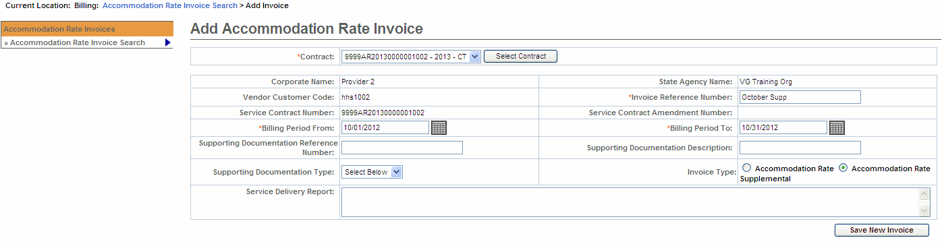
From the Accommodation Rate Invoice Summary page.
- Enter [Units]. This should be the adjusted number of units for the billing month. For example, if you originally billed for 31 days and it should be been for 29 days, you would enter -2 in the Units field.
Note: Depending on the contract you will enter daily or monthly unit(s). Locate the Unit field on the Invoice page to see whether you bill at a daily or monthly rate.
- Select the [Save Invoice] button.
Figure 33: Image of the Accommodation Rate Invoice Summary page with message 'Invoice Updated Successfully' displayed.
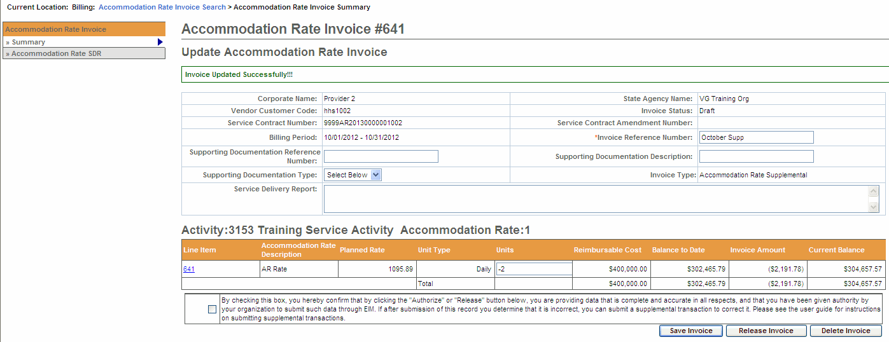

Supplemental Accommodation Rate Service Delivery Report (SDR)
Important Reminder for DDS Providers: You are required to include an SDR with your AR Invoice.
Note: The AR/SDR must be included with the AR Invoice in order for the payment to generate in EIM. If the SDR is not created as an AR/SDR, you will not be paid for services.
After saving the invoice you now need to add the SDR before releasing/authorizing this invoice.
From the Update Accommodation Rate Invoice page,
- Select [Accommodation Rate SDR] from the navigation bar.
- Select [Add New Accommodation Rate SDR] button.
- Select [Activity] from drop-down list.
- Select the [Select Activity] button.
Figure 34: Image of the Accommodation Rate Service Delivery Report page.
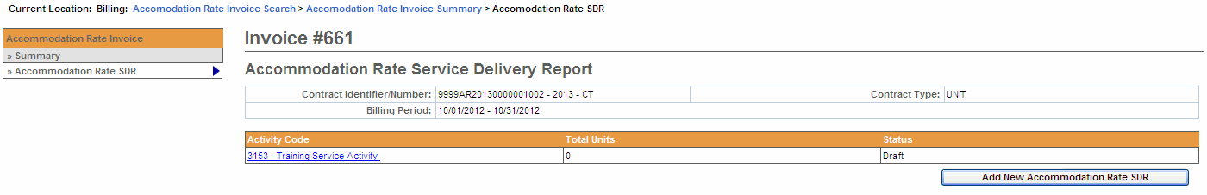
Reminder: The SDR should remain in “Draft” status until all client attendance is reported. If you are not finished reporting attendance, you should select the “Return to Draft” button. Once the AR invoice has been ‘authorized’ you cannot edit the SDR. You will need to enter and submit a Supplemental AR/SDR if additions or corrections to the SDR are needed after the AR invoice is has been authorized.
It is important to remember that if you Release and Authorize your AR invoice and have not marked the SDR as Reported; the SDR will not appear on the Printed AR Report. If changes/modifications are needed, a Supplemental AR Invoice/SDR will need to be entered.

Reporting Services on a Supplemental SDR – SDR Not Reported
From the Accommodation Rate Invoice Summary page.
- Select the [Client Name] link to view the client SDR calendar.
The calendar will display blank when you first come onto the page.
Figure 35: Image of the Record Service Delivery page with View Previous Service Delivery Reports button displayed.
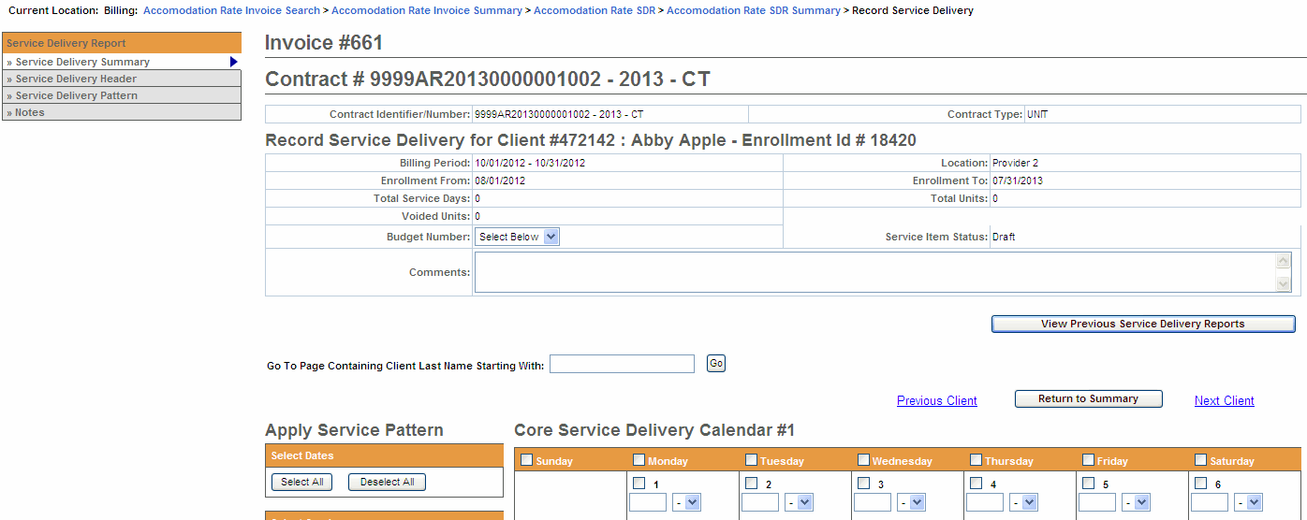
- Select the [Previous Service Delivery Reports] button to access the SDR calendar.
Figure 36: Image of the Record Service Delivery page with the Previous Service Delivery Reports displayed along with the Save Changes, Copy and Void buttons.
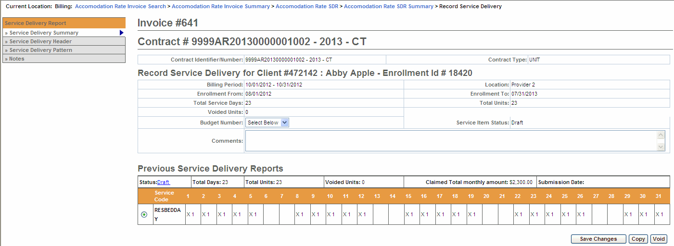
Notice that the Status of this calendar is ‘Draft’. This means that you did not report the SDR prior to the release and authorize so it did not attach itself to the invoice.
There are three buttons listed here: [Save Changes], [Copy] and [Void]. Based on what needs to be modified, select the appropriate button.
- If you need to Void the reporting of services (incorrectly entered on the regular SDR), then you would select the [Void] button. Note: If you VOID the previous month’s services you cannot delete the SDR/Invoice.
- To copy this data, select the radio button next to Service Code and then select the [Copy] button.
This will copy all of the attendance from the previous SDR onto the Core Calendar listed below.
Figure 37: Image of an updated Core Service Delivery Calendar #1 displayed.
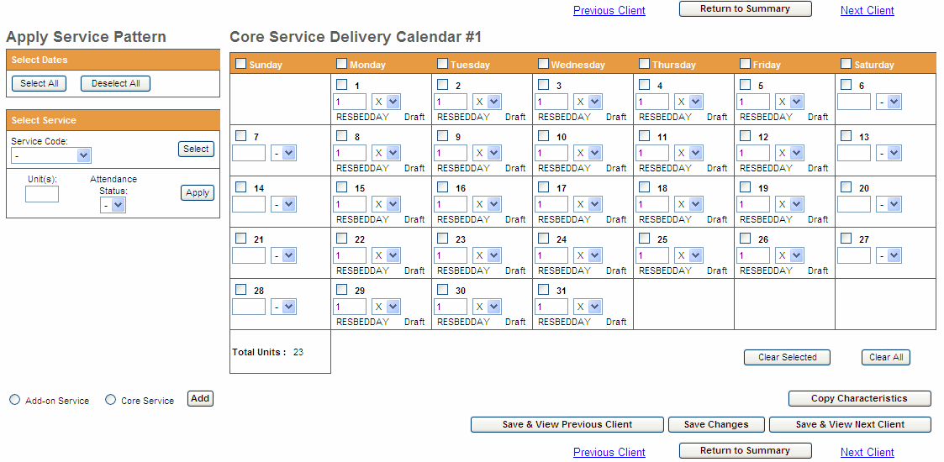
- Verify that the attendance is correct, and then select the [Save Changes] button.
A system verification message will appear on the page.
- Select the [Save & View Next Client] or [Return to Summary] page.
Figure 38: Image of an updated Accommodation Rate Service Delivery Summary page.
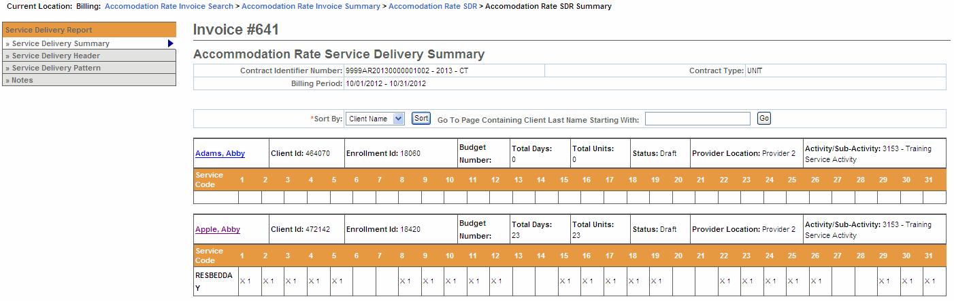
- Once all of the client data has been updated, scroll to the bottom of the Accommodation Rate Service Delivery Summary page and select the [Report Services] button.
Figure 39: Image of the 'Return to Draft' and 'Report Service' buttons that appear at the bottom of the Accommodation Rate Service Delivery Summary page.
Reminder Note: Once the Supplemental SDR has been reported, you must also remember to Release and Authorize the Supplemental AR Invoice.

Frequently Asked Questions (FAQs)
- How do I know if I need an AR-SDR?
- Please refer to your contract manager for assistance. Most DDS contracts require an SDR be entered and reported where many other agencies do not at this time.
- How do I attach an AR-SDR?
- While the AR invoice is still in draft status select the “Accommodation Rate SDR” link from the left navigation menu. Select the “Add new Accommodation Rate SDR” button; Select the Activity from the drop-down menu and select the “Select Activity” button. Populate the SDR and process the invoice. Refer to the Accommodation Rate Job Aid for step-by-step instructions.
- What codes do I use in the SDR?
- Please refer to your contract manager for assistance.
- The invoice has been paid, but the Agency is now asking that I submit an AR-SDR now. When I try to enter an AR-SDR the button to add is not highlighted?
- You can only add an AR-SDR when the AR invoice is in a Draft status. You cannot add the SDR to paid invoice.
- You will need to create a supplemental AR Invoice for the month in question, enter “0” for the number of units, select the ”Accommodation Rate SDR” link from the left navigation menu; Select the “Add new Accommodation Rate SDR” button. Select your Activity from the drop-down menu and select the “Select Activity” button. Populate the SDR and process the invoice. Refer to the Accommodation Rate Job Aid for step-by-step instructions.
- The agency stated that I did not include an AR-SDR with my invoice, but I see the SDR when I look at the invoice. Why isn’t it showing on the agency side?
- If the status of the SDR reads as Draft then the “Report Services” button was not selected prior to the invoice being released and authorized. You will need to create a supplemental AR Invoice for the month in question, enter “0” for the number of units, select the ”Accommodation Rate SDR” link from the left navigation menu; Select the “Add new Accommodation Rate SDR” button. Select your Activity from the drop-down menu and select the “Select Activity” button. Populate the SDR and process the invoice. Refer to the Accommodation Rate Job Aid for step-by-step instructions.
- My AR Invoice has been paid, but the agency advised me that the SDR is incorrect. How do I correct an incorrect SDR?
- You will need to create a supplemental AR Invoice for the month in question, enter “0” for the number of units, select the ”Accommodation Rate SDR” link from the left navigation menu; Select the “Add new Accommodation Rate SDR” button. Select your Activity from the drop-down menu and select the “Select Activity” button. Populate the SDR and process the invoice. Select the Enrollment ID link for the client that needs to be corrected. Select the radio button under the Previous Service Delivery Reports heading. Select the [Void] button and then [Save Changes]. The claim is now voided. Enter the new services for that client in the calendar, select the Report Services button and process the Invoice as normal. Refer to the Accommodation Rate Job Aid for step-by-step instructions.

Additional Learning Opportunities
- Online Learning: To take online course, log into PACE (www.pace.state.ma.us/vg).
- 136 Accommodation Rate Billing
- Additional EIM/ESM Provider Job Aids are found at:
- Virtual Gateway URL: www.mass.gov/vg/eimesm
- EIM/ESM Provider User Manuals and Instructional Materials

Need Assistance?
- Email the Virtual Gateway Business Operations Unit for assistance:
- EHS-DL-EIM-ESMBusinessOperations@massmail.state.ma.us
- Call the Virtual Gateway Customer Service for assistance:
- 1 (800) 421-0938
- 617-847-6578 (TTY people who are deaf, hard of hearing, or speech disabled)
- Monday – Friday: 8:30am - 5:00pm

