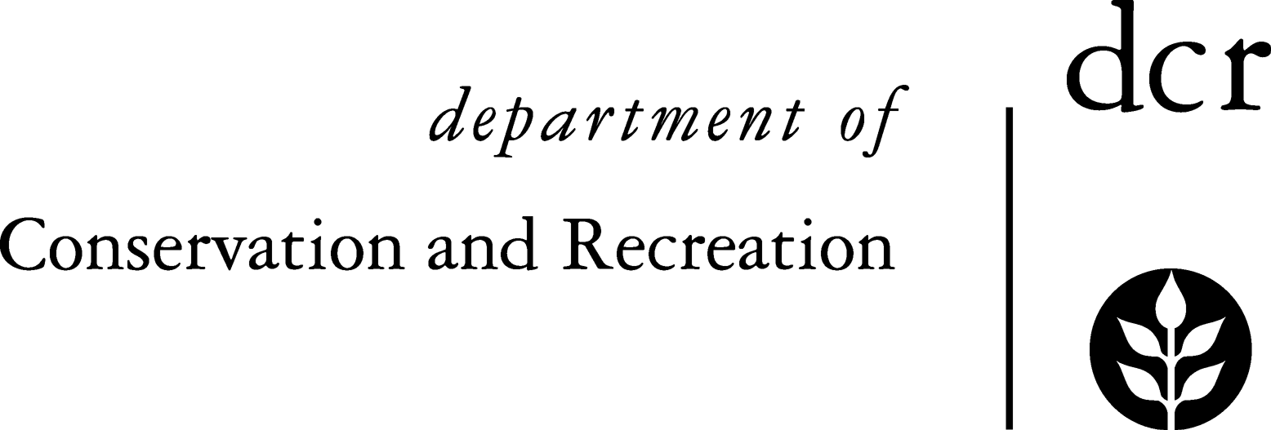
Massachusetts DCR Urban and Community Forestry
Challenge Grant Final Accomplishment Report

This report must accompany the final request for reimbursement, and both must be submitted within 30 days after contract end date.

E-mail to: Julie.Coop@mass.gov
Julie Coop, DCR Urban & Community Forestry State Coordinator

Organization
Person Reporting: Name Title
Phone # e-mail

Part I: ACCOMPLISHMENTS (fill in the blanks for only the items applicable to your project)

Tree Planting and Maintenance
Number of landscape size trees planted Number of seedling size trees planted
Number of trees maintained (watering, mulching, pruning, fertilizing, pest control, hazard tree management, planned removals, etc.)

Education and Outreach
Type of education or training programs conducted
Number of education or training programs conducted (classroom and/or field instruction)
Total number of participants
Total hours of instruction (all presentations added together)

Volunteer and Partner Participation
Total number of volunteers involved in all aspects of the project
Estimated total volunteer hours
Was a new partnership developed?

Community Forestry Program Development
Type of tree inventory or natural resource assessment conducted (street tree, hazard tree, canopy analysis, storm, invasive insect etc.).
Number of trees inventoried or Street miles inventoried or
Number of acres inventoried or analyzed
Was a written management plan prepared? Type of Plan:
Was a new Tree Board, Shade Tree Committee, etc. formed, or an inactive board reactivated?
Was a new tree group created?

Was a new Tree Ordinance developed?
Type of Ordinance created: Tree Care Tree Conservation Landscape Other public policy
Was an existing tree ordinance, policy, regulation, etc. revised or strengthened?
Did staff attend training sessions in urban and community forestry?
Did staff attain an arborist certification?

Cities and towns: Do you plan to apply for Tree City USA recognition this year?

Part II: ACCOMPLISHMENT NARRATIVE
Please attach a separate sheet(s) of paper and provide a summary of this project in your own words. The following questions are provided as a guide to your accomplishment narrative. Feel free to address other issues not enumerated below. Please highlight any successes and/or issues encountered during the project:

1. Look back at the application you submitted and read over the original goals and objectives.

 Did you accomplish what you set out to do?
 Were the project goals and objectives satisfied?
 If not, please explain why.
 Describe the goals and objectives that were accomplished and how you achieved success.

2. Pertaining to the goals of the Urban and Community Forestry Program, explain the impacts this project has had on the following, as applicable:

 Has this project helped establish or strengthen a community forestry program in your community? How?
 Has this project been successful in promoting volunteerism, cooperation, and partnerships? How?
 Has this project helped improve an understanding of the benefits of trees and the community forest? How?
 Has this project helped expand or improve the canopy cover in your community? How?
For example: through planned tree planting, maintenance of existing trees, protecting, or preserving trees through direct action or ordinances, management of insects, diseases, or other sources of tree decline, etc.
 Has this project helped enhance the technical skills of individuals involved in the planning, development, and maintenance of community forests? How?
 Has this project had a positive impact on city government leaders, elected officials, business owners, homeowners, or others? How?

3. Please identify a few individuals in your community who benefitted from your program. They may include a resident whose street received new trees, a participant in a workshop or educational event, or even someone within your organization. Please include names and contact information. DCR may follow up with these individuals to share their urban forestry stories.

4. Show us what was accomplished. This can include photos, newspaper articles, letters, or notes from beneficiaries, etc. Materials may be e-mailed to Julie.Coop@mass.gov.

Part III: REQUIRED ADDITIONAL DOCUMENTATION
If applicable to your project, the following documentation is required before final payment can be authorized.

1. Three (3) clean, final copies of all materials that were printed, published, or otherwise developed under
this grant. This includes management plans, planting design plans, streetscape plans, reports, full inventory data, inventory summaries, brochures, publications, newsletters, videos, training manuals, etc. For extensive, bulky or
costly documents and products, only one copy is required. Please contact Julie Coop if you have questions regarding this. If you have a digital copy, that should be included as well.

2. For site specific projects such as tree plantings, tree maintenance, trail development, outdoor classrooms,
demonstration projects, etc., include a few photos documenting on-the-ground accomplishments.

It is appropriate to use grant funds to offset any costs involved in satisfying the final reporting requirements.

Please call Julie Coop at 617-797-3392 or e-mail at Julie.Coop@mass.gov if you have questions.

