Adult Community Clinical Services
Commonwealth of Massachusetts
Department of Mental Health

Adult Community Clinical Services

IT/Data Exchange Requirements Version 1.2
July 26, 2018
25 Staniford Street
Boston MA 02114
Table of Contents
Introduction 4
Chapter 1: IT Responsibilities of the ACCS Providers 5
Establish a Dedicated Mailbox 5
Return Dedicated Mailbox Address to DMH 5
Access the Internet to use Secure Mail & Provider Portal 5
Process and Transmit XML 5
Chapter 2: The Virtual Gateway 7
Chapter 3: Referrals 9
Chapter 4: Data Reporting Requirements 10
A. Reporting Address & Phone Changes 10
B. Reporting Phone Changes Only 15
C. Reporting Event Data 18
Chapter 5: Department of Mental Health Provider Portal (DMHPP) 22
Login to the Department of Mental Health Provider Portal (DMHPP) 22
Steps to Upload an XML File 24
ROUND 1 Validation: Immediate 25
ROUND 2 Validation: Overnight 28
Chapter 6: Notifications/Reports Distributed to ACCS Providers 31
Chapter 7: Contact Information 33
Appendix 34
Appendix A: Definitions, Acronyms, and Abbreviations 34
Appendix B: ACCS Provider Mnemonics 34
Appendix C: ACCS RFR 34
Appendix D: ACCS Event Reporting 34
Appendix E: ACCS Facilities 34
Appendix F: Notifications/Reports Distributed to ACCS Providers (Sample) 34
Appendix: G: XSD template/schema 35
Appendix: H: ProviderEvents.xlsx 35
Appendix I: Round 1 - Validation Error Messages 35
Appendix J: ACCS Phase 1 – Data Elements 35
Appendix K: ACCS Programs and Contracts 35
Appendix L: Round 2 - Validation Error Messages 35
Appendix M: ACCS Webinar 6_DMH Provider Portal Presentation 36

Introduction
The Department of Mental Health (DMH), through RFR # 2018-DMH-3054-01 procured Adult Community Clinical Services (ACCS) statewide.
Adult Community Clinical Services (ACCS) is a comprehensive clinically focused service anchored by a multi-disciplinary team that provides clinical coverage 24 hours a day, 7 days a week, and 365 days a year through an integrated team led by clinical staff. ACCS Integrated Teams provide clinical interventions and peer and family support to facilitate engagement, support functioning and maximize symptom stabilization and self-management of individuals residing in all housing settings. In addition, Contractors are responsible for providing a range of contractor-based housing options as treatment settings to assist individuals in developing skills, establishing natural supports and resources to live successfully in the community.
Providers of ACCS Services must maintain an Information Technology (IT) infrastructure with the ability to integrate with the technology employed by the Executive Office of Health and Human Services (EOHHS), including the functionality of the Virtual Gateway and its automated POS billing service known as Enterprise Invoice Management/Enterprise Service Management EIM/ESM. Additionally, Providers must be capable of providing DMH with ACCS Services data in the format requested and according to specified timelines.
The purpose of this document is to provide Providers and other interested parties with the specifications for ACCS Services data format, exchange protocols, timelines and other information necessary for the successful exchange of data between Providers and DMH regarding the delivery of and payment for services.

Chapter 1: IT Responsibilities of the ACCS Providers
Providers of ACCS Services are required to comply with the following DMH IT requirements when providing ACCS Services:

Establish a Dedicated Mailbox
- Establish a Dedicated Mailbox for their agency in the Provider Agency email system for receipt of automated data transmissions from DMH.

Return Dedicated Mailbox Address to DMH
In support of these activities, Providers must:
- Return your Dedicated Mailbox address to DMH return dedicated mailbox address to Mary Merrill at Mary.Merrill@MassMail.State.MA.US
Note: After you submit your dedicated mailbox address to Mary Merrill, you will receive an email with “Secure:” in the subject line which will provide the link to establish your Secure Mail Account. Once your Secure Mail account has been established, you can login to the Commonwealth Secure Mail System Proofpoint at: https://ppsecuremail.state.ma.us/encrypt
Secure Mail System
The Secure Mail System is an enterprise solution for secured exchange of both e-mail and files using web technologies. Secure Mail is a Commonwealth shared service available to all its agencies and departments for use between themselves and their business partners.

Access the Internet to use Secure Mail & Provider Portal
- Access the internet to utilize the Commonwealth Secure Mail System as needed to exchange confidential information.
  - https://ppsecuremail.state.ma.us/encrypt
- Access the Virtual Gateway as needed to upload data to DMH.

Process and Transmit XML
- Process and transmit XML (Extensible Markup Language) documents for the purpose of data interchange using a map to be provided by DMH in the form of an XSD (XML Schema Definition) document that defines how data will be processed and accepted. Providers may choose to utilize a number of software products to generate an XML file when producing data for DMH from in-house systems, in which case the XSD will provide the format where each element in the complex type is defined.

Key Features
Some of the more prominent features of the Secure Mail Application include:
- All information is encrypted for storage and transfer to ensure security & privacy.
- Automated e-mail notification sent to all recipients when messages/files are available to be picked up.
- Reduced manual intervention in the delivery of information files to Commonwealth applications.
How to Retrieve a File from the Secure Mail Application
Notification: When a message is sent using the Secure Mail Application, a notification is sent that includes a link to the message posted on the Secure Mail servers.
Technical questions about Secure Mail should be directed to:
Common Help @ 866-888- 8608 or send an email to: commonhelp@state.ma.us

Chapter 2: The Virtual Gateway
The Virtual Gateway is an internet portal designed by the Executive Office of Health and Human Services to provide the general public, medical providers, community-based organizations and the Executive Office of Health & Human Services (EOHHS) staff with online access to health and human services.
DMH Provider Portal
ACCS Providers will use the Virtual Gateway’s secure website to upload ACCS data in XML format to the Department of Mental Health Provider Portal (DMHPP).
Refer to Chapter 5: Department of Mental Health Provider Portal (DMHPP) for guidance on using the DMHPP application.
Become a Virtual Gateway User
To access the Virtual Gateway, the organization you work for must register with Virtual Gateway Customer Service. Once your organization is registered, individual user accounts may be requested. Virtual Gateway Customer Service coordinates registering organizations and creating user accounts.
Register and Obtain User Accounts
Steps to register an organization and obtain user accounts are as follows:
New Virtual Gateway Organizations
To register on the Virtual Gateway, all organizations must complete and sign certain forms and documents. At a minimum, all organizations new to the Virtual Gateway must download and complete three forms.
- Virtual Gateway Services Agreement
The Virtual Gateway Services Agreement sets forth the terms and conditions that your organization must agree to in order to access the Virtual Gateway. The Agreement must be signed by an individual who has the legal authority to sign on behalf of your organization, as evidenced by your organization's charter or bylaws. This form only needs to be completed once - the first time your organization signs up to use the Virtual Gateway.
- Access Administrator Designation
Each organization must designate an individual to be their Virtual Gateway Access Administrator. He or she is responsible for approving, modifying, and/or removing user access privileges for any of the Virtual Gateway's business services used by your organization. The Virtual Gateway Designation of Access Administrator Form must be signed by an individual who has the legal authority to sign on behalf of your organization, as evidenced by your organization's charter or bylaws.
- User Request Form
In order to gain access to the Virtual Gateway, an organization's Access Administrator (AA) must complete the appropriate User Request Form (URF). Each URF is specific to the Virtual Gateway service an organization will use.
The User Request Form for Virtual Gateway access is used to add, change, or delete individual user account information for all Virtual Gateway business services. Your Access Administrator (AA) must complete the User Request Form to request user accounts for anyone within your organization who requires access to a Virtual Gateway service.
Access Administrators (AA) should download the latest version of the URF to their desktop, complete the form as per the instructions on the form, and email the complete form to the email address indicated on the form.
New User Request & Account Modification:
- Complete the DMHPP URF (https://www.mass.gov/service-details/user-request-forms)
- Email completed URF to: VirtualGatewayHelpDeskFaxes@massmail.state.ma.us
Note: URF’s are only accepted from an authorized Access Administrators (AA) for your organization.

Chapter 3: Referrals
DMH ACCS Referral Process
- DMH refers the client to the provider by emailing the referral form to the ACCS staff member identified to receive this information. The referral will be sent via secure mail.

- DMH will send the Client Data Summary Notification to the providers dedicated mailbox via secure mail. Client is in pre-registered status in the DMH application.

- ACCS provider submits the date of the first face to face encounter to DMH. Please see Chapter 4: Data Reporting Requirements.

- The submission of the face to face date triggers DMH staff to enroll the person in an ACCS service in the DMH application.

- At the time of enrollment, DMH will send the Client Action Notification to the providers dedicated mailbox via secure mail. The client’s record will now be available in EIM for Service Delivery Reporting (SDR).

The DMH ACCS Referral Form is available on the DMH Website at https://www.mass.gov/service-details/accs-documents-and-information-for-providers .

Chapter 4: Data Reporting Requirements
- Address & Event data may be reported in the same xml file
- Address & Event data for multiple programs may also be reported in the same xml file
- Data Entry should begin on line 2 of your excel file

A. Reporting Address & Phone Changes
The ProviderEvents.xlsx file (refer to Appendix H) can be used to report the clients address change, update phone, housing status and effective date.
Steps for Reporting Address & Phone Changes
- Providers only need to submit address changes for Integrated Team programs
- Report
Field Name | Required / Optional
*ServiceID | Required, ACCS
*ProgramID | Required  Mnemonic of program providing a DMH contracted or operated service. Each program is associated with only one contract#, but one contract # may be associated with multiple programs
*AccountNum | Required  Unique client identifier for each enrollment into a program, generated by DMH’s EHR.
*ClientName | Required  For information purposes and to assist you with locating the record in your file. DMH uses the AccountNum for validation
EffectiveDate | Required / Format = mm/dd/yyyy
HousingID | Required  1 = Provider Based Independent Setting  Individual apartments or buildings occupied by Persons Served for which Contractors are the lease holders. These locations do not have planned staffing but rather services and interventions are provided by the Integrated Team(s) in accordance with the Persons’ Treatment Plans. This includes any lease arrangement where the provider is the sponsor on the lease (e.g. DMH Rental Assistance).  2 = Independent Setting  Settings in which Persons are responsible for their own living arrangement (e.g., Persons are lease holders, live with their families. etc.).
Address1 | Required
Address2 | Optional
City | Required
State | Required
Zip | Required Format = 99999 or 99999-9999
Phone | Optional Format = 999-999-9999

- Otherwise if the client is homeless please report:
Field Name | Required / Optional
*ServiceID | Required, ACCS
*ProgramID | Required  Mnemonic of program providing a DMH contracted or operated service. Each program is associated with only one contract#, but one contract # may be associated with multiple programs
*AccountNum | Required  Unique client identifier for each enrollment into a program, generated by DMH’s EHR
*ClientName | Required  For information purposes and to assist you with locating the record in your file. DMH uses the AccountNum for validation
EffectiveDate | Required / Format = mm/dd/yyyy
HousingID | Required  3 = Homeless
Address1 | Optional
Address2 | Optional
City | Optional
State | Optional
Zip | Optional Format = 99999 or 99999-9999
Phone | Optional Format = 999-999-9999
* Found on the Client Data Summary Notification or Client Action Notification
If the Effective Date is prior to the ACCS Enrollment date, please use the Enrollment date as the Effective Date. Date cannot be in the future.
Before saving your file: PLEASE DO NOT DELETE ANY COLUMNS FROM THE EXCEL FILE
- Are all required key fields reported for each row? (ServiceID, ProgramID, AccountNum, ClientName)
- If you are reporting a HousingID of 1 or 2 – did you report the address and effective date?
- For HousingID of 3 did you report an effective date?
- Be sure there are no blank lines between rows
- File Naming Convention: The file name must follow the allowed file naming convention:
  - XML Filename will have 3 sections separated by underscore (_) symbol
    - Section1- Provider mnemonic: Example: PRO
      - System will accept only a single underscore (_) between Section1 and Section2 in File Name. If user adds any other special character other than underscore system will display an error.
    - Section2- Date file Uploaded: Example: 20180516
      - Date Format: “ “YYYYMMDD”
      - The date can be past date or current date, but cannot be a future date
    - Section3- A word such as Events or Address or the provider’s choice of any alphanumeric combination or any special characters with or without the underscore followed by a Sequence number. Example: Events1
      - No spaces are allowed in XML Filename; if any spaces exist in XML Filename, the system will reject the file.
    - Example of Acceptable File Name:
PRO_20180516_Address1.xml
    - Example of Unacceptable File Name:
PRO 20180516_Address1.xml
Please refer to Appendix B: ACCS Provider Mnemonics
Note: The file will be rejected if file naming convention is not followed.
Saving Your File (Please follow the file naming convention below)
- Save your file first as an excel file
- Select File, select Save As Ex: Pro_20180516_Address1.xlsx

- Now save your file as an xml file
  - Select File, select Save As - remove .xlsx from the file name
  - Save as type: Xml data; Ex: Pro_20180516_Address1.xml
  - Check your file name, remove any spaces in the file name
  - Select the SAVE button
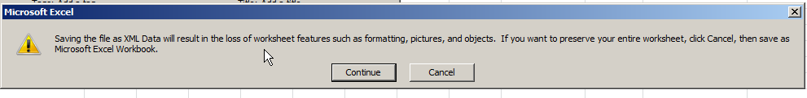
- Select the Continue button
- Close your excel file
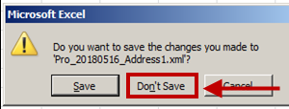
- Select the Don’t Save button
- Submitting your file – Refer to Chapter 5: Department of Mental Health Provider Portal (DMHPP).

B. Reporting Phone Changes Only
The ProviderEvents.xlsx file (refer to Appendix H) can be used to report the clients new phone number (voluntarily reported) and effective date.
Please report:
Field Name | Required / Optional
*ServiceID | Required, ACCS
*ProgramID | Required  Mnemonic of program providing a DMH contracted or operated service. Each program is associated with only one contract#, but one contract # may be associated with multiple programs
*AccountNum | Required  Unique client identifier for each enrollment into a program, generated by DMH’s EHR
*ClientName | Required  For information purposes and to assist you with locating the record in your file. DMH uses the AccountNum for validation
EffectiveDate | Required / Format = mm/dd/yyyy
Phone | Optional / Format = 999-999-9999  Note: Reported voluntarily by the provider
* Found on the Client Data Summary Notification or Client Action Notification
If the Effective Date is prior to the ACCS Enrollment date, please use the Enrollment date as the Effective Date. Date cannot be in the future.
Before saving your file: PLEASE DO NOT DELETE ANY COLUMNS FROM THE EXCEL FILE
- Are all required key fields reported for each row? (ServiceID, ProgramID, AccountNum, ClientName)
- Did you report a phone and effective date?
- Be sure there are no blank lines between rows
- File Naming Convention: The file name must follow the allowed file naming convention:
  - XML Filename will have 3 sections separated by underscore (_) symbol
    - Section1- Provider mnemonic: Example: PRO
      - System will accept only a single underscore (_) between Section1 and Section2 in File Name. If user adds any other special character other than underscore system will display an error.
    - Section2- Date file Uploaded: Example: 20180516
      - Date Format: “ “YYYYMMDD”
    - The date can be past date or current date, but cannot be a future dateSection3- A word such as Events or Address or the provider’s choice of any alphanumeric combination or any special characters with or without the underscore followed by a Sequence number. Example: Events1
      - No spaces are allowed in XML Filename; if any spaces exist in XML Filename, the system will reject the file.
    - Example of Acceptable File Name:
PRO_20180516_Address1.xml
    - Example of Unacceptable File Name:
PRO 20180516_Address1.xml
Please refer to Appendix B: ACCS Provider Mnemonics
Note: The file will be rejected if file naming convention is not followed.
Saving Your File (Please follow the file naming convention below)
- Save your file first as an excel file
- Select File, select Save As Ex: Pro_20180516_Address1.xlsx
- Now save your file as an xml file
  - Select File, select Save As - remove .xlsx from the file name
  - Save as type: Xml data; Ex: Pro_20180516_Address1.xml
  - Check your file name, remove any spaces in the file name
  - Select the SAVE button
- Select the Continue button
- Close your excel file
- Select the Don’t Save button

- Submitting your file – Refer to Chapter 5: Department of Mental Health Provider Portal (DMHPP).

C. Reporting Event Data
The ProviderEvents.xlsx (refer to Appendix H) file can be used to report the client’s event data
- Events – Date_EventStarted, Date_EventEnded & Date_TransitionEncounter should each be reported within one business day of occurrence. Each date may be submitted in a separate xml file.
- Please only report new or modified events. Submitting a historical file of events will produce warnings on the ACCS Reconciliation Report noting the data has already been reported.
Please report:
Field Name | Required / Optional
*ServiceID | Required, ACCS
*ProgramID | Required  Mnemonic of program providing a DMH contracted or operated service. Each program is associated with only one contract#, but one contract # may be associated with multiple programs
*AccountNum | Required  Unique client identifier for each enrollment into a program, generated by DMH’s EHR
*ClientName | Required  For information purposes and to assist you with locating the record in your file. DMH uses the AccountNum for validation
Event_Deletion | Optional – Report a ‘D’ if you wish to delete a misreported event
EventID | Required = 1 – 5  - Incarceration  - Inpatient Medical  - Inpatient Psychiatric  - Skilled Nursing  - First Face to Face Encounter after referral to program
Date_EventStarted | Required, if event started before ACCS enrollment please use the clients enrollment date as the event start date
Date_EventEnded | Reported for EventIDs 1-4  When reporting an end date please also provide the EventID, Date_EventStarted, FacilityID or Facility_Other  If reporting Date_TransitionEncounter - Date_EventEnded must be reported.
FacilityID | Required, if EventID = 1 or 3
Facility_Other | Required, if EventID = 2 or 4
Date_TransitionEncounter | Reported for EventID 1 -4  Date of first face to face encounter after return to community following an event  When an individual transfers from one facility to another, the provider reports the same date for the end date of the first event and the start date of the second event. Examples include, but are not limited to, transfer from one acute psychiatric unit to a second acute psychiatric unit, transfer from a medical unit to an acute psychiatric unit and transfer from a medical unit to a skilled nursing facility. As the individual is transferring from one facility to another without return to the community, the provider does not report a transition encounter until the individual is discharged to the community (i.e. a transition encounter is not reported for the first event).  Crisis Stabilization, Hospice and substance use residential admissions are not reported as events. When a person is discharged from a hospital setting into a diversionary or residential setting (e.g. Crisis Stabilization, substance use residential, Hospice), the Care Transition encounter is reported as the first face-to-face contact the Integrated Team has with the Person in this environment. Inpatient detox admissions are reported as either a medical or acute psychiatric inpatient admission, depending on the facility/unit type.
* Found on the Client Data Summary Notification or Client Action Notification
Please refer to Appendix D: ACCS Event Reporting for definitions.
If the Date_EventStarted is prior to the ACCS Enrollment date, please use the Enrollment date as the Date_EventStarted. Date cannot be in the future.
Before saving your file: PLEASE DO NOT DELETE ANY COLUMNS FROM THE EXCEL FILE
- Are all required fields reported for each row? (ServiceID, ProgramID, AccountNum, ClientName)
- If you are reporting a new event, did you already report or are you reporting the end date for the prior open event?
- Be sure there are no blank lines between rows
- File Naming Convention: The file name must follow the allowed file naming convention:
- XML Filename will have 3 sections separated by underscore (_) symbol
    - Section1- Provider mnemonic: Example: PRO
      - System will accept only a single underscore (_) between Section1 and Section2 in File Name. If user adds any other special character other than underscore system will display an error.
    - Section2- Date file Uploaded: Example: 20180516
      - Date Format: “ “YYYYMMDD”
      - The date can be past date or current date, but cannot be a future date
    - Section3- A word such as Events or Address or the provider’s choice of any alphanumeric combination or any special characters with or without the underscore followed by a Sequence number. Example: Events1
      - No spaces are allowed in XML Filename; if any spaces exist in XML Filename, the system will reject the file.
    - Example of Acceptable File Name:
PRO_20180516_Address1.xml
    - Example of Unacceptable File Name:
PRO 20180516_Address1.xml
Please refer to Appendix B: ACCS Provider Mnemonics
Note: The file will be rejected if file naming convention is not followed.
Saving Your File (Please follow the file naming convention below)
- Save your file first as an excel file
- Select File, select Save As Ex: Pro_20180516_Address1.xlsx
- Now save your file as an xml file
  - Select File, select Save As - remove .xlsx from the file name
  - Save as type: Xml data; Ex: Pro_20180516_Address1.xml
  - Check your file name, remove any spaces in the file name
  - Select the SAVE button
- Select the Continue button
- Close your excel file
- Select the Don’t Save button

- Submitting your file – Refer to Chapter 5: Department of Mental Health Provider Portal (DMHPP).

Chapter 5: Department of Mental Health Provider Portal (DMHPP)
Overview
This system will allow contracted DMH providers to transmit standardized Protected Health and other information through the Virtual Gateway using the Provider Portal (DMHPP). Data transmitted may include, but is not limited to, demographic, psychiatric and behavioral events, outcomes and utilization. Data passing the file and record level process will be loaded to the Department of Mental Health Data Warehouse. Phase I of the DMHPP allows for providers of Adult Community Clinical Services (ACCS) to submit address, housing changes and psychiatric and behavioral events.

Login to the Department of Mental Health Provider Portal (DMHPP)
The Department of Mental Health Provider Portal (DMHPP) is accessed through the Virtual Gateway. All users of the DMHPP must have a Virtual Gateway UserID and password in order to use the application. Users should speak with their Agency Access Administrators (AA) if they require access to this application.
Refer to Chapter 2: Virtual Gateway for guidance on how to become a Virtual Gateway Organization/User.
- Open Internet Browser window, type https://sso.hhs.state.ma.us/ in the Address field and press the Enter button.
Note: Suggested Internet Browsers:
- Internet Explorer 11.0 and greater
- Latest Chrome Version
The Welcome to the Virtual Gateway screen appears.
This screen contains three keys areas that users should be familiar with:
- Important Messages: Guidance on Virtual Gateway Account Maintenance
- Maintenance Notices: System outage/unavailability notices
- Virtual Gateway Customer Service: Telephone Numbers and hours of operation information

- Username: Type Username in this field.
- Password: Type Password in this field.
- Select the Login button.
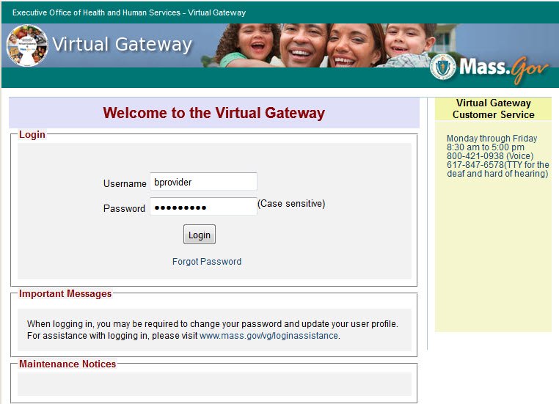
The Virtual Gateway Business Service screen appears.
- Select the DMH Provider Portal link.
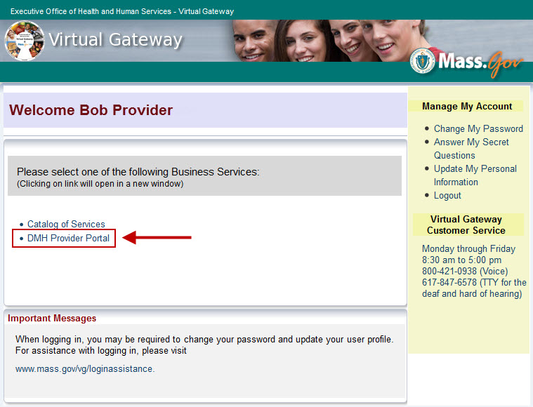
The DMH Provider Portal File Upload screen appears.
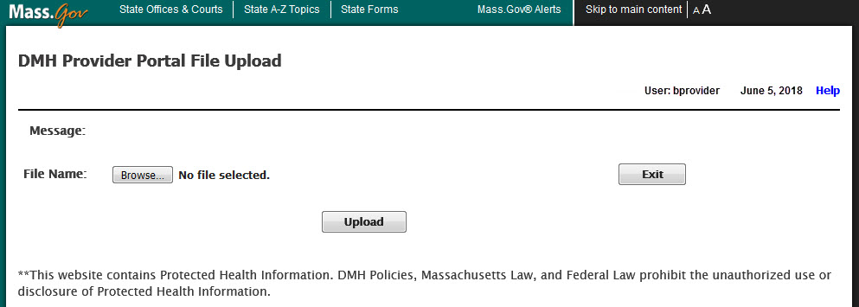
This screen contains the following information/action buttons that users should be aware of:
- User: Virtual Gateway User ID displays.
- Date: Current system date displays.
- Help: Select this link to access the ACCS IT/Data Exchange Requirements.
- Message: DMHPP system will display success or error messages in this area. Message is empty by default; system will only display message after user uploads a file.
- Browse: Select this button to browse for a file to upload into the DMHPP application.
- Upload: Select this button to upload the file into DMHPP application.
- Exit: Select this button to exit/logoff the DMHPP application.
Note: DMHPP Disclosure: **This website contains Protected Health Information. DMH Policies, Massachusetts Law, and Federal Law prohibit the unauthorized use or disclosure of Protected Health Information.

Steps to Upload an XML File
- File Name: Select the Browse… button.
- File Upload: Locate and Select the XML file to upload.
- Select the Open button.
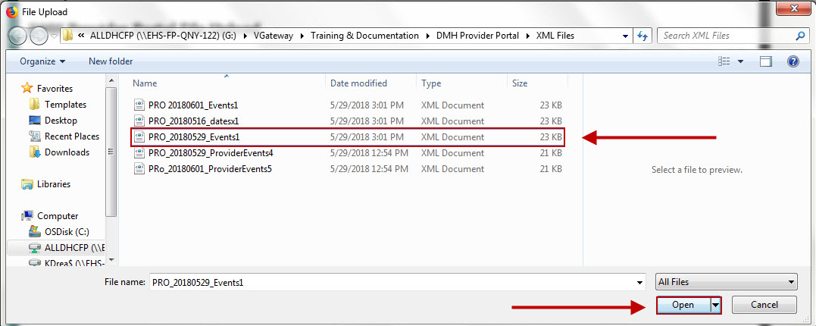
The selected File Name will appear on the screen.
- Select the Upload button.
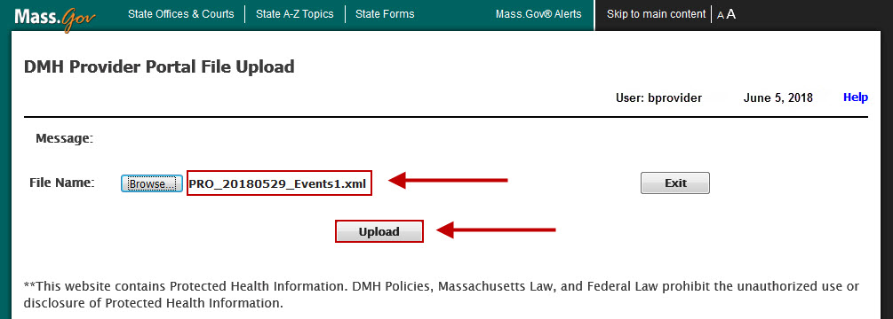

ROUND 1 Validation: Immediate
DMHPP will display a success or error message depending on whether the uploaded XML file passes the Round 1 validation.
The DMHPP application will validate the file name and the content of the XML file during Round 1 validation.
- Virus: Scans file to be uploaded for possible virus.
- File Name Convention: The file name must follow the allowed file name convention:
  - XML Filename will have 3 sections separated by underscore (_) symbol
    - Section1- Provider mnemonic: Example: PRO
      - System will accept only a single underscore (_) between Section1 and Section2 in File Name. If user adds any other special character other than underscore system will display an error.
    - Section2- Date file Uploaded: Example: 20180529
      - Date Format: “YYYYMMDD”
      - The date can be past date or current date, but cannot be a future date
    - Section3- A word such as Events or Address or the provider’s choice of any alphanumeric combination or any special characters with or without the underscore followed by a Sequence number. Example: Events1
  - No spaces are allowed in XML Filename; if any spaces exist in XML Filename, the system will reject the file.
    - Example of Acceptable File Name: PRO_20180529_Events1.xml
    - Example of Unacceptable File Name: PRO 20180601_Events1.xml
- File Duplicate Name: No other previously uploaded file has the same name for a given day.
- Required fields: All required fields, by row, are completed.
- Format: All fields are in acceptable format.
- .XML Extension: File must contain .XML extension.

Round 1 Validation: Success
If the XML file meets all of the above criteria the user will receive the success validation message on the portal screen and an email will be sent to the providers dedicated mailbox. The file will move to the second round – record validation which will occur overnight.
Success Message Example: File: PRO_20180529_Events1.xml successfully passed Round 1 validation. Round 2 validation will occur overnight. Providers will receive a reconciliation report noting the # of records passed, # of records failed and the detail of the error.
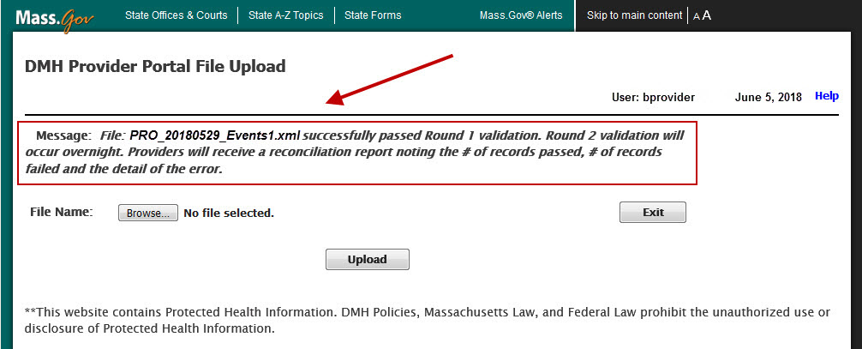

Sample Success Email Template
Confirmation email will be sent to the providers dedicated mailbox
From:DONOTREPLY_DMHACCS@STATE.MA.US [mailto:DONOTREPLY_DMHACCS@STATE.MA.US]
Sent: Day of Week, Month Date, YYYY00:00 AM/PM
To: Provider Dedicated Mailbox
Subject: Secure: Success Round 1 – UserID - FileName
Filename: PRO_20180529_Events1.xml uploaded at: 5/29/2018 3:03:46 PM.
Number of records uploaded: 3.
File: PRO_20180529_Events1.xml successfully passed Round 1 validation. Round 2 validation will occur overnight. Providers will receive a reconciliation report noting the # of records passed, # of records failed and the detail of the error.
Important Warning: This message is intended only for the use of the person or entity to which it is addressed and may contain information that is privileged and confidential, the disclosure of which is governed by applicable law. Confidentiality Notice: Protected Health Information from the Massachusetts Department of Mental Health Protected Health Information is personal and sensitive information related to a person’s health care. It is being e-mailed to you after appropriate authorization from the person or under circumstances that do not require the person’s authorization. If you are not the intended recipient, or the employee or agent responsible to deliver it to the intended recipient, the disclosure, copying or distribution of this information is Strictly Prohibited. If you have received this message by error, please notify the sender immediately.

Round 1 Validation: Errors
If the XML file fails to meets any of the above criteria the user will receive the error validation message on the portal screen and an email will be sent to the provider’s dedicated mailbox. The user should review the errors, make corrections and resubmit the file for processing in the DMHPP application. Guidance will be provided in the email as to which row records caused the file rejection.
Refer to Appendix I: Round 1 - Validation Error Messages for a listing of error messages.
Error Message Example: File: PRO 20180601_Events1.xml - Invalid file name. Spaces not allowed in file name – File not processed.
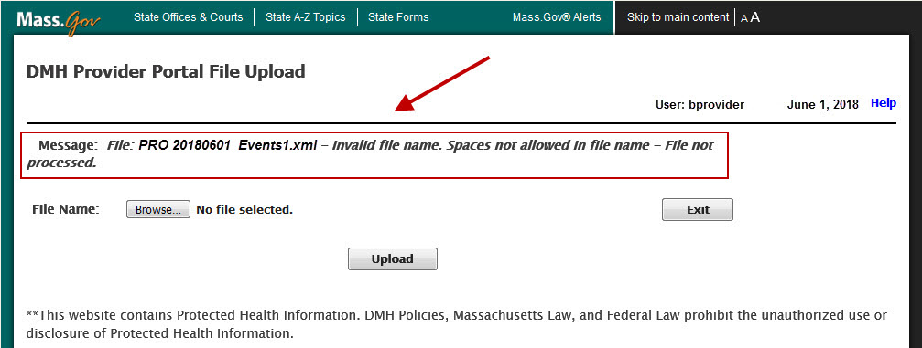
The user should review the errors, make corrections and resubmit the file for processing in the DMHPP application.
Note: The file sequence # of the file name MUST be incremented before resubmitting the file again for processing.

Sample Rejection Email Template
From:DONOTREPLY_DMHACCS@STATE.MA.US [mailto:DONOTREPLY_DMHACCS@STATE.MA.US]
Sent:Day of Week, Month Date, YYYY00:00 AM/PM
To: Provider Dedicated Mailbox
Subject: Secure: Error Round 1 – UserID - FileName
Filename: PRO_20180601_Event1.xml uploaded at: 06/01/2018 9:51:40 AM
Filename: PRO_20180601_Event1.xml rejected with errors
File Upload Errors:
XML Record | Client Name | ProgramID | Account Number | Error Message
8 | John Doe | PROACCS1 | FW000009999 | Address1 is required if HousingID = 1 or 2.
8 | John Doe | PROACCS1 | FW000009999 | City is required if HousingID equals 1 or 2.
8 | John Doe | PROACCS1 | FW000009999 | State is required if HousingID equals 1 or 2.
8 | John Doe | PROACCS1 | FW000009999 | Zip is required if HousingID equals 1 or 2.
Important Warning: This message is intended only for the use of the person or entity to which it is addressed and may contain information that is privileged and confidential, the disclosure of which is governed by applicable law. Confidentiality Notice: Protected Health Information from the Massachusetts Department of Mental Health Protected Health Information is personal and sensitive information related to a person’s health care. It is being e-mailed to you after appropriate authorization from the person or under circumstances that do not require the person’s authorization. If you are not the intended recipient, or the employee or agent responsible to deliver it to the intended recipient, the disclosure, copying or distribution of this information is Strictly Prohibited. If you have received this message by error, please notify the sender immediately.

ROUND 2 Validation: Overnight
The record level validation process will be executed each night.
For every file processed the provider will receive an ACCS Reconciliation Report (see Appendix F: Notifications/Reports Distributed to ACCS Providers (Sample)).
. The provider should review the report and correct any errors reported.
Only resubmit those records in error. (see Appendix L: Round 2 – Validation Error Messages)
To correct your errors:
- Right click on the excel file name for the errors reported
ex: Pro_20180516_Address1.xlsx
- Delete those records successfully processed in the file
- Correct rows reported as errors
- Save the File. Select File, select Save As: increment the sequence # and save the file as an excel file. Ex: Pro_20180516_Address2.xlsx
- Now save your file as an xml file
  - Select File, select Save As – remove the .xlsx from the file name
  - Save as type: Xml data Ex: Pro_20180516_Address2.xml
  - Check your file name, remove any spaces in the file name
  - Select the SAVE button
- Select the Continue button
- Close your excel file
- Select the Don’t Save button
- Resubmit the file for processing in the DMHPP application
Note: The file sequence # of the file name MUST be incremented before resubmitting the file again for processing.
Things to Remember When Using DMHPP
- Virus Scan: DMHPP will scan for viruses each time a file is uploaded. If the scan finds a virus, the system will reject the infected file. Since the file was rejected and not uploaded, no email will be sent to the provider.
- Required Fields: The XML required fields will be validated by the system.
- Number of Records: The system will accept XML files with maximum of 200 records.
- Validation Process: The system will validate all records in XML file row by row; and will display errors row by row.
- Round 1 Validation: During Round 1 validation, system will validate XML data formats and required fields; if any discrepancy is found, system will display reject XML file and send email with errors.
- Round 2 Validation: Overnight process will perform a further record level validation.
- XML Data Fields: All incoming XMLs should have the same XML fields as mentioned in the XML template; User might leave a field blank, but if the user leaves a required field blank, system will display an error on screen and will forward an email.

- XML Template: All tags are required in every xml file submitted for processing
  - <providerevents>
<providerevent>
<ServiceID>
<ProgramID>
<AccountNum>
<ClientName>
<Address1>
<Address2/>
<City>
<State>
<Zip> >
<Phone/>
<EffectiveDate>
<HousingID>
<Event_Deletion/>
<EventID>
<Date_EventStarted>
<Date_EventEnded/>
<FacilityID/>
<Facility_Other>
<Date_TransitionEncounter>
</providerevent>
</providerevents>

Chapter 6: Notifications/Reports Distributed to ACCS Providers
Action | Notification/Report to Provider | Subject Line | Frequency
Client is pre-enrolled in DMH System | Client Data Summary Notification  - Upon receiving this report the ACCS provider has the clients account number to submit their first face to face date.  (see Chapter 4) | Secure: xxxx CLIENT DATA SUMMARY NOTIFICATION | Daily
Client is enrolled in DMH System | Client Action Notification  - Upon receiving this information, the ACCS provider can now submit any address, phone, housing or event data for the client (see Chapter 4) | Secure: xxxx Client Action Notification | Daily
Pre-Enrollment or Enrollment cancelled in DMH system | Client Action Notification | Secure: xxxx Client Action Notification | Daily
Enrollment Start Date modified in DMH system | Client Action Notification | Secure: xxxx Client Action Notification | Daily
Dis-Enrollment entered in DMH system | Client Action Notification | Secure: xxxx Client Action Notification | Daily
Enrollment End Date modified | Client Action Notification | Secure: xxxx Client Action Notification | Daily
Dis-Enrollment rolled back to Enrolled status | Client Action Notification | Secure: xxxx Client Action Notification | Daily
NA | Program Census Report | Secure: xxxx Census Report | Weekly, each Friday
Submission of Address & Event xml file(s) | Reconciliation Report  - Report is generated for each file submitted.  - Notes the # records reported in file, # of deletions for event reporting, # records passed and # records with errors. The detail of the errors will be noted | Secure: VGUserID Reconciliation Report – File Name | Daily
xxxx = ACCS ProgramID - Please refer to Appendix K: ACCS Programs and Contracts.xlsx *
Note: *As Contract Numbers become available DMH will send out updates to the ACCS Programs and Contracts.xlsx found in the appendix of this document.
The Client Action Report will only be distributed if one or more of the actions in the above table occurred for the previous day. This report may contain multiple names if more than one person was enrolled, dis-enrolled or enrollment status changed on the same day.
Please see Appendix F: Notifications/Reports Distributed to ACCS Providers (Sample)

Chapter 7: Contact Information
Questions regarding the DMH Provider Portal and Data Processing:
Virtual Gateway Customer Service
Monday through Friday
8:30 am to 5:00 pm
800-421-0938 (Voice)
617-847-6578 (TTY)
The Virtual Gateway Customer Service will create a ticket and assign to Tier 2 DMH.Provider Portal Group.
Questions regarding the Enterprise Invoice Management/ Enterprise Service Management (EIM/ESM) application:
Michleen.Rygiel@MassMail.state.ma.us / 617-626-8018 (Voice)
Questions regarding the ACCS Services Program:
Jeff.Morton@MassMail.state.ma.us / 617-312-6286 (Voice)

Appendix

Appendix A: Definitions, Acronyms, and Abbreviations
Term | Definition
AIMS | Access & Identity Management System
DMH ACCS | Department of Mental Health Adult Community Clinical Services
DMHPP DB | Department of Mental Health Provider Portal Data Base
EIM | Enterprise Invoice Management
EOHHS (or EHS) | Executive Office of Health and Human Services
OMS | Organization Management System
PHI | Protected Health Information
PMO | Project Management Office
SDR | Service Delivery Report

Appendix B: ACCS Provider Mnemonics

Appendix C: ACCS RFR

Appendix D: ACCS Event Reporting

Appendix E: ACCS Facilities

Appendix F: Notifications/Reports Distributed to ACCS Providers (Sample)

Appendix: G: XSD template/schema

Appendix: H: ProviderEvents.xlsx

Appendix I: Round 1 - Validation Error Messages

Appendix J: ACCS Phase 1 – Data Elements

Appendix K: ACCS Programs and Contracts

Appendix L: Round 2 - Validation Error Messages

Appendix M: ACCS Webinar 6_DMH Provider Portal Presentation

