Reset Password
Step Actions:
- Go to the ACES Online homepage and select the next to the Enter Password field:
(https://performancemanager4.successfactors.com/login?company=MA&)
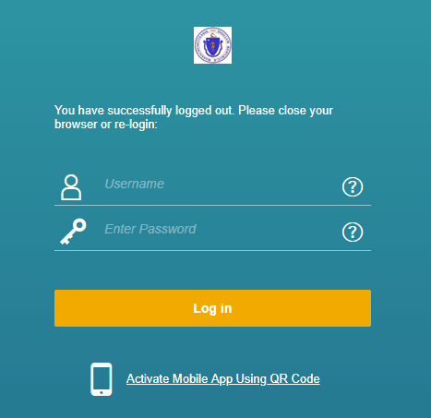
- Enter your username or email address and select Reset.
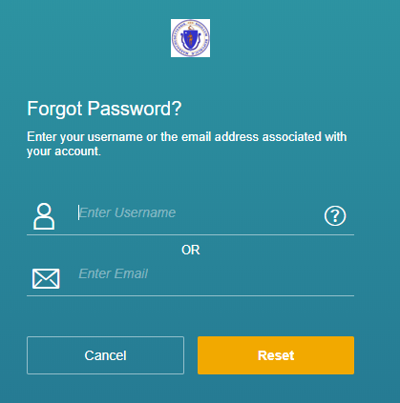
- A new screen will appear informing you to check your email. Please note, it can take approximately 5 minutes for the email to arrive.
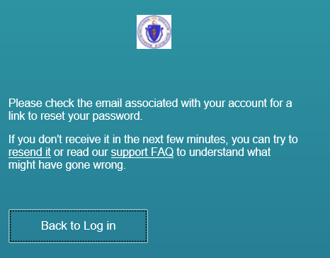
- The email will have Reset Password Support Notification as the subject. Open the email and select the Click Here link.
- Enter a new password twice. Select Submit.
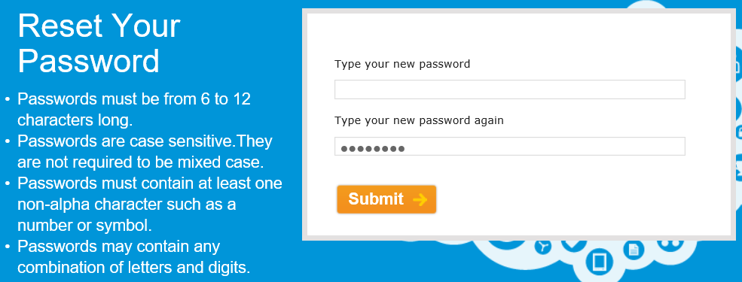
- Select Back to Log in and enter your username and new password.

