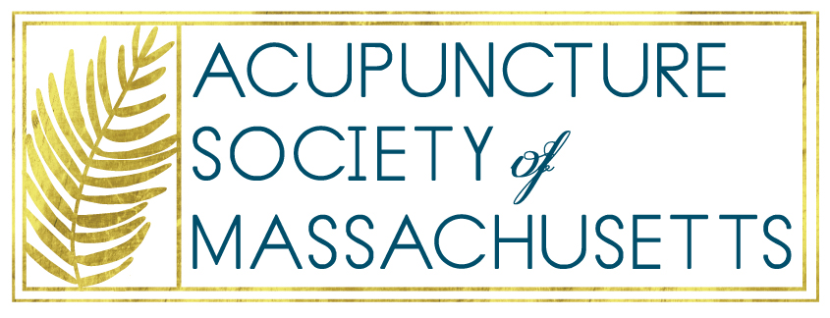
PO Box 775
Beverly, MA 01915
www.aomsm.org
admin@aomsm..org

Board of Registration in Medicine
200 Harvard Mills Square, Suite 330
Wakefield, MA 01880
February 15, 2017

Dear Board of Registration in Medicine,

The Acupuncture Society of Massachusetts, (formerly the Acupuncture and Oriental Medicine Society of Massachusetts), would like to thank you for your work on the acupuncture regulations. We especially wish to applaud the changes in wording that modernise the definition of acupuncture to include anatomical locations on the body and include biomedical theories as the basis for diagnosis for acupuncture.

We would like to suggest you remove the word “Oriental” from all places it is found in 243 CMR due to the term being perceived by many as pejorative. On May 20, 2016, President Obama signed bill H.R. 4238 into law, which eliminates the terms “Oriental” and “Negro” from federal laws. ASM would like to suggest the Committee on Acupuncture do the same.

Many organizations use “East Asian”as an inclusive replacement since it refers to a place rather than what has been deemed a culture.

The Acupuncture Society of Massachusetts has also removed “Oriental” from its name and respectfully requests that it be done so from 243 CMR as well.

Sincerely,
Board, Acupuncture Society of Massachusetts, (ASM)
Formerly Acupuncture and Oriental Medicine Society of Massachusetts (AOMSM)

