Commonwealth of Massachusetts
Executive Office of Health and Human Services

Office of Medicaid
www.mass.gov/masshealth

MassHealth
Acute Inpatient Hospitals Bulletin 150
February 2015

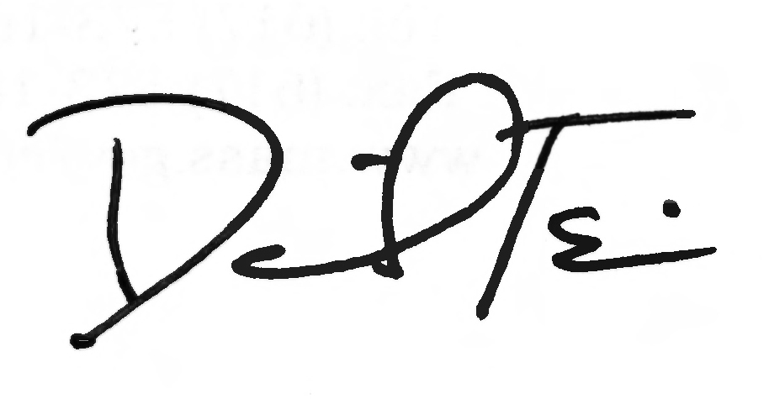
TO: Acute Inpatient Hospitals Participating in MassHealth

FROM: Daniel Tsai, Assistant Secretary for MassHealth

RE: New Fax Number for MassHealth Applications and Documents

New Fax Number for MassHealth Applications and other Eligibility Documents

MassHealth is introducing a new fax number for the Electronic Data Management Center/Health Insurance Processing Center (EDMC/HIPC). Beginning immediately, please use the following fax number for completed applications, verifications, written notifications, and any other documents that you fax to EDMC/HIPC.

- 857-323-8300

For a limited time, MassHealth will continue to receive and process documentation faxed to the previous number, but we encourage all providers and applicants who wish to fax to use the new number.

Fax Cover Sheet

An updated fax cover sheet with the new fax number is available on the Apply for MassHealth web page, under the heading, How to Submit Your Application. Go to www.mass.gov/eohhs/consumer/insurance/apply-for-masshealth.html.

Questions

If you have any questions about the information in this bulletin, please contact the MassHealth Customer Service Center at 1-800-841-2900, e-mail your inquiry to providersupport@mahealth.net, or fax your inquiry to 617-988-8974.

Follow us on Twitter @MassHealth

